MOSQUITO PROJECT
RESILENCE ACT TO REDUCE THE IMPACT OF TEMPERATURE CHANGE ON LARVAL MOSQUITO OUTBREAKS

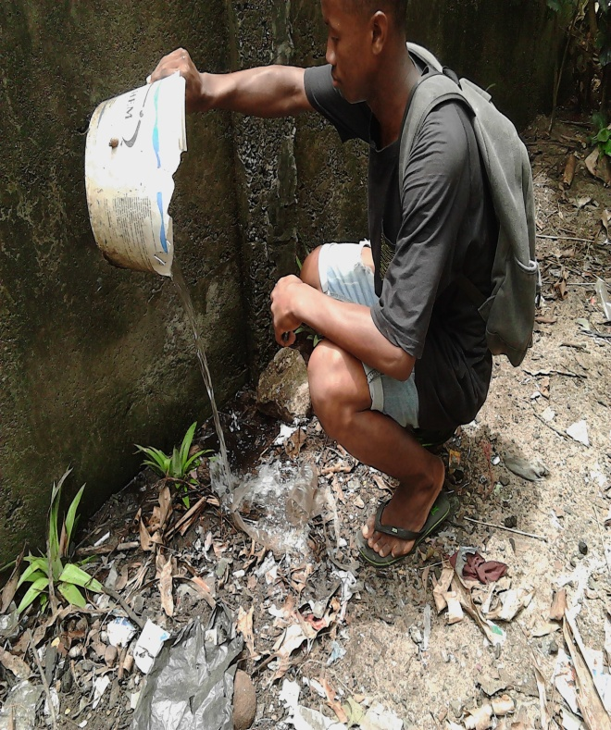

RESEARCH TEAM
GLOBE STUDENT: - RATOVOSON John David
- ZAFINANTENAINA Roméo Ejanick
- MAHAVY Johny Geraldo
GLOBE TEACHERS: - RABENANDRASANA Doris
-TORA Adonis Ricardo
ORGANIZATION :LYCEE JACQUES RABEMANANJARA High School -District Toamasina I -Commune Salazamay Sud – Toamasina Madagascar

Date : March 10, 2020

- 2 -
TABLE OF CONTENT
PAGES
* Title of research project and research team…………………………………………………………………… 1
* Table of content………………………………………………………………………………………………................ 2
* Abstract………………………………………………………………………………………………............................. 3
*Introduction and review of the literature………………………………………………………………………. 4
*Research methods and materials…………………………………………………………………………………….. 5
*Results ………………………………………………………………………………………………………………………..6-10
*Conclusion……………………………………………………………………………………………………………………....11
*BIBLIOGRAPHY…………………………………………………………………………………………………………………12
*BADGES……………………………………………………………………………………………………………………….....13
*PHOTO RELEASES………………………………………………………………………………………………………..14-17

- 3 -
ABSTRACT

Our school is called Lycée Jacques Rabemananjara,it is located in the eastern part of Madagascar ,in the city of Toamasina..Considering the fact that malaria kills children(500 ) and adults(150) every year in our region .We have chosen two malaria sites to determine the factors that cause the larval proliferation, since 2012 and we have taken actions to reduce this proliferation in order to take part in the national fight against malaria.
We hypothesize
“During the hot period and at high temperature there is an intense proliferation of mosquito larvae if the place was predatory or less. And when the temperature decreases the proliferation of the larvae also decreases”
But also, all actions against malaria will reduce larval proliferation and will be a commitment for social development”
To test these hypotheses we conducted two larval sampling in 2 different places (Figure 1-6) and awareness rising in different ways (photos1-8).
According to these graphs, in both bamboo and stagnant water, the high temperature (29 ° in March 2012 ) causes larval proliferation, but it is more intense in bamboo(92 in 2012)because of the absence predators. But when the temperature decreases (27 ° in 2012) the larval proliferation also decreases (39/ l in April 2012) with or without predators. In addition it was noted that the number of predators is inversely proportional to the temperature (March 2012 to April 26, 2012).
We can conclude that the proliferation of mosquito larvae depends on the temperature and the absence of predators. Thus to eliminate the breeding huts we carried out intense awareness raising for students, families and neighborhood as well as the community at any time, during special or world environment days. Then we recycled these breeding places so that they have a second useful life for us and the population (photos A to H)

RESEARCH PROBLEM
- In the first ,we want to know what is the relationship between the temperature variation and the larval outbreak ?
- Then What can be done to make the fight against larval mosquito proliferation a resilience action for the sustainable development of a region or a country

-4 -
INTRODUCTION OF LITTERATURE
Since 2012, the Lycée Jacques Rabemananjara Toamasina's Globe Program has been fighting malaria, in partnership with the regional health department. Because malaria rages every year and causes considerable infant (.500..) and adult (..159.) mortality in our region. This virulence has caused disabilities such as the inability of adults to work, paralyzing family life and even the economy of the region, as well as chronic weakness and stunting for children and adolescents.
It is for this reason that we students, responsible citizens, have started this study of the 2 malaria sites in order to determine the relationship between the larval proliferation, the factors which cause them on one side and on the other side, Relate the actions already started by our association in terms of the fight against malaria in order to take action to neutralize the larval proliferation as well as the development of our region.
So we ask the following 2 questions:

1 - What is the relationship between the water temperature and this larval proliferation? and what is the factor that determines it?
2 - Is this study sufficient and what can be done so that the fight against the larval proliferation of mosquitoes becomes a simple action but which can save a lot of life and also it ensures sustainable development within our association and that of the region itself.
First we made the following assumptions
- During the hot season and at high temperature, there is an intense larval proliferation whether there are predators or not. But when the temperature decreases, the larval proliferation decreases with or without predator. But also, "awareness actions carried out at the level of students and people in the community will serve to reduce the virulence of malaria, stimulate the creativity of students globally and their personal development as well as sustainable development within society

So to test our hypotheses, we carried out two actions, one of analysis and research and the other of various types of actions. (See photo A-H)
After analyzing the observations on the 2 malaria sites, we obtained the results mentioned on the graphs (1-3) which indicate that the larval proliferation is intense (92 larvae in a 25cm3 section of bamboo) at high temperature then that it is less (10 larvae) in the other site because of the intense presence of predators (52 /l).However, whatever the case, the decrease in temperature leads to the marked decrease in larvae.
Admittedly, the study of the impact of temperature on the quantity of larvae is important. But it will still be accompanied by a fight and engagement action such as raising awareness among all level of students (photo), families and neighbors as well as the community (photo). Besides, one of us has a silver medal in the national competition by recycling the larval huts (photo) and we were able to embellish the school by doing the same (photo) .In conclusion, "Acta no verba"

-5 -
RESEARCH METHODS AND MATERIALS
State school uses a globe materials mentioned in protocols globe and the method concerned
MATERIALS
Tube of transparency, pH paper, sampling pipette ,,forceps, sampling larvae and predatory bottle beaker 250ml ,rope ,tape ,compass ,GPS ,camera ,pencil
METHOD: A- SAMPLING LARVAE
1-Sampling of the larvae in bamboo
For sampling larvae in leftover cut bamboo ,we use the method of Deeping
- We draw all of the water quantity in the bamboo using the pipette
- We measured the diameter and height of bamboo portion
- We separate and count the number of the larvae and predators
- We keep in bottles labels samples collected
- we write on the sampling sheet all this information, the description of the site, the date of sampling, the geographical coordinates, the average pH and the temperature
2- Sampling of larvae in the standing water
After identified all of information in globe website ,we use either the transect method (star)
- We collect mosquito larvae in the four corners of the
- We will separate and count the larvae and predators in bottles for this purpose
- We note that information in the data sheet
- We calculate the larval density of each site using the following formula
V * Number of larvae
DENSITY (%) =-----------------------------------------
1liter or 1cm³

B- MAKING ACTION
After research project about relationship between the temperature variations, we started raising awareness of globe students than those of high school. Then, the other students . After that, the parents , the neighbors of globe students. Finally, the community of the region during special days and world days, by the method of conference debate, door to door, peer to peer, by audio sensitization, etc. but above all by actions of elimination together of the mosquito larvae deposits. But also, by way of national competition

-6 -
RESULTS: 1-FIGURES 1 TO 3
:TS1
FIGURE 1 :Number of larvae in the 2 sites of observation

FiIGURE 2 : Temperature variation in the 2 sites

-7 -

FIGURE 3: Number of predator in the 2 sites

2- PHOTOS A TO H

-8 -

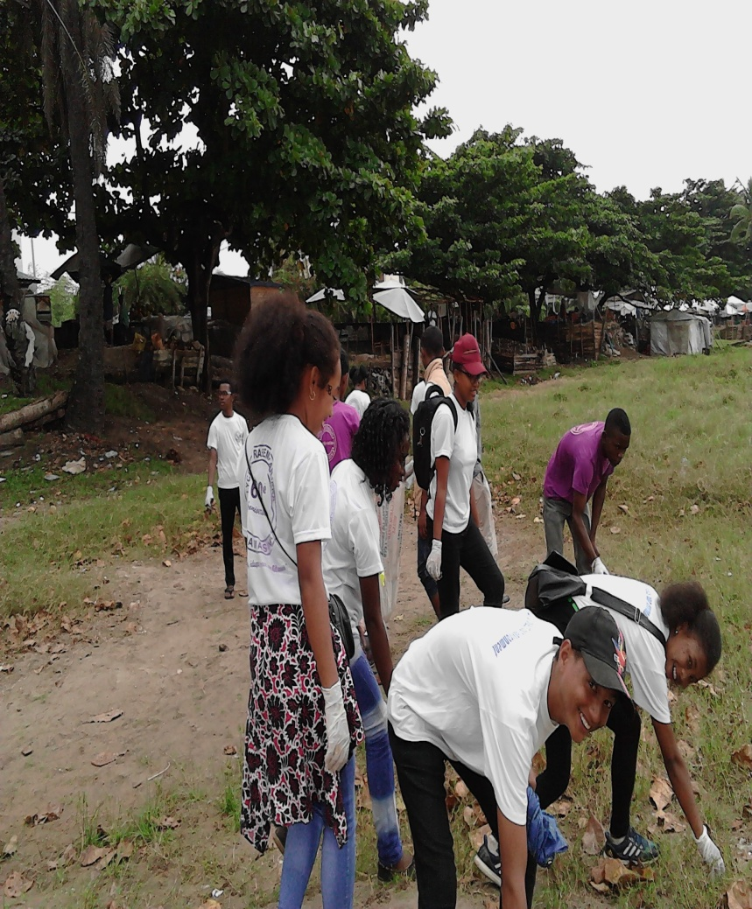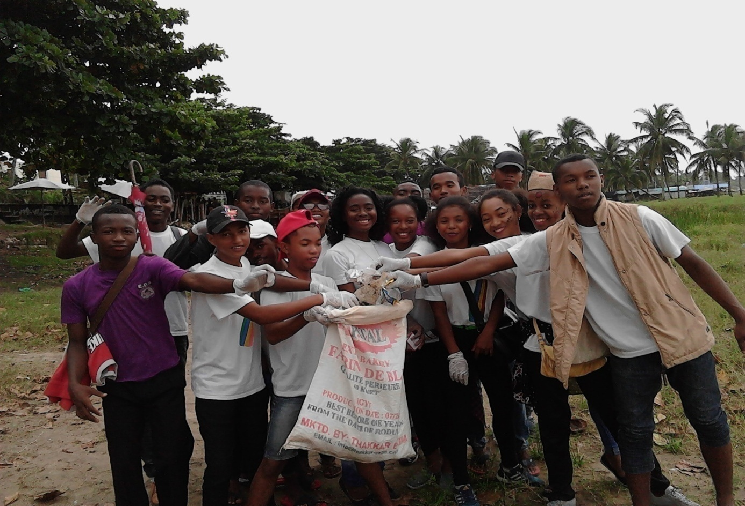
A &B : BEACH CLEANING TO ELIMINATE LARVAE MOSQUITOS HUTS
-9 -

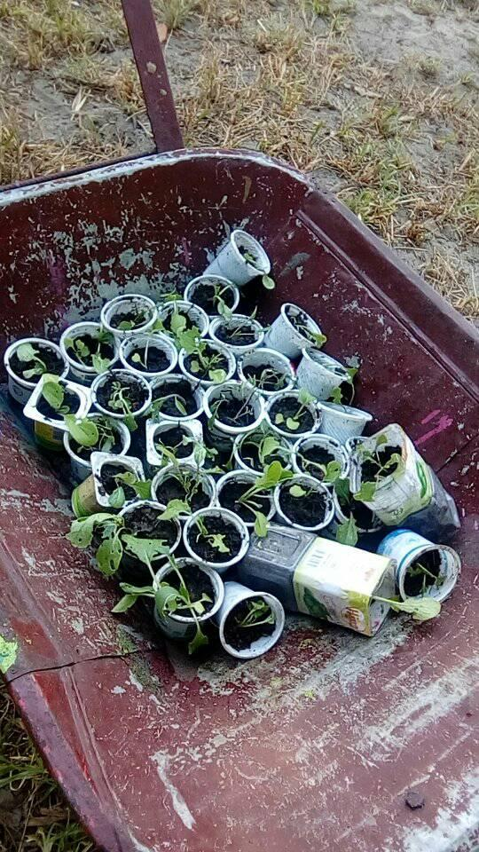

PHOTO C& D recycling of breeding places and globe student silver medal

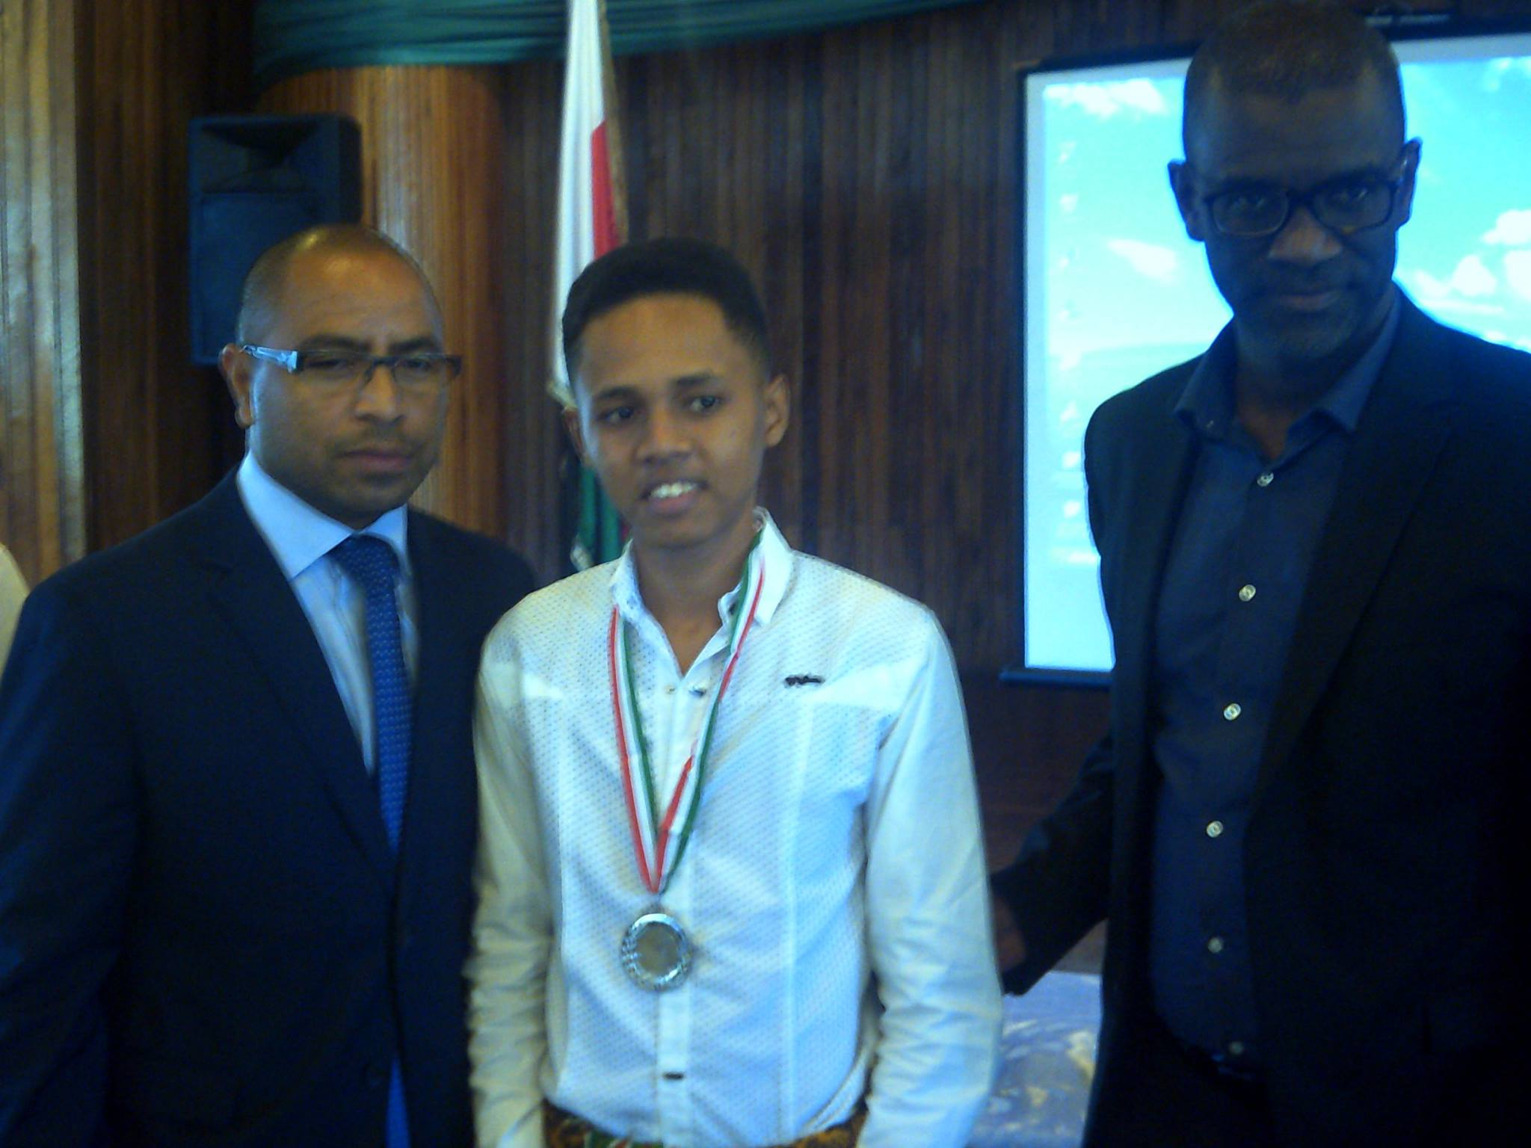
-9 -
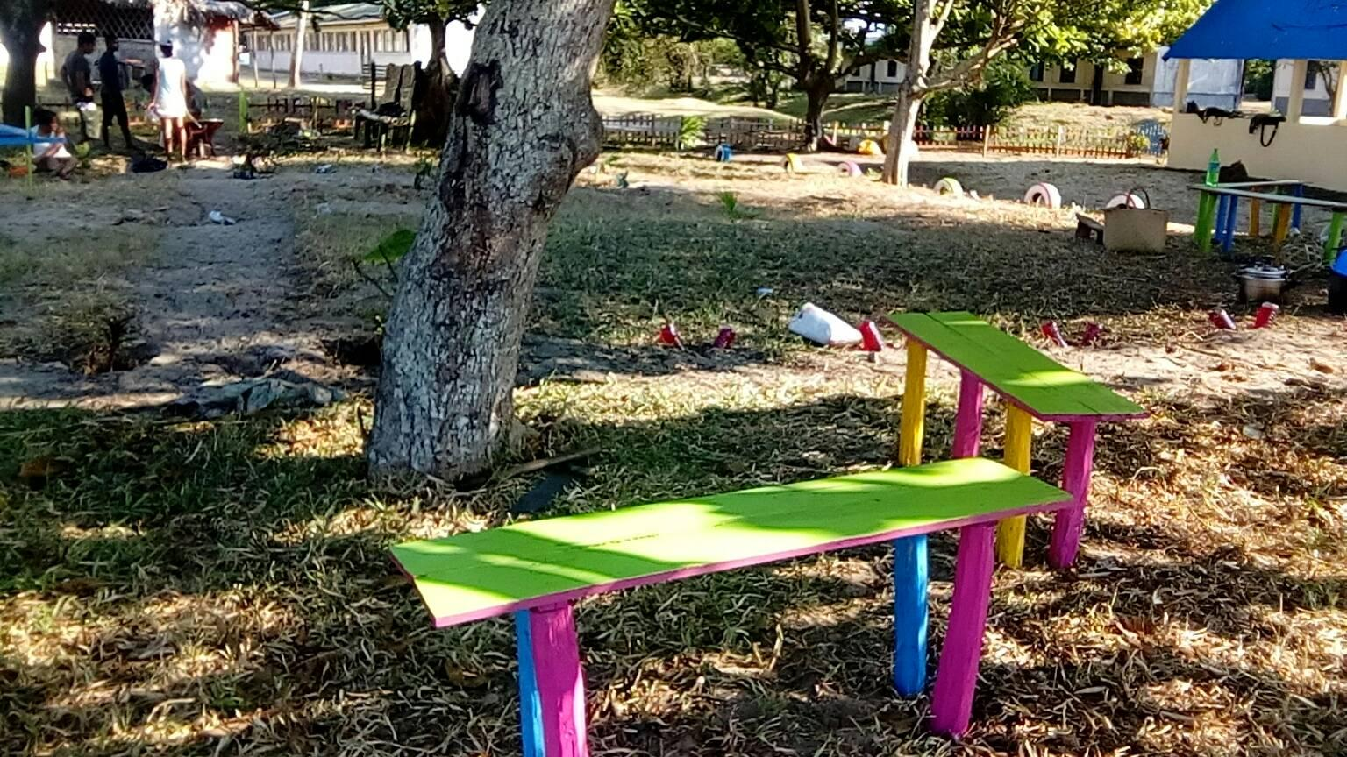
PHOTOS E & F : school beautification by recycled mosquito breeding places

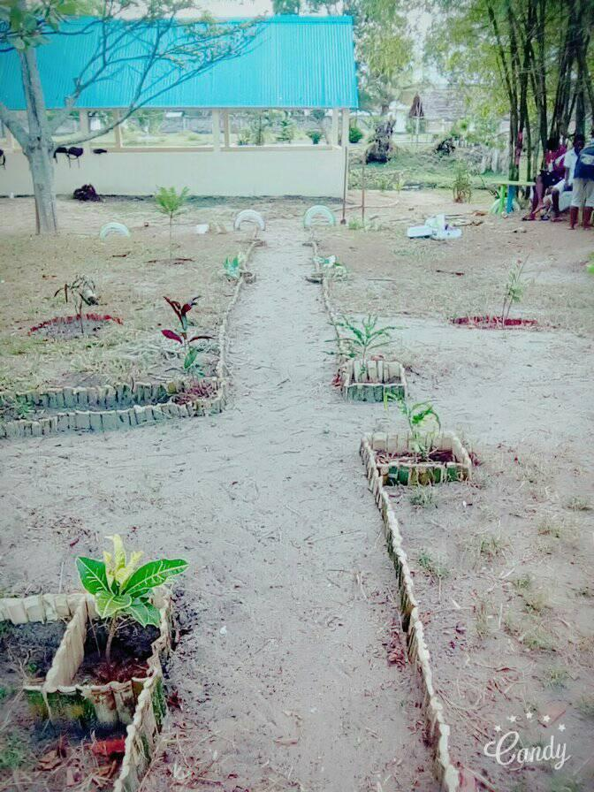

-10 -
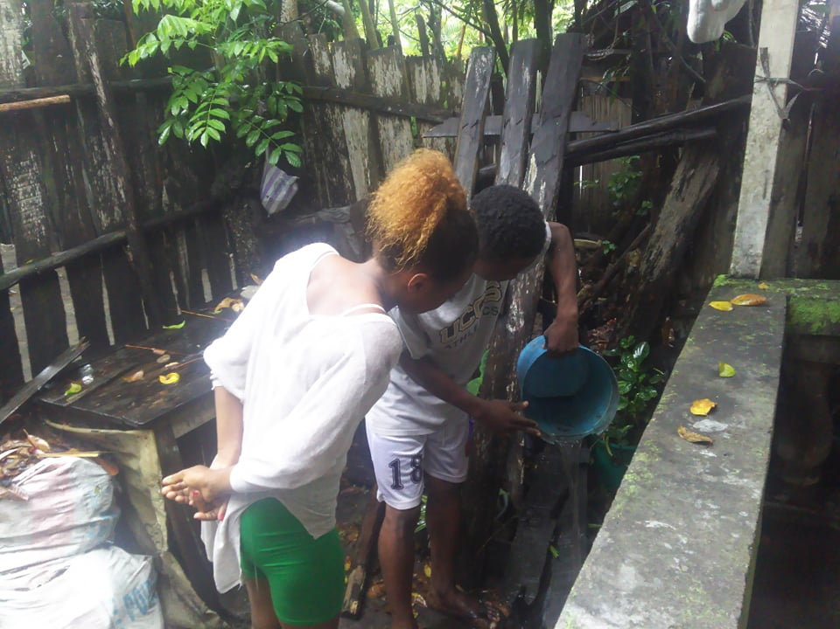
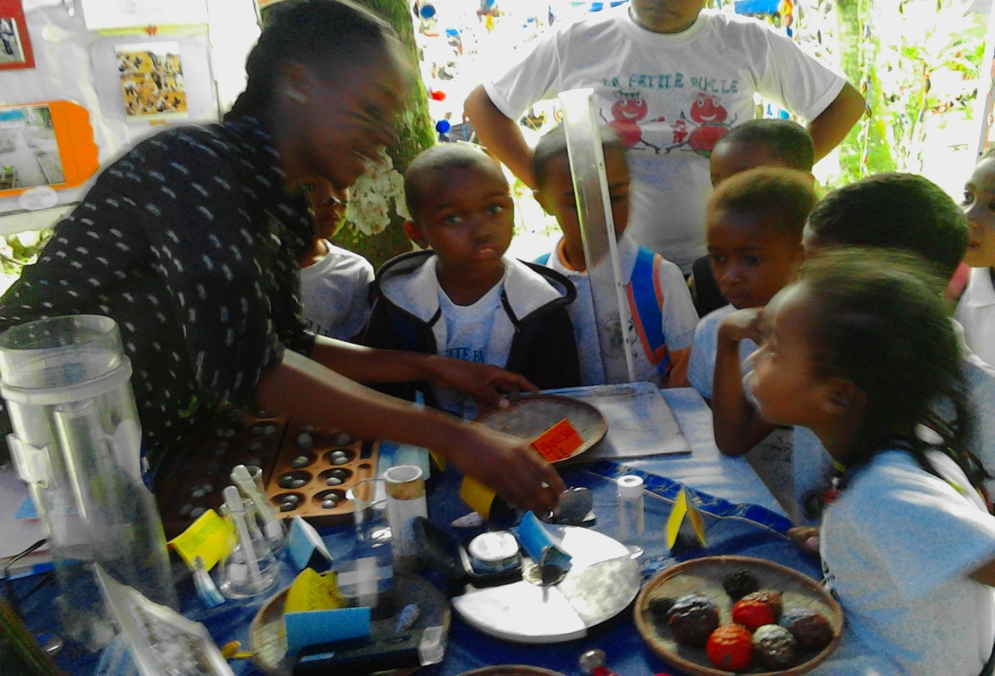
PHOTOS G & H : Community awareness

-11 -
CONCLUSION
. We can conclude that the outbreak of mosquito larvae increases when the water temperature is higher, and decreases in presence of predators or in low temperature. So, we took measures as added fry in standing water, cute the bamboo to the brim, educate the students, family, neighbors and the community to throw objects accumulating rainwater. Especially, to prevent thes objects from becoming waste that pollutes, we recycled them to give second life of their recipients
In last ,we are just little students to make these acts, helping by our educators, parents and community ,but we are very proud to making this magnificent and awesome mission .Once again, to be globe students is for us honor. Also, fighting against malaria is just beginning, so, we invite the entire community globe program to follow our slogan “Acta no verba” .Thank you.

-12 -

BIBLIOGRAPHY
RAFARASOA L, RANDRIANARISOA E, RANDIMBIVOLOLONA N,
RAFALIMANANA A, RALISOA B O, 2007 « GLOBE Malaria Project Madagascar »
Communication scientifique et Restitution de 2 années de travaux à Riversdale, Western
Cape Province South Africa au Globe Consortium 2007

RAFARASOA L, RANDRIANARISOA E, RANDIMBIVOLOLONA N,
RAFALIMANANA A, RALISOA B O, 2007 « GLOBE Malaria Project Madagascar »
Communication scientifique et conférence débat à « l’Environnement Healtth Congress 2007 » à George Town South Africa
-Site Web Globe Program : -« IVSS research project and ZIKA project »
-Education au Développement Durable et à la solidarité Internationale(EDDSI), 4 Avril 2016, »Etablissement et école en marche de développement durable »
- Virtual documents on Education for sustainable development and recycling(www.ac_grenoble.fr,dumas.ccsd.crns.fr,etc...)

OPTIONAL BADGES

*Be a collaborator because it ‘is very important to take part in a world observation than work all alone in a limited region. Science evolves every day, doing science with several observations and sharing it is so enriching and allows to verify so many things
*Be a data scientist because this is our main global mission, it makes it possible to explain scientifically all the events and to prevent those which could affect the proper functioning of our unique system

*Be an engineering because it is also very important to take part in creations which make it possible to solve social problem. Indeed, science always has a solution to propose for the social problem by means of the discovery

-13 -
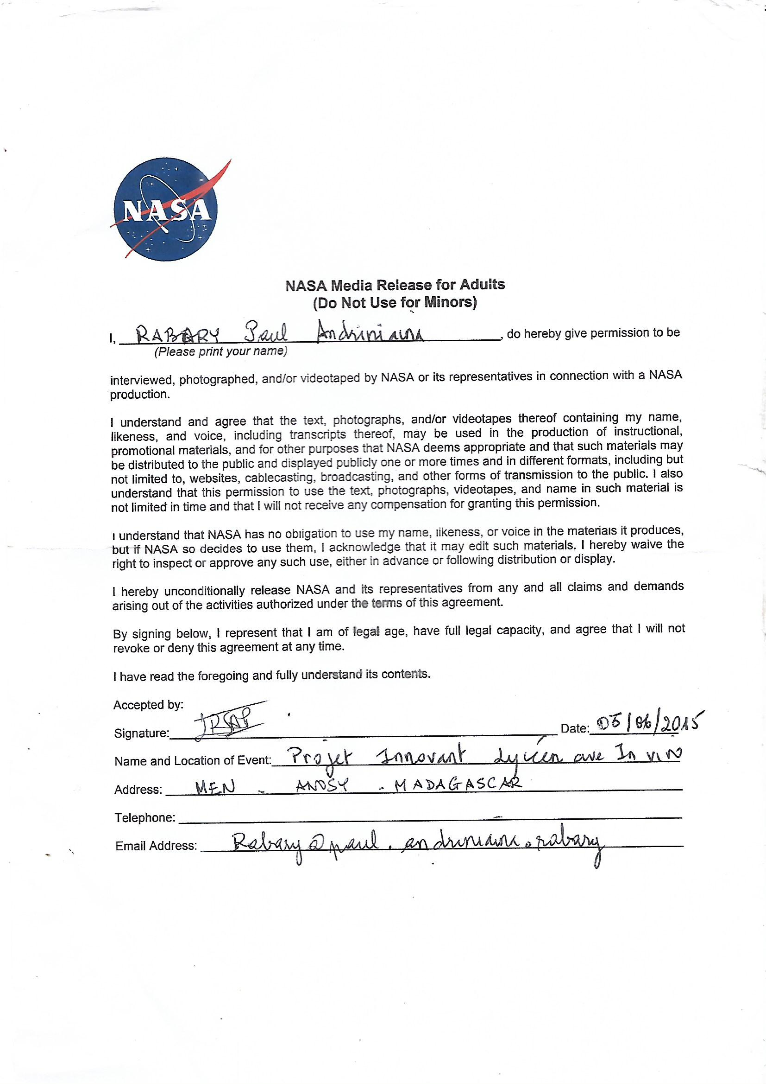

-14 -
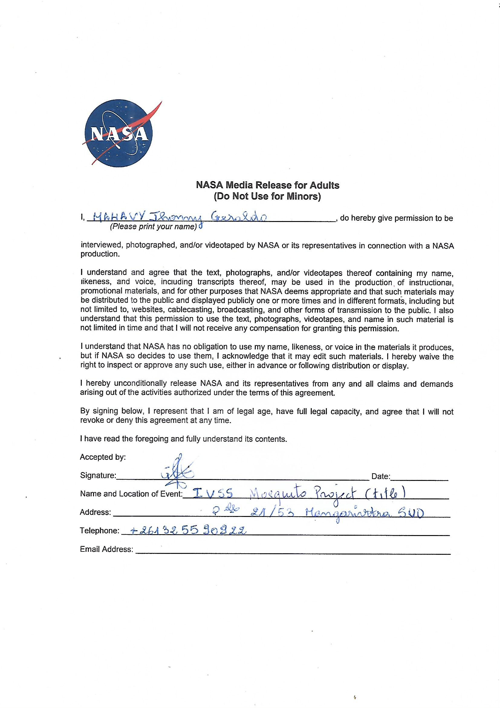

PHOTOGRAPHIC RELEASE