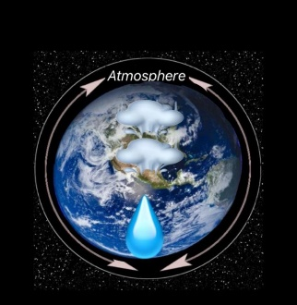

The relationship between relative humidity and air pressure

Reema abdullatif al-ajlan
Reef saeed al-qahtani
Jumanah mohammed al-amri

Arqa First High School
Riyadh, Saudi Arabia

Tr.Noura Fahad Alsebie
1 March 2020

Contents:

- Abstract
- Research Question and Hypothesis
- Materials and Methods
- Data summery
- Analysis and results
- Conclusions

1. Abstract

The study aims to find the relationship between air pressure and humidity in Arga First High School in Riyadh Saudi Arabia.
In this study we used the experimental method in which the relative humidity and air pressure protocol was measured within three months in several regions in Saudi Arabia. During this period the relationship between them and their effect on each other was observed

From this study we find that the relationship between humidity and air pressure is a positive relationship, whenever the humidity increased, air pressure increased and vice versa.

At the end we recommended
1 - Experiment should take place in high relative humidity or none relative humidity areas.
2 – the need to monitor daily readings of humidity and air pressure.
3 – The study of the effect of atmospheric pressure on humans and plants.

This study contributes significantly in developing and monitoring the geographical and climate database in our region.

2. Research Question and Hypothesis
From our study to the relative humidity protocol and our observations of their effect on air pressure in several regions we began to suggest our hypothesis:
1. Is there a relationship between relative humidity and air pressure.
2. What is the effect of water vapor on air pressure.

Relative humidity is a measure of the amount of water vapor saturation in the air (Moussa, 1986, p. 255).
The air pressure is (based on the weight of the air column on the unit spaces).
Based on previous studies, we hypothesized:
There is a direct relationship between relative humidity and atmospheric pressure in Riyadh, Saudi Arabia.

3. Materials and Methods
In the beginning, we looked for the relationship between relative humidity and air pressure. Measurements were taken at the Arqa high school in Riyadh and in different regions of Saudi Arabia during the period from (August 2019 - March 2020).

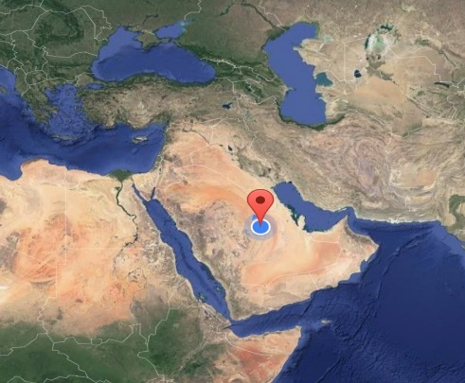

Then we noticed that there is a relationship between relative humidity and air pressure.
In order to take measurements, we used a hygrometer (a device used to measure moisture) (moisture protocol) (Figure 1)

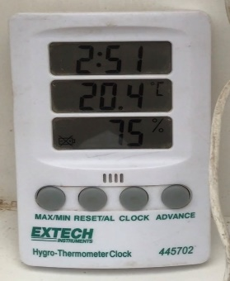

Figure 1: hygrometer

The barometer (a device used to measure atmospheric pressure) (atmospheric pressure protocol) (Figure 2).
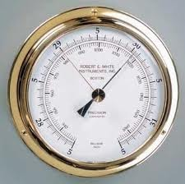

Figure 2: Barometer

4. Data summery

Global measurements of relative humidity
Latitude and longitude | City | relative humidity
46.43'0.01" N, 24.24'0" E | Abha | 20%
46.43'0.01" N, 24.24'0" E | Riyadh | %30
26.11'15.9" N, 44.14'56.4" E | Alqassim | 63%
50.6'0" N, 26.25'48" E | Dammam | 79%
39.10'0" N, 21.32'0" E | Jeddah | 86%

(Figure 3: according to Relative Humidity Protocol)

Globe measurements of air pressure
Latitude and longitude | City | air pressure
46.43'0.01" N, 24.24'0" E | Abha | 802
46.43'0.01" N, 24.24'0" E | Riyadh | 933
26.11'15.9" N, 44.14'56.4" E | Alqassim | 942.9
50.6'0" N, 26.25'48" E | Dammam | 1013
39.10'0" N, 21.32'0" E | Jeddah | 1015

(Figure 4: by air pressure protocol)

5. Analysis and results
From the graphs, we conclude that the relationship between relative humidity and air pressure is a direct relationship. The higher the humidity, the higher the atmospheric pressure and vice versa. The reason for that is when the humidity increases, the water vapor increases in the air and the air pressure is the weight of the air column on the unit Spaces.
As we all know, that there is a relationship between relative humidity and air pressure. we noticed the difference in the values ​​of air pressure from one region to another in Saudi Arabia because of the difference in humidity in the region we noticed the difference in pressure in a certain area, Riyadh, because of the difference in moisture from day to day.

6. Conclusion:

In this research, we found the relationship between relative humidity and air pressure. We conclude that the relationship is a direct relationship between them. This study contributes significantly to the development and monitoring of a geographic and climate database for our region.
In conclusion, we recommend:
1 - Experiment should take place in high relative humidity or none relative humidity areas.
2 – the need to monitor daily readings of humidity and air pressure.
3 – The study of the effect of atmospheric pressure on humans and plants.

Acknowledgement: We wish to acknowledge, Globe coordination T.Noora Al-Subaie for selecting this topic, Computer teacher Najlia for helping us in logo design and T.Nada and the professor\ Alolyan for their contribution on writing a research paper.

cooperation | Engineering Solutions | Communicate with a specialist
We Reema, Reef and Jumanah-  cooperated to collect data and our department worked among us to find humidity and atmospheric pressure measurements in several areas and then we collected our results and wrote a research report. | We analyzed all the data obtained from the engineering analysis by Excel and explained it graphically. | We contact with Globe coordination T.Noora Al-Subaie for selecting this topic, Computer teacher Najlia for helping us in logo design and T.Nada and the professor\ Alolyan for their contribution on writing a research paper  .
Badges

