

**GLOBE Learning Expedition and Annual Conference**

**New Delhi, India**

**4th August- 8th August 2014**

**“GLOBE Research for Sustainable Communities”**

**“Evaluation of Changes in the Water Quality of the Tumpuna River**

**between the Years 2008 and 2014”\**

**by**

**Precious St. Clair, Zephan Pathron, Randy Sookoo,**

**Dwight Ashton**

**Advisors: Mrs Roshni Madoo & Mr Kameel Mohammed Ali**



**Brazil Arena Road, Brazil Village, Trinidad & Tobago, W.I.**

**Project Title:** *“Evaluation of Changes in the Water Quality of the Tumpuna River*

*between the Years 2008 and 2014”*

**Name of School:** *Brazil Secondary School*

**Names of Co-ordinators:** *Mr. K. Mohammed Ali*

*Ms. Tricia Ramsepaul*

*Mr. Michael Slater*

*Ms. Glenda Gajradge*

*Mrs. Roshni Madoo*

**Names of Participating Students:** *Precious St. Clair*

*Zephan Pathron*

*Randy Sookoo*

*Dwight Ashton*

**Date:** *30th June 2014*

**Table of Contents**

Acknowledgements 4

1. Abstract 5
2. Research Question 7
3. Hypothesis 9
4. Investigation Plan 9
5. Research Method 11
6. Data 12
   1. *Data Collected* 12
   2. *Data Summary* 12
7. Data Analysis 14
8. Discussion of Measurement Limitations 14
9. Conclusion 15
10. References/Bibliography 17

Appendix 1: Collection Method 18

Appendix 2: Water Quality Tests: 19

* *Nitrate Levels & pH* 19
* *Dissolved Oxygen Content* 20
* *Turbidity* 23
* *Electrical Conductivity* 24
* *Temperature* 24

Acknowledgements

The members of the GLOBE club of Brazil Secondary School wish to thank the following persons and organisations for their invaluable assistance in the production of this research paper.

* The Water and Sewage Authority (W.A.S.A.): for providing data on the quality of the water in the Tumpuna River for the last 10 years.
* The Institute of Marine Affairs of Trinidad and Tobago: for their generous donation of Water Quality Monitoring Kit.
* The Principal and Staff of Brazil High School: for their support in the production of this project.
* Mr. Henry Saunders, GLOBE Co-ordinator for Trinidad and Tobago: not only for his invaluable supervision and guidance during the production of this document , but also for his motivation and sincere commitment to keeping the GLOBE Club of Brazil Secondary School alive.

**1.0 ABSTRACT**

**Evaluation of Changes in the Water Quality of the Tumpuna River between the Years 2008 and 2014.**

Authors: Mrs. R. Madoo, Ms. P. St. Clair, Mr. Z. Pathron & Mr. R. Sookoo

Presenting Authors: Ms. P. St. Clair, Mr. Z. Pathron & Mr. R. Sookoo

School: Brazil Secondary School

Region: Latin America and the Caribbean

Country: Trinidad and Tobago

In 2008 the water quality of the Tumpuna River was assessed by members of the GLOBE Club of Brazil Secondary School. Since then, there have been changes in the Brazil community, which the GLOBE Club members suspect may be impacting on the water quality of the Tumpuna River. Since the Tumpuna River is still used by residents for both recreational and utilitarian purposes, the quality of the water of the Tumpuna River continues to significantly impact the lives of the people of Brazil Village.

The sampling point used in this project was selected as the water quality at this point was previously determined in the 2008 research project. The water quality was determined using GLOBE hydrology protocols. The parameters used to determine the quality of the water included levels of nitrates, dissolved oxygen content, turbidity, pH, temperature and electrical conductivity. These readings were taken over a two month period and compared to the readings taken in 2008 at this sampling point.

Comparison of the readings of 2008 with those of 2014 revealed that the changes in the community did not significantly impact on the quality of the Tumpuna River. The turbidity level did however fall from 35.00cm to 50.00 cm. This supported the assumption that the high turbidity reading obtained in 2008 was primarily due to the construction of a nearby bridge. Despite growing concerns over increased agriculture in the area the quality of the water in the river remained largely unchanged and fell well within acceptable standards.

1. **Research Question:**

In 2008 the students of the GLOBE Club of Brazil Secondary School embarked on a project to determine the water quality of the Tumpuna River. This project was particularly pertinent to the students as this river was used by the villagers for several reasons. These included recreational as well as for household use, since the supply of pipe borne water to Brazil Village was extremely unreliable. The students were concerned about the purity of the water in the Tumpuna River as Brazil Village historically has been a thriving agricultural district. However modern agricultural practices were not widely used in the area. As a result of the investigation done by the GLOBE Club it was determined that the water quality of the Tumpuna River was in fact quite good and free from expected contaminants.

Since 2008 there have been some changes in Brazil Village, which the GLOBE Club members suspect may be impacting on the water quality of the Tumpuna River. These changes include:

* The Ministry of Food Production of Trinidad and Tobago has embarked on a “Go Local” drive in which nationals are encouraged to grow and eat locally grown food. As a result of this the number of vegetable farmers surrounding the river has significantly increased since 2008.
* The pig farmer on the banks of the river has extended his farm. In 2008 this farmer had 5 stalls; this number has since increased to 15.
* In 2012 two large housing developments began close to the Tumpuna River. This involved substantial clearing of natural vegetation.
* At the time of the 2008 GLOBE Project, a bridge was being constructed over the Tumpuna River. This was used to explain the high turbidity readings recorded at this time. This bridge was completed in 2009. It would be interesting to note the turbidity readings 5 years after the construction of said bridge was completed.

Although the supply of pipe borne water has improved, many villagers continue to rely on the Tumpuna River. River bathing, fishing, cooking on the banks are all cultural practices which are deeply embedded in the lives of the villagers and as such are still enjoyed today. In 2012 Trinidad and Tobago experienced one of the worst droughts in recorded history. During this time the reliance on river water increased significantly. Therefore, it is clear that the purity of the water in the Tumpuna River is still of importance to the villagers of Brazil Village.

This research paper is designed to answer the following question:

**“Does the quality of the water in the Tumpuna River remain at a sufficiently high standard to be safely used to enrich the quality of life of the villagers of Brazil Village, despite the maximized agricultural production coupled with the increased population density?”**

1. **Hypothesis:**

The increased agricultural activity in the Brazil Village has resulted in a greater deposition of animal waste and inorganic fertiliser run off into the Tumpuna River. This has significantly reduced the quality of the water in the river, thereby making it unsafe for use by the residents.

# 4.0 Investigation Plan:

A point was selected along the Tumpuna River at which the water quality was determined. (See Map 1) The quality of the water at this point was previously determined in the 2008 research project. This point was chosen because of its proximity to the pig and large vegetable farms and to the competed bridge.

Once the site was chosen data collection began. It was decided that readings would be taken every two weeks for a period of 2 months. This gave a total of 4 readings for each protocol. An average of these readings were taken and then compared to the readings obtained in 2008. The readings were taken between the months December and January, as this was the time period in which the readings were taken in 2008.

A team of three students were assigned this task and their duties were as follows:

* Collecting the water samples from the Tumpuna River.
* Using GLOBE protocols to determine the water quality of the samples.
* Comparing this data with that collected in 2008.
* Representing this comparison graphically such that analysis could be done more easily.
* Extracting conclusions from this analysis.
* Compiling the written report of this project.

All three students were involved in each step of this investigation. In the practical aspect of the project the students were guided by coordinating teacher Mr. K. Mohammed Ali. The students were assisted in the write up of the project by Mrs. R. Madoo, Science Teacher.

Point 3: Water quality in 2008 compared to 2014.

10.5602oN, 61.2675oW, elevation: 25m

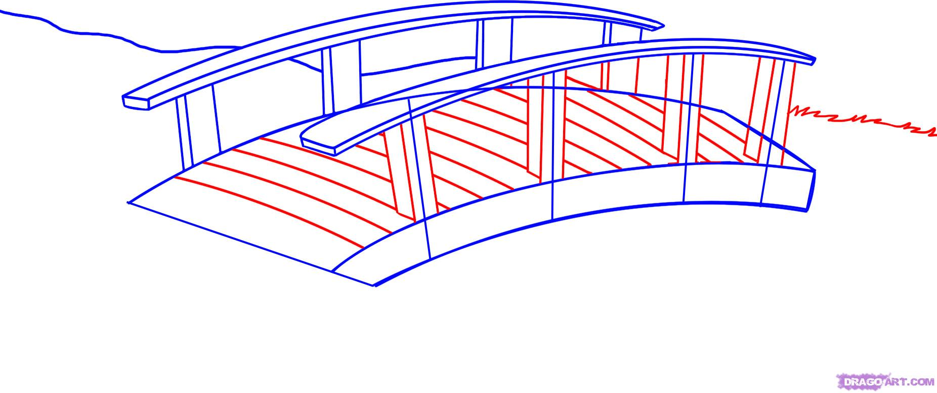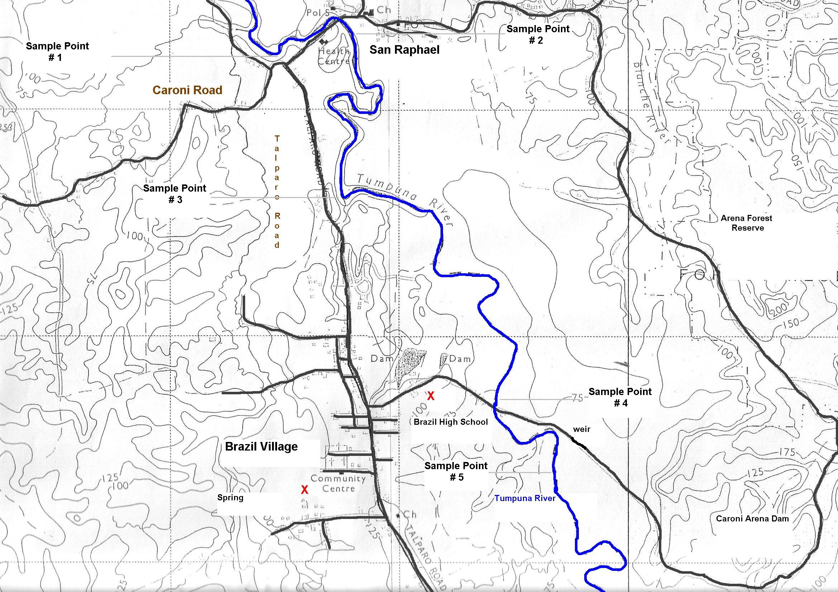

*Map 1: Map of Brazil Village showing the Sampling point and its Proximity to the Pig and Vegetable Farms and to The Completed Bridge*

## 5.0 Research Method

Water samples were collected, following the GLOBE protocol, (see appendix 1), from the sampling point. The water quality of each sample was determined by measuring the following parameters: (i) Temperature (ii) Nitrate level, (iii) Dissolved oxygen content, (iv) pH, (v) Electrical Conductivity and (vi) Turbidity. This was also done following GLOBE protocols, (see appendix 2).

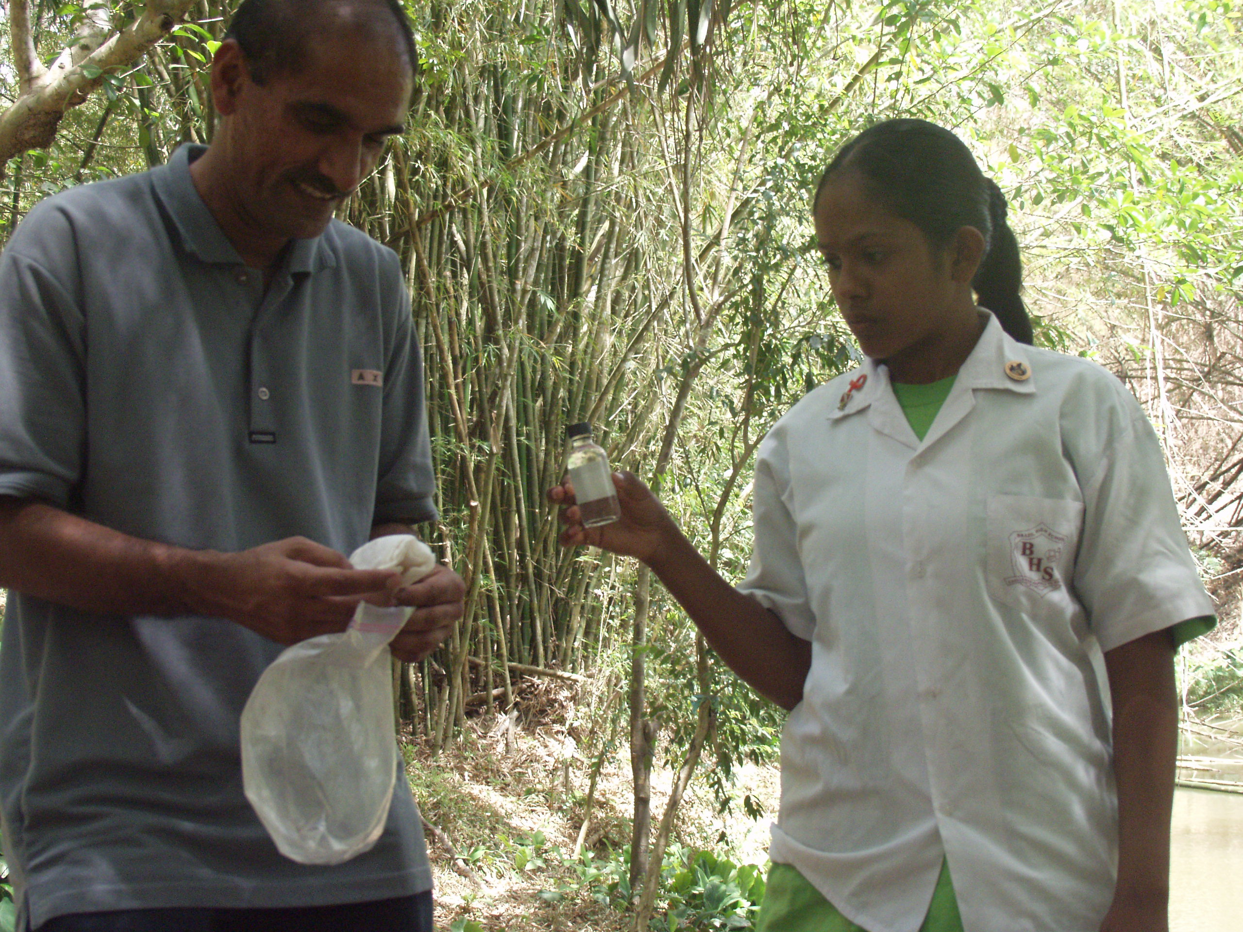

*Fig. 1: Student with Sample of Water from the Tumpuna River*

**6.0 Data**

**6.1 Data Collected**

|  |  |  |  |  |  |
| --- | --- | --- | --- | --- | --- |
| **Water Quality Parameter** | **Readings** | | | | **Average** |
| 1 | 2 | 3 | 4 |
| Temperature/ 0 C | 25 | 23 | 27 | 29 | **26** |
| Nitrate Level/ppm | 0 | 0 | 0.1 | 0.1 | **0** |
| Dissolved O2/ppm | 5.2 | 5.6 | 5.4 | 5.4 | **5.4** |
| pH | 7 | 7.6 | 7.5 | 7.5 | **7.4** |
| Electrical Conductivity/uS | 160 | 155 | 157 | 148 | **155** |
| Turbidity/ cm | 45 | 65 | 50 | 40 | **50** |

*Table 1: Water Quality Parameter Values of the Tumpuna River in 2014*

|  |  |
| --- | --- |
| **Water Quality Parameter** | **Reading** |
| Temperature/ 0 C | 27.0 |
| Nitrate Level/ppm | 0 |
| Dissolved O2/ppm | 5.4 |
| pH | 7.4 |
| Electrical Conductivity/uS | 200 |
| Turbidity/ cm | 35.0 |

*Table 2: Water Quality Parameter Values of the Tumpuna River in 2008*

**6.2 Data Summary**

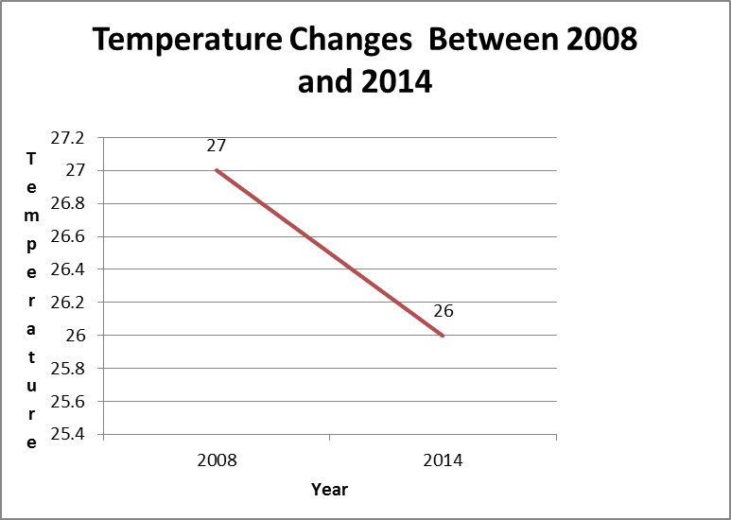

*°C*

*Graph 1: Temperature Changes*

*in the Tumpuna River*

*between 2008 and 2014*

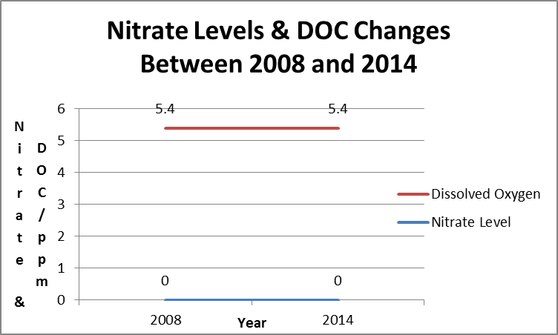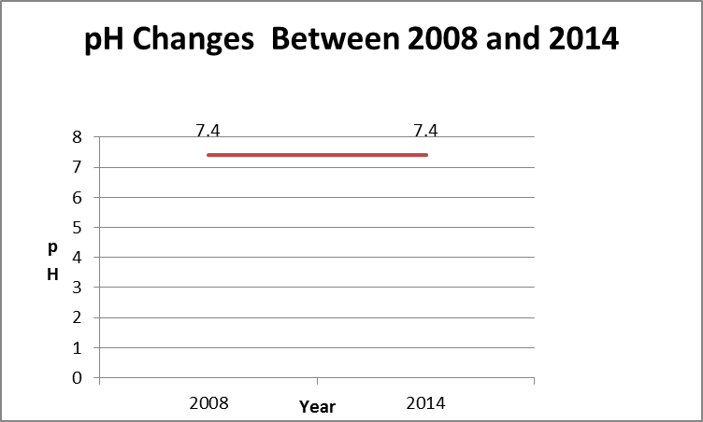

*Graph 2: Nitrate Levels & DOC Changes Graph 3:pH Changes in the Tumpuna River*

*in the Tumpuna River between between 2008 and 2014*

*2008 and 2014*

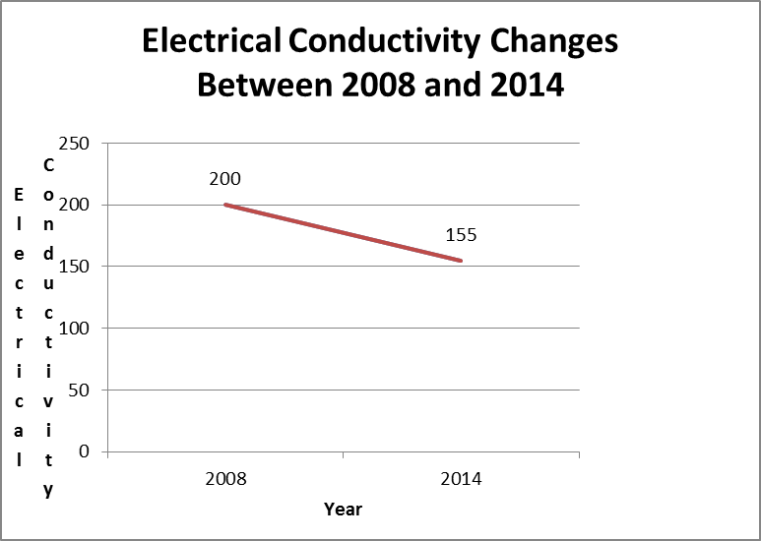

*Graph 4: Electrical Conductivity Changes in the Tumpuna R Tumpuna River between 2008 and 2014*

*in the Tumpuna River between*

*2008 and 2014*

/uS

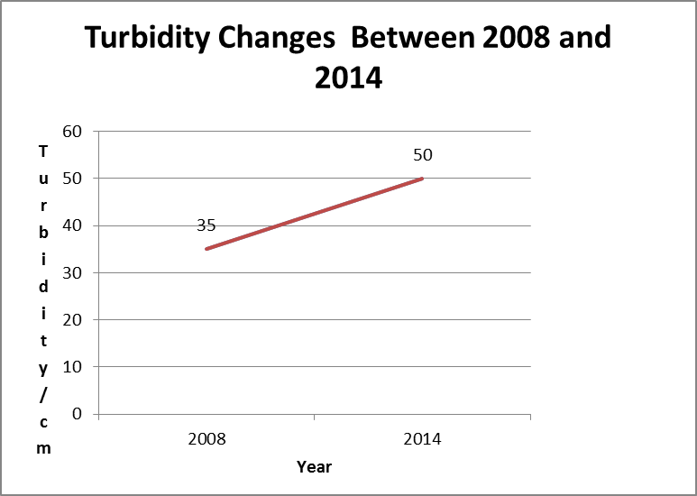

*Graph 5: Turbidity Changes in the Tumpuna River River between 2008 and 2014*

*in the Tumpuna River between*

*2008 and 201*

# 7.0 Data Analysis

**7.0 Data Analysis**

# For each parameter the average of the four readings, obtained in 2014, was plotted against time. The average reading for the same parameter, obtained in 2008, was also plotted on the same pair of axes. This facilitated an easier comparison of the two years for each parameter. The nitrate levels, dissolved oxygen content and the pH levels all remained constant, 0.0 ppm, 5.4 ppm and 7.4 respectively. The temperature fluctuated slightly, falling from 27 0C in 2008 to 26 0C in 2014. This was not significant. The electrical conductivity fell from 200uS in 2008 to 155uS in 2014. Again, this was not significant. There was however a significant decrease in the turbidity. The depth at which the Secchi disc could be seen increased from 35cms to 50cms.

**8.0 Discussion of Measurement Limitations.**

This investigation revealed that the water quality of Tumpuna River was not being negatively impacted by the increased agricultural production in the Brazil Village, as previously suspected by the GLOBE Club of Brazil Secondary School. This conclusion was however based on sampling at one point of the Tumpuna River, as compared to five points, which was sampled in 2008. Sampling at the other 4 points was impossible as access to these areas was made extremely difficult due to landslips and development at these points. The erratic weather patterns experienced during the months of December and January of 2013-2014 made collection of the water samples difficult.

Further research should be done to enhance the understanding of the relationship between the agricultural activity in the Brazil Village and the water quality of the Tumpuna River. This research should include:

1. Sampling at several points along the Tumpuna River.

2. The sampling in this investigation was done in 2014, six years after the last

sampling. The water quality of the Tumpuna River should be determined more

frequently, perhaps every year. This would give a more accurate representation of

how the quality of the water changes over time.

3. The students should visit the pig and vegetable farms in the area to determine what

agricultural practices are being employed, which are reducing the impact of their

increased production on the water quality of the Tumpuna River.

# 9.0 Conclusion

Evaluation of the comparison of the water quality parameters collected in 2014 to those collected in 2008 revealed that there was very little change in the quality of the water of the Tumpuna River. There were slight deviations in the readings of temperature, dissolved oxygen content, pH and electrical conductivity. The electrical conductivity decreased from 200uS to 155uS. This decrease was not considered to be significant as it could be explained by a fall in mineral content of the water in the river. This fall in mineral content could have occurred when construction of the bridge was completed. During construction of the bridge ions, such as calcium ions from cement, were being deposited into the water, which increased its electrical conductivity. Once construction was completed the mineral ion content of the water fell, lowering the electrical conductivity. The above deviations were not significant, indicating that these parameters were not affected by the changes in the community. The turbidity of the water did however decrease, as indicated by the increase of the depth at which the Secchi disc could be seen, from 35cm to 50 cm. In 2008 the nearby bridge was under construction. The river bed was being disturbed and material was being deposited into the water on a daily basis. This resulted in an increased turbidity. This bridge was completed in 2012. As such the turbidity level recorded in 2014 was considerably lower than that recorded in 2008.

# 10. 0 References/Bibliography

* *Surface- water hydrology.* (n.d.).Retrieved January 8, 2008, from

<http://en.wikipedia.org/wiki/Water_quality>

* *What is water quality?* (n.d.). Retrieved November 10, 2007, from <http://www.epa.nsw.gov.au/envirom/waterqual.htm>
* LaMotte Company (2003). *Dissolved Oxygen Instruction Manual.*
* Ministry of Education. *GLOBE, Teacher Certification Field and Lab Book* (December 2004 – December 2005)
* Rahil, A.M. Vohn (2002). *New Caribbean Geography with Map Reading and* *C.X.C. Questions*. Caribbean Education Publishers.

**APPENDIX 1**

**Collection Method:**

With the exception of the “dissolved oxygen content” determination, all water tested was obtained from a general sample, which was collected as described in the following steps:

* A plastic bucket was rinsed with the sample water at the sample point. To avoid contamination, the rinsed water was not reintroduced into the sampling point. Care was taken not to disturb the bottom sediment.
* A rope was attached to the handle of the bucket.
* The bucket was then thrown into the river. The site in which the bucket was thrown was as close to the centre of the river as possible. An effort was made to collect water from areas in which the water was flowing.
* The water sample was collected from the top surface water. Care was taken to ensure the sample water was not contaminated with bottom sediments.
* The bucket was allowed to fill to 2/3 to 3/4 with sample water. It was then slowly pulled back to the shore using the rope.
* All following tests were immediately carried out on the water collected in the bucket.

**APPENDIX 2**

**Water Quality Tests:**

### Nitrate levels & pH

Material and Apparatus:

- 100 ml beaker

* Nitrate test strip
* pH test strip

Method: - The water sample was placed in the 100ml beaker.

* The test strip was dipped into the sample and held there without motion, for 2 seconds.
* The strip was then removed and shaken briskly to remove excess water.
* After one minute, the colour of the strip was compared to the standard colour chart to determine the nitrate level of the water sample.
* A pH test strip was dipped into a fresh sample of water and left for 5 seconds.
* After 1 minute the colour change observed was compared to a standard colour chart to determine the pH of the water.

### Dissolved Oxygen Content

Materials and Apparatus

- 1.0 g plastic spoon

**-** DirectReading Titrator

- Test Tubes- 5 mls, 10mls, 12.9mls, 15mls, 20mls and 25mls, with caps.

- Water Sampling Bottle. (60mls glass bottle)

- Manganous Sulfate Solution

- Alkaline Potassium Iodide Azide

- Sulfamic Acid Powder

- Sulfuric Acid (1:1)

- Sodium Thiosulfate (0.025N)

- Starch Indicator Solution

Method:

1. Sample Collection.

* The sampling bottle was rinsed with water from the sampling point.
* The bottle was tightly capped and submerged under the water at the sampling point.
* Keeping the bottle submerged, the cap was removed.
* The bottle was allowed to fill with the sample water. The bottle was kept submerged until it was completely filled and all air bubbles removed.
* The cap was replaced on the bottle, while the bottle was still submerged.
* The bottle was removed from the water and slowly inverted to check for air bubbles.
* If air bubbles were seen, the entire procedure was repeated until the water sample was free of air.

1. Adding the reagents.

* The cap was removed from the sample bottle.
* Immediately after removal of the cap, 8 drops of Manganous Sulfate Solution and 8 drops of Alkaline Potassium Iodide Azide were added. The bottle was then quickly recapped. This step is crucial as once the cap is removed the sample could be compromised by oxygen in the atmosphere.
* The contents of the bottle were thoroughly mixed by inverting it several times.
* A precipitate was then formed, which was allowed to settle below the shoulder of the bottle.
* Immediately after the precipitate settled, the 1g spoon was used to add one level measure of Sulfamic Acid Powder.
* The bottle was recapped and gently inverted until the precipitate and the reagent were completely dissolved.
* The colour of the solution was then noted. The presence of dissolved oxygen was indicated by a clear yellow to orange colour. Once this colour was seen, the sample was then used in a titration to determine the actual amount of dissolved oxygen.

1. Titration

* The sample was now referred to as the “fixed sample”.
* The titration tube was filled to 20ml. line with the fixed sample.
* The titrator was filled with Sodium Thiosulfate. Care was taken to ensure that there were no air bubbles in the aliquot of the reagent taken. This was done by taking the aliquot from the inverted reagent bottle. If air bubbles were seen, they were expelled by partially filling the barrel of the titrator and pumping the aliquot back into the reagent bottle. The procedure was repeated until an aliquot free of air bubbles was obtained.
* If the fixed sample is a dark yellow, the Sodium Thiosulfate, from the titrator, was slowly introduced into the titration tube. While this was being done, the titration tube was constantly swirled.
* Once a pale yellow colour was observed, the cap was removed and 8 drops of Starch Indicator Solution added. The solution was now blue. If the initial colour of the fixed sample was pale yellow, then the preceding step was omitted and the Starch Indicator Solution added directly to the sample.
* The titrator, with the Sodium Thiosulfate, was now reintroduced into the titration tube, and the titration continued.
* The Sodium Thiosulfate was slowly added until the sample in the titration tube became colourless.
* The amount of dissolved oxygen (parts per million) in the sample was read directly from the calibrated scale on the titrator.
* If the titration required more Sodium Thiosulfate than what was contained in the titrator, the titrator was refilled and the total volume of Sodium Thiosulfate used to determine the dissolved oxygen content.

### Turbidity:

Materials and method: Turbidity tube, container with spout

Method:

* The tap at the bottom of the turbidity tube was securely closed.
* Using the container with the spout, a small amount of sample water was slowly poured into the tube.
* While this was being done, the disk on the inside of the tube was observed from directly above the tube.
* Additional water was slowly added and the disk continuously observed. This procedure was continued until the disk was no longer visible.
* At this point, 50mls of the sample water was added.
* The tap at the bottom of the turbidity tube was slowly opened, such that the sample water ran slowly out of the tube. While this was being done, the turbidity tube was constantly monitored from above. Once the disc reappeared, the tap was quickly closed.
* The level of sample water left in the turbidity tube was read off the calibrated side. This reading indicated the turbidity of the sample point in terms of depth.

### Electrical Conductivity:

Material and apparatus: - 100mls beaker, electrical conductivity meter

Method:

* A small sample of the water was placed in the beaker.
* The probe of the electrical conductivity meter was submerged in the sample of water.
* The liquid crystal display was observed until a stable reading was obtained. This reading was noted as the electrical conductivity of the sample.

**(e) Temperature**

Material and Apparatus: 100 ml beaker, a calibration thermometer

* A small sample of the water was poured into the beaker.
* The calibration thermometer was submerged in the sample of water.
* The temperature of the sample was read off the thermometer.