Country -GHANA

Ins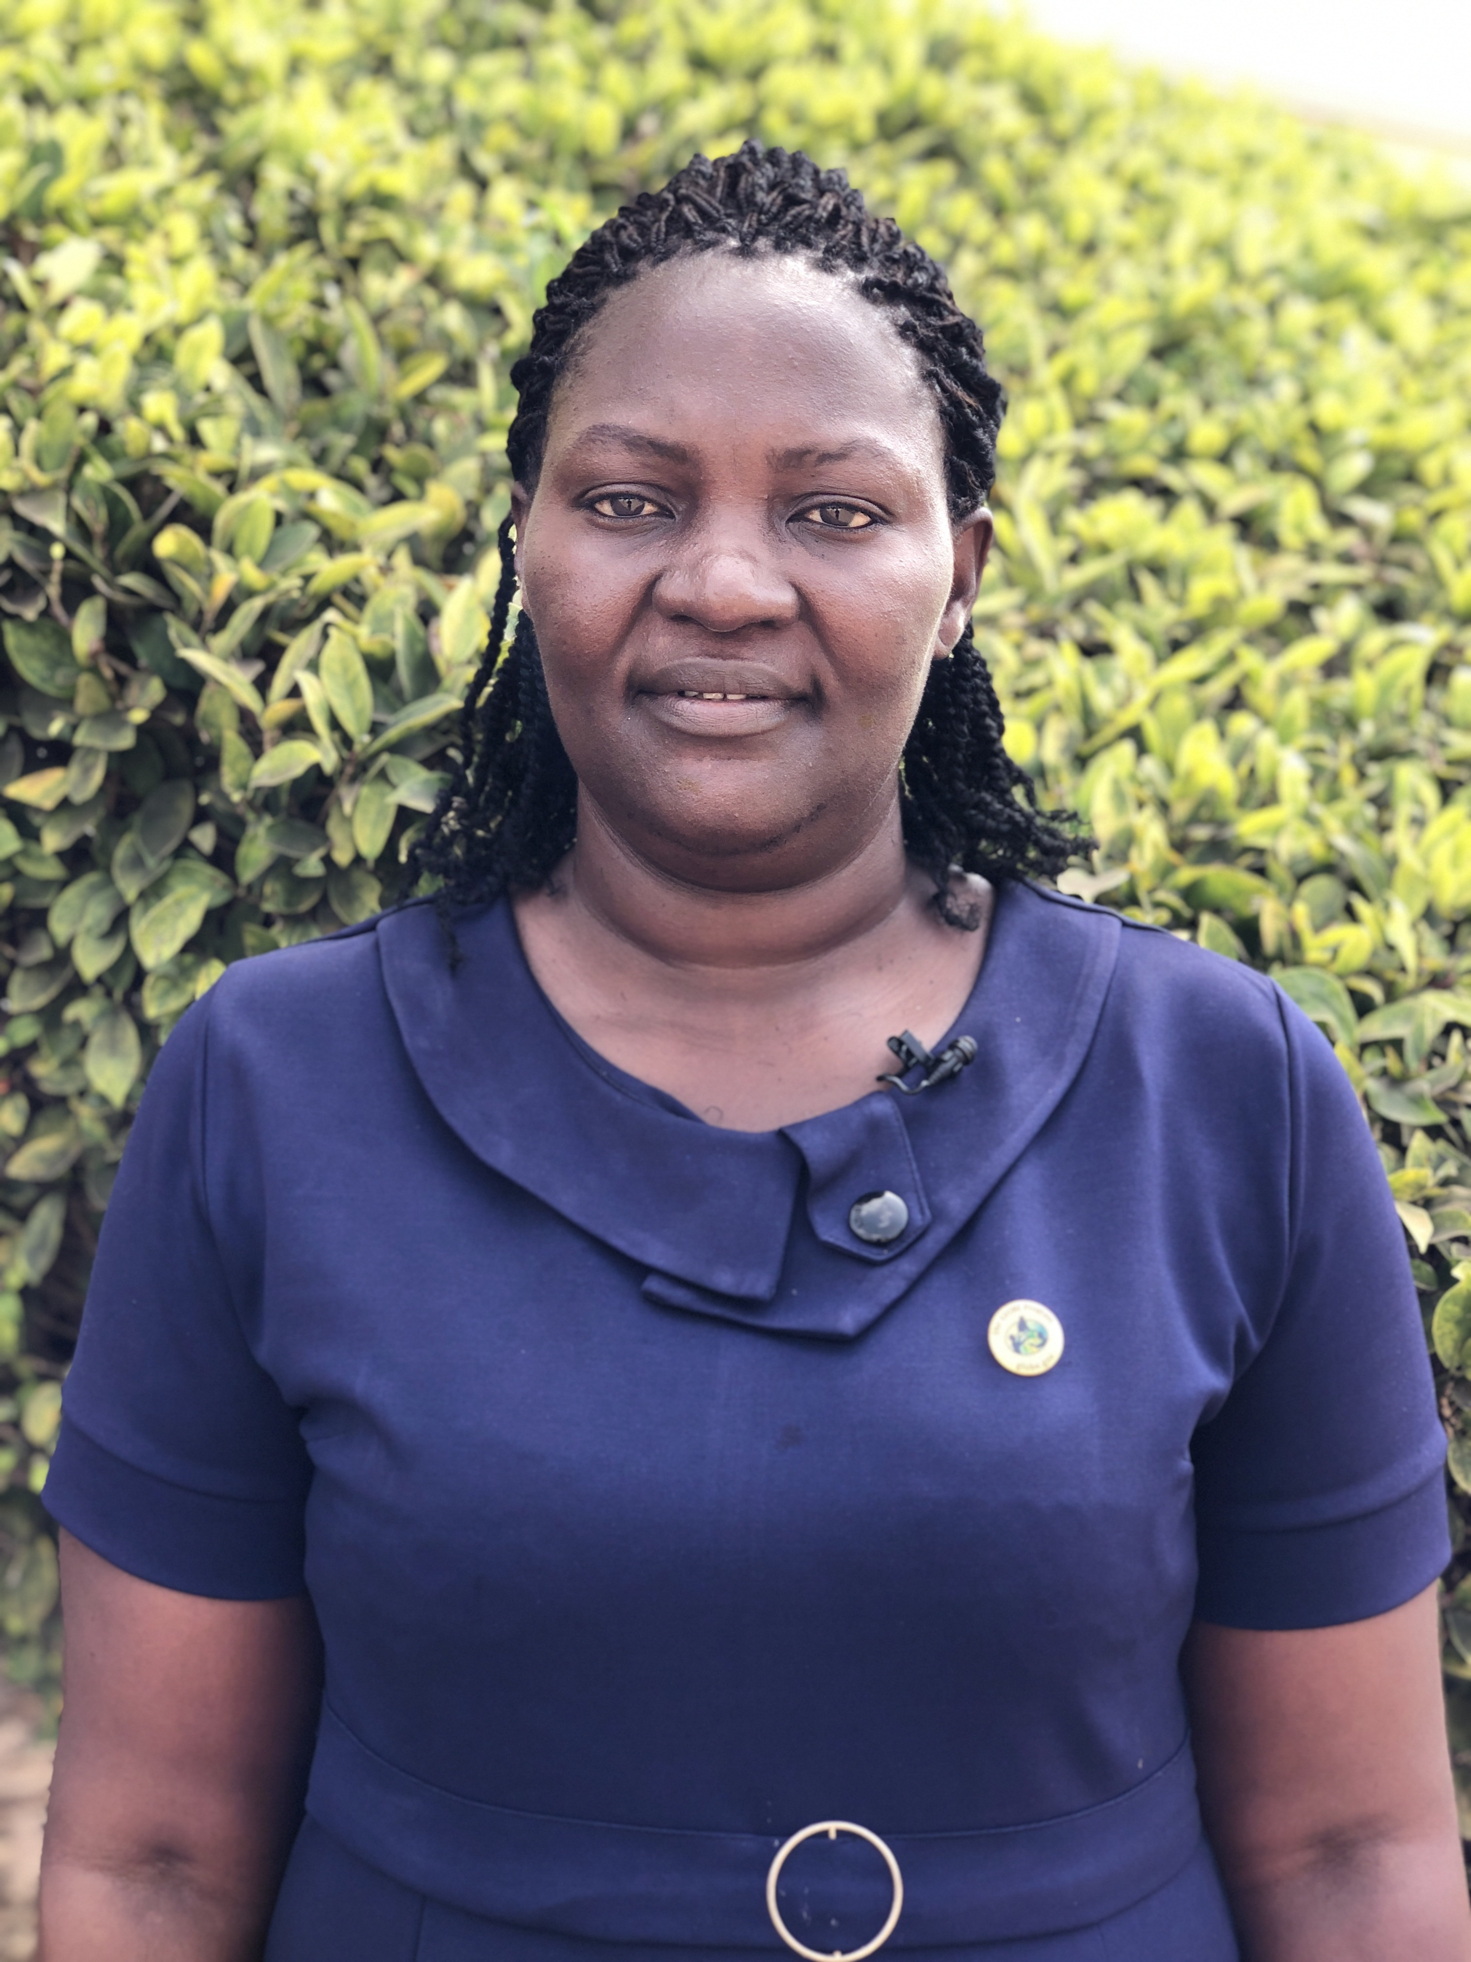ert photo of CC
Name: BERTHY BUAH
Function: Country Coordinator (CC)
Organisation: GHANA EDUCATION SERVICE
E-mail: bbuah45@gmail.com
Tel:
Skype:
Website:

Name:
Function: Assistant CC
Organisation:
E-mail:
Tel:
Skype:
Website:

Organization and Number of Staff:

Funding by: IGF / Organisations with projects

Cooperating Organizations/Individuals:

GLOBE Schools: 53

GLOBE Protocol Areas: Atmosphere, hydrosphere, GLOBE Observer APP.

Number of Schools Reporting Data over Past Year: 5

Program Implementation, International Cooperation in GLOBE Network, and Activities over Past Year (categorized by GLOBE Strategic Plan 2018-2023 Goals):

- Education- we organized stakeholders' engagement meetings to sensitize them on the activities under the globe program. A total of 25 different organizations participated. The Director General of Ghana Education Service gave the welcome address and open and Director Olivia Serwaa Opare (Government point of contact) gave the closing remarks

- Science: a workshop on mosquito habitat mapper. American Corner in Ghana collaborated with GLOBE to select students to attend their program (Ten schools participated in US Embassy on STEM for Girls program). Took part in the Africa Region Water Quality initiative and other data gathering.

- Community- we had the opportunity to talk about the GLOBE Program during the Ghana National Climate Week celebration. Celebrated the Earth Day with University Basic School-UG

- Technology- both students and teachers were engaged in the use of the globe observer app and how to create GLOBE account on the website, visualize data and enter data

- Communications: GLOBE Ghana Point of contact and the Deputy Regional Environmental Officer at the embassy visited the government point of contact to discuss about possible collaborations.

Plans and Ideas for Next Year:

- Launch of GLOBE and weather station installation with HBCU
- Teacher training
- Ideathon competition and workshop for GLOBE schools
- Atmospheric data gathering from two schools
- Local student symposium

