Chad
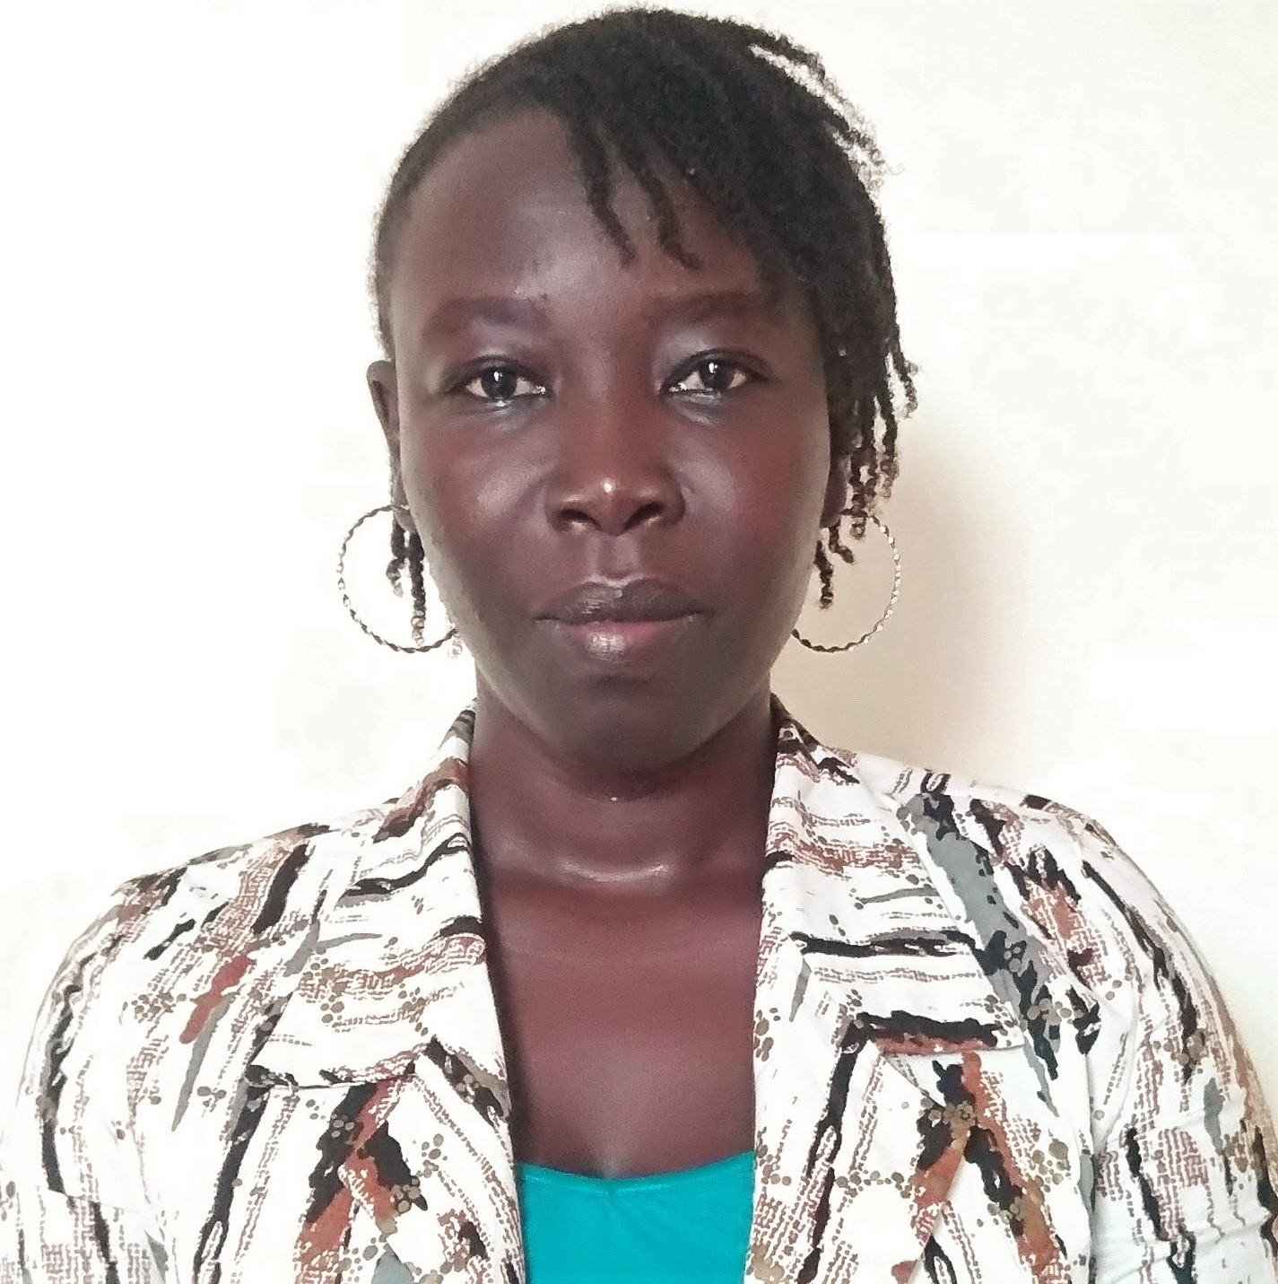

Nom: Tchissem Hortense Massissou
Fonction: Country Coordinator (CC)
Organisation: GLOBE CHAD
E-mail: thmassissou@gmail.com
Tel: +235 63 05 73 00 / +1 (734) 545-8730
Skype: live:thmassissou
Website: https://www.globe.gov/web/chad

Organization and Number of Staff :01

Funding by: No fundings for the moment, relaunch point

Cooperating Organizations/Individuals: Atrone’s Official Primary School

GLOBE Schools: 01 active

GLOBE Protocol Areas: Atmosphere (cloud), mosquito

Number of Schools Reporting Data over Past Year: 02 (Atrone’s Official Primary School and Chad GLOBE v-School reported 14 cloud observations and submitted 01 report for the water bodies IOP)

Program Implementation, International Cooperation in GLOBE Network, and Activities over Past Year (categorized by GLOBE Strategic Plan 2018-2023 Goals):

- Education
  - Increase data collection.
  - Increase access to GLOBE materials and educational resources.
  - One student project submitted to GLOBE Africa Waterbodies IOP

- Science

- Community
  - Engage communities with the Mosquitoes protocol.

- Technology
  - Use of WhatsApp and other social media communication platforms to communicate about GLOBE.

- Communications
  - Use of new communication networks to develop the communication with GLOBE schools.

Plans and Ideas for Next Year:

For Chad, the plans for 2024 is to meet with Chad’s authorities, the US embassy in Chad and other local partners for notification of our existence. We also envision expanding this learning opportunity to two more local schools to assure environmental education and ongoing data collection on a larger scale on behalf of Chad. We will also request collaborations from other Globe schools around the world to ensure global relations among our science citizens.

