Country : South Africa

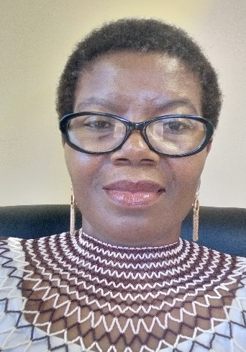
Insert photo of CC
Name: Mokgadi Madiga
Function: Country Coordinator (CC)
Organisation: Department of Science and Innovation
E-mail: Mokgadi.Madiga@dst.gov.za
Tel: +27 12 843 6866
Skype: N/A
Website:

Name:
Function: Assistant CC
Organisation:
E-mail:
Tel:
Skype:
Website:

Organization and Number of Staff:

The GLOBE programme in South Africa (SA) is implemented by the South African Agency for Science and Technology Advancement (SAASTA) on behalf of the Department of Science and Innovation(DSI). The programme is implemented as part of science engagement programmes. There is one staff member in the implementing agency who is assigned to implement the GLOBE programme as part of his portfolio of science engagement activities.

Funding by:

100% government funding (funded by the DSI as part of science engagement programmes. The funding allocation changes as and when the environment changes. It is currently funded under science clubs).

However, we have recently seen some schools that go on to the website on their own, register, do e-training, collect and upload measurements without using the funding from the DSI allocation. Other interested organizations have also started to do GLOBE on their own. It is however difficult to cost their contribution since it occurs randomly and occasionally.

Cooperating Organizations/Individuals:

- Department of Education (DOE).
- Various Science Centres and DSI entities
- Non-government organizations

The cooperating organisations played a critical role of ensuring that learners were available for NASA’s outreach during their BioScape project in South Africa, in November 2023.

GLOBE Schools:

GLOBE South Africa currently has 384 schools, an increase from 261 in 2022.

GLOBE Protocol Areas:

Atmosphere. Land cover, and Hydrology.

Number of Schools Reporting Data over the past year:

At least 48 schools reported data. The number is made of more than 13 schools including those that could be identified in the virtual school that reported data in 2023 and 30 that reported data at the beginning of 2024.

Four collaborating organisations and GLOBE Africa Regional Coordinating Office (RCO) reported data in the past year.

Program Implementation, International Cooperation in GLOBE Network, and Activities over Past Year (categorized by GLOBE Strategic Plan 2018-2023 Goals):

- Education

The DSI collaborates with its entities and stakeholders on a number of science engagement activities including the GLOBE programme to enrich education.

One of the initiatives that the GLOBE activities will form part is the St John’s College Presidential commitment towards establishment of technology and innovation hub at a school. About 60 schools in the Eastern Cape province will benefit from this programme. The GLOBE programme has already been introduced to more than half of the targeted schools.

- A face-to face workshop with educators from the target schools has taken place in February 2024. The training was offered by the RCO.
- Few e-training by the teachers.

- Science

GLOBE programme is implemented as part of science engagement activities. The GLOBE learners got to engage in various science activities.

- Community:

No information yet.

- Technology
No information yet.

- Communications

A big challenge for GLOBE SA is lack of appropriate equipment and internet connectivity that hinder flow of information within the South African GLOBE community. We are doing the best we can to address the challenge.

Plans and Ideas for Next Year:

Feedback on the previous plan

- Previously we were working on collaborating with other role players who were already doing school outreach projects for their own programmes. The intention was to add the GLOBE programme on their activities and support them in kind or financially where necessary as a way of expanding the GLOBE programme.
- A framework of support for the collaborators still awaiting approval from authorities.
- Preparation to implement the GLOBE programme are taking place with some of the identified organisations, especially those that can implement the programme without financial support from the DSI.

Plan for the next year.

Ongoing process to bring on board various stakeholders to implement the GLOBE programme in SA.

