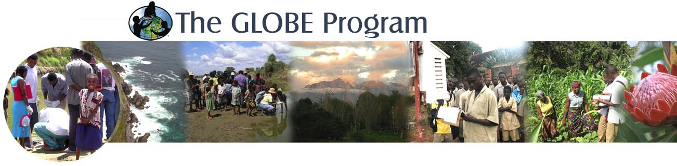
Date: 18 March 2024
The Country Coordinator: Burkina Faso – Jean-Paul Boumboundi

GLOBE’s Strategic Priorities are to improve student understanding of environmental and Earth system science across the curriculum; contribute to scientific understanding of Earth as a system; build and sustain a global community of students, teachers, scientists, and citizens; and engage the next generation of scientists and global citizens in activities to benefit the environment. GLOBE encourages and supports students, teachers, and scientists to collaborate on inquiry-based investigations of their local environment, sharing results in person and virtually through local, regional and international science symposia.

The GLOBE Implementation Office and the GLOBE Africa Regional Coordinating Office with the collaboration of the Ministry of Secondary Education in Cameroon hereby invites your participation in the 2024 Annual GLOBE Africa Country Representative Meeting hosted by Cameroon in the city of Yaoundé.
The details as follows:

Date: 29 April – 3 May 2024
Venue: Franco Hotel , Rue Onembele Nkou, Nlongkak, Yaoundé 03336 · +237 2 22 20 13 07

Regional Office – 0027 44 6911108, 0027 722737997 or Fax 0027 866091994

end_of_the_skype_highlightingGLOBE has always been considered a unique educational force to educate, train, inspire and encourage young people to preserve the environment for current and future generations. Your input and contribution to work towards greater participation, cooperation, collaboration, and innovation to strengthen the GLOBE program in the Africa Region is invaluable and we look forward to seeing you in Cameroon.

GLOBE will cover your flight ticket, transfers, registration, and accommodation.
You are required to arrive on 28 April 2024 and depart on 04 May 2024 or as per flight availability.

Sincerely,
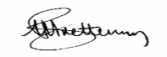
M A Brettenny, Regional Office-Africa, P O Box 514, MosselBay, South Africa, Tel +29 722737997

