Country : South Africa

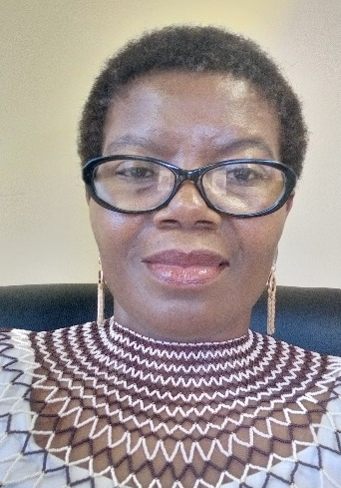
Insert photo of CC
Name: Mokgadi Madiga
Function: Country Coordinator (CC)
Organisation: Department of Science and Innovation
E-mail: Mokgadi.Madiga@dst.gov.za
Tel: +27 12 843 6866
Skype: N/A
Website:

Name:
Function: Assistant CC
Organisation:
E-mail:
Tel:
Skype:
Website:

Organization and Number of Staff:

The GLOBE programme in South Africa (SA) is implemented by the South African Agency for Science and Technology Advancement (SAASTA) on behalf of the Department of Science and Innovation(DSI). The programme is implemented as part of science engagement programmes. There is one staff member in the implementing agency who is assigned to implement the GLOBE programme as part of his portfolio of science engagement activities.

Funding by:

100% government funding (funded by the DSI as part of science engagement programmes. The funding allocation changes as and when the environment changes. It is currently funded under science clubs).

Cooperating Organizations/Individuals:

- Department of Education (DOE).
- Various Science Centres and DSI entities
- Non-government organizations

GLOBE Schools:

The number of schools increased from 232 to 261. However there are other schools that were and still are registered under virtual school. Other teachers were mistakenly registered under Observers thus making it difficult to identify them,(unless one knows the teacher’s email address or their profile appears with their names). The schools under virtual school and observers are disadvantaged since their activities are not easily identifiable.

GLOBE Protocol Areas: Atmosphere. Land cover and Hydrology.

Number of Schools Reporting Data over the past year:

13 schools (the number increased from 8), virtual school and two organisations that have school outreach programmes reported data in the past year.

Program Implementation, International Cooperation in GLOBE Network, and Activities over Past Year (categorized by GLOBE Strategic Plan 2018-2023 Goals):

- Education

The DSI collaborates with its entities and stakeholders on a number of science engagement activities including the GLOBE programme. Although the plan was to focus on resuscitating the GLOBE programme in all the SA GLOBE schools, from time to time we have new schools coming on board through the collaboration effort. Activities of the collaboration included:

- A face-to face workshop with collaborators and some teachers to introduce the GLOBE programme.
- Few e-training by the taechers.
- 5-day teacher workshops facilitated by the RCO.

Two teachers who came on board under the collaboration attended the regional meeting and the annual partner meeting.

- Science

The GLOBE programme is implemented as part of science engagement activities. The GLOBE learners got to engage in various science activities. For example, GLOBE learners under the guidance of:
SANSA (Hermanus, Limpopo & Gauteng) were exposed to and learn about the space science and Astronomy;
the science centres got to interact with scientific processes that are the focus of the said centre; and
others(especially Mpumalanga schools) took part in the SA National Science Week which is an annual event full of hands-on science activities.

- Community:

No information.

- Technology
No information.

- Communications

A big challenge for GLOBE SA is lack of appropriate equipment and internet connectivity. Some schools give up doing GLOBE because of lack of the proper equipment. Others collect data which end up in their books citing difficulty accessing internet.

Plans and Ideas for Next Year:

Feedback on the previous plan

- In the previous year we planned to expand the GLOBE programme and get the buy-in from the Departments of Basic Education to support the implementation of the programme.
  - Mpumalanga Department of Education came on board Five(5) officials(1 provincial coordinator and four district coordinators are overseeing the implementation of the GLOBE programme in their areas.
  - Subject advisors from the four districts of Mpumalanga were trained on the GLOBE programme
  - The science graduates who serve as volunteers were deployed to the schools in Mpumalanga to assist with the implementation of the GLOBE programme along with other science engagement activities.
  - The GLOBE programme now forms part of the Mpumalanga DoE’s annual action plan.
  - We have new GLOBE schools from Mpumalanga that are uploading data though not regularly.

- We are currently working on collaborating with other role players who are already doing school outreach projects for their own programmes. The intention is to add the GLOBE programme on their activities and support them in kind or financially where necessary as a way of expanding the GLOBE programme..
- A framework of support for the collaborators has been drafted and awaiting approval from authorities.
- Some collaborators have been identified and a briefing meeting held with them.

Plan for the next year.

Ongoing process to bring on board various stakeholders to implement the GLOBE programme in SA.

