Country : Cameroon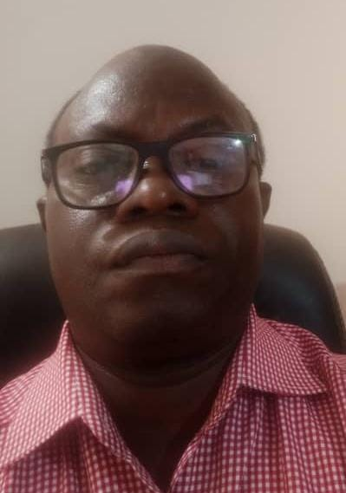

Insert photo of CC
Name: Lawrence Kambiwoa Nunatcho
Function: Country Coordinator (CC)
Organisation: Ministry of Secondary Education
E-mail: LawrenceKambiwoa@hotmail.com
Tel: (00237) 677819751
Skype:
Website:

Name:
Function: Assistant CC
Organisation:
E-mail:
Tel:
Skype:
Website:

Organization and Number of Staff: GLOBE Program Cameroon, (no direct staff)

Funding by: Ministry of Secondary Education

Cooperating Organizations/Individuals:

GLOBE Schools: 40+

GLOBE Protocol Areas: Training include the five major investigation areas

Number of Schools Reporting Data over Past Year: Not reporting as a school but some teachers including myself are reporting as citizen scientists

Program Implementation, International Cooperation in GLOBE Network, and Activities over Past Year (categorized by GLOBE Strategic Plan 2018-2023 Goals):

- Education : GLOBE Teacher training workshops and mentoring across the country

- Science : Teachers work with students but unfortunately or deliberately do not contribute datasets or IVSS submissions

- Community: no reports or vlog or blog contributed

- Technology: We have been able to take part in some webinars and use the admin tools to set up onsite training workshops

- Communications: No approved reports so far

Plans and Ideas for Next Year:

- For the purpose of data contribution, I am going to hand pick teachers, provide motivation on data reporting, Vlogging, and IVSS submissions. Nevertheless, GLOBE Program Cameroon will continue to provide GLOBE materials and training to teachers in the schools.
- The Government of Cameroon is working on a new format to doing GLOBE in Cameroon. The new format shall see the appellation of Coordinator and Assistant Coordinator GLOBE Program including a spell out inter-ministerial back office. Your office shall be informed as soon as the administrative documents are ready for implementation. Hence and until then, GLOBE Program Cameroon shall continue with the practice of GLOBE Program worldwide.

