***BENIN*** 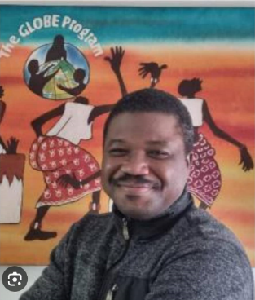

*Name:* ***LAWANI Ylliass Destin***

*Function:*  ***Country Coordinator***

*Organisation: GLOBE Benin*

*E-mail:*  [*ylliass@outlook.fr*](mailto:ylliass@outlook.fr); [ylliassdestin@gmail.com](mailto:ylliassdestin@gmail.com)

*Tel: +229 0197397176 (whatsapp) / 0198984111*

*Website:* [*https://www.globe.gov/web/ylliass*](https://www.globe.gov/web/ylliass)

GLOBE web page: <https://www.globe.gov/web/benin>

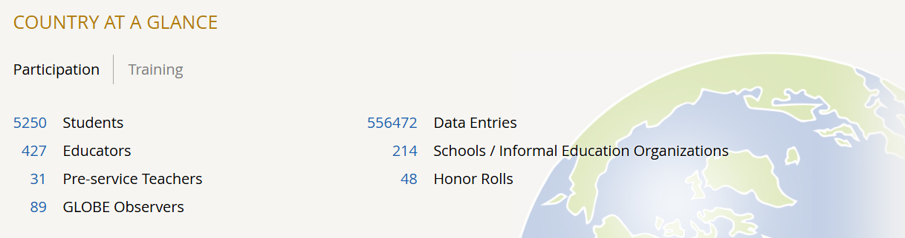

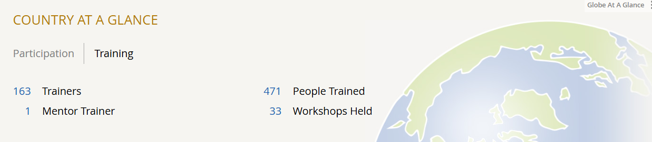

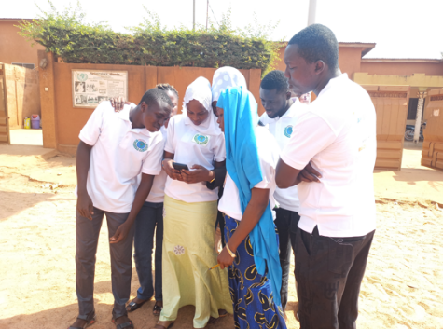At the beginning of 2024 GLOBE Benin started a collaboration with APISERVICES MONDE, a Beninese agribusiness organization specializing in tropical beekeeping and agroforestry, based Parakou (in the north of the country) through its Apis Labtech project.

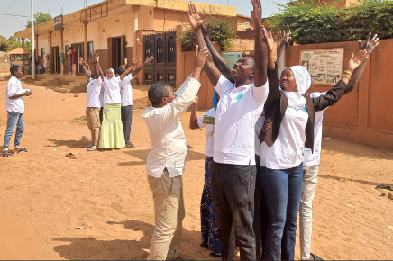It is important to note that there are 20,000 different species of wild bees worldwide. According to scientists, bees appeared on Earth 100 to 150 million years before human beings. They enabled the evolution of flowering plants and ensured their survival.  Bees play a crucial role in the environment. They pollinate plants and trees, enabling vegetation to grow and prosper. They play a major role in the supply of high-quality foodstuffs: honey, royal jelly and pollen, as well as other products such as beeswax, propolis and honeybee venom. Without bees, biodiversity would be threatened and many plant and animal species would disappear. But bees are threatened with extinction due to climate change, air pollution and pesticides. Hence the importance of collecting environmental data! This is why GLOBE Benin and APISERVICES MONDE started a collaboration which intends to use GLOBE data to provide local beekeepers and farmers with information and reference advices in local languages, so that they can improve their yields by aligning different beekeeping and agricultural practices with climatic and environmental variations. This is the first platform in Africa dedicated to training and support in beekeeping, as well as agricultural and environmental aspects.

After an [introduction to the GLOBE program session](https://www.globe.gov/get-trained/workshops/workshop/UJHJ0g2EMDa8/175901) on 15 January 2024, particular emphasis had been placed on the atmosphere protocol. Finally, participants were introduced to the GLOBE Observer App and its Cloud and mosquitoes component (breeding sites destruction).

Our second important activity during year 2024, was our collaboration with Terre à Terre Benin, an organization specialized in environmental communication in Benin, headed by Mrs. Inès KUASSI a GLOBE Alumni.

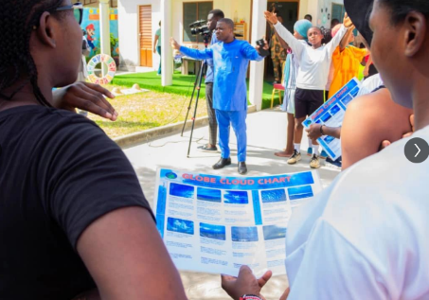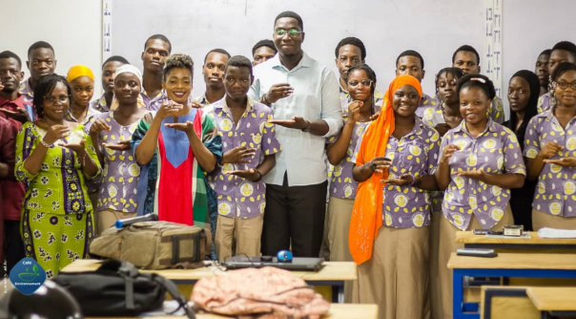We participated in the café environnement TV show, an environmental education program run by Terre à Terre Benin. This program is the most innovative environmental education program in Benin because it calls for action. Each participant is obliged to sign a letter of commitment to become a GLOBE ambassador to carry GLOBE experts' message further. In fact, each month a café environnement session is held, experts come and give their message, and young people can ask any questions they may have, to be enlightened. At the end of each session, ambassadors are welcome for individual coaching sessions in environmental communication. A kit that enables them to make the right point in the field and share the message they have received is provided to them. GLOBE Benin used this opportunity to recruit new members and informed about the huge number of opportunities available. All other the year **about 500 GLOBE ambassadors** were enrolled as GLOBE teachers and registered in the GLOBE database (each training had been done using our GLOBE workshop administration tools). Please click on the links below to get an idea of what has been achieved by our team of GLOBE trainers [Dr. Simon Yemalin ALLAGBE](https://www.globe.gov/web/allagbeyemalin), [Dr Halile Fidele PARAISO](https://www.globe.gov/web/paraisofidele), [Mr. Gorgias AIKPON](https://www.globe.gov/web/gorgiaspremier), [Mrs. Berenice Berkegui SERO](https://www.globe.gov/web/wassangari)! We would like to express to all of them our gratitude.

It is important to state that some lenses were given to each participating school in order to facilitate mosquito data collection.

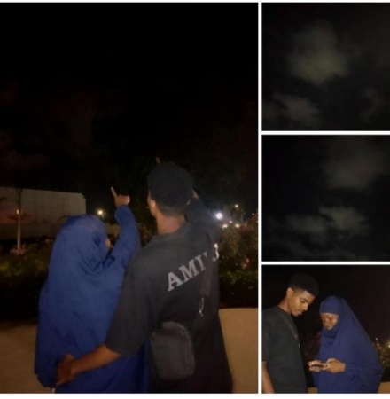During these sessions, participants posted on their social network accounts. The most striking was that of Mrs Sakinatou MOHAMED who collected cloud data at night with her husband, highlighting the fact that GLOBE unites couples and families around highly educational scientific activities. 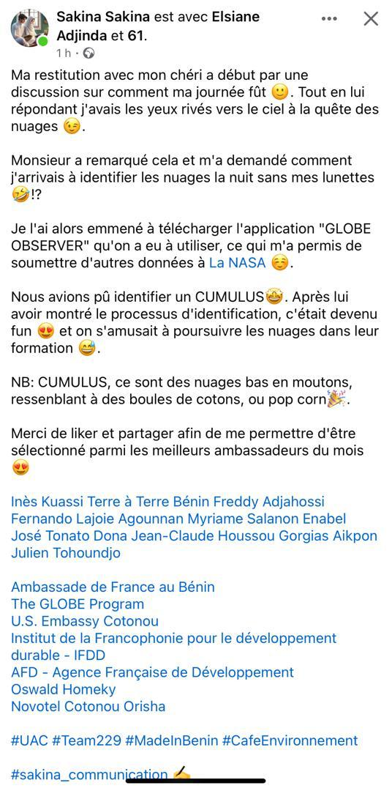

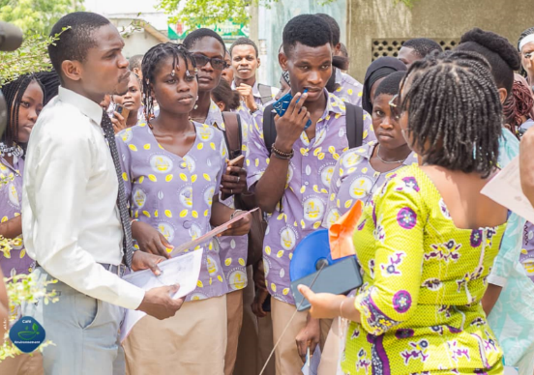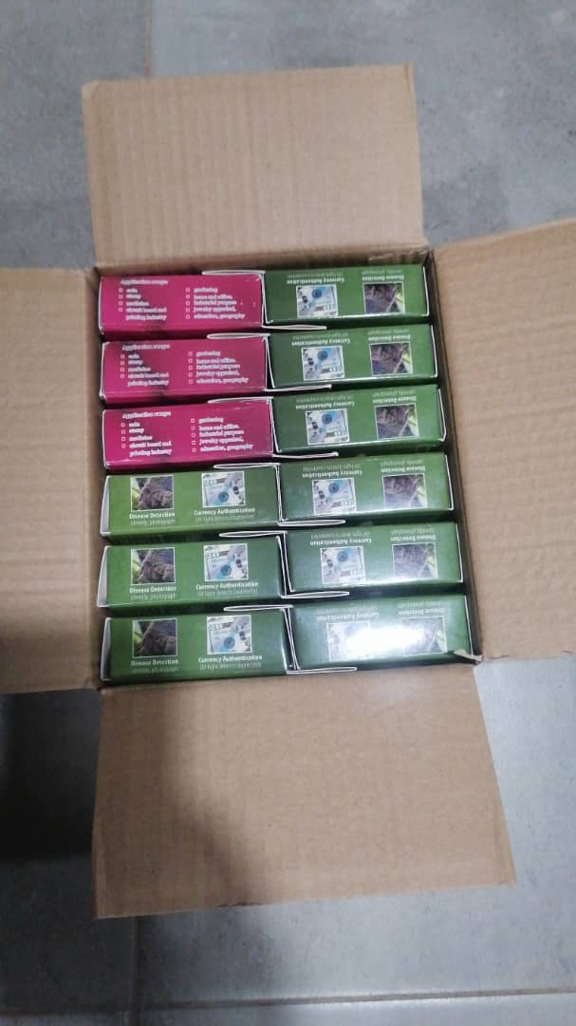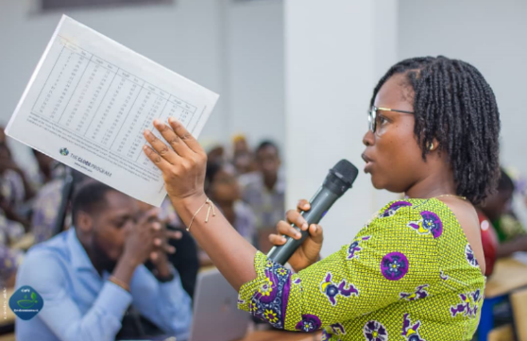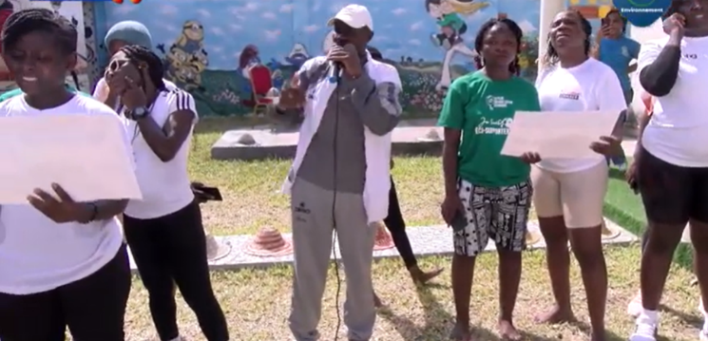

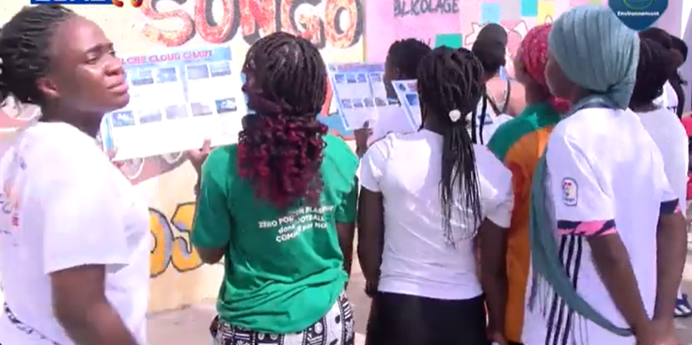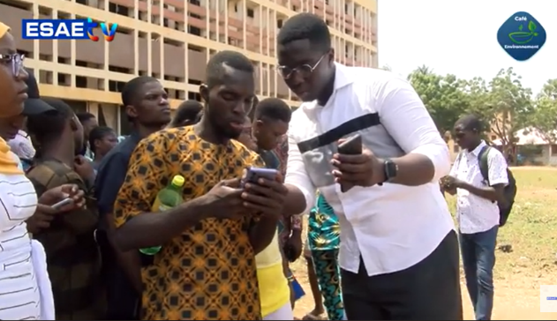

Please find below couple links to the recordings available on YouTube:

<https://www.youtube.com/watch?v=iiIiIsxeyA4>

<https://www.youtube.com/watch?v=AL5G8OPPpyI>

<https://www.youtube.com/watch?v=AQX8MYNtXzI>

ENVIRONMENT AND SPORT AT INTERNATIONAL WOMEN DAY 2024

<https://www.youtube.com/watch?v=zQagtlGcgfY>

Benin also participated in the 19th GLOBE Africa Regional Meeting in Cameroon from 29 April to 3 May 2024, the 2024 GLOBE Annual Meeting held from 15 to 18 July 2024 at the State University of New York (SUNY) in Fredonia, and had been part of the 2024 IVSS (judges’ participation).

In addition, the coordination could contact officials and resources people who can help GLOBE activities to be relaunched and funded by the Government. Unfortunately, these efforts were halted by the tragic death, following a car accident of Mr. Kouaro Yves Chabi, Benin's Minister of Secondary and Technical Education and Vocational Training, who was in charge of GLOBE in Benin.

Organization and Number of Staff: GLOBE BENIN / *GLOBE Alumni Africa, 10*

Funding by: No funding available

Cooperating Organizations/Individuals: University of Abomey Calavi ; Saved People NGO ; Terre a Terre NGO producer of the Café Environnement TV Show; APISERVICES Monde

GLOBE Schools:

CEG 3 Akpro Misserete, University of Abomey Calavi, Université de Parakou, Terre à Terre Benin, ONG HAPPY SCIENCE, GLOBE Alumni Benin, Apiservices Monde;.

GLOBE Protocol Areas: Hydrosphere - Atmosphere

Number of Schools Reporting Data over Past Year: 6 schools

Program Implementation, International Cooperation in GLOBE Network, and Activities over Past Year (categorized by GLOBE Strategic Plan 2018-2023 Goals):

* 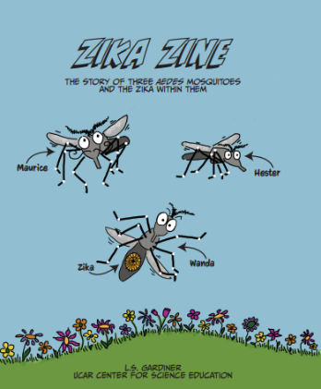Education: Mosquito awareness for kindergarten and primary school students through the Zika Zine.
* Science: Mosquitoes and cloud data collection

Participation in the 2024 GLOBE Africa Waterbodies initiative,

Creation of a local GLOBE Science Network to promote STEAMs and research initiatives finalized with the Alidjennatou Aliou Emmanuel price for national research competition with GLOBE Schools in Benin.

* Community: part of the GLOBE Zika project, we continue to work with GLOBE communities in Benin (scientists, lecturers, teachers, Public Health officers, doctors, school clinics, and

Municipalities). We are also collaborating with local NGOs (Saved People, Terre à Terre Benin, ONG HAPPY SCIENCE, and Apiservices Monde)

* Technology: Use of whatsapp, zoom plateform and phones to explore GLOBE resources
* Communications: Earth Day 2024 Celebration: we participated in the Café Environnement TV Show. We invited our audience to take part and benefit from GLOBE opportunities offered.

Creation of GLOBE whatsapp group to communicate with the community for each training organized.

Participation in the zoom and Google Meet calls.

Plans and Ideas for Next Year:

Organize STEM competitions through the Alidjennatou Aliou Emmanuel prize for national research

Organize learning expeditions

Raise the number of GLOBE Trainers

Execute GLOBE Benin’s annual working plan with priorities.

Reengage more community members and alumni.

Make plans to conduct GLOBE Trainings as much as possible.

Enroll lecturers and researchers from other Universities.

Ensure to have community leaders involved.

Develop more interactions with neighboring countries through collaborative research.

Encourage trainers and community members to use GLOBE online resources.

Increase the number of mentor trainer candidates by motivating people to apply.

Continue contact with officials and resources persons who can help for GLOBE implementation.

Increase Benin participation in regional and international GLOBE events.