***Country***

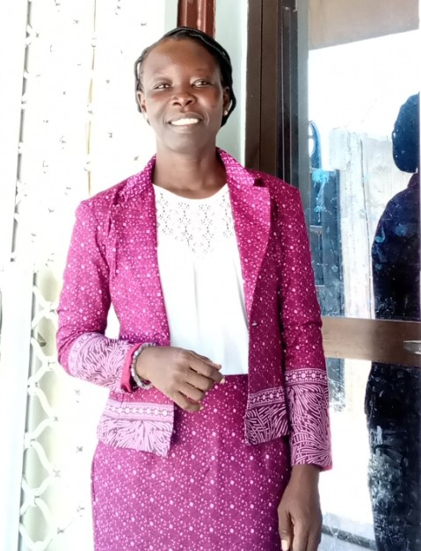

*Name:*TCHISSEM HORTENSE MASSISSOU

*Function: Country Coordinator (CC)*

*Organisation: GLOBE-Chad*

*E-mail: thmassissou@gmail.com*

*Tel: +235 63 05 73 00*

*Skype:*

*Website:*

*Name:*

*Function: Assistant CC*

*Organisation:*

*E-mail:*

*Tel:*

*Skype:*

*Website:*

Organization and Number of Staff: 4

Funding by: No funds yet. Country coordinator uses personal funds for training, meetings and staff transport.

Cooperating Organizations/Individuals: Ministry of Plan and International Cooperation, US Embassy, GLOBE schools in Chad.

GLOBE Schools: GLOBE v-School, Negmaye, Academie Royale, Saint-Benoit.

GLOBE Protocol Areas: Klessoum, Abena

Number of Schools Reporting Data over Past Year: 01 (GLOBE v-School)

Program Implementation, International Cooperation in GLOBE Network, and Activities over Past Year (categorized by GLOBE Strategic Plan 2018-2023 Goals):

* Education: Following the program’s reactivation, we addressed correspondences to 3 pilot schools, leading to a meeting with two of the three and one NGO promoting environmental health and awareness.
* Science:
* Participation in the GLOBE MacroMappers project
* Submission of 60 clouds observations
* Submission of 30 mosquito habitat Mapper
* Community: 3 neighborhoods surrounding our school pilots have been sensitized on environmental health and awareness.
* Technology: YLACES grant application submitted for GLOBE equipment
* Communications:

3 official reports were published through the GLOBE newsletter page. More communication is planned for each future activities in local newspapers, television and social media

Plans and Ideas for Next Year:

* Meeting with the ministry of plan and international cooperation to elaborate partnership directives
* Officially launch the GLOBE program
* Acquire an office