***TANZANIA***

*Insert photo of CC*

*Name:* ***ROBERT E. M. LWIKOLELA***

*Function: Country Coordinator (CC)*

*Organisation: MINISTRY OF EDUCATION SCIENCE AND TECHNOLOGY*

*E-mail: robertlwikolela@yahoo.com*

*Tel: +255739363110* 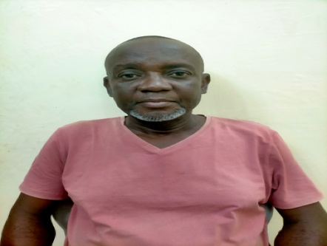

*Skype:*

*Website:*

*Name:* ***SYLVESTER CHISANDA***

*Function: Assistant CC*

*Organisation: Tanzania Meteorologial Authority*

*E-mail:sylvester2000@yahoo.com*

*Tel: +255782826975*

*Skype:*

*Website:*

Organization and Number of Staff: 2

Funding by: Goverrnment / GLOBE

Cooperating Organizations/Individuals:

Youth in Action Against Poverty and HIV/AIDS ( YAAPHA ) - NON GOVERNMENT ACTOR

Tanzania Environmental Data Lab – NON GOVERNMENT ACTOR

Girls Education for Climate Action GECA - NON GOVERNMENT ACTOR

GLOBE Schools: 40

GLOBE Protocol Areas: Atmosphere, Soil, Hydrology

Number of Schools Reporting Data over Past Year: 30

Program Implementation, International Cooperation in GLOBE Network, and Activities over Past Year (categorized by GLOBE Strategic Plan 2018-2023 Goals):

* Education
* Science
* Community
* Technology
* Communications

Plans and Ideas for Next Year:

Approve account for newly requestered teachers and those require to train

Advise the government to assist schools and teachers to see to it that funds are allocated for the implementation of GLOBE activities

Facitate collaboration with non goverrnment actors to include GLOBE related activities