Country : Botswana 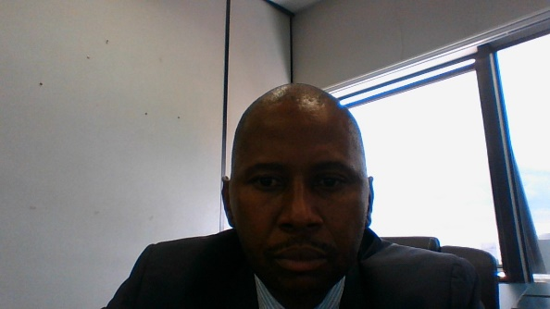

Insert photo of CC
Name: LESOLE LABBEUS LESOLE
Function: Country Coordinator (CC)
Organisation: GLOBE Program-Ministry of Education Basic Education
E-mail: lesolesupo@gmail.com
Tel: +267 73148188/77510710
Skype:
Website:

Name: Phatsimo Kwenane
Function: Assistant CC
Organisation: American Embassy
E-mail:
Tel:
Skype:
Website:

Organization and Number of Staff: The Ministry of Basic Education seems to be reluctant to assist and abide to the MoU agreement.

Funding by: It is supposed to be funded by the ministry I have since notified the Ministry Permanent Secretary to act on the issue particularly when it comes to issue of financing.

Cooperating Organizations/Individuals: Wilderness Safari

GLOBE Schools: 71 trained teachers from three Regions

GLOBE Protocol Areas: Atmosphere, soil study, Hydrology, Land cover, though minimal work down

Number of Schools Reporting Data over Past Year: 00

Program Implementation, International Cooperation in GLOBE Network, and Activities over Past Year (categorized by GLOBE Strategic Plan 2018-2023 Goals):

- Education
  - Use of teaching material from GLOBE web site though very minimal.

- Science
  - Very little is being done

- Community
  - Very little is being done

- Technology
  - Very little is being done

- Communications
  - Very little is being done

Plans and Ideas for Next Year:
- To train more teachers in GLOBE
- Request government to fully adhere to the MoU
- Increase collaboration with other organisation

