Country - Kenya

Insert photo of CC
Name: Dr. John Njoroge Kimani
Function: Country Coordinator (CC)
Organisation: Kenya National Space Secretariat
E-mail: njorokim2@gmail.com
Tel: +254 722 850510
Skype:
Website:

Name: Charles Maina Mwangi
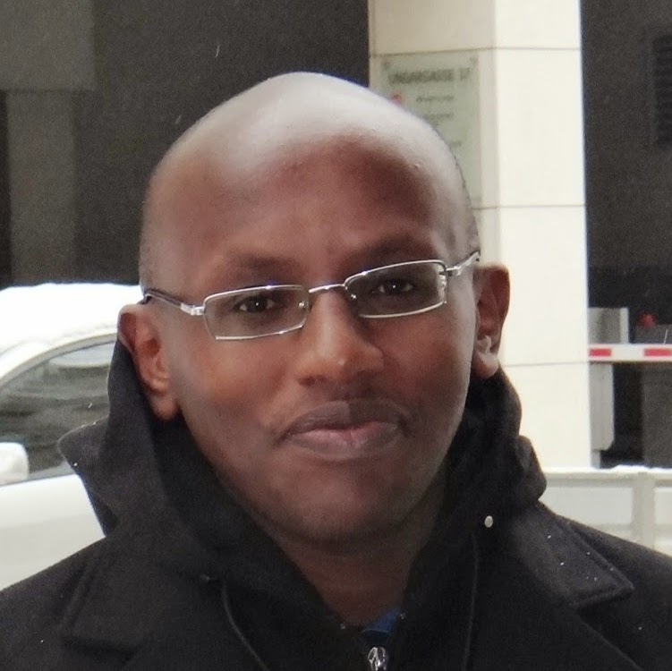
Function: Assistant CC
Organisation: Kenya National Space Secretariat
E-mail: maina.charles@gmail.com
Tel: +254 722 534753
Skype:
Website:

Description of the program in your country and recent activities in 2014:

- The GLOBE Program was introduced in Kenya in 1997 and 31 teachers from different schools trained on the various protocol. However, over time the activities of the GLOBE program ground to a halt and there has been a lull. To resuscitate GLOBE Program activities in Kenya, we have developed a concept paper to guide the implementation of the GLOBE Program in the country. This year (2014), we have reintroduced GLOBE activities in Kenya. On 16th October 2014, we held a GLOBE Program Sensitization workshop for Principals and Teachers from pilot schools and members of Centre for Mathematics, Science and Technology Education in Africa (CEMASTEA) at CEMASTEA centre in Nairobi, Kenya to introduce them to GLOBE program. This was followed by a 5-day GLOBE Teacher Training workshop on 1st-5th December 2014 in CEMASTEA centre, where 40 participants from 30 schools and CEMASTEA were trained on all the FIVE major protocols; atmosphere, hydrology, soil, land cover/biology and earth as a system. One key achievement has been the participation of kids in the GLOBE Art Competiion. For the second year running, kids from primary schools in Kenya scooped the first 3 positions in the Africa region.

Cooperating organizations:

- The following organizations has shown interest in collaborating in the implementation of the GLOBE program in Kenya;

- State Department of Education (Ministry of Education, Science & Technology)
- Kenya Meteorological Service (KMS)
- Regional Centre for Mapping of Resources for Development (RMCRD)
- National Environmental Management Authority (NEMA)
- Water Resources Management Authority (WARMA)
- Kenya National Commission for UNESCO (KNATCOM)
- Universities: University of Nairobi, Kenyatta University and Jomo Kenyatta University of Agriculture and Technology

Participating schools:

- We have identified 30 Secondary Schools to pilot the GLOBE Program in the Country from all the regions of the country. These schools will commence taking GLOBE measurements in January 2015.

- See attached List of participants trained in December 2014 and their Schools

Funding by:

- The GLOBE Program activities in Kenya are currently solely funded by the Kenya National Space Secretariat (KNSS). We are actively engaging the cooperating organizations to assist in funding to increase the footprint of the GLOBE program in Kenya.

GLOBE protocols used in country:

- Schools have not been using GLOBE protocols in their learning activities. Since the initial training conducted in 1997, there has not been any other training. The teachers trained then, have ceased reporting. Starting January 2015, we are anticipating revived GLOBE activities in schools whose teachers were trained in December 2014.

Number of schools currently reporting data (2014):

- As noted, we had no record of GLOBE teachers previously trained and the GLOBE schools from 1997 training have not been reporting data. This is anticipated to change in January when the GLOBE teachers trained from the 30 schools start reporting data. After the GLOBE teacher training, the teachers proceeded on school holidays and are expected to resume in January 2015.

ANNEX 1: LIST OF PARTICIPANTS
S/No | First Name | Last Name | School/Organization
1. | Mohamed | Abdikarim | Garissa High School
2. | Daves | Bii | Kipsigis Girls High School
3. | Ruttoh | Cheruiyot | Bute Mixed Day Secondary School
4. | George | Gitau | CEMASTEA
5. | Richard | Jakomanyo | CEMASTEA
6. | Gerald | Kagwi | Kahuhia Girls High School
7. | Edwin | Khayeka | Sacred Heart Mukumu Girls High School
8. | Mary | Kiarie | Molo Academy
9. | Benjamin | Kilonzo | CEMASTEA
10. | Mary | Kimani | Mang'u High School
11. | Victor | Wekesa | Kisima Girls High School
12. | Michael | Kipkulei | Sacho High School
13. | George | Kiria | CEMASTEA
14. | Stephen | Kisilu | Nairobi School
15. | Lawrence | Leeba | Bute Boys Secondary School
16.. | Renson | Lusenaka | Moi Forces Academy - Nairobi
17. | Simon | Mathenge | Moi Forces Academy - Lanet
18. | Peter | Munywoki | Makueni Boys Secondary School
19. | Silas | Murithi | Alliance Girls High School
20. | Timoth | Musiani | All Saints Cathedral Primary School
21. | Pulkeria | Muthengi | Kenyatta High School
22. | Dickson | Mutie | Garissa High School
23. | Cosmus | Mutua | Muthale Girls High School
24. | James | Mutugi | Meru High School
25. | Hope | Mwagona | Malindi High School
26 | Kakai | Wasula | Light International Schools
27. | Evanson | Mwangi | Murang'a High School
28. | Joan | Mwangi | Murang'a High School (Not completed)
29. | Paul | Wangai | Alliance High School
30. | Eliud | Ndung'u | Ole Tipis Girls Secondary School
31. | Eliud | Ngugi | Kaaga Boys High School
32. | Juliana | Nzeki | Star of the Sea High School
33. | Alex | Odhong' | Karima Girls High School
34. | David | Ododa | St. Albert's Girls Secondary School
35. | Victor | Ogal | Nasokol Girls Secondary School
36. | Bernard | Ogola | Nyamira Girls High School
37. | Jasper | Sifuna | Friends School Kamusinga
38. | Stephen | Tarus | Kapsabet Boys High School
39 | Charles | Mwangi | GLOBE Program Office
40. | Benjamin | Kipsang | Baringo High School (Started late)

ANNEX 2: International GLOBE Teacher Training Workshop

_________________________________________________________________________________

Report prepared by: GLOBE Program Office (Kenya)

