BENIN
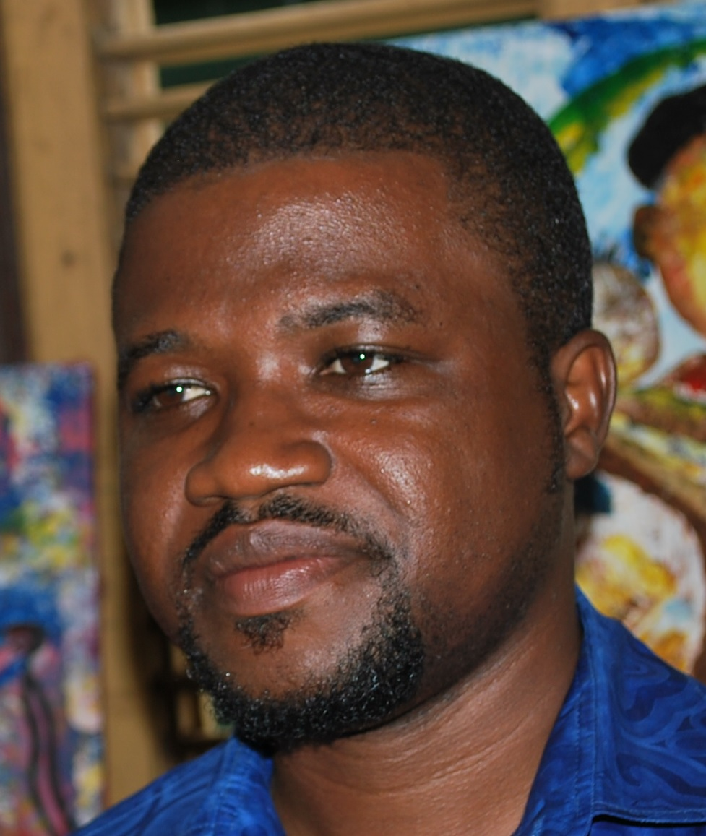

Nom: LAWANI Ylliass Destin
Function: GLOBE Alumni Benin/Africa coordinator, Assistant Country Coordinator, member of the GLOBE Evaluation Working group
E-mail: ylliass@gmail.com
Tel: +229 95235037 / 97397176 or +224 627475273
Skype: ylliassesf
Website:

In 2017

Benin Republic hosted the 12th GLOBE Africa annual Regional Meeting (West Africa session) and GLOBE/TAHMO Teachers Training workshop.

GLOBE Benin facilitated contact between TAHMO and Benin Met Agency

Cooperating organizations: TAHMO, Météo Bénin (Benin Met Agency), SOS Children Village, University of Abomey Calavi (Agriculture Faculty of University of Abomey Calavi, Laboratory of Genetics, Biotechnology and Seed Sciences, and Laboratory of Bio Geography and Environmental Expertise), IITA / BENIN.

Participating schools: CEG Tangbo Djèvié, CS le Ruisseau, CEG TORI Aïdohoué, CEG HONTON (Dogbo), CEG FIYEGNON, CS le Ruisseau, CEG ITA-DJEBOU, SOS ESMA, EPP AMANVEDA
CS La CIME Glazoué, EPP Houègbo Gare/B, CEG DAVIE P/N, CEG HOUIN (Lokossa), University of Lomé, University of Abomey calavi, Lycée technique commerciale P/N, CEG1 Akpro-Misserete, CEG TAKON (Sakété), Lycée technique commerciale P/N, CEG Atchoukpa,SOS Village d’enfants
National Direction, SOS Village d’enfants Abomey Calavi, SOS Village d’enfants Dassa Zoume, SOS Village d’enfants Natitingou,CEG HOUIN, CEG ZOGBO

Funding by: GIO, GLOBE Africa, TAHMO

GLOBE protocols used in country: atmosphere, hydrology, soil and land cover

Number of schools currently reporting data (2018): 1

Description of the program in your country and recent activities in 2017:

I-

The 12th GLOBE Africa annual Meeting (West African session) was held in Cotonou (Republic of Benin), SOS children village of Abomey Calavi http://www.sosvillagesenfantsbenin.org on 23rd february 2017 was the first of the series of three meetings which will held this year in the africa region.. I was followed by a 3 days Teachers Training Workshop from 24th to 26st February 2017.

Apart from Dr. Tony Murphy, GLOBE Implementation Office Director and Mr Mark BRETTENY the Regional Coordination Office Director, most of the west African country coordinators, the Regional Alumni Representative Ylliass Destin LAWANI from Benin, attended this event, according to the following:

Names | Designation | Phone number | Email addresses
Ngossé FALL | Senegal Country Coordinator | +221771018677 | fallngosse@yahoo.fr
Elizabeth Jachens | School 2 school coordinator at TAHMO | +1 530 295 7615 | jachense@oregon.state.edu
GARBA MAHAZOU | GLOBE Country Coordinator Niger | +227 96985233 | gmahazou@yahoo.fr
OKOYE CELESTINE | GLOBE Country Coordinator Nigeria | +234 708 66 01 204 | okoyetech@yahoo.com
SIMYELI ESSOWE BEN | U.S Embassy Togo | +228 92383455 | sshlome@state.gov
Ylliass Destin LAWANI | Alumni Coordinator | 0022995235037 | ylliass@gmail.com
Tony Murphy | GIO | 303-497-2625 | tmurphy@ucar.edu
BRETTENNY Mark | GLOBE Africa Coordination Office | 0027722737997 | mark@globe-africa.org

After the regional meeting a three days GLOBE/TAHMO Workshop took place from 24 to 26 february at SOS Childrens village, and University of Abomey calavi.

21 schools and university laboratories, 35 teachers (included 2 students from University of Lomé - 2 peoples from Météo Benin, the Benin Met Agency, and 1 Alumni doctor in charge of the participant’s health) attended this workshop

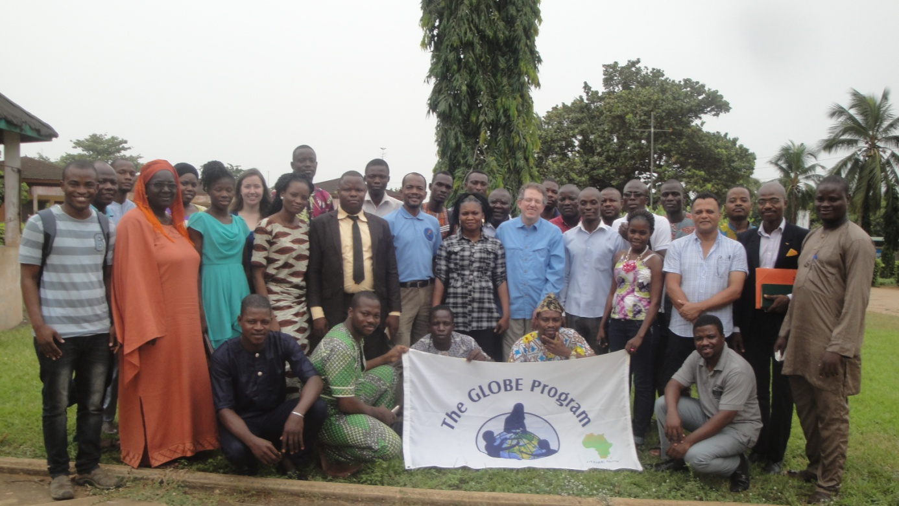

II- Facilitation with TAHMO

After the GLOBE/TAHMO Teachers Training workshop during the regional meeting 10 additional automated weather stations had been negotiated by the GLOBE regional office to be added to the 20 first identified in the MOU signed between TAHMO and Meteo Benin. It was said that GLOBE would identify schools (existing GLOBE schools or new recruited ones for this purpose) in the 20 cities identified in the MOU. During an exploration phase we had installed weather stations in 6 GLOBE schools (CEG TANGUIETA, CEG ALLADA, CEG DAVIE, CEG Ganvier, SOS Children Village of Natitingou and CEG 1 GLAZOUE) and the University of Abomey calavi (Laboratory of Genetics, Biotechnology and Seed Sciences (GBIOS)). We used the schools identified in the areas where there is not GLOBE schools (like Ouèsse and Aklampa) to introduce GLOBE and create a GLOBE Clubs. The idea is to have them attend future GLOBE Workshops and register them as GLOBE Schools.

Unfortunately the Benin Met Agency did not want to collaborate with GLOBE after this phase and TAHMO did not help to maintain GLOBE onboard. We don’t have updated information about the installation process of the other affected weather stations.

See below the places identified all around the country.

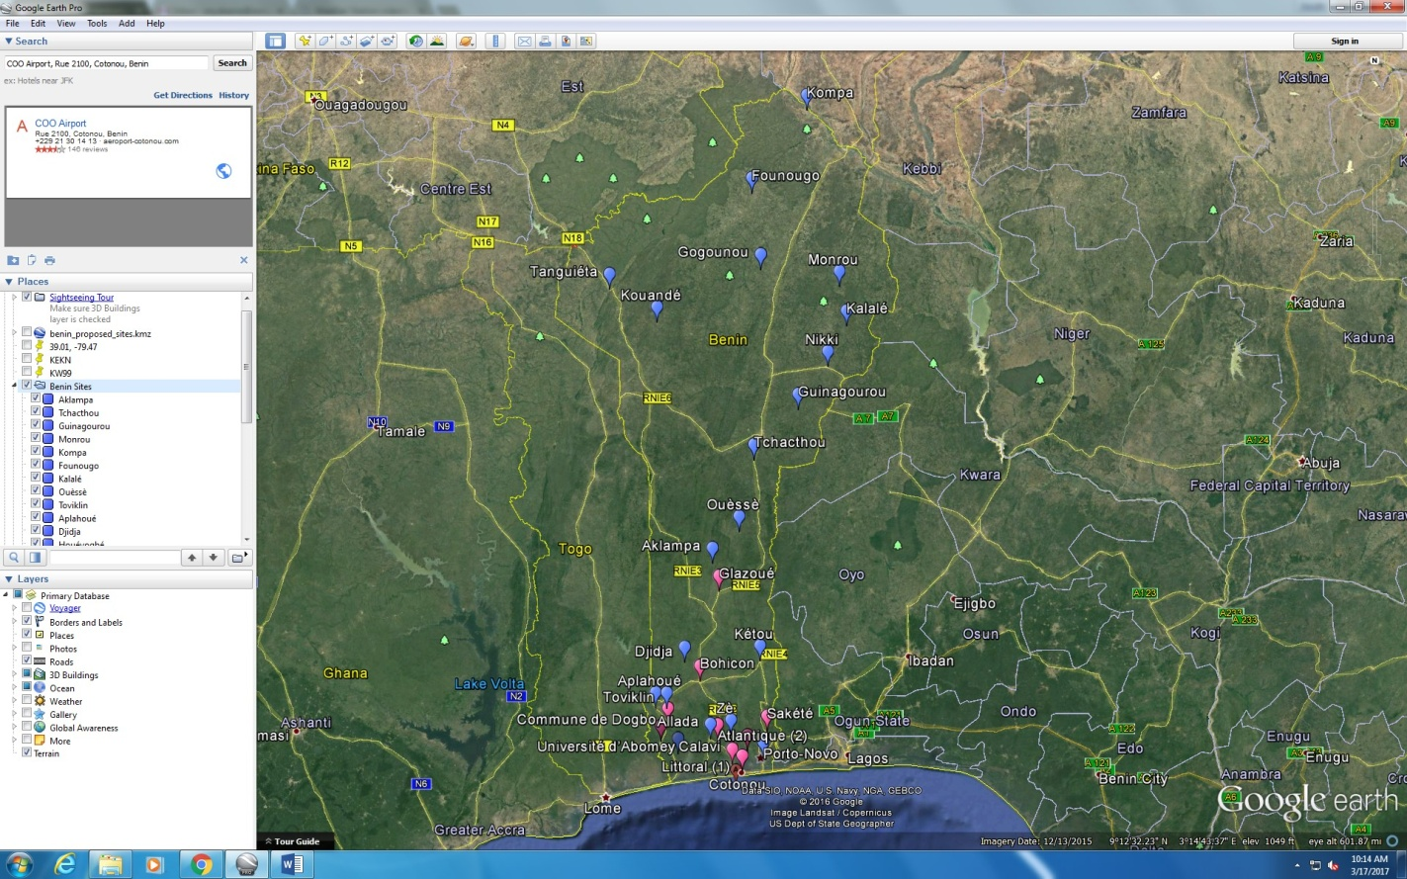

The liste of citied identified in the MOU

