The 8th GLOBE Africa annual Regional Meeting, April 20-23rd 2013, Mossel Bay, South Africa

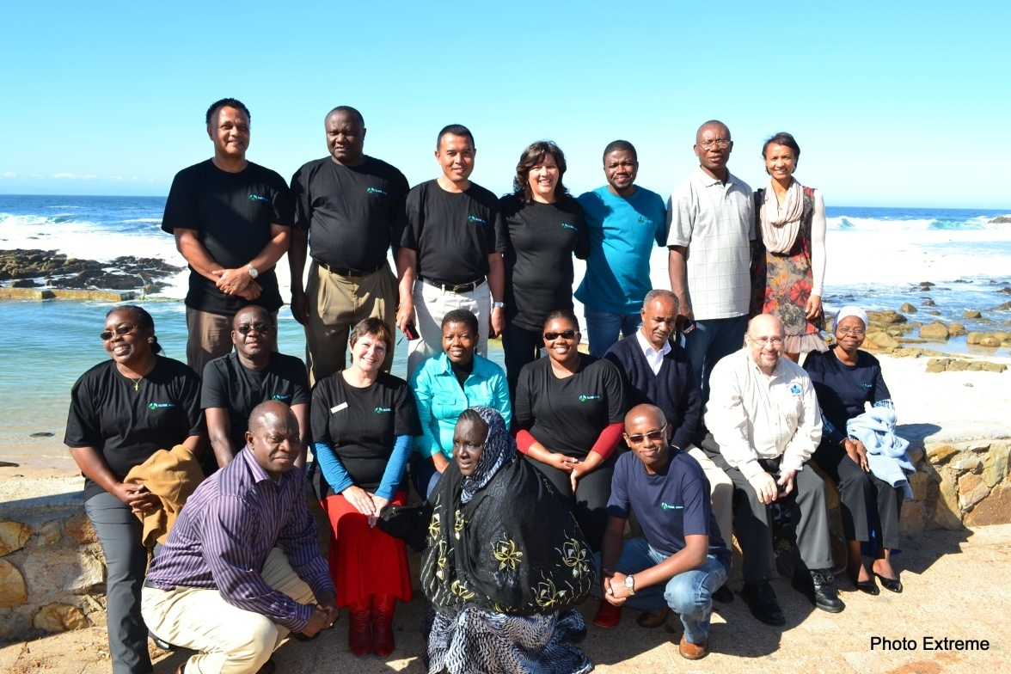

REPORT

The 8th GLOBE Africa annual Meeting was held in Mossel Bay, South Africa from 20 – 23 April 2013 with a welcome, greetings and opening ceremony on 19th at Ponto Grill. The Mayor was represented by counselor E Scheepers (Photo Opening ceremony)

The objective of this meeting was to work towards greater participation, cooperation, collaboration and innovation to strengthen the GLOBE program in the Africa region.
The central themes for potential research projects were:
Day 1 – Discussion
Day 2 – Design
Day 3 – Implementation
Day 4 – Monitor / evaluation
Apart from special guests Mr. ALOYSIOUS D. Gowne, Public Affairs Specialist at the U.S Consulate General, Cape Town (photo Gowne), and Gary RANDOLPH, the Science and Education Team Lead representing the GPO (Photo Gary), most of the Africa country coordinators and the Regional Alumni Representative Ylliass Destin LAWANI from Benin attended this event:

Names | Designation | Phone | Emails
Aloysious Gowne | U S Consulate General, Cape Town | Tel : 0027 21 7027392  Cell : 0027 79110982 | Gowne, Aloysious D [GowneAD@state.gov]
Jacob Seconna | HoP: Environmental Management  Applied Sciences  Environmental & Occupational Studies  Cape Peninsula University of Technology | Tel: (021) 460-9008/9  Fax: (021) 460-193/3905 | seconnaj@cput.ac.za
Arno Munro | Department of Agriculture, Forestry and Fisheries | Cell : 0027 836672100  Office : 0027 44 6919066 | ArnoM@daff.gov.za
Gail Linnow | South African Weather Service | Tel: 082 233 8400  Fax: 021 934 0470  Cell: 082 233 8400 | gaillinnow@weathersa.co.za
KAMBIWOA Lawrence | Cameroon Coordinator | 0023796149618  0023722742033 | lawrence96k@yahoo.com
EMMANUEL ALIOU Alidjennatou | Benin Republic Coordinator | 0022995153406 | atoualiou@hotmail.fr
RANDRIANARISOA Paul | Madagascar Coordinator | 00261331106321 | randripaul@yahoo.fr
LWIKOLELA Robert Euphrase | Tanzania Coordinator | 00255754363110 | robertlwikolela@yahoo.com
MWANGI Charles | Representing Kenya | 00254722537453 | mainacharles@gmail.com
Prof. ZERIHUN Woldu | New Ethiopia Coordinator | 00251911407255 | zerihun.woldu@aau.edu.net
SEMPALA Patrick Samuel | Uganda Coordinator | 00256772395245 | pssempala@yahoo.com
FALL Ngossé | Senegal Coordinator | 00221771018677  00221771018677 | fallngosse@yahoo.fr
MEMINE ME ZVE Séraphine | Gabon Coordinator | 0024107843785  00241763595 | adadaseraphine@yahoo.fr
KORIE Eberechukwu Ernest | Nigeria Coordinator | 002348035367798  002348023216355 | eberechukwukorie@yahoo.com
MOKGADI Madiga | South Africa Coordinator | 0027128436866  00270829440036 | mokgadi.madiga@dst.gov.za
TEBOGO Gule | South Africa Representative | 0027128436538  0027711131693 | tebogo.gule@dst.gov.za
Ylliass Lawani | Alumni Coordinator – Africa | 0022995235037 | ylliass@gmail.com  alumni@globe-africa.org
BRETTENNY Mark | GLOBE Africa Regional Officer | 0027722737997 | mark@globe-africa.org
BRETTENNY Rogeline | GLOBE Africa Regional Office | 0027822980095 | rogeline@globe-africa.org
Gary Randolph | GPO | 001303-652-7579  001303-497-2645 | randolph@globe.gov

The following GLOBE countries did not attend: Namibia (excused), Mali (excused), Ghana (excused), Rwanda (last minute government assignment), Guinea Conakry (encountered a problem in Nigeria on his way to meeting), Burkina Faso (non responsive), Cape Verde (non responsive), CHAD (CC on official mission – assassinated on 25 April), Gambia (no cc appointed), Niger (non responsive).

The meeting was coordinated by the Chair of GLOBE Africa Consortium Mr. Paul RANDRIANARISOA, heavily assisted by the host, Mr. Mark Brettenny. GLOBE Program Office Representative, Mr. Gary RANDOLPH was in attendance.

Mr. RANDRIANARISOA Paul, as the chair of the GLOBE Africa Consortium delivered a welcome massage to the participants. He emphasized that Africa has a lot of research opportunities and resources that must be explored in order to progress GLOBE in Africa. He thanked Mark for the great work he is doing and the invaluable contribution he is making as the head of the Regional office. He also extended his greetings to the Country coordinators for attending this strategic meeting.

Mr. Mark BRETTENNY, after Mr. Paul also made opening remarks, and communicated the agenda of the meeting (Photo Mark).
Then he introduced Mr. Gary Randolph by welcoming him at the meeting.

In the regional office report he made, Mr. Brettenny talked about the Mt. Kilimanjaro 2012 learning Expedition, which he considered as the pride of the GLOBE Africa Region. In fact this project, initiated by the Africa region grew and the entire world is interested. “Africa is moving toward; Africa is on the way!!” he said in order to encourage and motivate each of the countries represented.

The first presentation of the meeting was made by Mr. Jacob SECONNA on “sustainable development through Institutional Collaborations for Quality of life” (Photo Seconna). In fact he developed the Waste Management qualification for Environmental Waste Officers, which gave rise to the invitation to the meeting.
Mr. Seconna shows the global sustainable development agenda which is demonstrated in a circle. This circle called “the circle of sustainability” aims to address all issues related to sustainable development improving the quality of life of the world populations. The circle demonstrates the different types of agendas point: green; brown, white and grey issues (issues with blurred boundaries)

He also presented the Environmental leadership academy with credits and trainings. He also invited the participants to join the African College of Environmental Protection for the climate change workshop on 9/20 September 2013 in South Africa.

After lunch there was a workshop supervised by Mr. SECONNA. This workshop aims to make the participants get tools to better work in their respective countries by integrating the education for sustainable development into GLOBE activities (photo group). Groups were made and questions were asked to them:

Group 1: Identify current and future environmental projects in the schools?

Group 2: Who else should we include at school? Who else should we include in the training?

Group 3: What is currently done in GLOBE Schools? What is required for sustainable development at GLOBE schools to develop future environmental technicians and technologists to analyze environmental resources (water, soils, air) as occupations? Can GLOBE students articulate into higher science education in your countries?

Group 4: Can the GLOBE students from the GLOBE Schools access these Fields of study? Who will fund the unemployed GLOBE students? What is required by GLOBE schools to access these types of programs? Do we need a special accreditated GLOBE academy/school/college in every country?

Each group presented the results on board to the other participants (Photos group 1 output 1 and output 2; group 2 output; group 3 output; group 4 output 1 and output 2; Robert, and Lawrence), and there were discussions.

Day 2, 21 April 2013 continued with the presentation of Mr. Arno Munro from Department of Agriculture, forestry and fisheries based in Mossel Bay (photo Arno). He talked about the work he do with the whole of South African to take the animals and train all over the country. He works with grad 11 students, as grad 12’s students are too busy to prepare for the final exam. Mr. Munro spoke about how weather phenomena influenced fishing and unemployment on the West Coast of South Africa.

The second presentation of the day was made by Ms. Gail LINNOW (Photo Gail) on behalf of GLOBE Scientist Santjie DU Toit of the South African Weather Service who talked about their activities and the possibility cor collaboration. She mentioned the custodian of data drifters for GLOBE Africa, Sydney Marais and stlla-projet with learners, Polar year, Pre Cop 17 Cruise. She also explained the automated thermometer and compare it to the GLOBE accepted rainguage; same with the wet/dry thermometer and hygrometer.

The third communication of the day was by Emmy DOUGLAS (Photo Emmy), Assistant Chief of Eden District Municipal Health Services, and participant in the 2011 Kilimanjaro Learning Xpedition on “GLOBE learners and the Municipal Bio monitoring project”. She explained how they adopted a river project in the Eden municipality area, and invited the participants to do the same in their countries.

After Lunch the country reports started with Mr. Paul RANDRIANARISOA of Madagascar who expressed that his country is trying to advance implementation of the GLOBE Program, in spite of the political crisis. He talked about the activities they made since the last meeting, and inform that GLOBE Madagascar works with WWF to more implement GLOBE and this will continue.

Ms. Fall NGOSSE from Senegal in her presentation (following Paul) talked about the strengths and weak points regarding GLOBE in Senegal. Mainly she is getting problems in the continuation of the program in the schools when administrative authorities of the schools move to another school or region. Despite the lack of funding she made activities and got support of National meteorology Service and the International Francophone Organization (OIF). Her work with GLOBE helped to her nomination as Inspector of school wellbeing (1st place in the selection process). She asked to integrate administrative personal in the data collecting process as they help to protect the GLOBE material in the schools.

Ms. Mokgadi from South Africa expressed the difference between GLOBE Regional Office and the country coordination. Mark was the main person who represented South Africa at the international level, prior to 2007 when the government was “reminded” about the bilateral agreement.
She also talked about the achievements (learners activities and teachers workshops), challenges (getting equipment, log in details and access to internet), and way forward (schools to identify a topic relevant to their environment and focus on researching the topic; source assistance from neighboring Universities to assist the schools).

On closing the day Mr. Gary Randolph informed the participants on the key new Features related to the new GLOBE workshop application, as many changes appeared on the GLOBE web page.

Day 3, April 22nd started with the celebration of the Earth day and 18th GLOBE Program anniversary. The delegates of the 14 countries attending the meeting signed the earth day declaration (see Photo “declaration signing”) to focus attention on the environmental issues and the climate changes we are all facing today. It also signified the launch of the annual Africa Earth Day Competition that will be coordinated by the Regional Office with participation from all countries in the Region.

After that a guided tour of the Mossel Bay Pinnacle Point Caves was made. This “point of human origins”. Having yielded many archaeologically significant finds, scientists believe these caves are the place where Modern Humans first emerged about 160.000 years ago.
Because of the rather large delegation of representatives the group was allowed to go on this guided archaeology tours which will only start in June!!

After a very interesting lecture made by Dr Peter NILLSEN about the origins of the site, the group went down the steep slope to visit Cave 13. “It was a rather emotional moment when 17 people from all over Africa stood on the site that is believed to be the Point of Human Origins. It is as if a full circle of life had evolved”, wrote Tersia Marais in the Mossel Bay Advertiser of 27 April 2013, page 3 (read her passionate article online at the following link http://www.mosselbayadvertiser.com/news.aspx?id=51431&h=Mossel-Bay-hosts-regional-GLOBE-meeting and get a look to photos cave 1 , photos cave 2 and photo cave 3 ).

In the afternoon Mr. Gary Randolph made a review of the GPO trainer and Master Trainer plan, followed by a discussion on the regional training priorities.
He also reviewed and experimented the GLOBE protocol on water salinity with the country coordinators.

Followed the country reports of Mr. Korie Eberechukwu Ernest of Nigeria, Ms.MEMINE ME ZVE Séraphine of Gabon, and Robert Euphrase Lwikolela of Tanzania. From their presentations it is important to note that all of the GLOBE countries have common problem: funding, equipments and maintaining the interest of GLOBE teachers and their students.

In the evening country coordinators completed the 2012 country survey online.

On day 4, April 23rd there was a discussion on invasive plants, and the importance for GLOBE to study them. Mr. Mark indicated that this would be a great opportunity for Africa region to create awareness on the invasive plants.
He added that there are many other researches possibilities such as: the mobile classroom through all the African countries, the Kilimanjaro expedition, and the Lake Victoria which can potentially attract other people, other scientists…

A GLOBE Africa contact group on the invasive plants and the effect on Lake Victoria as a central theme were established with Prof. ZERIHUN Woldu of Ethiopia as the project lead. The members of this group are: Séraphine MEMINE ME ZVE, Alidjennatou EMMANUEL ALIOU, Lawrence KIMBIWOA, and Mark and Rogeline BRETTENNY. August 2013 had been chosen to start a research under the supervision of Prof. ZERIHUN.

Then there had been a field activity in the area of Mossel Bay to see how invasive plants are nowadays challenging the municipality (see photo Invasive plants visit).

After the field, the country reports continued and finished by the presentation of Ms. Alidjennatou EMMANUEL ALIOU of Benin, MWANGI Charles representing Kenya, and Patrick Samuel Sempala of Uganda.
From 1995 to 2008, GLOBE program in Benin Republic trained thousands of GLOBE teachers and students to scientific researches. In 2010 Benin Government decided to evaluate the Program, as usually for such governmental projects and programs. The results of this evaluation, made by a expert private and independent evaluation cabinet named Cabinet SOBReCO, had been presented to the Benin GLOBE community (Government authorities, Teachers, Students, partners) on 27 December 2012. This evaluation report had been adopted and recommendations were made to start a new process for the generalization of the GLOBE program in all the Benin schools.
In Kenya very few schools are currently active in the GLOBE program. There is many problems such as lack of coordinated effort in running the GLOBE program, lack of equipment/instruments for taking readings/conducting research, poor distribution of schools selected for the program, and Lack of awareness of the huge benefits that the GLOBE program would offer to learners.
Uganda also is facing many challenges such as inadequate equipment and materials; unstable teachers; unstable internet in most parts of the country; Need for proper guiding on implementation of Education for Sustainable Development (ESD) developed by UNESCO to be implemented strategically in the country.

Then followed the GLOBE alumni representative presentation, which emphases the fact that the Alumni must be considered as the link between the past and the future of the program all other the world. As he said at the 7th annual meeting in Madagascar, the African Country coordinators have a crucial role in the establishment of national structures of the globe alumni.

Mr. Gary Randolph made a brief exploration on how to use the new GLOBE Visualization Tools, and Mr. Mark made a closing remarks pointing 2014 GLOBE Learning Expedition through the African contribution and participation teams, and the need for capacity building of trainers and Master trainers in the region.

A special thank to Ms. Tersia Marais of the Mossel Bay Advertiser (http://www.mosselbayadvertiser.com/news.aspx?id=50953&h=Earth-Day-2013-celebrated ), also extended to Mr. Fred Orban, his guide Willie and Dr Peter Nillsen of the Pinnacle Point Caves, The municipality of Eden, the Mossel Bay Fire and Rescue, etc.

It is in an atmosphere of gaiety and frank collaboration that the 8th annual GLOBE Africa Regional Meeting in Mossel Bay ended.

