The 13th GLOBE Africa annual Regional Meeting and Teachers Training workshop, 04-06 June 2018, followed by the Zika RMT at the
American Corner, University of Lomé
Togo Republic

GENERAL REPORT

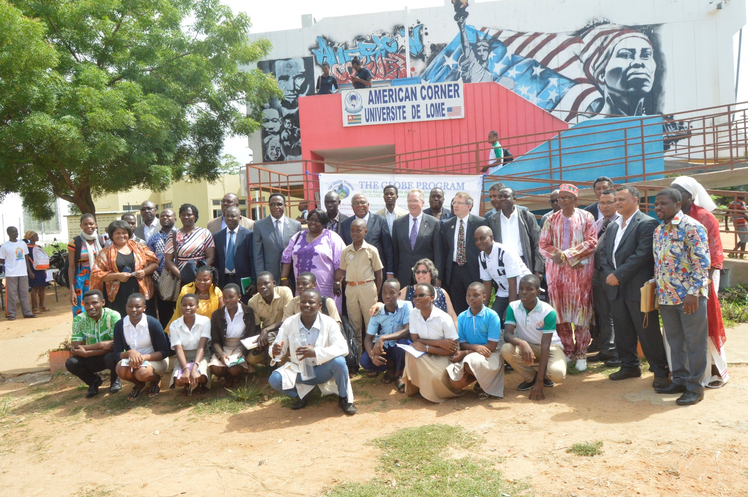

The 13th GLOBE Africa Regional Meeting was held in Lomé (Republic of TOGO), American Corner of University of Lomé, from 4 to 5 June 2018. It was followed by a Teachers Training Workshop on 6 June 2018, and the Regional Mosquito Training (part of the “GLOBE Engaging Citizens in the Forecasting and Observation of Mosquito Threats” project) from 7 to 8 June 2018.
The objective of these meetings was to:
- work towards greater participation, cooperation, collaboration and innovation to strengthen the GLOBE program in the Africa region, and
- work on the implementation of the newest “GLOBE Engaging Citizens in the Forecasting and Observation of Mosquito Threats” project.

Apart from Tony Murphy, GLOBE Implementation Office Director, Mark BRETTENNY the Regional Coordination Office Director, and a team from the Mosquito/Zika GLOBE Project, most of the Africa region country coordinators (representing 17 GLOBE countries), the Regional Alumni Representative Ylliass Destin LAWANI from Benin, attended this event, according to the following:

Names | Designation | Phone number | Email addresses
Tony Murphy | GIO | 303-497-2625 | tmurphy@ucar.edu
BRETTENNY Mark | GLOBE Africa Coordination Office | 0027722737997 | mark@globe-africa.org
BRETTENNY Rogeline | GLOBE Africa Regional Office | 0027822980095 | rogeline@globe-africa.org
CORNELL Lewis | Raytheon /USA | 626.744.5537 | cornell.lewis@ssaihq.com
RANDRIANARISOA Paul | Madagascar Country Coordinator | +261331106321 | randripaul@yahoo.fr  randripaul@gmail.com
MWANGI Charles | Assistant CC. Kenya | +254722537453 | maina.charles@gmail.com
RAMDEWOR Anil | Mauritius Country Coordinator | +23052507227 | aramdewor@gouvmu.org.com
SEMPALA Samuel Patrick | Uganda Country Coordinator | +256772395245 | pssempala@yahoo.com
Dr Gilbert Dennis | Professional Integral Coach | +27 219876708 | gilbert@coachg.co.za
FAELEN Sangay | Liberia Country Coordinator | +231 886397595 | sangayfaeflen@gmail.com
BOUMBOUNDI Jean Paul | Burkina Faso Country Coordinator | +226 70 00 06 93 | jp64boumboundi@gmail.com
BUAH Berthy | Ghana Country Coordinator | +233 24 408 5614 | bbuah45@gmail.com
JAMMEH Abdou | Gambia Country Coordinator | +220 6519711 | sibojammeh38@gmail.com
NAMUPALA T. Maria | Namibia Asst Country Coordinator | 0811293983  061221179 | tharacky@gmail.com
KAMBIWOA Lawrence | Cameroon Coordinator | +237 96149618  +237 77819751 | lawrence96k@yahoo.com
LWIKOLELA Robert Euphrase | Tanzania Coordinator | 00255754363110 | robertlwikolela@yahoo.com
FALL Ngossé | Senegal Country Coordinator | +221771018677 | fallngosse@yahoo.fr
FOLLY Richard Komlan | TOGO Country Coordinator Togo | +228 91 99 90 20 | richardfolly228@gmail.com
LAMINE Barry | Guinea Country Coordinator | +224 622 080 173 | laminbarry@yahoo.fr
OKOYE CELESTINE | Nigeria Country Coordinator | +234 708 66 01 204 | okoyetech@yahoo.com
LAWANI Ylliass Destin | Benin Assistant Country and Alumni coordinator | +22997397176 | ylliass@gmail.com

The following GLOBE countries from the region did not attend: South Africa (excused) Mali, and Cape Verde (inactive).

It is important to note that many inactive countries attended this meeting: Guinea, Ghana, Gambia, Burkina Faso and Liberia. The newest GLOBE Country, Togo, was also welcome.

The meeting was coordinated by Mr. Mark Brettenny, and Dr. Tony Murphy was in attendance.

The official opening ceremony was under the chairmanship of U.S. Ambassador to Togo HEM Gilmour Remarks, and the Togolese Environment and forest resources Minister HEM André Johnson.
“It is especially gratifying that this meeting is taking place here in Togo, because it was just a few months ago that Togo officially joined the worldwide GLOBE network. I want to take this opportunity to applaud the government of Togo for having taken this important step, which will permit Togolese students and teachers to connect and share scientific data with counterparts in 118 other countries. Thanks to this program, Togolese students will have the opportunity not only to learn about their local environment, but also to contribute meaningfully to our understanding of the global environment and climate” said the US Ambassador in his speech.

In his address the minister in charge of Environment in Togo said that the rollout of the GLOBE program in his country will begin in five pilot schools spread across the country. Each school will receive a kit of specialized equipment to collect samples of soil, water, air, and plant life, analyze the data, and put it on the GLOBE platform where scientists can study it. Another kit will be housed in Mo-Lab, the U.S. Embassy’s mobile STEM learning center.
After the opening ceremony there was a protocol stand visit by the officials. TOGO students under the guidance of Mark Brettenny demonstrated their ability to take GLOBE data in hydrology (using the labquest), surface and air temperature, etc. The meeting started with a welcome, greetings and opening remarks by Mark Brettenny Regional Coordination Office Director who emphasized the new countries (Togo and Liberia) and the ones that are back on board (Burkina Faso, Guinea, Ghana, and Gambia).
During the tour of table which followed the opening remarks of Dr. Tony MURPHY, representing the GLOBE Implementation Office, each Country coordinator present got an opportunity to introduce him/herself.
The Africa region GLOBE Alumni representative Ylliass Destin LAWANI from Benin reported on the activities of the Alumni group. Value Added to each country, 12 active Alumni countries: Benin, Cameroon, Ethiopia, Gabon, Ghana, Kenya, Madagascar, Nigeria, Senegal, South Africa, Tanzania and Togo.
Dr. Tony Murphy said that Africa has the strongest Alumni group. The Alumni's form part of the working groups. Laura Altin is on the Science group Ylliass LAWANI in the Evaluation group and Allison Edwards on technology group.GPO is big enough to realise the value of the Alumni group. Many alumni were congratulated for their great contribution to the community: Emmanuel Adjei Boadi of Ghana, Mwasapi Kihongosi from Tanzania, Doris Rabenandrasana and his alumni and studnts group from Madagascar, etc. Alumni work with different ways Comic books, using drones for anti-poaching,etc. They face challenges like funding sources, and are committed to assist Country Coordinators. Mr LAWANI said to continue working on GLOBE Countries where alumni are not active yet.

After this Dr Gilbert Dennis conducted a Capacity building session called “Committing to strategic priorities and how do you contribute as a leader”. He said that this time is interesting time for GLOBE Africa. It is 13 years old, teenager, not a little child anymore. The communication must change, Include culture, improve relationships, as well as the quality of communication. 3 years ago there was 30 000 data sets today we have passed 150.000.000 data sets. All the communities need to improve understanding encourage, support, Collaborate and support the global Network. Country Coordinators must have a sense of where they are.
They are the diplomat of their countries.
Mark at the end said that regarding the communication issue, if coordinators do not share and report on their activities and difficulties, “they did not do it”.

Tony then took the floor and talked about the GLOBE strategic plan: Increase collecting data, Send articles and do publications. Eg: Annual Survey during December, Country reports for regional meetings, Schools enter data correctly, Telling stories - what is happening. There is also the NSTA where all the U.S Embassy's meet and learn more about GLOBE. Normally NSTA fund 4 sites to attend an event.
Regarding communication issue Country Coordinators are asked to add an item to the regional homepage. He finished by calling African countries to participate in the next IVSS (this year Africa sent only 1 project!). The research project to be considered must be in English.

Then Mr. Cornell Lewis presented on GLOBE Website interaction, new developments and administration tools.
What is new? Mobile apps: Mosquito and Clouds app – GLOBE Observers App – Phenology app and GLOBE data entry App. These apps offer now the possibility to create sites like Atmosphere, Hydrosphere, Phenology, map interface, aerosols, and precipitation. They are now available in 9 languages. The Carbon Cycle offers 3 types of vegetation at the site.

Regarding the GLOBE website: New homepage, recent measures, new region pages, news calendar, summarize number of schools most active competition.
On Country pages: School page -School list, trainer, organization.
About My Page session (Where you talk about yourself) there is a new design.
The day closed at 17:00

On 5 June the agenda started with a capacity building session with Dr Dennis: “Moving from “ I" to "We" ”

Participants were divided in 5 groups to work on:
- Short term goals
- What makes it possible for you
- Longer term strategic goals
- What makes it possible for you
- What will you need to support with and from you.
Group 1: Engaging the US embassy, Inclusive CC, Public / private partnerships, Quarterly monitoring, funding and material availability from donors ( short term)
Set up a website.

Group 2 : to get material to implement Globe, Use the existing activities and learners that are active already, We use this way to raise funds, use funds to buy material, Try to train teachers. vocal point - to collect data and enter on website. automated weather stations so the data entered automatically. Every school have Science educators to work with the learners. Some protocols do not need lots of equipment, so we will start with them to increase our data. we will send all our information and activities to the regional office. so when we meet again the government will see how important is GLOBE.

Group 3: Government support to get everything together, Human resources, commitment to human Capital, training and education, integrate GLOBE activities to other stake holders ,
There can be a few government points to include GLOBE. Science, Technology, environment, education. Clean up campaign GLOBE can even integrate them: plant trees outdoor activities. Government involvement and NGO to make a success of the GLOBE program.

Group 4 : Successes of countries in the program. Relationship between the government and GLOBE, and importance of the buy in of ministries, Active trainers, GIO existing countries to support the new ones. Benin GLOBE part of the syllabus in Benin, makes it easier to do GLOBE.
Constraints: Funding. Thinking of looking at International funders.....without funding effect on training and equipment.
Way forward register: more school, enter data,
Seek funding, Benin want to be 1st again in terms of Data Collection.

Group 5: Old members to assist new members. Spoke about our different challenges and activities. Strategy: Madagascar ministry of education, secondary schools. Technology and education alternative training for people since we are not strong with internet activity.
Encourage Government. to include GLOBE activities and allow schools to do activities on their own. we need promote the program. Request the ministry to assist more not only for Science people but everybody that love the environment.
He emphasized what he called the super powers:

1 Listening level of understanding.....
what the person is not saying. how do you listen to what the person is not saying? you develop it over time. silent or speak less.... the followers may interpret your silence incorrectly. Exp Previous session I could have spoken...... but I did not and listened more. and you worked on your own and worked out your own strategic plan. Co-Creating and partnering.

2 Silence
Not all the time but you need to know when to be silent. In Communities it is useful to know when to be quiet and when to speak cultivate inner Silence.

Tony thanked Gilbert for his interesting session and said that community Communication goes together. He makes the remark that the goals set by the groups are still the old ones, at different levels while participants are all at different level. He thinks there are challenges in countries that Coordinators can overcome. Eg Student research Project IVSS (Africa had 1 entry for the last one. He asked participants to think of just one entry for IVSS). It can show a huge regional improvement. While the infra structure is in place they just need to get one teacher in their country.

After this session Cornell communicated on the GLOBE Website interaction, administration tools, and answered to specific questions from cc’s (Creating and administrating workshops)

Then on behalf of all participants Mrs. Berthy BUAH of Ghana made the closing speech to the regional meeting by congratulating everyone and thanking the GLOBE management staff.

After the regional meeting a Teachers Training Workshop took place from on 5th june after lunch and continued 6th june 2018 at the same venue.

Mark welcome to the new teachers that will be trained in Togo. “you are the lead trainers for the GLOBE program in your country” he said the teachers and alumni who joined the group for the training.

Dr. Tony made an introduction to the program and its instruments. He emphasized on the role of the teachers: Use the GLOBE protocols to collect data in their local environment, upload or enter, and use the data for their researches and the ones of their communities. He invited them to update the personal GLOBE page on the website they will receive after completing their training.

The next day was dedicated to the GLOBE Protocols. Paul RANDRIANARISOA from Madagascar and Ylliass LAWANI from Benin introduced themselves as the trainers. They were assisted by Mrs. Brettenny Rogeline from South Africa. They gave trainees an overview of Atmosphere and Hydrology protocols, whit an emphasis on GLOBE observers app (Cloud component). This session was followed by a practice in the field where the participants could practice what they have learned.

The teachers Training workshop finished by a ceremony where trainees could get their GLOBE teacher certificate. All of them were happy to attend this workshop.

Please note that the photos of the meeting are available on the GLOBE Africa region facebook page at https://www.facebook.com/africa.globe.5

