The 14th GLOBE Africa Annual Regional Meeting, 10-12 April 2019,
Hotel LE PAVE, Antananarivo,
MADAGASCAR

GENERAL REPORT

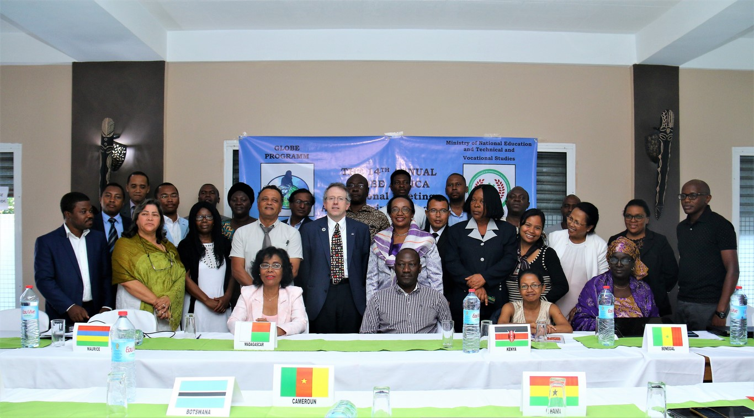

The 14th GLOBE Africa Regional Meeting was held in Antananarivo (Republic of Madagascar), from 10 to 12 April 2019. This Annual Country Representative meeting integrated a Strategic Planning for Sustainability and Participation workshop.
The objective of this meetings was to:
- work towards greater participation, cooperation, collaboration and innovation to strengthen the GLOBE program in the Africa region, and
- align in country activities to the Strategic Objectives of the GLOBE program.

Apart from Dr. Tony Murphy, GLOBE Implementation Office Director, Mr Mark BRETTENY the Regional Coordination Office Director, and a team from GLOBE Madagascar, most of the Africa region country coordinators (representing 14 GLOBE countries), attended this event, according to the following:

Names | Designation | Phone number | Email addresses
MURPHY Tony | GIO | 303-497-2625 | tmurphy@ucar.edu
BRETTENNY Mark | RCO | 0027722737997 | mark@globe-africa.org
BRETTENNY Rogeline | RCO | 0027822980095 | rogeline@globe-africa.org
MWANGI Charles | Assistant CC. Kenya | +254722537453 | maina.charles@gmail.com
RAMDEWOR Anil | Mauritius Country Coordinator | +23052507227 | aramdewor@gouvmu.org.com
BOUMBOUNDI Jean Paul | Burkina Faso Country Coordinator | +226 70 00 06 93 | jp64boumboundi@gmail.com
BUAH Berthy | Ghana Country Coordinator | +233 24 408 5614 | bbuah45@gmail.com
KAMBIWOA Lawrence | Cameroon Coordinator | +237 96149618  +237 77819751 | lawrence96k@yahoo.com
FALL Ngossé | Senegal Country Coordinator | +221771018677 | fallngosse@yahoo.fr
FOLLY Richard Komlan | TOGO Country Coordinator Togo | +228 91 99 90 20 | richardfolly228@gmail.com
OKOYE CELESTINE | Nigeria Country Coordinator | +234 708 66 01 204 | okoyetech@yahoo.com
MOKGADI Madiga | South Africa Country Coordinator | +27790558844  +27829440036 | mokgadi.madiga@dst.gov.za
Francis Wasswa Nsubuga | Assistant Country Coordinator Uganda | Tel +27 (0)12 420 2532,  Fax +27 (0)12 420 5678  Cell +27 (0)622711943 | francis.nsubuga@up.ac.za
SESUPO Lesole | Botswana Country Coordinator | +26773148188 | lesolesesupo@gmail.com
LAWANI Ylliass Destin | Benin Assistant Country and Alumni coordinator | +22997397176 | ylliass@gmail.com
UMEANO Oyobo | GLOBE Nigeria | +2349063576638
RANDRIANARISOA Paul | Madagascar Country Coordinator | +261331106321 | randripaul@yahoo.fr  randripaul@gmail.com

The following GLOBE countries from the region did not attend: Guinea, Mali, Cape Verde, Gambia (did not meet criteria), Liberia (Did not meet criteria), Tanzania (Travel permission denied), Ethiopia and Rwanda (Travel permission denied)

The meeting was coordinated by Mr. Mark Brettenny, and Dr. Tony Murphy was in attendance.

Before the regional meeting starts, there was a Zika meeting with all GLOBE countries that participate in the GLOBE Zika Education and Prevention project on 9th April evening. At this meeting Mr. Mark BRETTENNY made opening remarks of the meeting and communicated the agenda. He also introduced Dr. Tony MURPHY by welcoming him at the meeting. Tony took the floor and talked about the project development. He provided a global summary of CMTs, number of people trained and data reporting globally and from region, schedule of CMTs, Mission Mosquito Campaign, and a few key initial survey results. At this point Senegal was the country with the most data points (10 491) followed by Uganda (2 261), Togo (1 182), Benin (1048), Nigeria (115), Madagascar (95), Cameroon (35), Burkina Faso (34), Ghana and Kenya had not reported yet at this point.

Mark took the floor to make a summary of CMT updates. He talked about models of success Public Health Officials, and other RCO updates. He introduced the two RPHOs (Regional Public Health Officials) and presented their activities and future plans based on their reports. At this point the Anglophone RPHO Sr Meyer and Rogeline visited Rwanda and reengaged this country. They met about 1700 learners in order to motivate them to participate in GLOBE activities.

Than francophone RPHO Dr. Rock AIKPON is working with his students to investigate on Zika. They wrote an article "Assessment of population dynamics and biting trends of Aedes aegypti in northern Benin: Public health implications" published in International Journal of Mosquito Research (available for download at http://www.dipterajournal.com/pdf/2019/vol6issue2/PartA/6-1-23-674.pdf). This research will be presented at the next Pan-African Mosquito Control Association (PAMCA) conference in Cameroon.

Then each country took the floor to present the status of the zika project.

Berth Buah of Ghana said that there is no equipment to do the workshops. Ghana started taking data. But the data are not registered in the system. They did also hydrology.They get in touch with the National Control diseases office which is ready to support but willing to have the lenses to move forward. 69 people are now registered in the GLOBE system. The challenge is with the ministry asking for equipment and funding, because they say they don’t have any funding at their level to support.
Mark replied to this by saying that we can do GLOBE without equipment by doing basis GLOBE, for example Atmosphere, Cloud Protocol. Sending equipment is very expensive. Regarding the lenses purposes he suggested to liaise with local China shops to get quotes and communicate with his office/GIO.
Tony then explained the situation with the lenses. At the beginning having the lenses were easy but the company with which GLOBE has started have closed and reopened with higher prices. Also shipment of lenses cost a lot for the budget. That is why they are suggesting approaching local china companies in the countries in order to get quotes, which will avoid shipment costs from US.

Paul from Madagascar said that they have hosted 6 workshops across the whole country. We have trained 140 Trainers of trainers. People are very motivated, even scientist like Dr Lala who will be attend the meeting.

Charles from Kenya stated that his country is additional country lately added to the project. Kenya will have to figure out how the system works. They are facing challenges with the SERVIR Hub. It will be possible for teachers to compare weather parameters. They keep in contact with the mosquito control unit. If the teachers don’t see the values of the works such as the way it is addressing social challenges, people are not motivated. The remark is that most the time just focused on technical aspect or sending the data.

Ylliass from Benin said that his country is part of the ZIKA evaluation countries. The project is very interesting for Benin because for the last 3 years, the country was conducting a Malaria-related project. The problem they have is the incompatibility of the devices, (Phones, tablets etc). Sometimes during the CMTs, they have more participants more than expected, which lead to find extra funding to cover all related costs. We have to be clear the funding is not sufficient. The other challenge that may rise is the incapacity of people to go through the system and complete all the process. They are thinking to host a specific workshop to show how to do that, but the remaining question was where they will get funding to support this workshop. Another problem is how to help people get their certificate as Mosquito Master Trainer. Also, people are seeing the project very strangely especially when they are talking about NASA.

Mark replied to this by saying that GIO can guaranty that very soon country will get the funding. If country coordinator use money from him pocket, it should be consider as a part of our heart saying that this is good for my country… That funding of ZIKA is with the State of Department, and before sending the funding, they are looking to the country data metrics in the system. That is also regional office bring expertise like aligning the strategic plan with the objectives, expectations. Countries have to report and communicate their work.

Ngosse Fall from Senegal said that they have completed the 6 CMTs. All the receipts were sent to Mark. She emphases that she choose to work with a small group in Senegal. What is important is to train the good students/profile to do the work. Because what is important for GLOBE is the data. But they are having some technical issues regarding the data counting. The other challenge is also the way the GLOBE administration is going. “We need to go more official” she said. Also GLOBE need to motivate the participants, those who are collecting the data, etc. The motivation is not necessary money, but any kind that should come through the CC. Lastly, all the lenses she got are working well with good quality. She expressed his thanks to Ylliass for his assistance and his help to set up the workshops during the process.

Mark replied and said that for the quality of the data/equipment we will be sending emails to the chief sciences coordinators for the have their advice.

Richard from Togo said that his country is also part of the ZIKA evaluation countries like Benin. They have done all the CMTs, remaining the final one in Lomé. They are facing technical issues like internet connection, compatibility of devices, etc. They are working to collaborate with Benin and organize joint workshop.

Mr. BOUBOUNDI from Burkina Faso informed that he finished with 3 CMTs in Ouagadougou, Kaya and Fada Ngourma. They are waiting for additional funds to organize the 3 remaining CMTs. He expressed his thanks to Ylliass for his assistance and his help.

On 10th april before the meeting starts there were an official opening ceremony under the chairmanship of Ms. Aurélie RAZAFINJATO Secretary General representing Her Excellence Ms. VOLAHAINGO Marie Thérèse Minister of National Education and Technical and Professional Education of Madagascar.
Dr Tony Murphy, GLOBE Implementation Office, make a presentation of GLOBE to the audience and shared the current metrics with all.
In her opening remarks the Secretary General welcomed the participants and thanked GLOBE for the choice of Madagascar to host the 14th Regional Meeting of GLOBE Africa. In reiterating Madagascar's commitment, through the Minister of National Education, she added: "We are convinced of the place of science in development in different fields. For sustainable and harmonious development, it is therefore essential to have a better knowledge of natural resources in order to better manage them for the benefit of current and future generations”

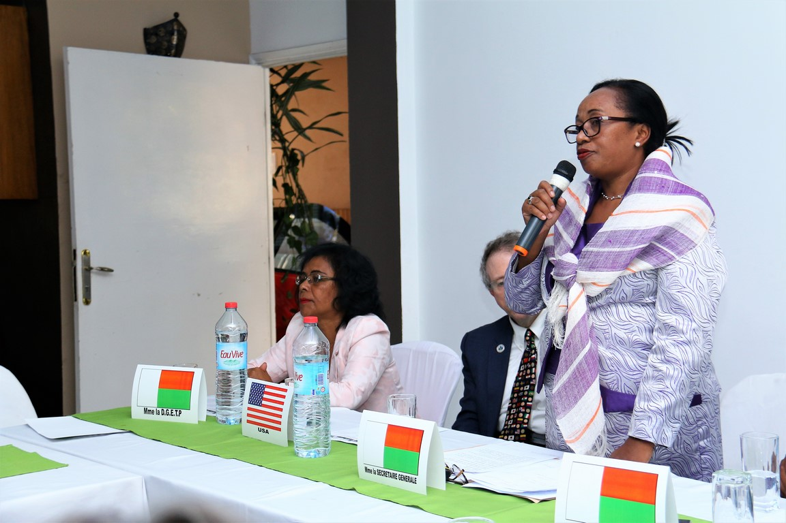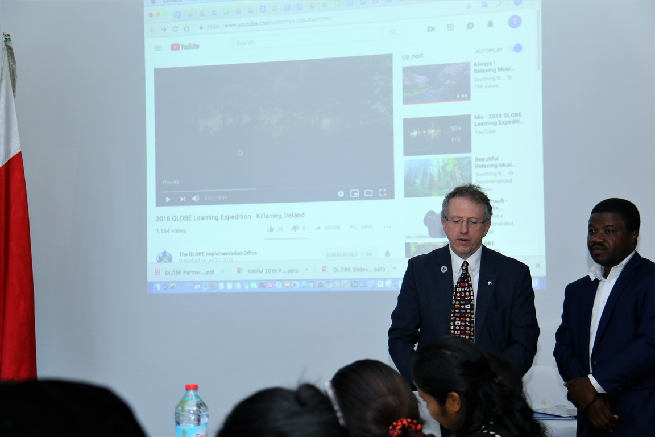
Dr. Tony Murphy doing his presentation
Ms. VOLAHAINGO Marie Thérèse opening the 14th GLOBE Africa regional meeting

After the opening ceremony there was a tea break and Mr Mark Brettenny Regional Coordination Office Director took the floor to make the Regional Office Report. After welcoming Botswana (this was his first meeting with the group) he talked about projects going on in Africa, like the Africa lakes project (previously Lake Victoria project, and Pokarah project). Now this project may be renamed the “Waterbody Project” in order to not marginalize countries without lakes.
Everybody can take part at any water body. Mark also stated that last year everybody indicated they will enter IVSS project. Sadly only 2 projects (one from Kenya and one from Niger) were submitted from our region at this moment. He hopes that at the end of the day there will be at least 5 projects from Africa region in the system.
The Biomes project use to be Kilimanjaro learning expedition. But this was too expensive. So the objective is now to compare different biomes from the word. During the last edition Dr. Francis from Uganda attended as scientist. About 10.000 people shared their biomes (Kenya, Botswana, Namibia, Tanzania, etc) and this led to a big level of collaboration. Why not to do the same with the water project?
Mark talked about SOS Villages as well as schools in Namibia where he conducted refresher workshops. Also he trained 25 teachers in Gaborone (Botswana), as well as he involved citizen scientists in George.
Part of the Zika-Public Health Officer’s work, he talked about connecting Dr Lala of Madagascar with Dr. Rock Aikpon.
After the ESTH conference many countries like Burkina Faso and Ghana was reengaged with close link to American Embassy collaborations.
He finished with the GLE 2018 held in Ireland and to which Africa was well represented with a wonderful keynote speech from Kenya.
During the tour of table which followed the opening remarks of Dr. Tony MURPHY, representing the GLOBE Implementation Office, each Country coordinator present got an opportunity to introduce him/herself. In addition to what had been said the previous day at the Zika meeting, Berthy from Ghana said that she had to conduct the training with the support of the strong alumni network in the country. She mentioned that there are no master trainers available to work with her in the country. She wrote proposals searching for people to support GLOBE and hop to get responses.
Lawrence from Cameroon talked about the training he will conduct in Cameroon with the support of his government in the next days.
Dr Francis trained participants on how to align their in-country activities to the Strategic Objectives of the GLOBE program. He said that everybody is joined in the current strategic plan of GLOBE: learners-teachers-parents-scientists, to understand their environment and create awareness. To understanding the GLOBE community, GIO to encourage students learning methodology, to support each other to get their goals, engage and share their researches. 3 things are important to note:
- involve teachers and scientists community
- share – individually or in group
- create an African Partner Forum

After lunch Burkina Faso talked about the situation that brought to his country’s reengagement in GLOBE, stated that soon his country will start sending data in the system as his main challenge was data entry.
Uganda stated that they did not register their CMT’s workshops on the system as participants did not give their email addresses. Citizen scientists with 3 schools are currently reporting on other GLOBE Protocols too. He is willing to carry out LMTs.
Ghana CC and Alumni worked through the Zika project. Due to limited equipment (lenses) they made 3 groups per workshop, 1 lens per group.
In Senegal work in progress. Ngosse choose to focus only on students that are reporting, and people that are interested. GIO to be involved with connection with government at high level (letter from GIO to ministry). They need incentives. They have more scientists’ networks participating. But this work could not have been done without her alumni (She thanked the RCO for supporting Ylliass who assisted them diligently).

Richard from Togo said that the first challenge he faced was to organize the 6 CMTs across the country. People are not comfortable with computers in the field (he mentioned the collaboration with the USA Embassy funded Molab project), lack of internet connection was also a challenge. He realizes that he must change his approach and be more selective when inviting participants. He however enjoys the continuous support of the U.S Ambassador who came to visit him in the field during the workshops.
His further challenge was to get the previously trained GLOBE alumni on board. The RCO supported an alumni outreach to Togo before the bilateral agreement was signed. Ylliass was sent and it seem they only respond to him and not the CC. Most of them are not responding. He plans to do the last CMT in Lomé with them and requested that Ylliass motivate them to participate.
GLOBE Togo will concentrate on data collection now.

Dr Francis took the floor and continued with aligning in country activities to the Strategic Objectives of the GLOBE program.
Mark came and focused on the 3 criteria to be invited to the next regional meetings:
- Complete country survey
- Complete annual survey
- Get at least 100 data points in the system
He also emphasized the importance of meeting the prescribed deadlines.

He closed the work day by asking everyone to think of a group research activity to be done as collaborative project.

Then Paul communicated about the logistics of GLOBE school visit (Lycée Sabotsy Namehana)

The following day the group visited Lycée Sabotsy Namehana, which is a GLOBE school. Teachers and students communicated about their work and passion to do GLOBE. Participants found that this school had numerous research reports available but not uploaded on GLOBE website. They suggested that they send one or two projects to be part of the IVSS. Charles and Ylliass volunteered to help them to type and send two of them at the end of the day.

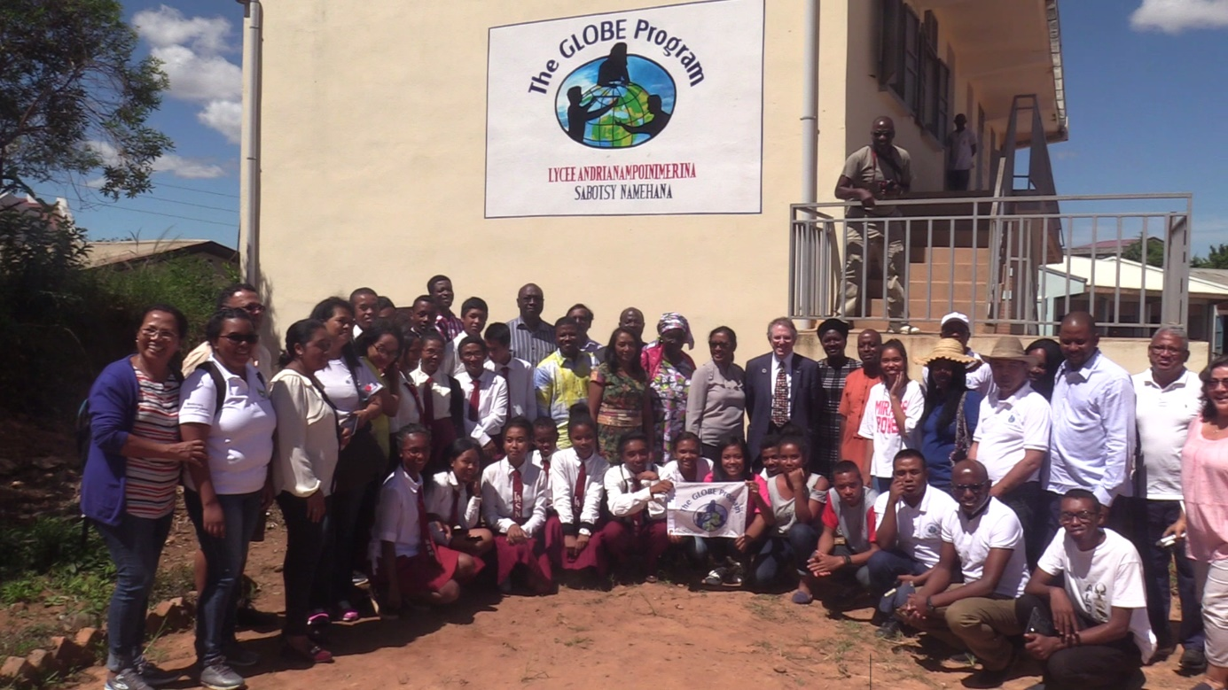
Participants with Lycée Sabotsy Namehana GLOBE Community

On their return way the group visited the Royal Hill (Ambohimanga) in the afternoon just after lunch.

The next day was dedicated to professional development focusing on the GLOBE workshop training / administration process. After a very interesting icebreaker done by Rogeline BRETTENNY, Charles MWANGI from Kenya and Ylliass LAWANI from Benin helped with the PD session. They gave trainees an overview of Workshops creation and administration tools, school site definition, data collection, data entry, retrieve and visualization tools.

After that there were working groups presentations by Ylliass (Evaluation Working group, in conjunction with Lawrence), Charles (technology working group) and Francis (Education working group).

Tony did a final presentation that recall to all country coordinators their roles and responsibilities.

Mark then shared the regional opportunities and plans. He announced the 2020 Regional Meeting host which will be the RCO and which will be in South Africa, and finished with his closing comments.
In the afternoon the meeting finished with a closing ceremony at Anosy- conference hall with intervention of the chief of Cabinet, Rija RAKOTOMALALA of Her Excellence Ms. VOLAHAINGO Marie Therèse Minister of National Education, Technical and Professional Education. All participants were awarded with certificates. Everybody agreed that this was a very fruitful and productive RM.

After dinner the RM resumed with CC’s reporting forward. The Zika participating countries also included their CMT / LMW strategies. Countries spoke about their challenges and the pursuit of overarching funding was again under discussion. We spoke about strategies that will ensure GLOBE activities without the outlay of funds and Tony spoke about instruments that can be made cheaply. All CC’s committed to more active participation, contributing to the data pool and having their students participate in GLOBE initiatives like IVSS. They also committed to remote participation at the upcoming Biomes and Water body research projects.
Please note that the photos of the meeting are available on the GLOBE Africa region facebook page at https://www.facebook.com/africa.globe.5

