The 11th GLOBE Africa annual Regional Meeting, March 29 – 31th 2016, Kopanong Hotel and Conference Centre - Johannesburg, South Africa

GENERAL REPORT

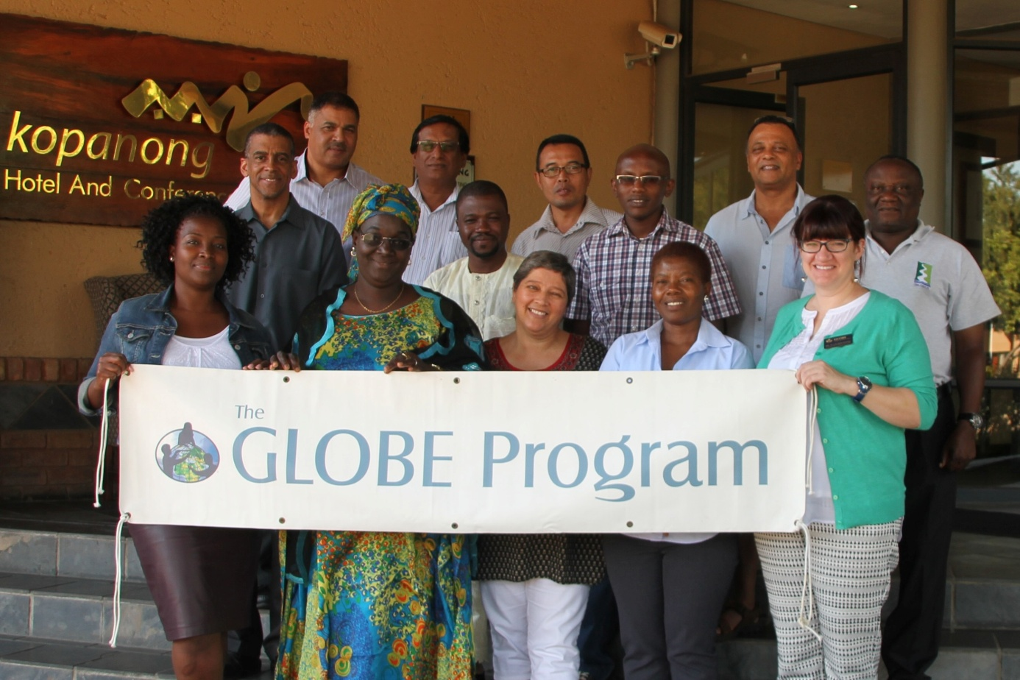

The 11th GLOBE Africa annual Meeting was held in Johannesburg (South Africa), Kopanong Hotel and Conference Centre from 29th to 31st March 2016 with a brief strategic planning session on 29th, followed by a dinner with attendance of Mr. Hagen Maroney from the U.S Embassy in South Africa. He emphasized that he will work with his counterparts in the various Africa countries in order to facilitate better cooperation and support.
The objective of this meeting was to work towards greater participation, cooperation, collaboration and innovation to strengthen the GLOBE program in the Africa region.
The Anticipated outcomes will be:
Better cooperation, collaboration and greater participation. The Africa region will come up with some innovative ideas to make collaborative projects exciting for participation by schools and communities. This should also lead to meaningful contribution by amongst other the private sector. The GLOBE Program in Africa will be more visible with all activities published on the regional website, social networks and media pages.

Apart from Julie MALMBERG, Education, Outreach, and Technology Specialist at the GLOBE Program representing the GIO, and Mr. Lewis CORNELL, from Raytheon, most of the Africa country coordinators, the Regional Alumni Representative Ylliass Destin LAWANI from Benin, and the newest GLOBE country representative from Mauritius who signed the bilateral agreement last year attended this event, according to the following:

Names | Designation | Phone number | Email addresses
Julie MALMBERG | Representing GIO |  | malmberg@ucar.edu
Lewis CORNELL | Raytheon /USA |  | cornell.lewis@ssaihq.com
Paul RANDRIANARISOA | Madagascar Country Coordinator | +261331106321 | randripaul@yahoo.fr  randripaul@gmail.com
MWANGI Charles | Assistant CC. Kenya | +254722537453 | maina.charles@gmail.com
Ngossé FALL | Senegal Country Coordinator | +221771018677 | fallngosse@yahoo.fr
Anil RAMDEWOR | Mauritius Country Coordinator | +23052507227 | aramdewor@gouvmu.org.com
MOKGADI Madiga | South Africa Coordinator | +27790558844  +27829440036 | mokgadi.madiga@dst.gov.za
Patrick SEMPALA | Uganda Country Coordinator | +256772395245 | pssempala@yahoo.com
Thembi MOLALOSE | South Africa implementing agency SAASTA | +27 115515940 | thembi@saasta.ac.za
Dr Gilbert Dennis | Professional Integral Coach | +27 219876708 | gilbert@coachg.co.za
Ylliass Destin LAWANI | Alumni Coordinator | 0022995235037 | ylliass@gmail.com
BRETTENNY Mark | GLOBE Africa Regional Officer | 0027722737997 | mark@globe-africa.org
BRETTENNY Rogeline | GLOBE Africa Regional Office | 0027822980095 | roge@globe-africa.org

The following GLOBE countries did not attend: Tanzania (could not get travel permission) and Cameroon (could not get travel permissions), Nigeria (coordinator is sick), Mali (excused), Ghana (retired), Guinea Conakry (inactive), Burkina Faso (inactive), Cape Verde (inactive), CHAD (CC on official mission – assassinated since 25 April 2013), Gambia travel permission granted then revoked at last minute), Niger (inactive) Gabon (in the middle of annual review and could not travel), Ethiopia (nonresponsive) Namibia (indicated they would attend but last minute assignment from organization), Rwanda (indicated they wanted to host next RM and would send an alternate), Republic of Congo (inactive),

The meeting was coordinated by Mr. Mark Brettenny, and Dr. Dennis Gilbert (coach and outside resource for the regional office).

Mr. Mark BRETTENNY on 30th march 2016 made opening remarks of the meeting and communicated the agenda. He also introduced Dr. Julie MALBERG by welcoming her at the meeting. “We try to add more value to our regional meetings In addition to reporting about what is happening in our countries....So we have Gilbert, Julie and Cornell here to assist us to reach that goal” he said.

This is followed by a session engaging all participants aimed at how GLOBE will function best in their respective countries. Some remarks were made:
Ngosse Fall from Senegal expressed that for her one of the goals for this meeting is to improve her use of the GLOBE website and achieve a language a challenge.
Paul from Madagascar need assistance to from U.S embassy in his country (this was a common need of all countries represented) and expressed that GLOBE need to work with NGO’s to improve relationships and collaborations, and raise funds for GLOBE activities in the countries.
“We would like to assist as best we can but we as GIO or Regional office we can only do a certain amount...we may not pass over your country government…We would like to find a way of how we can overcome the lack of data” replied Mark.
Regarding Alumni, he expressed his satisfaction and the interest of the GLOBE Community to work closely with them. Addressing the CCs, Mark said that “Alumni are the future of the GLOBE program in your countries... Ylliass an example of that and a great model....He presented his mosquito malaria research in Helsinki in 1998 as student and is still engaged with GLOBE! We would like all the countries to start and encourage Alumni presence in their countries”

Dr Julie MALBERG in her presentation shows the GIO Vital statistics (11 people part of staff, 6 languages spoken, almost cumulative 80 years working for GLOBE, expertise, etc.). She discussed the different activities they are involved with (citizen Science launched 22 April, International virtual science fair with no Africa country participate, Earth day challenge 2015, Earth science week data challenge, NWF Eco schools new collaboration, GLOBE Teachers Guide updated, Kilimanjaro Expedition, e training…). Overall she said that data entry has decreased according to the graph. The GIO got 70% responded on the evaluation and Julie invited the CCs to email to her in case they have any enquires.
For her the reason for data decreasing is due to many factors like the GLOBE website changes, the excitement going off.....But she is hopeful as the measurement campaigns are working very well, and international science fairs will also help.
Many questions and contributions were then made. Regarding the international training it had been adopted that when a country host the regional meeting the Country Coordinators that are Master trainers will also do an international training in that country.

The major remark that was made is that while the Africa region is doing well, we really have nothing to show! The regional office can only report back what it receives as report from CCs. There is a need for a regional push for data and the inclusion of Africa scientists in order to have them work with the regional activities. Collaboration with overarching organizations like ecoschools, the Trans African hydro-Meteorological Organization (TAHMO), Development Initiatives, should act like footprint which will better the region, and could help with equipment. As example the regional office got equipment for the Victoria Lake and American embassy assisted with receiving the equipment.

Cornell Lewis, through his presentation talked about e-training tools available on the GLOBE website, the new account approval process for CCs (others like Citizen Scientists have less access. If someone want to become a GLOBE teacher and do not meet the requirements he/she can be referred as citizen Scientists. When he/she will try to register an account it will be send to the CC and not the helpdesk anymore), the low bandwidth which will help countries with limited or no strong connectivity to internet to easily navigate on the GLOBE website by providing a text only of the page, the possibility for every school to upload images if they want to, how to enter cloud data (App 1.2 to design sites), etc. He finished by inviting CCs to contact him if needed on his new email address cornelll.lewis@ssaihq.com.

After lunch Mr. Anton Moller, CEO Africa Office of WePresent WiPG presented software (essentially the WiPG-1000) GLOBE Teachers can use in classroom to better their teaching experience. Many GLOBE coordinators were interested in the product and promised to maintain the contact with Mr. Moller.

Then Dr. Dennis Gilbert, Professional Integral Coach, special guest and outside resource for the region, started a 2 days capacity building session with participants, in order to help to bring out the best in each for the region. This session focussed on Leadership development.
He started with the evaluation of the quality of the ccommunication with Regional Office during the past six months. As it is better, the communicator gave to his audience tools about Communicating Effectively, Constructive Feedback, managing conflicts, differences between a group and a team, Leadership, Building Trusting Working Relationships.
Mark took the floor and stated that there are Country challenges that the region we have at the moment. These included the appointments of deputy CC’s. When in the field they cannot receive mails, the Deputy CC is very good to do the running around and make sure they receive all your communication. They role will be to transform to a higher level, create a space to identify this and make sense of the different way people work.
Day 2 started with second communication of Dr. Gilbert which emphasis the constructive feedback everybody must have and not take it remarks personal. “Take the emotion out of it.
GLOBE Africa getting out of infancy state, we are a child who is wobbling” he said.

After that Dr. Julie from GIO had a fruitful brainstorming section with the participants on ways to achieve more involvement by GLOBE Africa teachers and students.
Here are the outcomes:

Requests for GIO/GLOBE/SSAI (formerly Raytheon)
- Videos of protocols
- One-pager/brochure for each campaign and project (PDF) – include contact information for team members
- Data case study – show how data goes from the students taking measurements to entering data to use by scientists
- Make the website easier for teachers

Tasks for Meeting Participants and GLOBE Africa
- Program easy for teachers to use
  - Lead: Charles (Kenya)
  - Assist: Patrick (Uganda), Ylliass (Benin), Ngossé Fall (Sénégal), Anil RAMDEWOR (Mauritius)
  - Components:
    - Easy to read and understand
    - Translation – (GIO Contact = Eslam Khair, help@globe.gov)
      - Workshop Tool
      - eTraining
      - Teacher’s Guide
      - Data Entry landing page
      - News Briefs
      - Big events, campaigns, projects
      - Content that doesn’t change
    - In country IT/web support – Country Coordinator training
- Volunteers
  - Lead: Ylliass (Benin)
  - Assist: Mokgadi (South Africa)
  - Components:
    - Framework for GISN and emerging scientists provided by GIO
    - Recruitment
    - Best practices – share between countries
      - Data entry
      - Emerging scientists
    - Motivation
    - Alumni
- Opportunities to practice skills
  - Lead: Paul (Madagascar)
  - Assist: Thembi (South Africa), Gilbert (external resource)
  - Components:
    - Leadership skills
    - Community presentations
    - Science Fairs (schools, communities, GLOBE International Science Fair)
    - Publications
- Motivation
  - Lead: Mokgadi (South Africa)
  - Assist: Charles (Kenya), Ylliass (Benin), Ngossé Fall (Sénégal), Thembi (South Africa), Paul (Madagascar)
  - Components:
    - Country support
    - Visits to labs
    - International connections
    - Association with NASA
    - Ask teachers why not motivated (survey)
    - Competitions and prizes
    - Certificates, recognition
    - Publications
- Local Relevance
  - Lead: Mark (Region)
  - Assist: All
  - Components:
    - What is interesting?
    - Consider students too
    - Relate to current initiatives, campaigns, and projects (GLOBE and local)
    - Consider local problems and challenges impacts

The Group leaders will have to contact their group’s members and coordinate the work.

After lunch Mr. Cornell did a web Training addressing the specific needs of the CCs and each country gave their views.

Ylliass Desin LAWANI, Africa GLOBE Alumni representative. After thanking and commending the RCO for the continuous support and guidance then presented the activities done in the region since last meeting (Moga school training in Tanzania; Volunteering; collaboration between Ghana and Germany; Contribution to the biodiversity conservation through anti-poaching drones in the W-Arly-Pendjari Parks; Transformation of Youth Culture through Comics: Building the next generation of Eco entrepreneurs etc.), he emphases the fact that the Alumni must build a strong and vibrant community in Africa region by achieving immediate goals like : Inauguration of the new GLOBE Alumni Africa Headquarter in Cotonou, Benin (the previous one in not longer available because the owner raised the rent and our principal partner YEP announced its withdrawal), the preparation of the 1st GLOBE Alumni face-to-face meeting for African region and involvement in research projects and science fairs initiated by GLOBE and its partners like SMAP, CloudSat, El Nino, CALIPSO, GPM, GGIC, etc.

Mr. Charles took the floor to explain more about TAHMO. The Trans African hydro-Meteorological Organization started in 2001. Most data from everywhere else than Africa, so they want to import that. They installed automated weather stations, partnered and installed about 30 stations at Globe schools. This station is made for this activity and measures temperature, rainfall, relative humidity, wind speed and wind direction as well as the time. It uses solar batteries.
Schools can access data through school2school.net network. They will install 70 stations in Uganda, a few already installed in Ghana. Malawi and Zambia will also receive stations although they not globe countries, Rwanda in future.
The regional office informed that the GIO is already in contact with the TAHMO and that they will officially pattern with them.

During the closing remarks by Mark, it was reiterated and agreed by all that a timeline should be followed, and that the participation at future Regional Meetings would be dependent on the following:
- Completion of annual survey online on time
- Submission of the country report on time
- Have at least 100 data entries on the website since the last regional meeting.

The countries won’t be invited if they don’t fulfill these criteria. Additional consultation will take place with the GIO to discuss alternatives to Regional Meetings.
The meeting was closed with many smiles and interest were expressed by Benin, Kenya, or Senegal to host the next RM in late February 2017.
Please note that the photos of the meeting are available on the GLOBE Africa region facebook page at https://www.facebook.com/africa.globe.5

