The 12th GLOBE Africa annual Regional Meeting (West Africa session) and Teachers Training workshop, 23-26 February 2017, S.O.S Children’s Village - Cotonou, Benin Republic

GENERAL REPORT

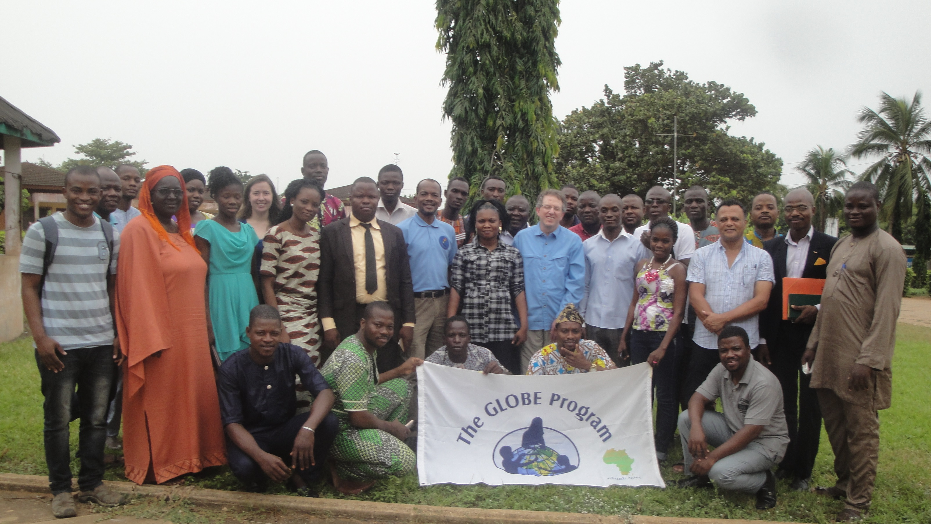

The 12th GLOBE Africa annual Meeting (West African session) was held in Cotonou (Republic of Benin), SOS children village of Abomey Calavi http://www.sosvillagesenfantsbenin.org on 23rd February 2017 was the first of the series of three meetings which will held this year in the Africa region.. I was followed by a 3 days Teachers Training Workshop from 24th to 26st February 2017.

The objective of this meeting was to work towards greater participation, cooperation, collaboration and innovation to strengthen the GLOBE program in the Africa region.

Apart from Dr. Tony Murphy, GLOBE Implementation Office Director and Mr Mark BRETTENY the Regional Coordination Office Director, most of the West African country coordinators, the Regional Alumni Representative Ylliass Destin LAWANI from Benin, attended this event, according to the following:

Names | Designation | Phone number | Email addresses
Ngossé FALL | Senegal Country Coordinator | +221771018677 | fallngosse@yahoo.fr
Elizabeth Jachens | School 2 school coordinator at TAHMO | +1 530 295 7615 | jachense@oregon.state.edu
GARBA MAHAZOU | GLOBE Country Coordinator Niger | +227 96985233 | gmahazou@yahoo.fr
OKOYE CELESTINE | GLOBE Country Coordinator Nigeria | +234 708 66 01 204 | okoyetech@yahoo.com
SIMYELI ESSOWE BEN | U.S Embassy Togo | +228 92383455 | sshlome@state.gov
Ylliass Destin LAWANI | Alumni Coordinator | 0022995235037 | ylliass@gmail.com
Tony Murphy | GIO | 303-497-2625 | tmurphy@ucar.edu
BRETTENNY Mark | GLOBE Africa Coordination Office | 0027722737997 | mark@globe-africa.org

The following GLOBE countries from the region did not attend: Mali (excused), Ghana (retired), Guinea Conakry (inactive), Burkina Faso (inactive), Cape Verde (inactive), Gambia (New Government and battling to secure permission to participate. Excused).

The meeting was coordinated by Mr. Mark Brettenny, and Dr. Tony Murphy was in attendance.

The meeting started with a welcome, greetings and opening remarks of Mr Mark Brettenny Regional Coordination Office Director who pointed out the presence of Niger at this meeting (after a long absence) and TAHMO (Trans-African Hydro-Meteorological Observatory) which will train later the Benin Teachers about the automated weather stations. Then he shared the objective of the meeting: Work towards greater participation, cooperation, collaboration and innovation to strengthen the GLOBE program in the Africa region.

During the tour of table which followed the opening remarks of Dr. Tony MURPHY, representing the GLOBE Implementation Office, who welcomed Mr. SEMYELI from US Embassy in Togo and wished that the bilateral agreement between Togo Republic and USA would be signed soon, many ideas were expressed.

Mr. Mahazou from Niger said that he could not attend the previous GARM because he got mails in English and could not understand. He expressed his thanks to Ylliass for helping to reconnect him to the GLOBE Program and the Regional office. After explaining the lack of commitment of the government of his country which does not put GLOBE in its priorities of the moment, he called for financial and material resources in order to help him to implement the program in the best conditions in his country. In response to this request, Dr. Tony Murphy said that GLOBE had reviewed his collaboration system with the GLOBE countries, that there is no more funding to support directly the implementation of the Program in countries, that it is the Governments that must do so.

Mrs. Ngosse FALL of Senegal, report about activities in her country. Presently 4 schools are taking data, but 2 of them are reporting. She also talked about funding.

Mr. SIMYELI was looking for more direction to figure out how to more implement GLOBE in Togo. He wished to be the middle man who makes and maintain the contact with the Togo Government.

Dr. OKOYE from Nigeria talked about the way he uses to motivate and recruit schools, teachers and students in GLOBE by organizing science competitions at local and regional scale. He suggested to the CCs to approach private schools and partners in order to create collaboration opportunities between them and GLOBE

All Participants congratulated Mark for improving the communication between the regional office and the French speaking GLOBE Countries by translating the mails and communications.

After lunch the group moved to Porto Novo to visit the Songhai centre http://songhai.org/index.php/en

After the regional meeting a three days GLOBE/TAHMO Workshop took place from 24 to 26 February at SOS Children’s village, and University of Abomey calavi.

21 schools and university laboratories attended this workshop (please find the list of schools attached). Their locations and contacts are listed on attendance sheet attached to this report.

35 teachers (included 2 students from University of Lomé - 2 peoples from Météo Benin, the Benin Met Agency, and 1 Alumni doctor in charge of the participant’s health) attended this workshop.

The field works took place at SOS children village for atmosphere and TAHMO, Landing stage of Ganvier for hydrology, and University of Abomey Calavi for soil and land cover.

Meanwhile Dr. Tony Murphy with Mark Brettenny assisted by Ylliass LAWANI and SIMYELI Ben paid visits to the scientific community of Benin. They first went to meet with Dr. TAMO Manuele, resident representative of IITA / BENIN where Dr. Nicodeme FASSINOU a GLOBE Alumni focused on GLOBE Star last year, is working.
The visit focused on insects in the sense that Tamo is an entomologist who conducts several works on the insect. He shared with the GLOBE delegation the biological control methods that his institution has developed. A similarity of objectives has been found with GLOBE as regards the setting up of an e-platform accessible to all and the mosquito protocol. Since insect dynamics are also influenced by climate changes, atmospheric data from GLOBE is very important, hence opportunities for collaboration.

After That Dr. Tony did a presentation to students in Master at the Agriculture Faculty of University of Abomey Calavi . Most of these students work with Dr. Eunoch ACHIGAN Laboratory (Laboratory of Genetics, Biotechnology and Seed Sciences) and were motivated to assist. His leadership and the interest that the students showed impressed the Director of the GLOBE Implementation Office and many collaboration opportunities were expressed.

The last day of the training was marked by the inauguration of the newest GLOBE alumni Africa headquarters based in Benin by Dr Tony Murphy and Mark Brettenny.

On Monday March 6th 2017, there was a newspaper article published on the event, exactly in "NOTRE VOIX" newspaper page 12 (please find attached the pdf and jpeg files of the article)
Please note that the photos of the meeting are available on the GLOBE Africa region facebook page at https://www.facebook.com/africa.globe.5

