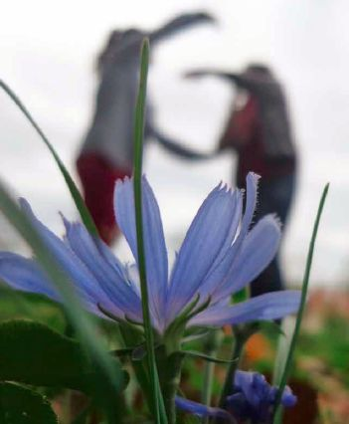

**Deadline**

Upload before the **20th October 2015**.

**Jury**

Members of the [GLOBE Europe & Eurasia Board](http://www.globe.gov/web/europe-and-eurasia/contact-info/representatives) will select the best photos.

**How to upload**

To join you need to have a school account on [www.globe.gov](http://www.globe.gov). When you login on your teacher account, click on ‘go to’ on the top right and navigate to your school page. Then go to image gallery tab and click on ‘add image’. Done!

Select only pictures of good quality and resolution that would allow for printing. For uploading pictures to the globe.gov website you may use small size copy, but always keep the high resolution original of the picture in case it will be featured in the calendar. Use only pictures taken by you or your GLOBE team, always ask the author for permission!

**Prizes**

* Your picture featured in the 2016 GLOBE at My School Europe calendar
* Your picture highlighted on [www.globe.gov](http://www.globe.gov)
* Check your country´s GLOBE website for national prizes or ask your country coordinator

If you have any questions, contact the Europe and Eurasia Regional Office at [europe@globe.gov](mailto:europe@globe.gov)

**How to join?**

Any student of a GLOBE school in Europe & Eurasia can join by uploading **Pictures** with the theme

**“GLOBE at My School”**

Take a snap of your study site or your GLOBE corner. Catch the best moments with GLOBE. Show us clouds, trees, soil, water and air around your school that shows how you do GLOBE.

*Your chance for international fame!*