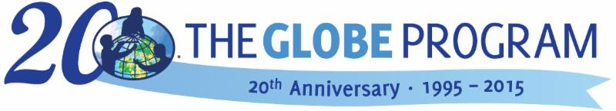

GLOBE Regional Meeting for Europe and Eurasia
Germany, Cologne, September 26 – 30, 2016
Notes by RCO Europe and Eurasia

Regional Meeting of the GLOBE countries across Europe and Eurasia Region was hosted in Cologne, Germany. More than 30 Country Coordinators, trainers, scientists and teachers from 18 countries came together to learn about the most recent activities of the GLOBE Program in the Region and worldwide. The University of Cologne hosted the Meeting that was organized in cooperation with GLOBE Deutschland, GLOBE Europe and Eurasia Board along with Region Coordination Office of GLOBE Europe and Eurasia. The five-day event between September 26 and September 30, 2016 was held at the University of Cologne comprised of :
- Meeting of GLOBE Country Coordinators on September 26 and 27, 2016.
- GLOBE Training on September 27 and 28, 2016
- MASS conference and Training between September 28 and 30, 2016
25th September – Sunday
Europe and Eurasia Board Meeting
26th September - Monday - Country Coordinators
Welcome
The meeting was started by Vice – Rector University of Cologne Prof. Herzig, representative of the US Embassy Dr. Darleene Ketten, Director of the GLOBE Program Tony Murphy, Chair of the Board Matthijs Begheyn and representatives of the GLOBE Program Region Coordination Office Bara Semerakova and Dana Votapkova.

Recapitulation of the last year and updates

News from GIO – Tony Murphy, GIO
Tony Murphy, director of the GLOBE program, delivered a presentation on various activities undertaken by GLOBE Implementation Office (GIO).
The main Highlights of activities in 2016 conducted by GIO were:
- Provided e-Training in Atmosphere, Biosphere, Hydrosphere and Pedosphere protocols.
- Hosted a highly successful event called GLOBE International Virtual Science Fair – 8 mentor scientists along with 5 judges from Europe and Eurasia helped, evaluated and provided feedback on 105 student reports of which 10 were exclusively from Europe and Eurasia region.
- Four GLOBE Working Groups continued their support towards the development and implementation of GLOBE worldwide.
- More than 200 participants from 31 different countries participated at GLOBE Annual Meeting that was organized in July, 2016 in Colorado which also included a Student Research Experience in Rocky Mountains National Park. A small video team filmed and interviewed the students during the two days of this event. The resulting video received considerable acclaim as it achieved 42000 views on Facebook alone. https://www.youtube.com/watch?v=3aTQtoPD7dE
- There were several available campaigns for schools like - El Nino, Aerosols etc.
- Organization of the event Earth Day Data Challenge in April in which a phenomenal number of 382 schools participated.
- It was observed that there was an increase in the manual collection of data followed by a decline in the amount of automated collection of data in the year 2016 when compared to the same time period in 2015. Over 136 million measurements were entered in the international database.
- New Citizen Science App GLOBE Observer was launched.
- Research articles based on GLOBE were published in Journal of Science Education and Technology.

Plans for 2017:
2017 GLOBE International Virtual Science Symposium – this will be a major opportunity for GLOBE community to share their student projects with the deadline for submission of reports being April 3 2017; webinars with detailed information have been made available.

Next Annual Meeting of the GLOBE program will be held from July 30 through August 4, 2017 in New Haven, Connecticut, USA

Go to presentation.

News from RCO by Bara Semerakova
Bara Semerakova gave an update on activities of the Region Coordination Office.
- There are around 26 active countries in the region; their activities are often presented as News or Stars at webpage. 7 GLOBE Stars and 4 STEM Stories were presented during the year at globe.gov.
- Some highlights from various countries: Water Day and Earth Day festival in Italy, Cherry Ukraine – phenology campaign, GLOBE Finland celebrated 20 years of continuous work in the program and submitting GLOBE data, GLOBE Games with international participants in the Czech Republic, GLOBE Learning Expedition in Estonia and many more.
- 10 student research reports were submitted for the 2016 International Virtual Science Fair. One of them, the student team from Croatia, Prirodoslovna i graficka skola Rijeka, was selected in drawing and were supported in their participation at the GLOBE Annual Meeting in Colorado in July.
- Regional Office supported planning and launching of the Phenology Campaign in Europe, participation and presentation of GLOBE activities at the European Citizen Science Conference in close cooperation with Juliette Vogel/(CC in Switzerland, interconnections of GLOBE and Eco-Schools, submitting the new proposal “ClimaLab” for period 2017-20 led by Costas Cartalis/CC in Greece (the results will be declared in January 2017) and led cooperation in preparation for the 2016 Regional Meeting in Cologne.
- GLOBE countries continued with their collaboration through EU funding – good examples of good practice were tested in various classrooms in 8 countries in the areas such as Science through digital learning, Early Inquiry and Low Achievers in Science under the MASS Project. MASS conference was organized immediately after GLOBE Regional Meeting in Cologne.
- RCO supported the regional project Aerosols and Climate in Europe led by Karl Torstein Hetland, CC in Norway. 15 schools from Norway joined the Aerosol Campaign and cooperated and interacted with schools from 6 other countries from the Region.
- Regional campaign – “GLOBE at my School” and its outcome calendar was repeated this year.
- You can watch short video prepared by RCO on the occasion of the Earth day celebration that highlights the activities in Europe and introduces the Regional Coordination Office.

Go to presentation

Highlights from countries
This year we did not organize a session for detailed individual “country presentations”. Instead that CCs were asked to present a specific highlight from their country in three minutes. The CCs could read detailed information in Country Reports booklet (given to them in advance) and discuss with one another. There was also enough space for sharing ideas and discussions during Idea Market and other sessions on the coming days.
- Ukraine – GLOBE Games in Ukraine
- Estonia – Planting the GLOBE forest! - 20 year completion celebration of GLOBE in Estonia
- Czech Republic – GLOBE Exhibition at the US Embassy and presentation of awards “Czech GLOBE Star” to 3 schools
- Norway – cooperation project “Aerosols in Europe”
- Switzerland – PhaenoNet – a national pilot project to promote phenological research by citizens and professional observers
- Poland – “Nature Observers” family contest – towards new sponsorship strategy in Poland
- France – Multidisciplinary environmental project with CNES – science-based project
- Croatia – Different Training Models
- Germany (GLOBE Deutschland) – GLOBE for schools in Germany – Implementation of GLOBE in the geography curriculum in the German speaking community in Belgium
- Germany (University of Cologne) – Internationalization – an international perspective in STEM education – Integrate GLOBE into teacher’s education programs
- Macedonia – Use of GLOBE data for student competitions or projects
- Israel – GLOBE Digital Games – Collaborative Inquiry Study – citizen for science
- Netherlands – GLOBE Science Schools
- Greece – Science education project for cooling the cities
- Latvia – How to conduct investigations related to student project based on using data
- Kyrgyzstan – school club – ecological problems in Kyrgyzstan that fit to GLOBE; cooperation with research institutions
- Malta – IBSE will be hopefully part of educational curriculum
Go to presentations

Info on new GLOBE activities

What’s new and what’s coming on globe.gov? – David Overoye, Science Systems and Application, Inc.
- New protocol Mosquitoes
- E-Training system
- GLOBE Observer App
- System changes to support Citizen Scientists
- Advanced Data Access Tool
- VIS system enhancements
- Find a project collaborator
Future: Frost tube, Redesign of the homepage, New Region and Country pages, GLOBE Observer – new protocols and many more
Go to presentation

Evaluation and Education Working Groups – Bara Semerakova (RCO), Nektaria (USA/Greece)
Presentation based on the Report from the GLOBE Annual Partner Meeting in Estes Park July 2016
Go to presentation
Science Working Group and campaigns – Danielle de Staerke (France)
Science Working Group Accomplishments
- Helped judge virtual science fair
- Reviewed new protocols and prioritized them (mosquito…)
- GLOBE scientist videos
- Supported field campaigns
- Higher priority: involving Globe Students in the Research
- Questions on the GLOBE annual survey
Go to presentation

Phenology Campaign – Matthijs Begheyn (Netherlands)
GLOBE Europe & Eurasia will organize a Phenology campaign to begin during January 2017 with a brand new app to make movies of how trees that are changing during different seasons and growing over the years.
Gather green-up and green-down data of 5 species that have a region wide distribution – birch, wild cherry, oak, beech, hazel, lime tree. While gathering GLOBE data, make a time-lapse movie.
Detailed information at web page http://www.globe.gov/web/european-phenology-campaign/overview
Join the campaign here.
Go to presentation

GLOBE in countries in next 2 years
Priorities in individual countries were discussed in groups and some individual and collaborative plans were created. Here is an example of priorities discussed. More is available here.

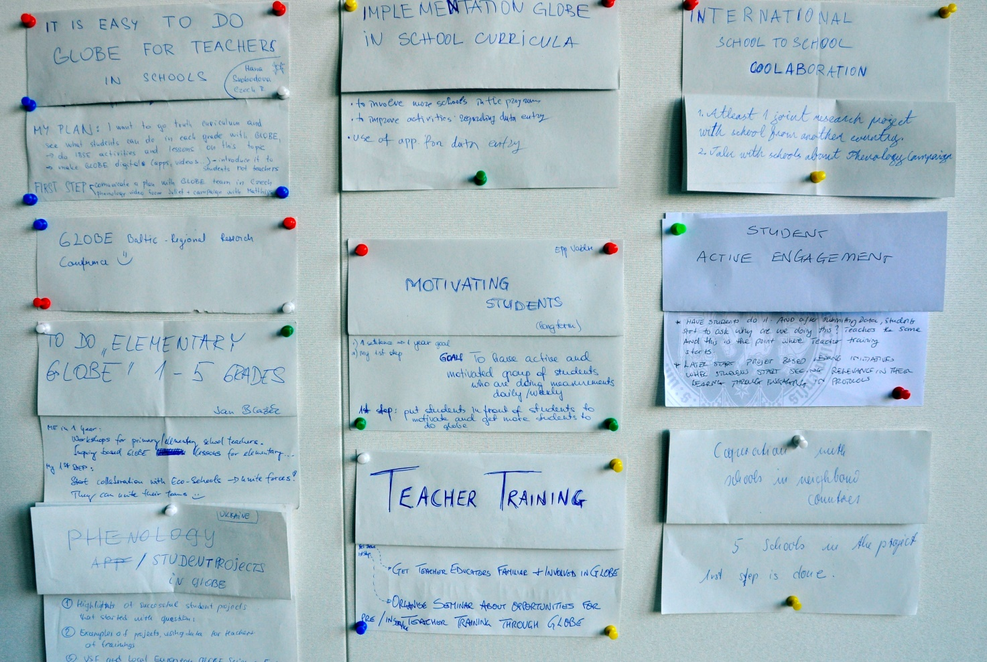

Outputs from discussion on the topic “International Collaboration”:
- Karl (Germany): pre-service teachers – exchange internship Europe wide – building platform
  - Aptitude
  - Erasmus +
- International collaboration between 2 or more schools
- Summer camp/online/virtual science fair
- Phenology campaign – discussion forum – Matthijs(Netherlands)
- Help teachers/students make good research (questions)
- Senior GLOBE Network – Magda (Poland), Diana (Croatia)

Umbrella on globe.gov – Bara (RCO)

Discussions on the topics “Citizen Science” and “Implementation GLOBE in School curricula” in 2 groups were opened by these presentations:
European Citizen Science Association – Juliette Vogel (Switzerland)
Examples of good practice from GLOBE countries – Katerina Nikolovska (Macedonia)
Both presentations and results of discussions are available here.

Outputs from discussion “Implementation of GLOBE in School curricula”:
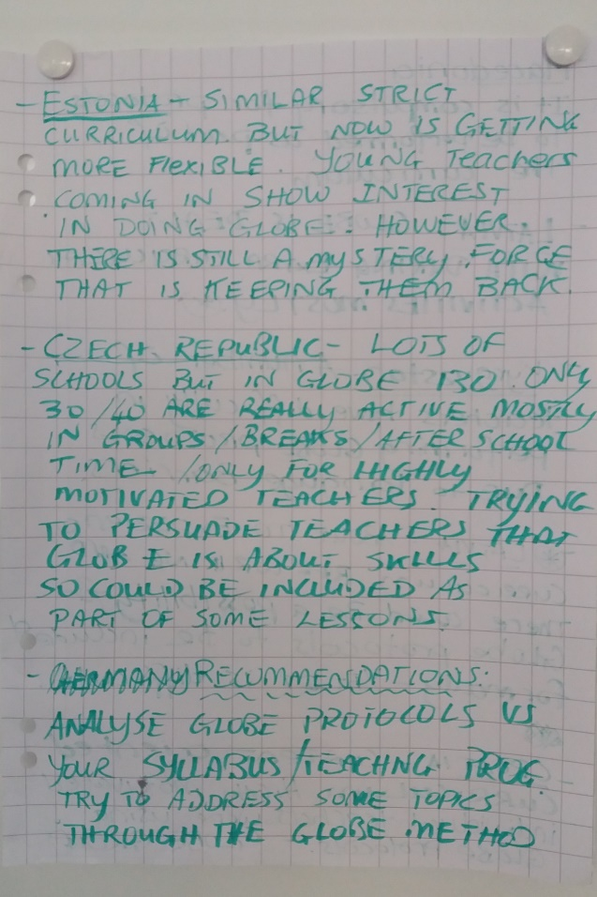
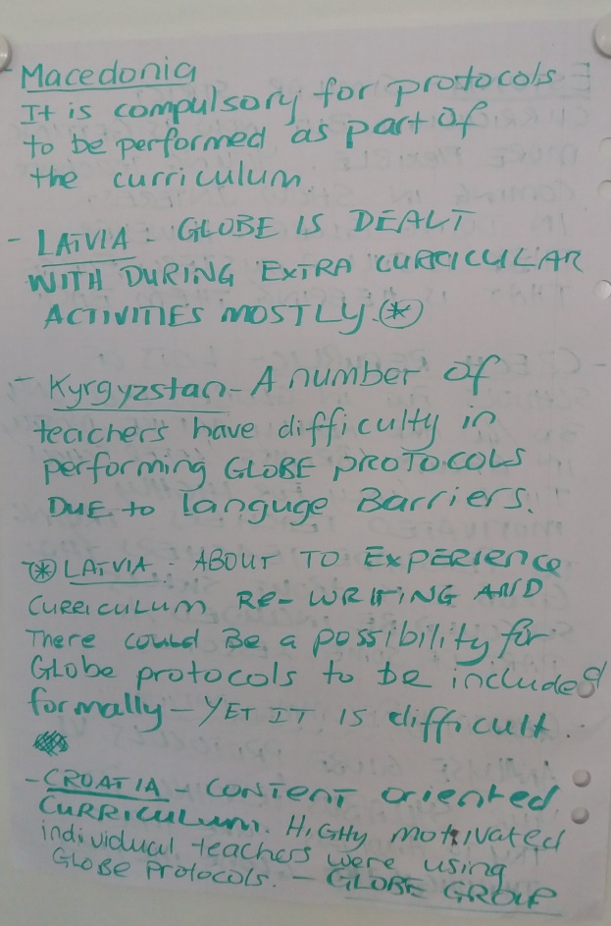

27th September- Tuesday - Country Coordinators + Teachers + Pre-service teachers
The election of members of the Board of GLOBE Europe and Eurasia – Country Coordinators
Costas Cartalis (GLOBE Greece) facilitated the election for the new Board.
Pre-Election Status: Five members concluded their mandate this year (Matthijs Begheyn, Magda Machinko-Nagrabecka, Juliette Vogel, Diana Garasic, Costas Cartalis) and one member had one more year on the Board (Natali Pustilnik), hence the election was carried out to elect five members.
There were 7 nominations: Farid Hamdan, Inese Krisjanis, Matthijs Begheyn, Magda Machinko-Nagrabecka, Juliette Vogel, Karl Schneider, Laura Altin
The election committee consisting of Costas Cartalis and Dana Votapkova counted the number of votes and announced the nominees along with the number of votes received by each one of them. The final results were as follows: Juliette 17, Matthijs 16, Laura 13, Karl 13, Magda 11
The new Board that came into effect from October 2016 consisted of the following:
Matthijs Begheyn (Netherlands), Juliette Vogel (Switzerland), Natali Pustilnik (Ukraine), Magda Machinko-Nagrabecka (Poland), Karl Schneider (Germany), Laura Altin (Estonia)

Regional Meeting 2017
Israel expressed a keen interest towards hosting the Regional Meeting in 2017 but the status has not been confirmed till date. So another host i.e Toulouse / France has been reserved as a backup in case of Israel’s inability to hold the meeting.
The next regional meeting will be held in November 2017. .
To hold the Regional Meeting in 2018, we have two interested candidates namely -Italy and Kazakhstan

Inquiry based approach and GLOBE related Research Projects at School
Presentations
Presentations of University Students from Germany
Presentations of GLOBE CCs
- Inquiry based approaches and GLOBE related research projects at schools and in teachers education - Diana Garasic (Croatia)
- Trainers and Mentors for Constructivism in Science Education - Jan Blazek (Czech Republic)
- Aerosols in Europe - Karl Torstein Hetland (Norway)
Go to presentations

Poster session and Idea Market
This was an opportunity to show examples of good practice and activities in GLOBE and a discussion was carried out on the same. There were two main topics:
Implementation of GLOBE in School curricula
Inquiry based approach and GLOBE related research project implemented at schools, and universities along with professional development of teachers

GLOBE Training on Inquiry Based Learning

How to make a real research project including collaboration with other GLOBE school – Matthijs Begheyn (Netherlands)
In this workshop we discussed how to make a good research question. A student from one country is paired with his colleague from another country to make a short research proposal for a research that could be executed. Participants were stimulated to bring this proposal into practice after the meeting. Country coordinators could also use it to help schools to set up a collaboration project.
Go to presentation

How to motivate students to ask questions and do research with use of GLOBE tools and instruments (IBSE lesson outdoors) – Hana Svobodova Jan Blazek (Czech Republic)
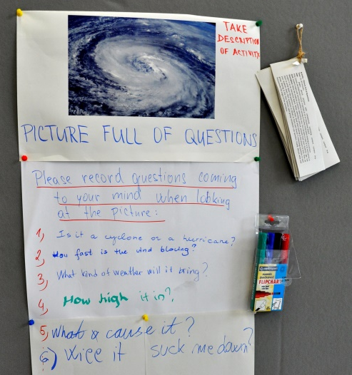

The lesson was developed with an objective of motivating students to do GLOBE. The participants’ came with their own research question, hypothesis and investigation plan based on the GLOBE tools shown at the beginning of the session. Trainers guided them through the steps of the research cycle, pointing out the do´s and don´ts and commenting IB learning process.
Go to presentation

Atmosphere and Climate – Karl Schneider (Germany), Costas Cartalis (Greece)
Participants formulated research questions related to climate characterization of a particular area (e.g. What is the relationship between air temperature and altitude? Does the annual temperature amplitude change with distance from water bodies or parks?). After a hypothesis was formulated, a suitable dataset was retrieved from the GLOBE database. We discussed simple graphical data analysis methods (based on recently published GLOBE Data Exploration classroom activities) as well as demonstrated the basic use of EXCEL worksheet, which featured basic statistics, graphs and histograms. Participants learnt the interpretation of extracted results when we linked them to daily life.
Go to presentation

Phenology – Traiming on Phenology campaign – Matthijs Begheyn, Arnold van Viet (Netherlands), Juliette Vogel (Switzerland)
The participants are first provided with an answer to the basic question by discussing -
Why was it so important to investigate phenology and what exactly scientists look for in phenology data? Participants learnt how to set up a good phenology research and also about the steps to follow to come up with research questions that are practically viable. They also tried out the new app developed for the Phenology Campaign to get familiar with the field guides for different species of trees.
Go to presentation

28th -30th September – GLOBE Training + Motivate and Attract Students to Science Conference
CC meeting continued over two and a half days of an educational conference namely Motivate and Attract Students to Science organized by the partners of MASS Project. The program included plenary sessions and trainings as well. More than 80 people joined the event.
Recordings and presentations are available at http://mass4education.eu/events/conference2016

GLOBE web training for CCs and GLOBE teachers – David Overoye (USA)
This training was for CCs and GLOBE teachers who have accessed the website and included the following :
- Scavenger Hunt: Where to find and how to use many of the tools listed on the website
- Using GLOBE's visualization and data retrieval tools (a practical example using data from the El Nino campaign)
- Setting up GLOBE Workshops
- and some more...
Go to presentation

Soils – Diana Garasic, Marina Barisic (Croatia)
During this workshop the link between moisture in soil and food you eat was explored For this purpose the soil moisture study was developed. in which knowledge was imparted on how to be part of the global soil moisture campaign – SMAP - and to generate ideas for other similar projects. In this activity the students experienced the incredible world of soil particles, their texture, size and other properties that influence soil moisture.
Go to presentation

El Nino Campaign – Claudia Caro (Peru), Magda Machinko-Nagrabecka (Poland)
El Niño Campaign was based on existing GLOBE Protocols. Participants learnt about the potential of integrating the investigations on atmosphere, soil and land cover. It was generally thought that EL Nino had no impact on a country so in that case the interrelationships between precipitation, surface temperature, air and soil temperature as well as land cover have been used to explain patterns and changes of climate in that particular region. It was also demonstrated how to share the Water Story through a Story map.
Go to presentation

