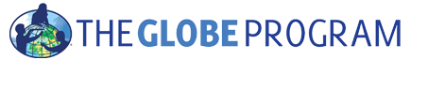

***INVITATION***

**2014 GLOBE Annual Meeting for Europe and Eurasia**

*29.4. – 4.5. 2014, Paralimni, Cyprus*

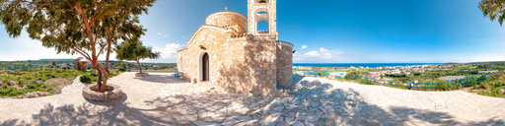

Dear GLOBE country coordinators, teachers, trainers and partners,

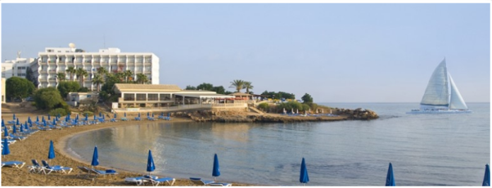We are very pleased to invite you to the 2014 GLOBE Annual Meeting for Europe and Eurasia.

The event will have two parts. Starting with the meeting of country coordinators on 29.4. – 2.5. 2014 and afterwards following with the training for teachers, country coordinators, and others on 3.5. – 4. 5. 2014.

The program and more info can be found on [www.globe-europe.org](http://www.globe-europe.org).

**Deadline for registration: March 15th**.

After the deadline subscription for the meeting is still possible, until March 30st, but though we can guaranty a room in the hotel and you cannot apply for funding.

We very much hope to see you in Paralimni, Cyprus!

***GLOBE Europe and Eurasia Board***

Karl Torstein Hetland - Norway

Magdalena Machinko-Nagrabecka – Poland

Danielle DeStaerke – France

Farid Hamdan – Israel

Kateryna Serednytska – Ukraine

Matthijs Begheyn – Netherlands

***GLOBE Europe and Eurasia Help Desk Office***

Dana Votapkova – Czech Republic

Bara Semerakova - Czech Republic

***GLOBE Program Office, USA***

Anthony Murphy

*The GLOBE Program Director*

***GLOBE Cyprus***

Fr Demetrios Mappouras1,2

Panayiota Neofytou1

Fr Anastasios Isaak1  
Mikis Hadjineofytou1

***“God created the earth, but the Dutch created the Netherlands”***

Half of the Netherlands would be under water without the man made dikes, dams and delta works.

Andreas Hadjichambis1,2,3

1 Cyprus Ministry of Education and Culture

2 Cyprus Biological society

3 CYCERE

