ANNUAL REPORT
GLOBE Argentina
2020 – 2021

TABLE OF CONTENTS
INTRODUCTION 3
EDUCATION 4
SCIENCE 6
COMMUNITY 8
APENDIX 9

INTRODUCTION
During the October 2020/2021 period, all activity was carried out virtually, because of the quarantine that we had to comply with, because of the COVID 19 pandemic.
Despite this, the Operational Technical Team that carries out the GLOBE Program in Argentina was able to verify the growing interest that GLOBE arouses among Government Institutions linked to Education, such as Ministries and Provincial Directorates of Education, among other actors.
This led to the Virtual GLOBE Trainer of Trainer Workshops being held, initially, in the Atmosphere and Biosphere Research Areas (Spheres), without ruling out the Hydrosphere and Pedosphere, which we will surely address in the next period.
Although this National Coordination placed emphasis on the training of new teachers, it did not neglect the organization of other activities as detailed later in this template.
The reasons mentioned above led us to recognize the advantages of virtual activity, since distances do not exist and anyone interested can participate in any activity that is called, which is very important so that more schools in this vast country have the possibility to have the GLOBE Program in their classrooms.
This does not mean that in the hopefully near future we will not restart our face-to-face activities, which are also very important for closer contact with our Community.
Needless to say, we feel satisfied with what has been done and the results obtained.
Marta Kingsland – National Coordinator
María Marta G. de Daneri – Alternate Coordinator
Graciela Martínez – Operational Secretary
Operational Technical Team
GLOBE Program Argentina

EDUCATION
2020
September / October | Virtual Workshop: "Atmosphere Research Area"
October 29 | Live talk: “GLOBE: Citizen Science and Solar Eclipse”, by Marta Kingsland, Ana Prieto and Mariana Savino, organized by Astronomy enthusiasts – Bariloche
November | Launch of the “Camera Obscura” Contest, on the occasion of the Solar Eclipse that would soon take place on December 14
November 26 | In relation to the Solar Eclipse and the making of the Camera Obscura, 1ra. Online talk: "Scientists for a day" by Marta Kingsland and Claudia Romagnolli.
December 3 | In relation to the Solar Eclipse, 2nd Online Talk: "Let's do science together" by Ana Prieto and Kristen Weaver
December 10 | In relation to the Solar Eclipse, 3rd Online Talk: "Solar Eruptions, the largest explosions in the Solar System", by Dr. Silvina Guidoni
December 14 | Date on which the Solar Eclipse took place. On this date, the Observations and Measurements were made with the support of the GLOBE Observer App with the participation of GLOBE students and teachers.

2021
March 10 | Informative webinar for teachers who want to learn about the GLOBE PROGRAM
March / May | Virtual Workshop Biosphere Research Area with synchronous meetings.
April 7 | Webinar for teachers on: Butterflies and environmental variables
April | On the occasion of World Earth Day, the GLOBE Community of Teachers and Students was invited to send an allusive photo
June | Working Meeting with Zonal Coordinators to program future activities
August | Work Meeting with Zonal Coordinators to specify actions to follow to carry out a contest on mosquitoes
September 29 | Webinar: “Informative talk about Mosquitoes” and the launch of the “Alert Mosquitoes” Poster Contest for high school students in the Argentine Republic, organized together with the Space Camp Program of the US Embassy in Argentina
September/October | Virtual Workshop Atmosphere Research Area, with Synchronous meetings

Comment: As usual, activities organized by the GIO and/or the Regional Office-LAC have been announced and/or invited, such as: “International Virtual Science Symposium 2021”, “GLOBE Annual Meeting 2021”, “Butterfly Observation Campaign and environmental variables”, “Informative Talk on Trainer and Mentor Trainer Certification”, as well as the “I Latin American Congress of Citizen Science”, organized by the Academic Department of Exact, Physical and Natural Sciences of the National University of La Rioja - Argentina. The GLOBE Program - Regional Office for Latin America and the Caribbean National University of Comahue - Argentina. La Molina National Agrarian University - Peru. University of the Americas – Chile that included a day dedicated to GLOBE and NASA. During this day dedicated to GLOBE, it had the participation of the National Coordinator of Argentina, who reported on the GLOBE Program in the country.

SCIENCE
In the context of a collaborative work between the Coordination of Argentina, Peru and Uruguay, a cycle of activities related to the theme "Butterflies and Environmental Variables" was carried out, according to the following detail:
- Participation of Argentina in virtual talks on the subject, for students and teachers.
- Workshop on butterflies, on the Educantel virtual platform (Uruguay). Marta Kingsland tutor of the course.
- Launch of the first and second observation campaign.
- Presentation of the Project at the Annual GLOBE Meeting (July 2021)
With the aim of bringing students closer to doing science, they were invited to participate in the following contests, which were organized together with the Space Camp Program of the US Embassy in Buenos Aires, who provided the prizes for the winners of each contest.
Camera Obscure
In order to observe the Total Solar Eclipse of December 14, 2020 with the greatest safety, students from Argentine schools were invited to make a model of the Camera Obscura.
Twenty-eight photographs of camera obscure models were received and three of them were selected as the best. The first prize was a Telescope for the school and for the three students whose cameras were selected, an Astronomy Course for each one.
Mosquito alert
In relation to the Mosquito Alert Contest, high school students from Argentine schools were invited to participate by sending Posters with an awareness message to the community about the danger of the diseases they could transmit.
Since the call was aimed at all students in general, one of the objectives of this contest was to publicize the GLOBE Program and the GLOBE Observer App.
On this occasion, the Space Camp Program of the US Embassy in Buenos Aires gave the winners the corresponding prizes: first Prize: one Drone and second Prize Headphones with speaker and for the schools whose students were awarded, laboratory. The winners were selected among the 25 posters received.

IVSS
As usual, schools in our country participated in the IVSS with the following projects:
- The changes that the seasons produce in trees and bushes of Pujato -Argentina Escuela Particular Incorporada N°1345 Nuestra Señora del Carmen
- Effect of total sun eclipse on meteorology and cosmic ray flow Science Club Huechulafquen (After School), Science Club Huechulafquen (After School)
- "Acebal, the Moon and the Sun" School No. 74 "María Saa Pereyra"
- Changes in light intensity and air temperature during a total solar eclipse (December 14, 2020) EPET N°

COMMUNITY
We understand the importance of maintaining a fluid exchange between our GLOBE Communities
- The social networks Facebook and Instagram are tools through which we inform the community of teachers, students and followers of the GLOBE Argentina Program about the activities and calls that are carried out.
- E-mail is also a means that the GLOBE Argentina Program uses for reciprocal contact with its community.
- For the October 2021-2022 period, we will continue with our projects related to:
- Encourage participation in the presentation of papers at the IVSS
- Deepen the relationship of the SDGs with the GLOBE Program
- Make known topics related to the GLOBE Program and its implementation in the school
- Promote collaborative work
- Work together with the Zonal Coordinators in the promotion of the GLOBE Program in Argentina through various activities

APENDIX
Images related to the mentioned contests and winning projects of Dark Camera
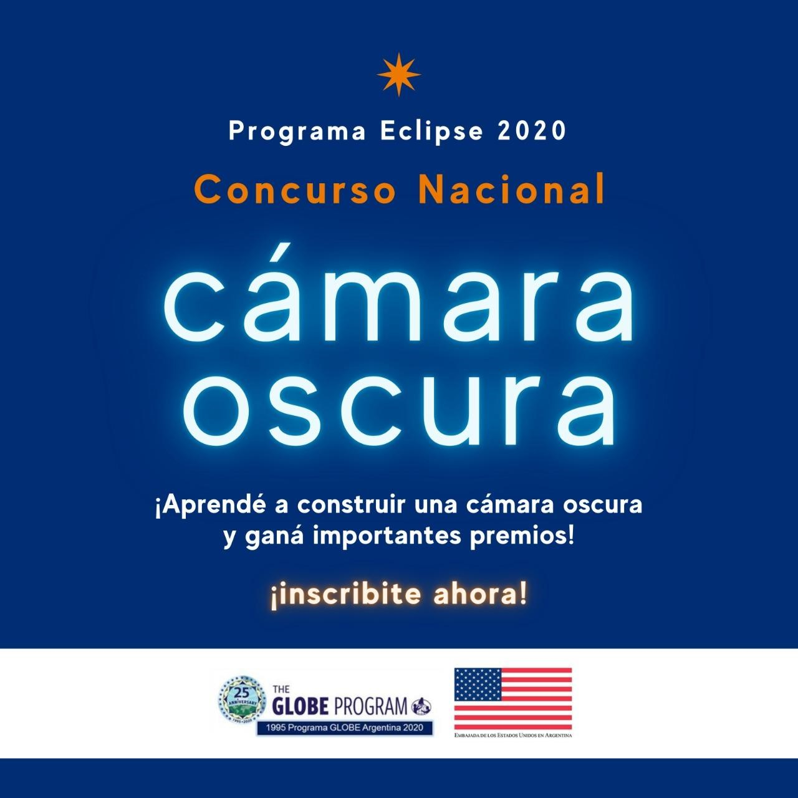
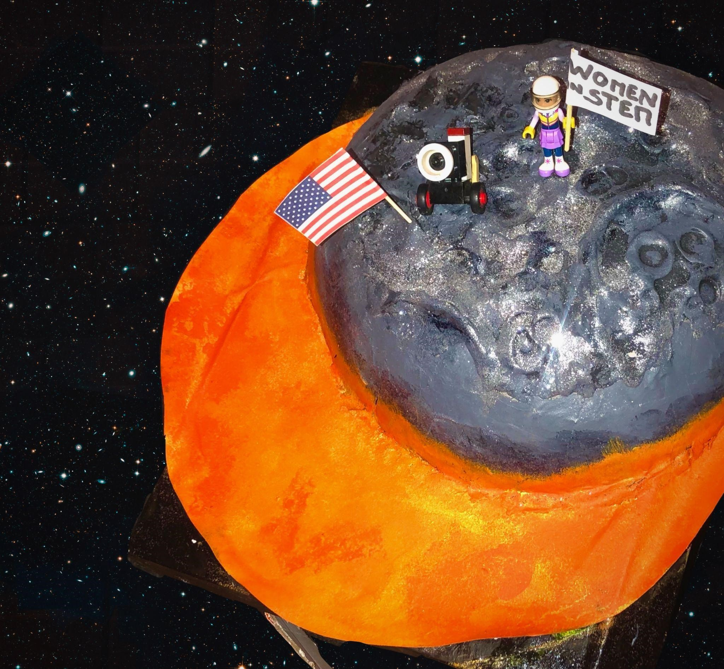
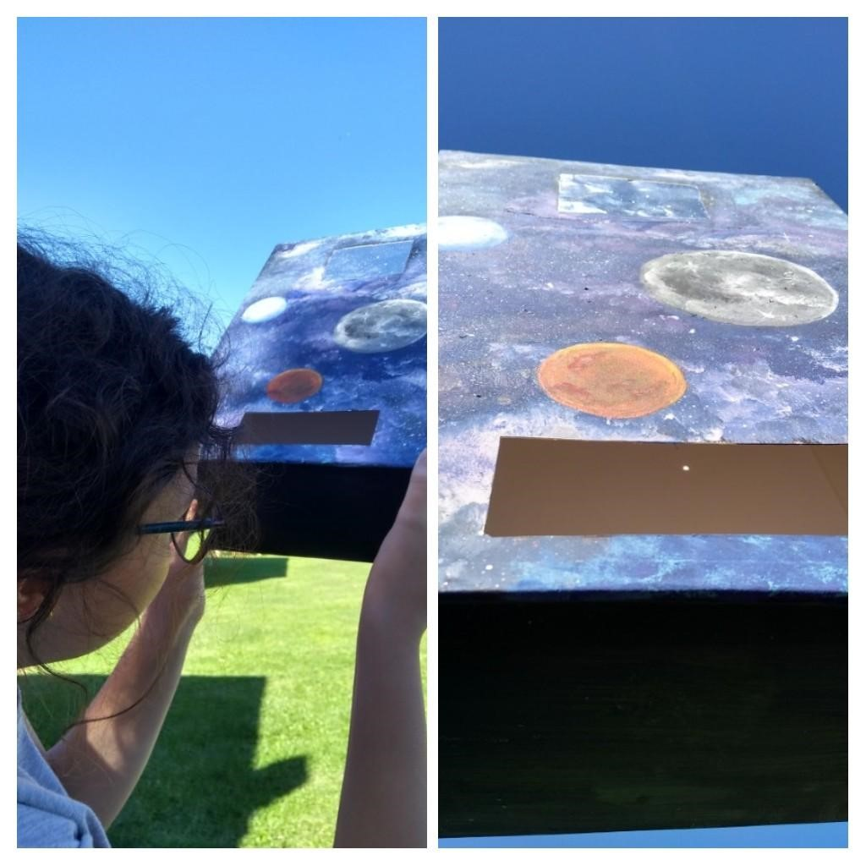
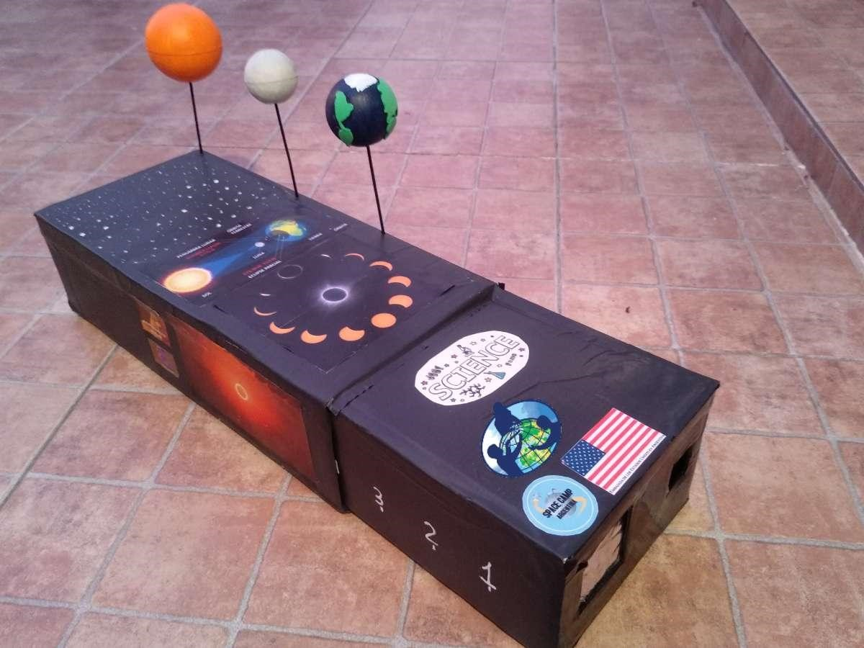

Mosquito Alert
