ANNUAL REPORT

GLOBE Colombia
2020 - 2021

TABLE OF CONTENTS
INTRODUCTION 3
EDUCATION 4
SCIENCE 6
COMMUNITY 7
APENDIX 8

INTRODUCTION
The Ministry of Science, Technology and Innovation (MINCIENCIAS) is the coordinating entity for Colombia of the Global Program for Learning and Observations for the Benefit of the Environment (GLOBE), an international science and education program that offers students and the world public the opportunity to participate in the collection of atmospheric data and the scientific process of analysis of these, in order to contribute to the understanding of the Earth as a system.
In light of its vision, GLOBE becomes a valuable tool for MINCIENCIAS, which, through the Ondas program, promotes in boys, girls and young people an interest in research and the development of attitudes and skills that allow them to actively insert themselves in a culture of science, technology and innovation.
To date, the GLOBE Colombia community has more than 407 members
The activities developed to achieve the objectives are the following:

EDUCATION
With the aim of increasing the availability of children, adolescents and teachers trained in scientific protocols and learning activities within the framework of the GLOBE program in Colombia that allows supporting the processes of scientific vocation and technology in children and adolescents, the following workshops were held:
Mosquito Habitat Mapper Workshop – Bolívar
Thanks to the alliance with the Technological University of Bolívar and the Autonomous Corporation of the Canal del Dique, on September 9, 2021, the training workshop on the Mosquito Habitat Mapper protocol in the hydrosphere research area was held virtually with the participation of 19 teachers and pedagogical advisors from the Ondas program.
The workshop was led by trainer Dhay Potes who offered a wide variety of topics that allow attendees to understand the Earth as a system and interpret various phenomena based on data collection.

INTERNATIONAL VIRTUAL SCIENCE SYMPOSIUM - IVSS
The International Virtual Science Symposium (IVSS) is a way for elementary and high school students from all GLOBE countries to display their research and work. With GLOBE, students learn the practices of science through hands-on investigations in their own communities, sparking their curiosity and interest in science. This often leads to research that helps solve real-world problems and a greater understanding of our global environment.
In 2020, Colombia participated with three projects, below, we present the recognitions obtained in the last IVSS:
City | School | Project
Barranquilla | Semillero de Investigación en Ciencias Espaciales, S.I.C. E | Thermal effect of trees on the surfaces of parks in the south of the metropolitan area of Barranquilla.
Bogotá | Rochester School | Collecting Data About Atmosphere and Hydrosphere at School
Cartagena | School Montessori of Cartagena | Heat islands and urban birds: Lácides and Román parks, Manga neighborhood, Cartagena.

Two stars: Heat Islands and urban birds: Lácides and Román parks, Manga neighborhood, Cartagena.
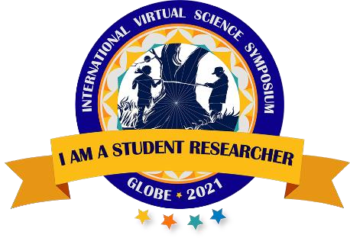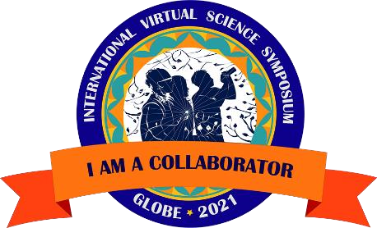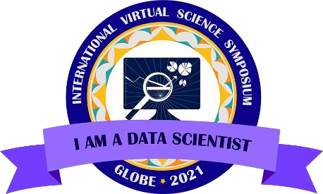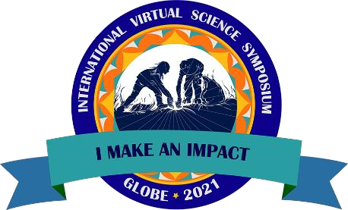
Two stars: Thermal effect of trees on the surfaces of parks in the south of the metropolitan area of Barranquilla.
One star: Collecting Data about Atmosphere and Hydrosphere at School
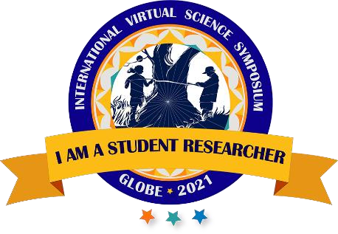

SCIENCE
At the close of this report, the number of GLOBE data loads for Colombia in the GLOBE database for science and research corresponds to 5,809 observations in total.
In the period from 2020 to 2021, a total number of 1,759 observations were reported.
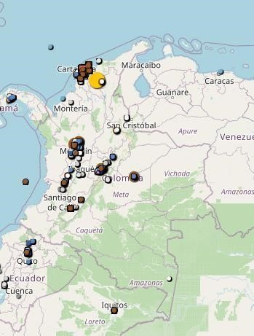
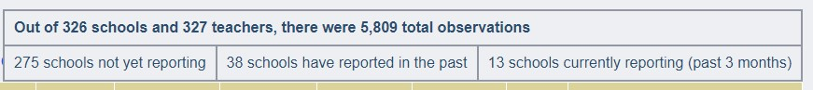

COMMUNITY
HIGH-LEVEL DIALOGUES
As of 2019, the GLOBE Colombia Program was included in the agenda of the High-Level Dialogue between Colombia and the United States (DAN), which is the most important political relationship mechanism between both countries and the highest instance at the political level to the diversification of the bilateral agenda and allows addressing issues of mutual interest through dialogue and cooperation; as well as strengthening the relationship in the face of challenges and new national, regional and global realities.
In this framework, for 2021 - 2022, the development of a virtual exchange program between schools/institutions/groups GLOBE USA with schools in Colombia is proposed as part of the commitments of the Education, Culture and Sports table of the DAN. who implement the program and work around the Zika, Dengue and Chicunguña education and prevention project.

APENDIX

CARLOS DANIEL ACUÑA CALDERA
Country Coordinator
https://www.globe.gov/es/web/colombia
globe@minciencias.gov.co

