ANNUAL REPORT

TABLE OF CONTENTS
INTRODUCTION 3
EDUCATION 4
SCIENCE 5
COMMUNITY 6
APENDIX 7

INTRODUCTION
Below we summarize the main GLOBE activities carried out by the GLOBE Uruguay Coordination between October 2020 and the end of October of 2021.
This year, despite having a month and a half of virtuality, the educational centers had a "relatively" normal activity, but the first semester they had to dedicate all the classes and times to catch up with the curricular contents and deficiencies and irregularities of the past anus.
We noticed in the case of Uruguay that many teachers, who were eager to carry out activities outside the classroom (outdoors), which made it possible to avoid confinement during the four hours of class and therefore a possible contagion of COVID. It also allowed the children to socialize with their peers and with external visits to the school staff that will provide them with new topics and activities in the field. For this reason, several of them required the accompaniment of GLOBE, for which a series of visits to these centers had to be planned in order to provide them with materials and technical support for the implementation of GLOBE activities and measurements. Thus, with the help of the LAC Regional Office, a very positive cycle of visits was organized in terms of results and acceptance by the directors of the institutes, the teachers themselves, and the students.
On the other hand, we continue to prioritize the development of online modules in Spanish in Uruguay and planning the launch of the Pedosphere module to implement as soon as possible.

EDUCATION
March-April-May-June-July 2021: GIO invited the national coordinator of Uruguay to participate in the organizing committee of the virtual XXVI Annual GLOBE Meeting. This consisted of several virtual meetings in which tasks and responsibilities of the participants were defined.
May 2021: Coordination meetings, definition of content, roles and responsibilities for the course "Citizen Science and Butterfly Monitoring". Preparation of exercises, specific presentations for the topic apart from the modules, definition of start dates, deliveries and completion of the course, evaluations for the platform, certificates, presentation videos, search of bibliographic sources and apps for the identification of species and measurement of atmospheric variables.
June 11 to July 14, 2021: First GLOBE online course "Citizen Science and Butterfly Monitoring" on the Educantel platform, with a view to implementing the butterfly observation campaign. Tutors: Lic. Andrea Ventoso, Dr. Biol. Claudia Caro (La Molina University, Lima, Peru), Prof. Marta Kingsland (Argentina GLOBE Program Coordinator), Mtro. Dir. Darío Greni (GLOBE coach from Uruguay).
Teacher training for the observation of butterflies and their relationship with atmospheric variables and land cover. The course was structured in the following modules: Introduction to GLOBE, Introduction to Atmosphere, Air Temperature, Relative Humidity, Surface Temperature, Clouds, Wind, Land Cover, and Butterfly Observation.
Each module is made up of the thematic module presentation, complementary material such as fact sheets, protocol and field guide, some learning activity, video and module evaluation. The Clouds module consisted of a final exercise that had to be done through GLOBE Observer and submit the verification email from NASA. Once the complete module is finished, the participants are asked to make a group presentation with four slides of what their butterfly project would be. These 10-minute presentations were held virtually on July 20 and 21, and the tutors provided feedback to each group.
40 primary and secondary school teachers from Argentina, Colombia, Ecuador, Paraguay, Peru and Uruguay completed the full course, with the expectation that they would be part of the observation campaign to be carried out between September and November 2021.
Approved: 15 Argentines, 3 Colombians, 3 Ecuadorians, 2 Paraguayans, 4 Peruvians, and 13 Uruguayans.
August-September – Planning is formulated for a cycle of visits to various schools and high schools that so requested, to initiate them in GLOBE activities in the field in educational centers and strengthen others that have already begun and required face-to-face support. The topics to be developed previously were coordinated, as well as the theme of the butterfly observation campaign and the practice of the protocols of air temperature, relative humidity, cloud classification and coverage, surface temperature, wind; as well as others that were of particular interest to some educational centers (hydrosphere and soils). The materials, field sheets, data sheets and protocols corresponding to each outing, supporting graphic material, instruments and bibliographic material were prepared for each of the centers.
We resorted to GLOBE funds through the Regional Office for the transfer to the centers (some 480 and 600 km from Montevideo), the purchase of some instruments and the Identification Guide for Butterflies of Uruguay, Argentina, Brazil and Paraguay to distribute to schools with a view to developing the work. Gabriela Bentancur Viglione, advisory entomologist of the butterfly project in Uruguay, prepared this guide.
All workshops, attended by at least two teachers were recorded on the GLOBE website, as a "mini-workshop", detailing in each case which protocols and research areas were covered, the coordinator as trainer and which teachers they intervened. References to workshops created on the website: 152101, 152302, 152401, 152701, 152801, and 153002.
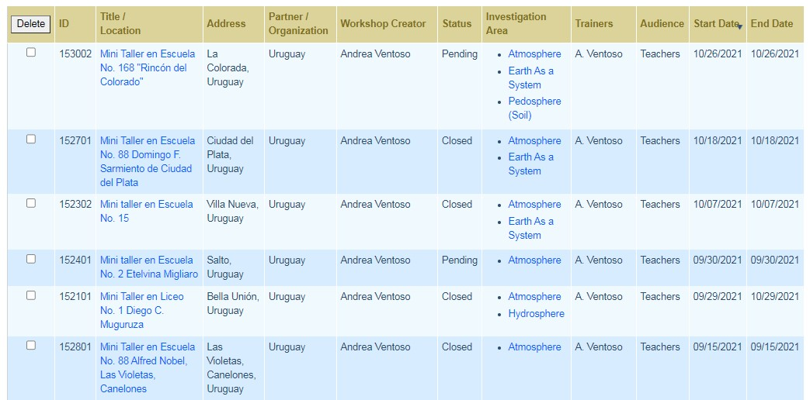

IN FIGURES:
209 students reached
11 trained teachers, of which 7 were already certified GLOBE teachers and 4 are new, to which are added 3 teacher interns.
7 educational centers in the interior of the country (1 in the department of Artigas, 1 in Salto, 1 in Soriano, 3 in Canelones and 1 in San José). These are three urban and four rural institutions.
Final report and photos presented independently to the Regional Office.

September 1 – November 30: Dissemination and start-up of the Campaign for sighting, observation, photography and recording of measurements of atmospheric variables, promoted together with Argentina and Peru aimed at a possible collaborative work on the subject, in the framework of the international collaborative project led by M. Kingsland, C. Caro, D. Greni and A. Ventoso.
September – Application of the Coordinator to be considered for the position of Mentor Trainer, following the call of the GIO to those Master Trainers who wish to reconvert to Mentor Trainers.
October 14 to November 25, 2021 – Completed the advanced edition of the online course Learning to see Butterflies and caterpillars of Uruguay, by the Master in Entomology Gabriela Viglione, Permanent Education course of the Faculty of Sciences. On this occasion, a field trip will be made for recognition as the closure of the course and its approval. The teacher Darío Greni is also taking it.
October 2021 - Faced with a new call from GLOBE to be part of the Working Groups, from the Coordination of Uruguay, the Teacher and Head teacher Darío Greni (GLOBE trainer) for the position in the GLOBE Education Group, as a member of the region for the period 2022-2025.
October 14 - November 25: Attending the "Uruguayan Butterflies Update and Deepening Course", virtual edition, given by Dr. Gabriela Bentancur-Viglione, which forms the continuation of the course we attended last year of initiation to the topic. Teacher Darío Greni is also taking the course. It will consist of a field trip at the end of the course for the recognition of species in situ.

SCIENCE
March 2021 – Participation of the Teacher and Head teacher Darío Greni at the IVSS with two science projects carried out jointly by 5th grade students and 6th elementary years: one on environmental variables and animal behavior during the 2019 eclipse and the other on butterfly sightings related to environmental variables.
March 29, 2021- GIO Webinar for those who have registered as judges for the GLOBE Virtual Science Symposium on guidelines for the correction of projects and their grading.
March 30 to April 6, 2021 – Participation of the Coordinator as a judge for this year's GLOBE Virtual Science Symposium, evaluating five projects by students of diverse backgrounds and ages. In addition, Teacher Darío Greni participated as a judge for the Symposium in this instance for the first time.
April 23: On the occasion of the celebration of Earth Day, Gabriela Bentancur-Viglione dictated a webinar for the LAC region in May 2021: "Do we see fewer Butterflies? Global change and crisis of pollinators". The Regional Office organized this and coordinators and teachers from various countries participated. This presentation was also used for the course "Citizen Science and Butterfly Monitoring" as reference material.
Throughout the year – The scientific advisor of the Mariposas a la Carta project, Master in Entomology Gabriela Viglione, has been advising teachers and students in Uruguay who require it through virtual talks or identification of butterfly specimens.
An example of this was a talk held in March of this year for school no. 88 of Canelones where they also explained to Gabriela her progress from last year and presented her project to the IVSS. Another of the presentations was August for the teachers Shirley Simoncelli and her 6th grade students, Alejandra Monfort and her fifth graders, Natalia Peraza and Silvana López for their 1st high school students, and for the teachers Valeria Soria and Laura Grzeszczyk. The contents in both cases dealt with the biology of the butterfly, its ecology, how to observe them, its importance as pollinators, caterpillar breeding, and identification of main families. The boys intervened asking questions and commenting on images presented by the biologist, and they were very motivated to continue observing, recording and investigating.
July 12-16, 2021- XXVI Virtual GLOBE Annual Meeting. Participation of the GLOBE Coordination and the trainer Darío Greni in the event, thanks to the financing of the registration by the LAC Regional Office.
Exhibition of the Coordinator of a poster about the eclipse of December 2019 during the meeting. Presentation of the butterfly project in one of the spaces.
Presentation in Spanish of the 6th grade students. Darío Greni's primary year, with his research on the eclipse, invited by the GIO for obtaining four stars in the IVSS.

Technology
May-June: Application to the GRANTS of the Embassy of the United States in Uruguay, which are granted for activities to promote science, women, and sustainable development to non-profit organizations and NGOs that request it for implement training, purchase of materials or instruments, workshops, etc. In the case of the Ministry, it is requested for the purchase of new instruments, materials for workshops and use in schools since many were lost, and others have deteriorated with constant use. It is also needed for the purchase of prizes that will be awarded in the photography and drawing contest to the participants of the butterfly observation campaign in December. It is still in progress, it has taken several months and we would be apparently receiving it in the month of November.

COMMUNITY
April 7 – Webinar “Butterflies and environmental variables” held for the region and organized by the LAC Regional Office, presentation by the butterfly project team (C. Caro, M. Kingsland, D. Greni and A. Ventoso), with the participation of the 5th and 6th grade students of School No. 88, recounting their experience working with butterflies and the project presented to the IVSS.
August 2 – LAC regional planning meeting for future activities in the region.
September 9 – Virtual Meeting with Schools no. 15 from Mercedes, Teacher Shirley Simoncelli and students and Colegio La Amistad, Teacher Carolina Báez and students (from Paraguay), who are carrying out a collaborative butterfly project.
October 28 – 2nd. Virtual meeting with School no. 15 and Colegio La Amistad to show progress of the work.
Attendance at various webinars held by the Regional Office throughout the year, of interest to the coordination and teachers.

COMMUNICATION
March 4, 2021: Participation in a webinar organized by the Regional Office with the National Coordinators to update the status of the countries regarding the pandemic and the virtual/face-to-face conditions in educational centers and the possibilities of implementing activities with them for the year.
March 22, 2021: GLOBE Uruguay article was written for the GLOBE Yearbook, at the request of the GIO and the LAC Regional Office. Photos of the activities were also incorporated and sent to the Regional Office for consideration for the Yearbook.
Thursday, April 1, 2021: The Coordinator of GLOBE Uruguay and the Head teacher Darío Greni were invited to participate in the live television program "La Mañana en Casa", which is broadcast on channel 10 Saeta. In the article, Darío spoke about his experience with his students in Detroit, United States, after winning the regional award in 2019 to present his macroinvertebrate project at the GLOBE Annual Meeting. He also talked about the years of working with GLOBE in the rural school to get to that moment and how they continue to work with this methodology year after year in the school. In the case of the Coordinator, Andrea Ventoso, referred to the GLOBE program, who and how it is developed in Uruguay, to whom it is directed, the areas of scientific research that it deals with and the main activities that it implements in the country, as well as the project aforementioned student.
May 12, 2021: students of the Macrocientis Club (Belén Viera, Mariano Aguiar and Nicolás Verde), accompanied by their science teacher and mentor, Darío Greni, were recognized by the Education and Culture Commission of the House of Representatives for their President Alfredo Fratti and the entire commission. They also did so at the Ministry of Tourism, where Vice Minister Remo Monzeglio received them. These recognitions went to the trajectory in the science club with its project on macroinvertebrates in the Canelón Chico stream and for its presentation at the GLOBE Annual Meeting in Detroit in July 2019 representing Uruguay the LAC region (winning project). They made a brief presentation of their work and were presented with words from the President of the Commission and with certificates and personal gifts. The event took place in May 2021, long after the trip, given the year and a half of pandemic that we faced and that face-to-face meetings were totally suspended.
Head teacher Darío Greni has given about 10 interviews and notes for different press media in the country and his department (Canelones) in the last year, always recounting his experience within the framework of the GLOBE Program, and the work carried out since 2014 when He learned about the program at the first workshop he attended. The diffusion that he makes of the program in this way is of fundamental importance to spread the enthusiasm to other teachers to join the program.
August-September 2021: Reformulation of the existing Agreement between the ministry and the ANEP (National Administration of Public Education) in which only primary education was contemplated, to adapt it to the new situation and needs. This took place in August-September 2021; he would be ready to sign in November. The new agreement contemplates the new Ministry of the Environment and the signing with the CODICEN (Central Directive Council), extending the agreement to secondary and technical education. There is also a need to draft a specific agreement for the GLOBE Program under the umbrella of that aforementioned macro agreement. This will be addressed once the aforementioned agreement has been signed.
October 6, 2021: The newspaper El País, one of the main press media in our country (with a history dating back to 1918) issued a note on the GLOBE Program, written by the well-known environmental journalist Hernán Sorhuet. In it he highlights how the program works in Uruguay, the coordination in the Ministry of the Environment (formerly the Ministry of Housing, Territorial Planning and the Environment), the methodology in science and education of the program aimed at caring for the environment, among other topics. The Coordination provided the corresponding information for the writing of the note.
A GLOBE STAR Story is in the process of being prepared to be sent to the LAC Office of Communications and to GLOBE Communications later for publication on the cycle of visits to GLOBE schools carried out between the end of August and the end of October of this year.

GOALS FOR NEXT YEAR
- Hold two virtual meetings with teachers to delve into data entry on the web.
- Next month we will be launching the Drawing and Photography Contest on butterflies, within the framework of the butterfly and atmospheric variables observation campaign. The verdict will be issued on December 15 along with the award to the students.
- Launch of the Pedosphere course on the Educantel platform, before the end of the year, for teachers in Uruguay.
- Continue training teachers from Uruguay and other Spanish-speaking countries in the region with the GLOBE online modules in Spanish, facilitating workshops for national coordinators and master trainers and providing tutoring for them.
- Encourage teachers to submit projects again to the GLOBE Virtual Science Symposium in the period January-March 2022.
- Coordination of joint projects in the region with priority issues of common interest.
- Continuous support to GLOBE teachers for the proposal of new projects, loan of instruments.
- Continue the plan of visits to educational centers that we resumed this year after the pandemic, for advice and support of GLOBE activities. In this case, we will prioritize colleges and schools in Montevideo that were not taken into account in this first round.

APENDIX
Article on the GLOBE Program in the newspaper "El País" by journalist Hernán Sorhuet (October 6, 2021).
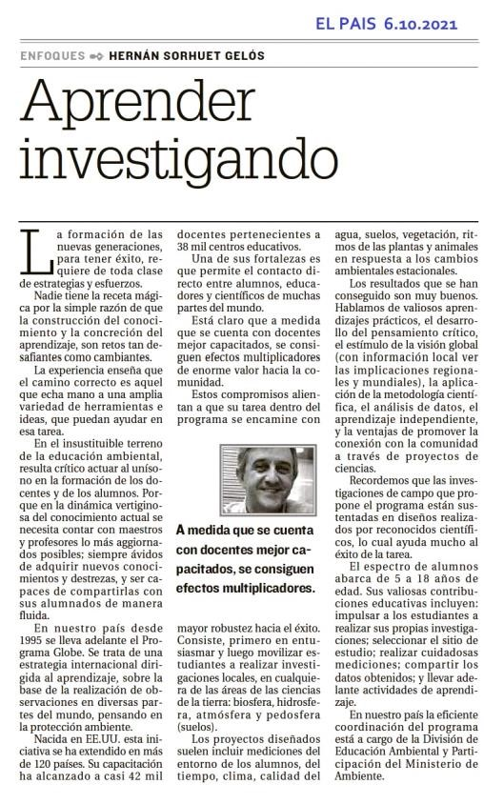
Channel 10, program "Morning at home". Journalistic program from 10:30 a.m. to 12:30 p.m. Interview with the Program Coordinator, Andrea Ventoso, and teacher Darío Greni about the GLOBE Program
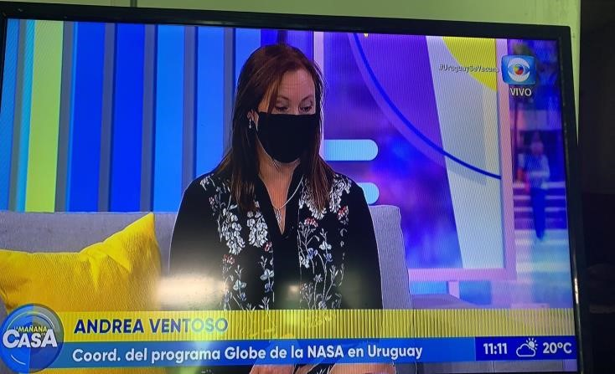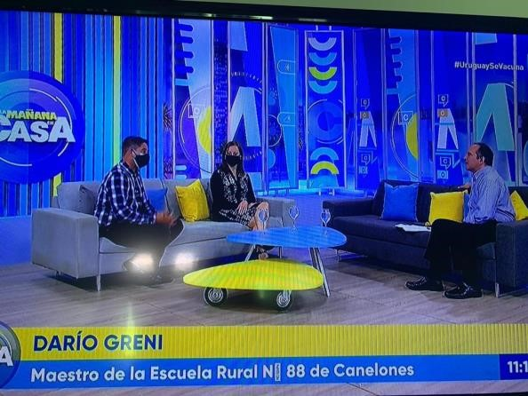

Recognition in the Senate Commission to the students who went to Detroit, United States, to represent Uruguay and the LAC region with their project on macroinvertebrates, accompanied by their teacher and mentor, Darío Greni. School 88 Alfred Nobel of Canelones.
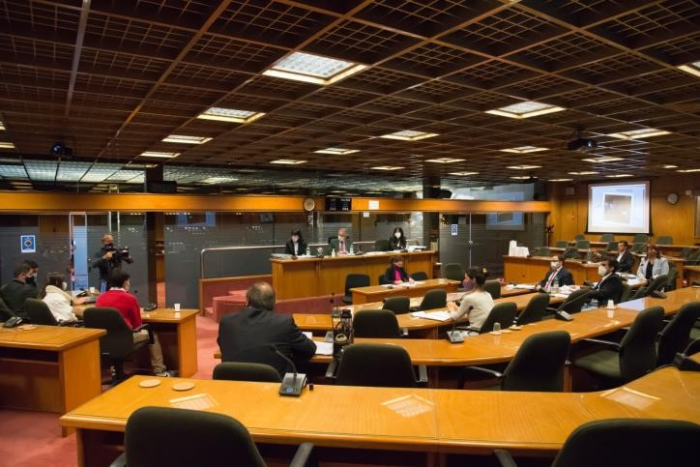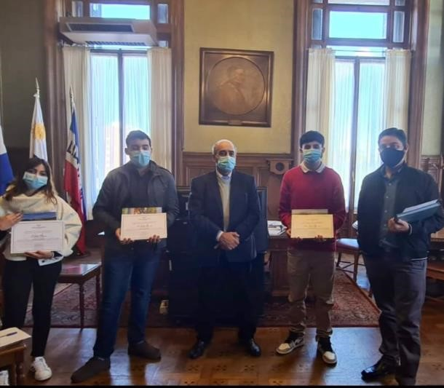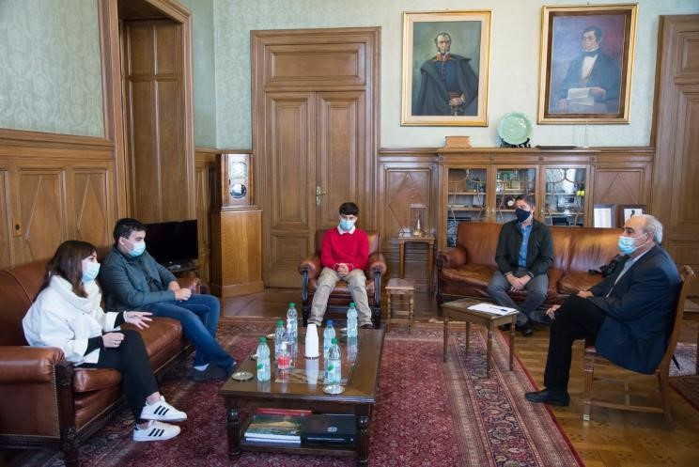

Cycle of visits to work on GLOBE protocols with schools and high schools, August 29 to October 26.
School No. 2 of Salto, children of 5th. Surface temperature protocol
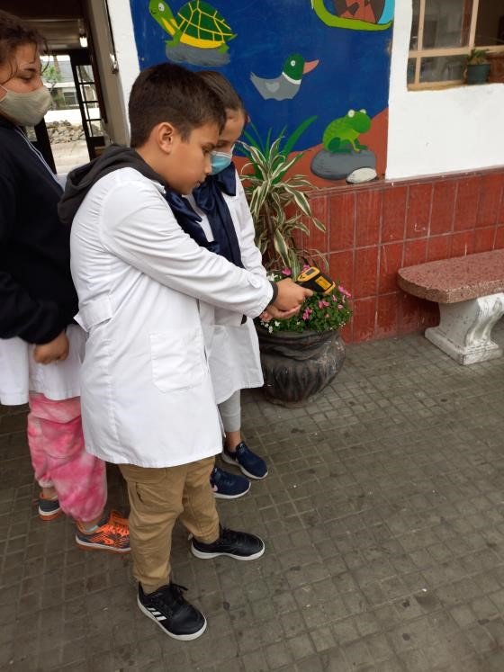
Lyceum No. 1 of Bella Union, Artigas. Second year students. Cloud cover calculation-learning activity.
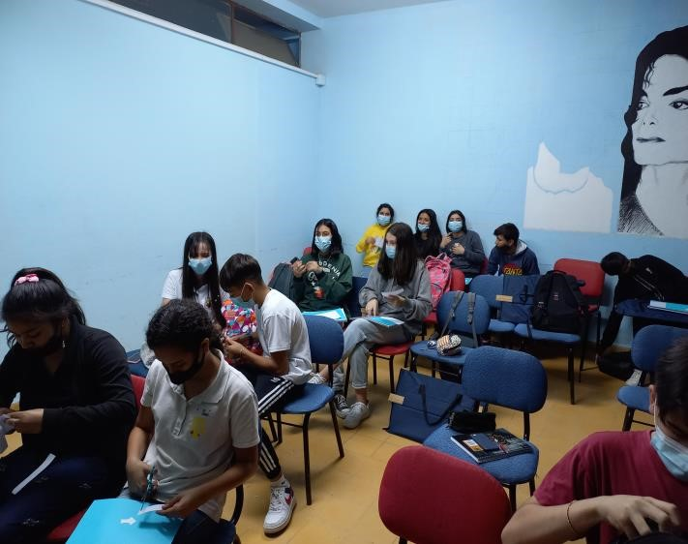
School No. 46 of Mercedes, Soriano. Children of sixth year with Coord. Andrea Windy. Surface temperature protocol
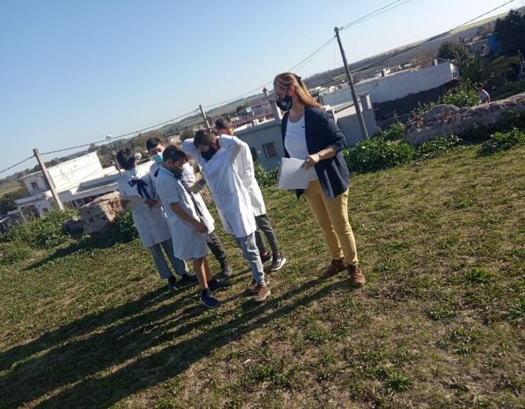
School No. 15 of Villa Nueva, Canelones, students of 6th year. Temperature protocol
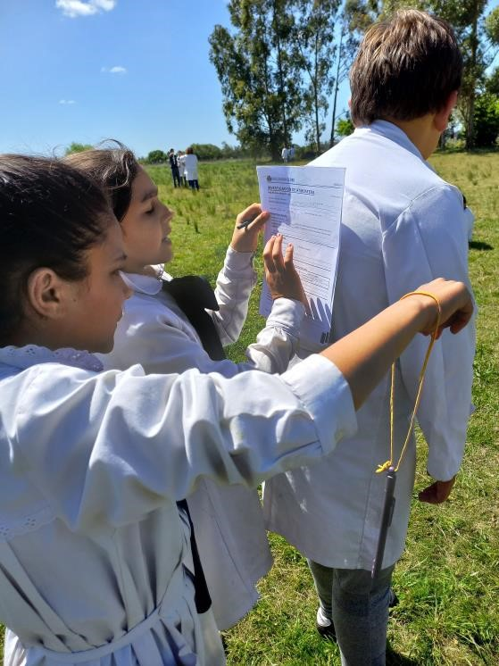
School No. 168 of Rincón Del Colorado, Canelones. Children of fifth and 6th years carrying out a learning activity on the pH of substances and soil
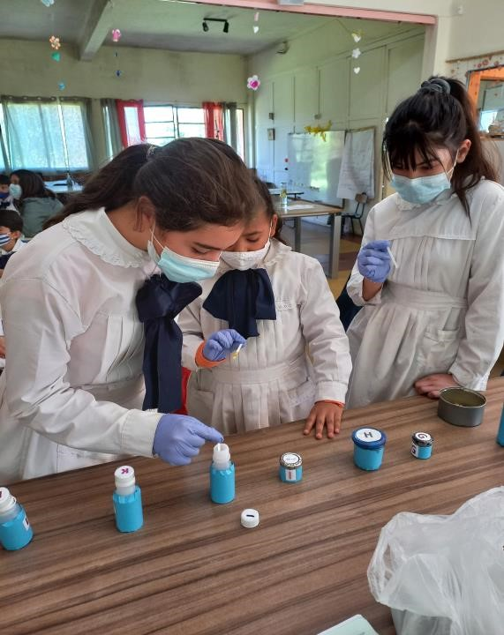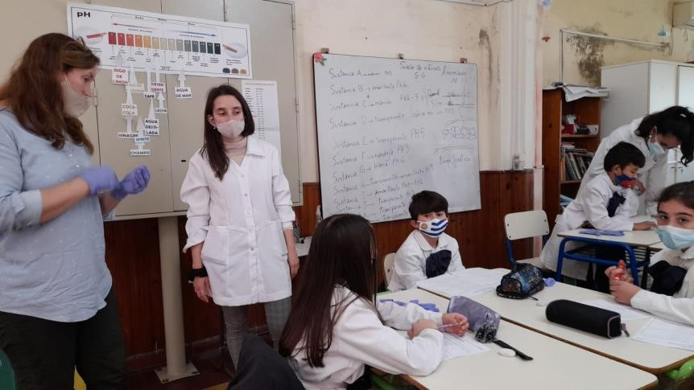
School No. 88 of Ciudad del Plata, San José. Children of 5th year. Thermometer calibration activity and cloud theme
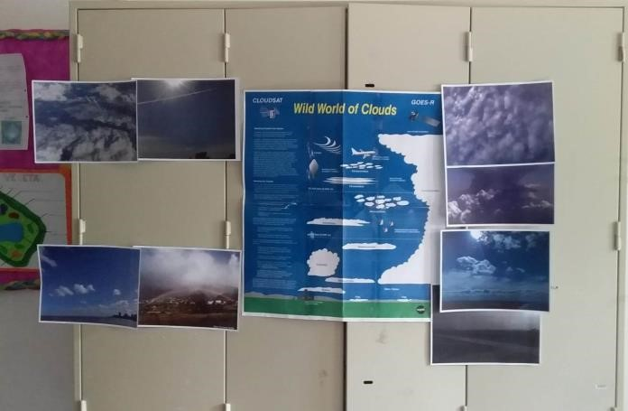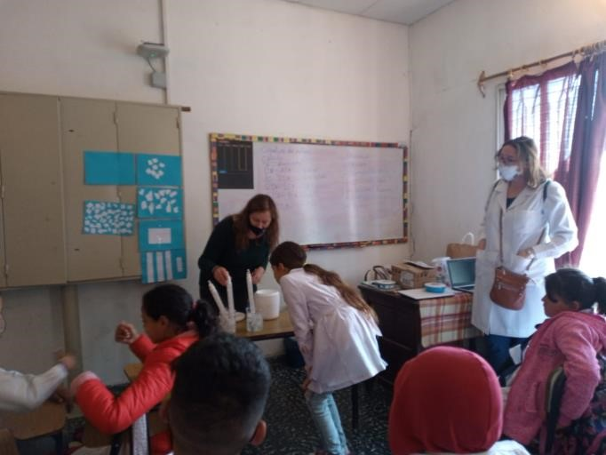

School No. 88 of Las Violetas, Canelones. Children of 5th and 6th year. Measurements and data sheet filling, cloud identification, planting flowers to attract butterflies
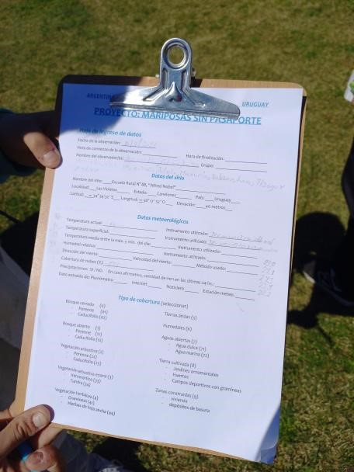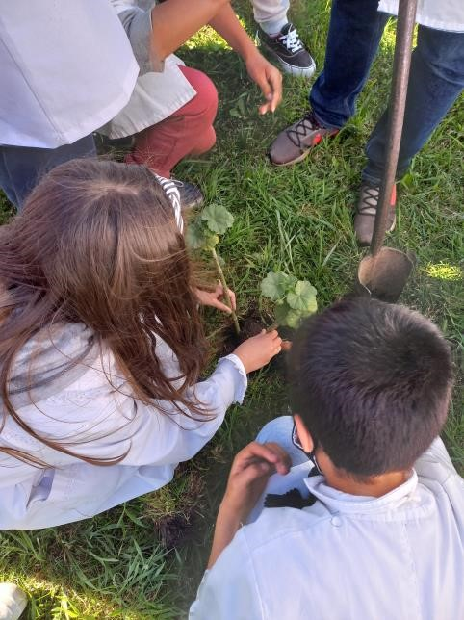
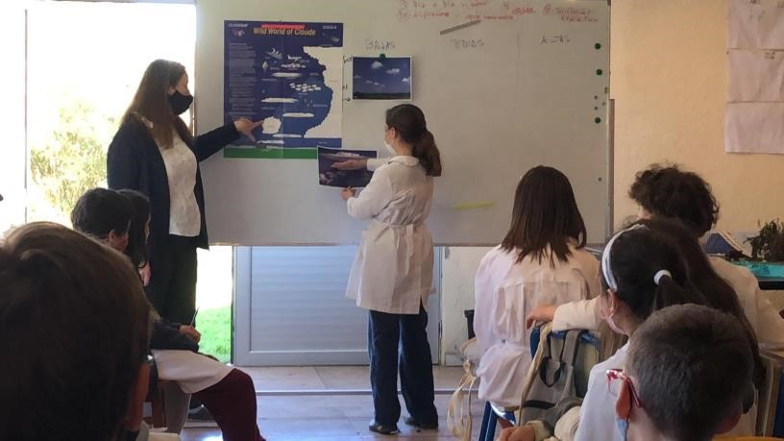
Online teacher presentations as a final requirement for the “Citizen Science and Butterfly Monitoring” course. July 2021
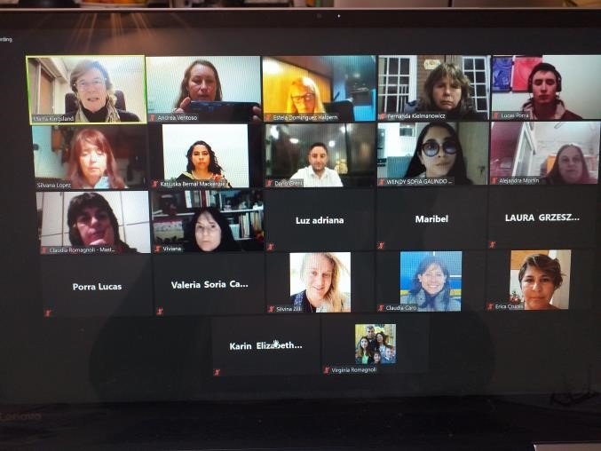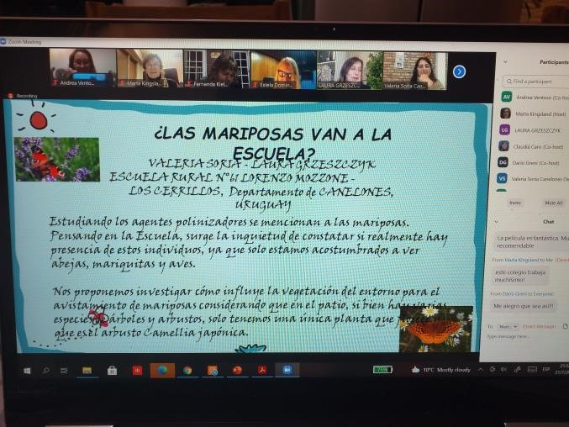

STAFF
GLOBE Uruguay Coordinator:
Lic. Andrea Ventoso
Atmosphere Master Trainer
Hydrosphere Trainer
Ministry of Environment
Mail: andrea.ventoso@ambiente.gub.uy
Telephone: 2917.07.10 ext. 4654

Honorary Staff:
Alternate GLOBE Coordinator:
Prof. Dir. Patricia Piriz
Hydrosphere Master Trainer - Biosphere Master Trainer
Mail: patywuan@gmail.com

Prof. Chem. Alejandra Gualco
Hydrosphere Assistant Trainer
Mail: prof.alejandragualco@gmail.com

Master Dir. Dario Greni
Hydrosphere and Atmosphere Trainer
Mail: dariovgreni@gmail.com

Bachelor of Biol. Elena Rodó
Water Quality Division Ministry of Environment

