ANNUAL REPORT

GLOBE Argentina
2019 - 2020

TABLE OF CONTENTS
INTRODUCTION 3
EDUCATION 4
SCIENCE 5
TECHNOLOGY 6
COMMUNITY 7
COMMUNICATION 8
APENDIX 9
STAFF 13

INTRODUCTION
This report details the activities organized by the GLOBE Program in Argentina, in charge of its Technical Operational Team, with the support of Zonal Coordination in different parts of the country, which collaborate in the dissemination of the Program and whose activity is reflected throughout this document.
We are proud to highlight that the GLOBE Program in Argentina celebrated its 25th Anniversary in June 2020 and that its activity has been carried out uninterruptedly to this day. Our thanks go to all the teachers and students who left their mark and made it possible that today GLOBE Argentina has a database of 532,290 measurements, 323 schools and 452 GLOBE teachers, and to this is added the 7,754 students, including GLOBE alumni and that are in activity.
Likewise, we cannot fail to mention the 1,447 scientific citizens, a number that is surely already out of date, given the interest it arouses in the community, the possibility – practically anonymously – of collaborating with its records. We know that the measurements of GLOBE student and citizen scientists from around the world are very valuable to NASA researchers, and it is gratifying to know that Argentina collaborates with this valuable information.
The present period of activities has a special characteristic, due to the COVID 19 Pandemic; we were forced to carry out practically half of it virtually.
Despite this, all those activities that were scheduled were continued and we are encouraged to say that, in this framework and thanks to the tools that we all have to get closer to each other remotely, the contact was very satisfactory. . Although, of course, we regret not being able to meet in person, we trust that in the near future, we will resume that contact.
As usual, part of these activities were aimed at disseminating the GLOBE Program in different areas of the educational field and in this sense, it is important to highlight the collaboration of the Embassy of the USA, which generated fruitful approaches with Ministries of Education of different Provinces, whose Authorities found in the GLOBE Program, a different approach to bring teaching to the classroom.
Despite the current circumstances, we are satisfied with the response of the teachers who joined the Program, through the workshops and virtual talks that we carried out and have detailed below.

EDUCATION
- 10/22/2019 - Face-to-face Workshop: Atmosphere and Earth Protocols as
System, by the Master Trainers Marta Kingsland and María Marta G. de Daneri, at the Tomás Godoy Cruz Institute of Higher Studies in the Province of Mendoza
- 10/23/2019 - Face-to-face workshop: GLOBE-ZIKA LTM, by the Masters
Trainers Marta Kingsland and Maria Marta G. de Daneri, at the Institute of Higher Studies Tomás Godoy Cruz in the Province of Mendoza
- 03/14/2020 - Face-to-face workshop: Eclipse 2020, by the Master Trainer
Ana Prieto and the participation of the GLOBE LAC Regional Office, in the María Auxiliadora Institute in the town of Junín de los Andes, Province of Neuquén.
- 03/18/2020 - 04/27/2020 - Virtual Workshop: Atmosphere Protocols. This workshop was held in collaboration with the GLOBE Uruguay Program led by Andrea Ventoso, national coordinator. 28 trained teachers accredited
- 07/01/2020 - 08/11/2020 - Virtual Workshop: Atmosphere Research Area, Cloud Protocol and GLOBE Observer, especially aimed at teachers of the Province of Misiones. 13 trained teachers accredited
- 09/05/2020 - 10/03/2020 - Virtual workshop organized by the Master Trainer Claudia Romagnoli, Atmosphere Research Area, and cloud protocol. 23 trained teachers accredited
- 09/28/2020-11/01/2020 - Virtual Workshop: Atmosphere Protocols, GLOBE Observer and Data Visualization System (ongoing)
- July 2020 -Talk by Marta Kingsland in the cycle of webinars organized by the Regional Office for Latin America and the Caribbean, on The GLOBE program applied to the classroom / The GLOBE program applied to the classroom
- Translation of research areas corresponding to the materials produced by the GLOBE Program for virtual workshops (e-Training).
- Development of informative educational material complementary to the Atmosphere research area and respective protocols.

SCIENCE
- Research papers presented by students from different schools and science clubs that are members of the GLOBE Argentina Program at IVSS 2020:

- MACROINVERTEBRATES AS BIOINDICATORS OF ORGANIC POLLUTION IN THE CHIMEHUIN RIVER, JUNIN DE LOS ANDES
- What is dengue? What mosquito produces it? “Total solar eclipse and its influence on environmental conditions”
- INFLUENCE OF TREES ON THE TEMPERATURE OF THE SOIL. JUNIN DE LOS ANDES, NEUQUEN. SPRING-SUMMER 2019-2020.
- Larval habitat characterization of Culex mosquitoes in parallel puddles along the Chimehuín River
- TECNABOT Technology, Nature and Robotics: a study of my place…
- We have a great task: research, education and prevention
- The Yin and Yang of the Mosquito
- Influence of aerosols on the color of the sky and visibility in Junín de los Andes
- Influence of clouds on air temperature in Junín de los Andes - Mosquito Alert!
- UNDER THE AUTUMN SKY
- The behavior of pigeons during the Solar Eclipse 2019

- Collaborative project on Butterflies with the participation of Peru, Uruguay and Argentina (in progress)

TECHNOLOGY
- Because of the COVID 19 Pandemic, face-to-face activities had to be suspended and due to commitments made, the Virtual Learning Platform based on Moodle was developed in order to implement Virtual Workshops. Therefore, we started with our own virtual platform. The workshops are complemented with activities applied to working from the protocols developed with the support of webinars.
- Video support conferences on the teaching material aimed at the participants of the virtual workshops.
- Webinars organized in conjunction with the GLOBE-LAC Regional Office and the National Coordination of Chile, in relation to the Total Solar Eclipse that will take place on December 14, in part of Latin America, with total shadow in part of Chile and Argentina.
- From October 5 to 9, 2020 Informative talk “What do we see when we see a solar eclipse?”
- Participation in the week of the ECO SEMANA Virtual Huergo, convened by the Luis A. Huergo Institute

COMMUNITY
- Participation of GLOBE Argentina, in the translation from English to Spanish of the material on the GLOBE Observer App in collaboration with Kristen Waever and Claudia Caro.
- As a member of the Education Working Group, Marta Kingsland participated in the presentation of the Trainer and Mentor Trainer certification process, for the representatives of the regional offices and the CCs of the LAC, Europe and Eurasia and Africa regions.
- Webinars organized in conjunction with the GLOBE-LAC Regional Office and the National Coordination of Chile, in relation to the Total Solar Eclipse that will take place on December 14, in part of Latin America, with total shadow in part of Chile and Argentina.
- Work meetings with representatives of the Ministries of Education of the Provinces of Misiones and Chaco, interested in implementing the GLOBE Program in the curriculum of a certain number of schools, as a pilot test to later advance with the rest of the schools.
- The participation of Marta Kingsland in the Education Working Group, representing the Latin American and Caribbean region during the period 2019-2021, who is its chair. One of the most important activities of the last period was working on the Certification Process for Trainers and Mentor Trainers.
- Ana Prieto's participation in the Technology Working Group, representing the Latin American and Caribbean region for the 2018-2020 period.
- Participation in webinars scheduled from the USA, on topics related to Mosquito and Hydrosphere in order to transmit the knowledge acquired to the community.
- Participation in Astronomy Bariloche, live talk "GLOBE: CITIZEN SCIENCE AND ECLIPSE 2020" through the YouTube channel.

COMMUNICATION
- Through the social networks Facebook and Instagram, the community of teachers, students and followers of the GLOBE Argentina Program is kept informed of the activities and calls that are carried out.
- Through email and WhatsApp, the GLOBE Argentina Program keeps in touch with its community.

Activities scheduled for the period October 2020-September 2021
- Encourage participation in the presentation of papers at the IVSS
- Deepen the relationship of the SDGs with the GLOBE Program
- Through online chats, publicize topics related to the GLOBE Program and its implementation in the school
- Promote collaborative work
- Work together with the Zonal Coordinators in the promotion of the GLOBE program in Argentina through various activities
- Continue with the Virtual Workshops from the Program Platform Argentina
- Schedule campaigns related to protocols following the suggestion of the GLOBE Program
- Maintain the development of joint actions with the Embassy of the United States

APENDIX
Images of various activities carried out by Master Trainers, teachers and students of the GLOBE Argentina Program:
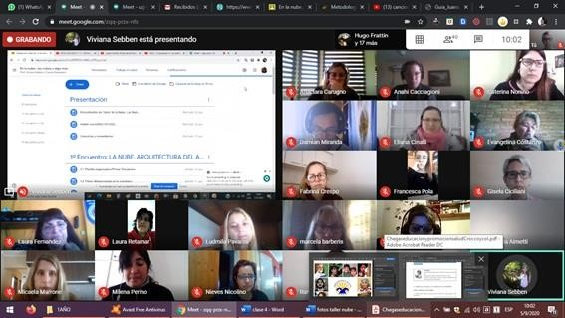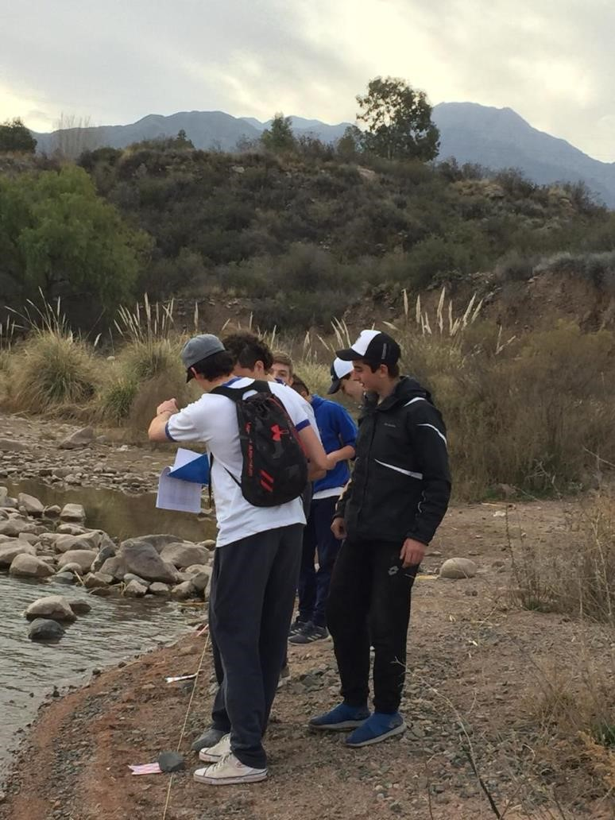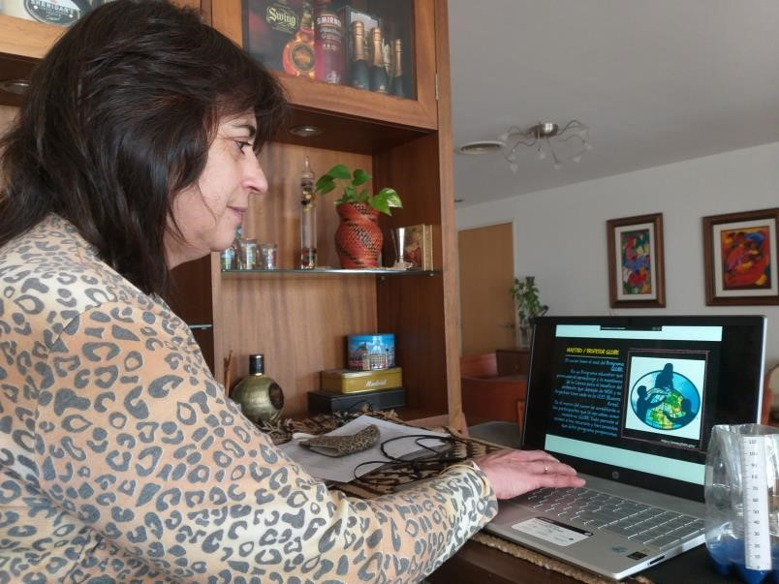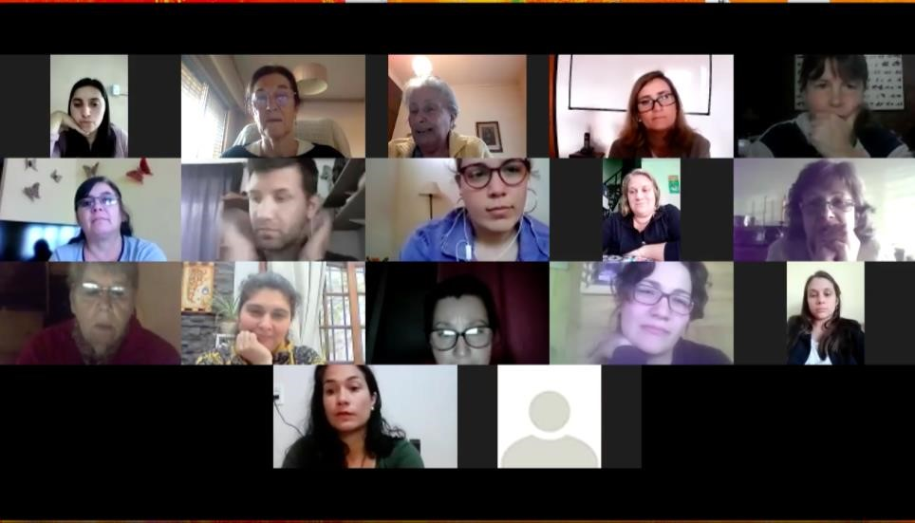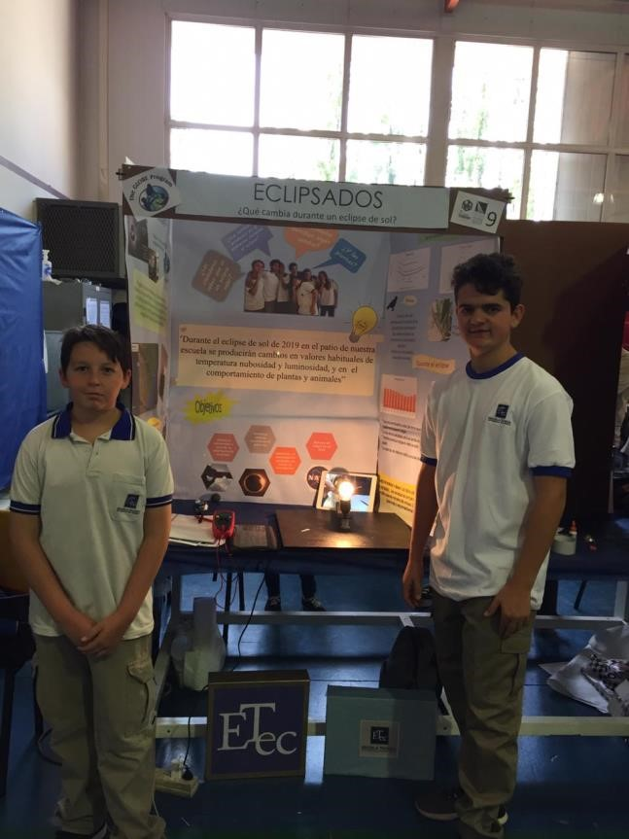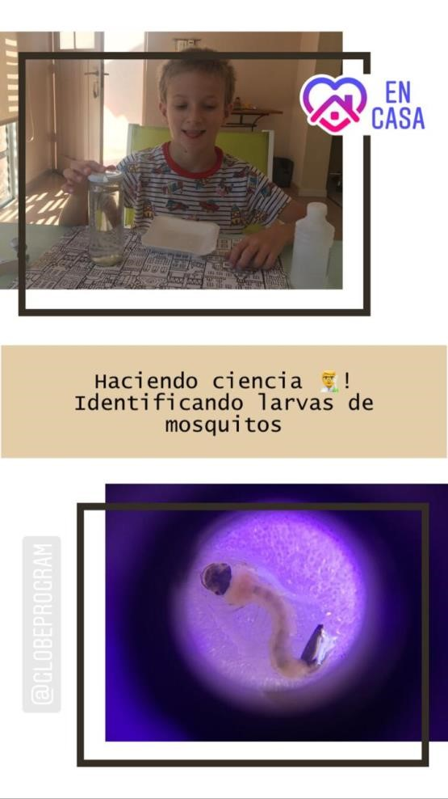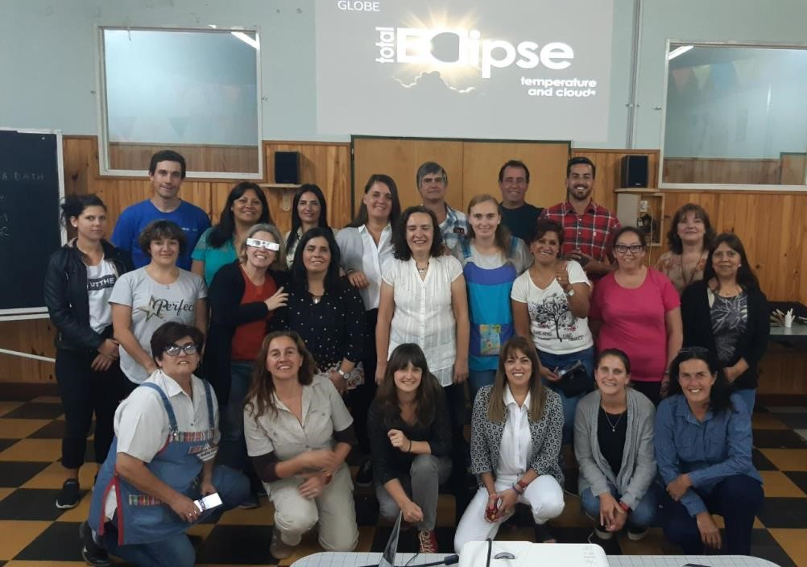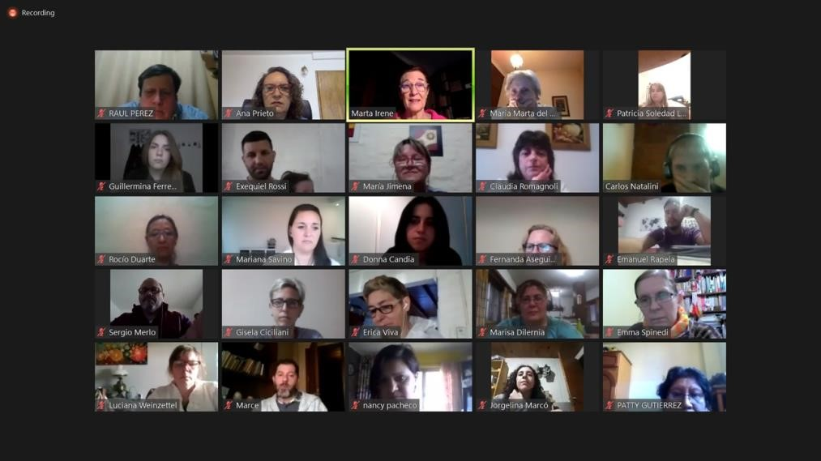

STAFF
Martha I. Kingsland
National Coordinator
Maria Marta G. de Daneri
Alternate National Coordinator
Graciela M. Martínez Operational Secretary
This National Coordination has the support of the following Coordinators
Zonal:
Autonomous City of Buenos Aires - Marisa Dilernia 9

Province of Buenos Aires - Oscar Busch

Province of Cordoba - Adriana Mistó

Province of Neuquén - Ana Prieto

Province of Santa Fe - Claudia Romagnoli

