ANNUAL REPORT

GLOBE Chile
2019 - 2020

TABLE OF CONTENTS
INTRODUCTION 3
EDUCATION 4
SCIENCE 7
TECHNOLOGY 8
COMMUNITY 9
COMMUNICATIONS 10
APENDIX 11
STAFF 15

INTRODUCTION
The GLOBE PROGRAM in Chile has been significantly affected by the political externalities and social unrest that have occurred in the country since October 2019 and consequently with the health emergency caused by the coronavirus contagion pandemic, which is currently in an endemic phase in our country, which will not have a solution until a massive vaccination can be produced. However, the reformulation of the processes and attempts to reactivate the schools that have participated at some time have continued, seeking the incorporation of new schools and organizations with educational purposes.
The process described above is based on a paradigmatic vision of sustainability and an action based on the Development of Environmentalization processes in the organizations in which it operates. To do this, there is a strict subscription to the GLOBE strategic plan, based on our academic affiliations, which we recognize as one of our strengths.
The following considerations remain:
• Prioritize participation in teacher training centers (Universities), especially initial training (considering its multiplying power in the construction of learning and the possibilities of linking students with the human environment), over training and services for individual teachers. of Schools, without excluding this last modality.
• Prioritize initial actions in schools that have expressed interest in the program and the ability to finance its inputs until a critical mass of resources is formed to implement the program in interested schools without financing capacity.
• Establish a pedagogical dynamic that privileges accompaniment (coaching), over intensive training workshops (not excluding the latter). In addition, seek the inclusion of the GLOBE protocols in the study curricula by inserting them in the framework of curricular environmentalization processes and proposals in the form of collaborative work and S.T.E.A.M.-type projects. Additionally, define a monitoring system through action research methodology.
• Establish an autonomous presence of the GLOBE Program independent of the institutions that have been linked so far, such as the Ministry of Education. For this purpose, cooperation agreements are being established with educational institutions and there is an NGO in formation. For the purposes of expeditiously and efficiently managing the logistics, function of the GLOBE application in the country.

EDUCATION
- Activities in execution.
  - Action in Higher Education.
Higher education actions focus on three universities that are the University of the Americas (UDLA), the Metropolitan University of Education Sciences (UMCE) and the University Of Chile (UCH): lately the Aipep Professional Institute has been integrated with whom we have an active agreement. We have participated in the processes of accreditation of careers as a collaborating entity and their students continue to participate in the local GLOBE actions.
    - University of the Americas (UDLA).
- The University maintains its support for the program with the participation of students in activities and provision of facilities. It works to form a stable group of students and teachers for GLOBE topics, whose focus is in the logic of linking with the environment (academic line) and research and development of environmentalization.
- In the School of Basic Pedagogy, the inclusion of elements of GLOBE protocols in practical activities has been practiced for years. They are considered an active part of environmentalization actions, together with the development of STEAM-type projects considered in the training process that include the use of protocols.

    - Metropolitan University of Education Sciences (UMCE):
- There is a working group with which we have given some training, there is a station that takes meteorology data and a virtual classroom available for GLOBE teachers who wish to register (it is conceived as a repository of materials and instruction platform). Additionally, we try to advance the protocols to build instruments. After last year's contingency, work in Entomology Areas is expanding, where work actions are structured in hydrology protocols, specifically with bentonic macroinvetebrates, (M, I, B,)

    - University of Chile.
- There are actions to support activities in the protocols of Atmosphere and Development in the Area of ​​Aerosols, with sponsorship and contribution of the Department of Meteorology and academic available to give talks about their specialties.

    - I.1.4. AIEP Professional Institute.
- The integration of this house of studies has begun with a process of training pre-service instructions and active participation in the period of the period with sanitary restriction. Other actions are being implemented apart from the talks and training, which contributes to institutional environmentalization and strengthening the B-Corp certification.

- School action.
We have increased our network with other schools, maintaining the constant work sustainability and commitment criteria, those that stand out are:
- Lincoln College Academy: it has bought equipment that will allow digital stations in its two venues and an exclusive laboratory for GLOBE for aerosols research issues and the implementation of the water protocols that will depart when the health emergency ceases.

- Eleuterio Ramírez College, there are stations and GLOBE Working Group that work rigorously and participate in campaigns. From GLOBE Observer, they prepare to attend measurements to the Astronomical event of La Araucanía, under the leadership of Professor (Trainer GLOBE) Manuel Bianchieri.

- Liceo Federico Lhose de los Vilos: they are installing their meteorological station, participated in the internal campaign of the eclipse from the town of Vicuña (Elqui Valle Waters whose associated school research goes to IVSS 2021.

- Manuel Rodriguez de Arica School: This establishment is in charge of the M.T. Viviana Zamorano, maintains the mission of integrating a couple of schools and working in the mosquito protocol (it is the only town in Chile with the presence of these vectors).

- This school is in status quo due to the pandemic effect. There we have an expert professor in technology with whom we have designed "low cost" instrument manuals and we have participated in the GLOBE Anemometer Challenger. We have nominated him to participate in the technology challenge of the association of Ralph Coppolla.

- Melián Talca College: Coordinated by our scientist Pamela Pizarro, he is conducting research in fog. He is also in Status quo per pandemic.

- Additionally we are reviewing the Santiago College participation, and we are analyzing the application of five schools that wish to make GLOBE Chile.

- Campaign action.
- At GLOBE CHILE, we prepare ourselves by setting up 4 teams on the ground to participate in a data collection and observations in the Araucanía eclipse (December 2020). Additionally, we coordinate parallel actions that are subject to the specific contingency of the health emergency.
- We have participated in a Diffusion bell with the Regional Consortium of GLOBE Lac, and GLOBE Argentina, consisting of a cycle of six webinars with high -level specialists, focused on the astronomical event south of the continent.
- We are in the elaboration of a webinars cycle and actions associated with Eclipse 2020, as an action of linking with the environment at the University of the Americas.
- We are projecting a base Studio of M.I.B. In some rivers of South America with GLOBE Focus, for Development in 2021, for which I fear committed to the GLOBE of Arequipa (Peru), the Ecuador team has been invited and we hope to summon other LAC participants.

SCIENCE
- Academic production:
- Additionally to the work on curricular setting with the inclusion of GLOBE protocols, a publication prospect on Steam projects for teachers in initial training and with two scientists are developing a work to relieve environmental education and GLOBE protocols associated with formal content associated with formal content associated with formal content of primary and secondary education in Chile.
- Presentation of “University Didactics in CCNN with resources from the GLOBE Program”, in the “8th, Specific Didactics Seminar in Basic Education: an interdisciplinary look for the educational context” (10/15/2020)

- Network of scientists.
- We are improving the management to channel the contributions of our scientific collaborators efficiently; we are also calling specialists in education, which is curiously perceived as one of the aspects of little participation in GLOBE.

TECHNOLOGY
Development of low cost instruments.
- Under leadership of Professor Paillali, modalities of building accessories and instruments based on Arduino hardware and use of 3D printers are still developed and we will be participating in a new Stem Technology Contest by 2021.
- Under the supervision of Professor Rondanelli's postgraduate students. School scientific research initiatives are supported with instruments in fog and aerosols.
- In the near future, we intend to be able to know and apply satellite technologies to our performance with GLOBE protocols.

COMMUNITY
In this field, we have had limitations for the health issue and actions, they have been:
- Realization 8 virtual presentations for schools about the GLOBE program.
- Diffusion talks by the participating teams of the Eclipse Campana 2019, in their surrounding communities and social institutions.
- Vital exhibition talks about GLOBE.
- Interview granted for communications in the southern wing of Santiago (Bridge B) on Environmental Education and GLOBE Project.

COMMUNICATIONS
- Within the framework of the collaboration agreement signed with the Ludens Company, contents are being integrated to reactivate our national website projected by March 2021.
- For now, our fan page is activated on Facebook.
- The first part of a stand has been installed in the Museum of Art and Technology of Quinta Normal in Santiago, which is closed by the health crisis.

APENDIX
Soil protocols at schools:
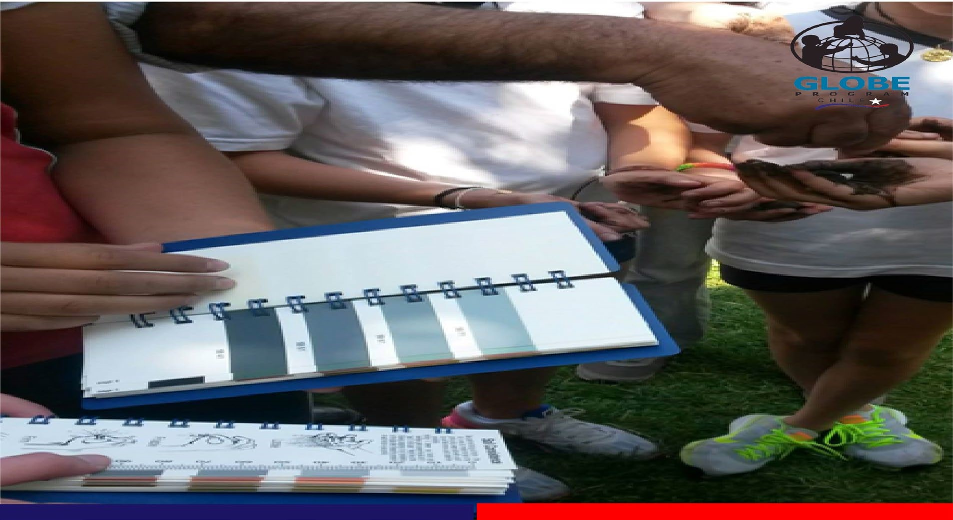
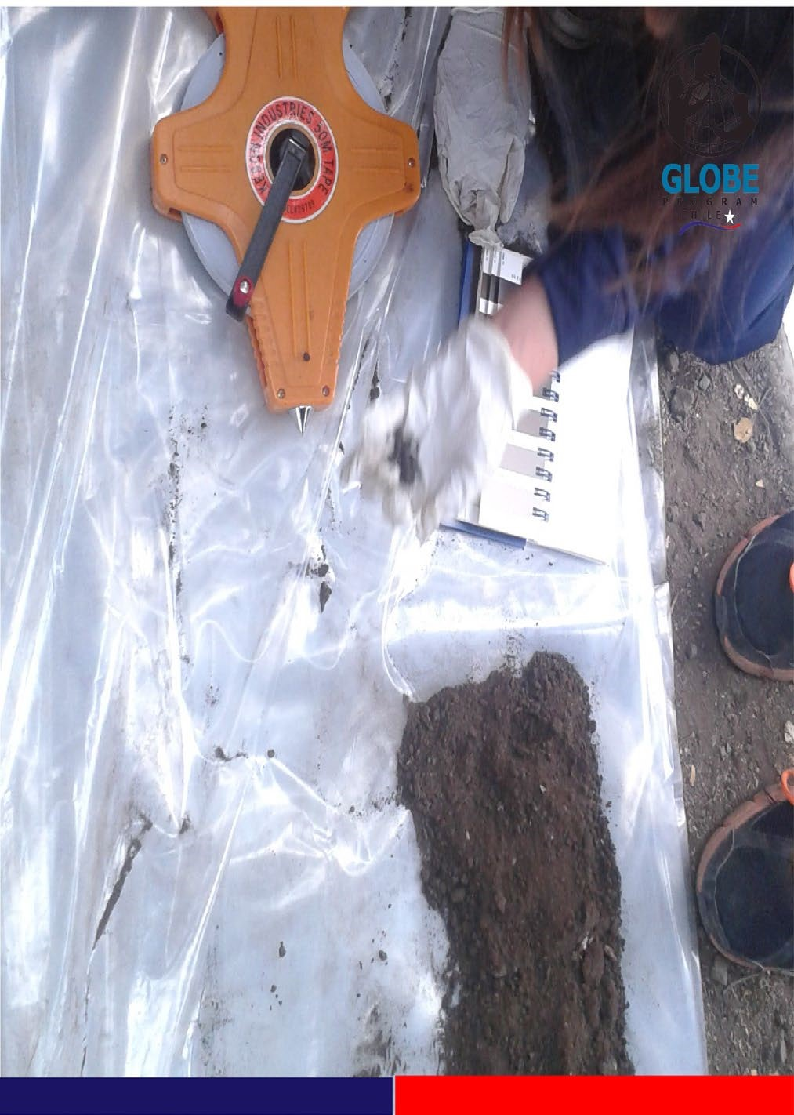

Super Luna Campaign in Santiago de Chile:
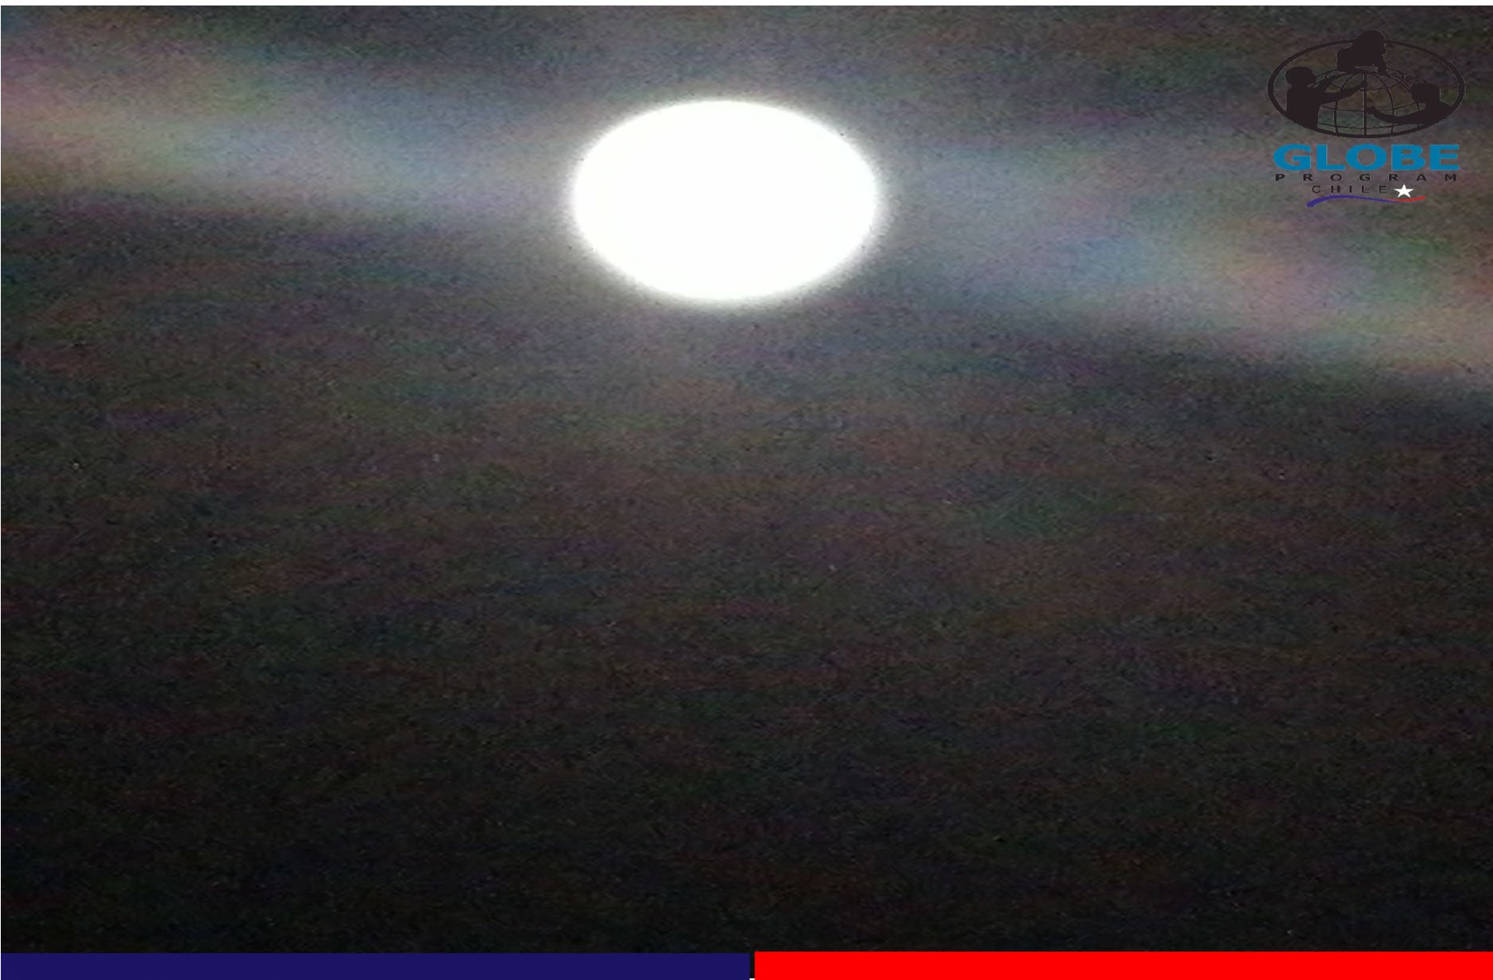

GLOBE LAC, Argentina and Chile Webinars:
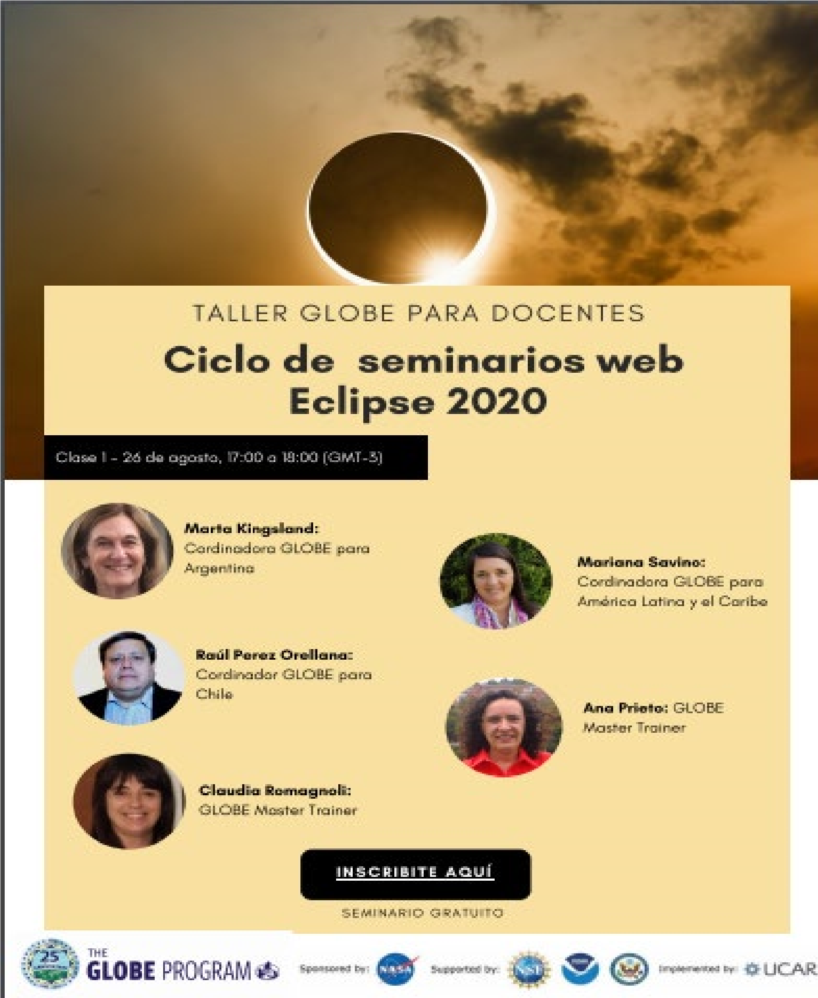
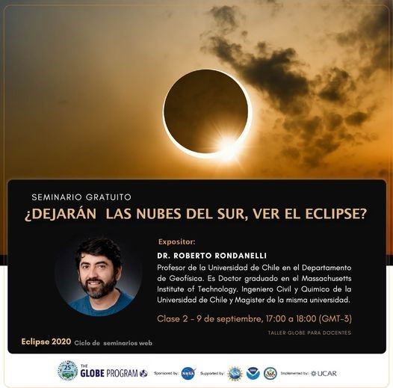

STAFF
Capacitadores activos:
M.T. Raúl Pérez
M.T. Viviana Zamorano
Trainers: Hernan Costabal
Manuel Banchieri

Convenios Activos:
- Ludens - Global Creative - Instituto AIEP.
- UDLA
- UMCE

