ANNUAL REPORT

GLOBE Colombia
2019 - 2020

TABLE OF CONTENTS
INTRODUCTION 3
EDUCATION 4
SCIENCE 5
COMMUNITY 6
APENDIX 7

INTRODUCTION
The Ministry of Science, Technology and Innovation – MINCIENCIAS – is the coordinating entity for Colombia of the Global Program for Learning and Observations for the Benefit of the Environment (GLOBE). GLOBE is an international science and education program that offers students and the world public the opportunity to participate in the collection of atmospheric data and the scientific process of analysis of these, in order to contribute to the understanding of the Earth as a system.
In light of its vision, GLOBE becomes a valuable tool for MINCIENCIAS, which, through the Ondas program, promotes in boys, girls and young people an interest in research and the development of attitudes and skills that allow them to actively insert themselves in a culture of science, technology and innovation.
To date, the GLOBE Colombia community has more than 393 members
The activities developed to achieve the objectives are the following:

EDUCATION
With the aim of increasing the availability of children, adolescents and teachers trained in scientific protocols and learning activities within the framework of the GLOBE program in Colombia that allows supporting the processes of scientific and technological vocation in children and adolescents, the following workshops: Atmosphere Workshop – Caldas
On March 11 and 12, a teacher-training workshop in the areas of atmosphere research was held in Manizales, Caldas, with the participation of 54 teachers and pedagogical advisors from the Ondas program.
The workshop, which was led by Master Trainer Carlos Acuña, offered a wide variety of topics that allow attendees to understand the Earth as a system and interpret various phenomena based on data collection.
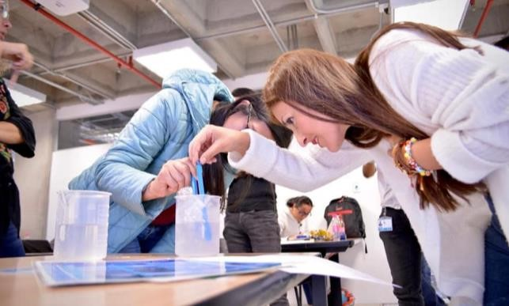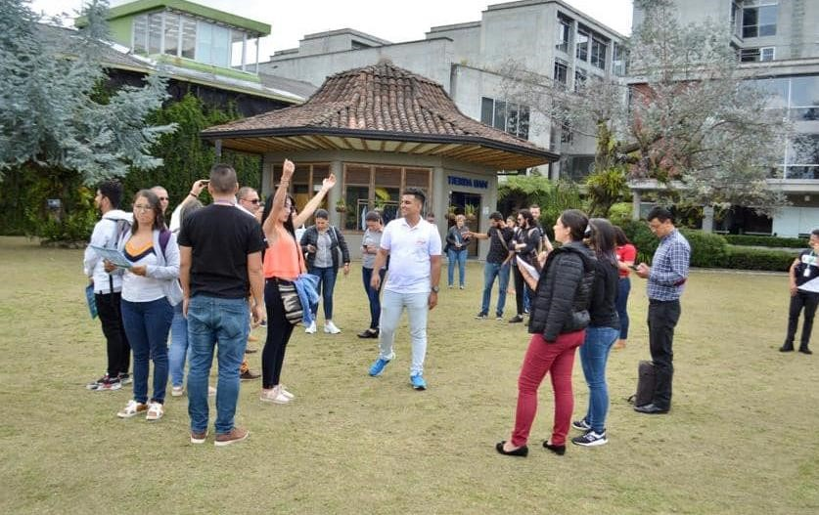

Atmosphere Workshop – Bolívar
Thanks to the alliance with the Technological University of Bolívar, the Autonomous Corporation of the Canal del Dique and the Montessori School of Cartagena, from August 27 to September 24, the training workshop in the areas of atmospheric research was held virtually; hydrosphere and land cover with the participation of 19 teachers and pedagogical advisors from the Ondas program.
The workshop was led by Master Trainer Juan Felipe Restrepo, who offered a wide variety of topics that allow attendees to understand the Earth as a system and interpret various phenomena based on data collection.
Atmosphere Workshop – Antioquia
In alliance with the Center for Aeronautical Studies of Civil Aeronautics, from September 16 to 30, 2020, the cycle of training workshops on "surveillance of atmospheric dynamics" was held, which included topics such as Clouds. - Satellites. - Atmospheric dynamics. - Integration of atmospheric parameters. The workshops were aimed at Educational Institutions from municipalities in the area of influence of the José María Córdoba Airport (Rionegro, Antioquia): Rionegro, Guarne, Marinilla, El Carmen de Viboral, La Ceja, El Retiro.
The workshop was led by Trainer José Norbey Sánchez, who offered a wide variety of topics that allow attendees to understand the Earth as a system and interpret various phenomena based on data collection.
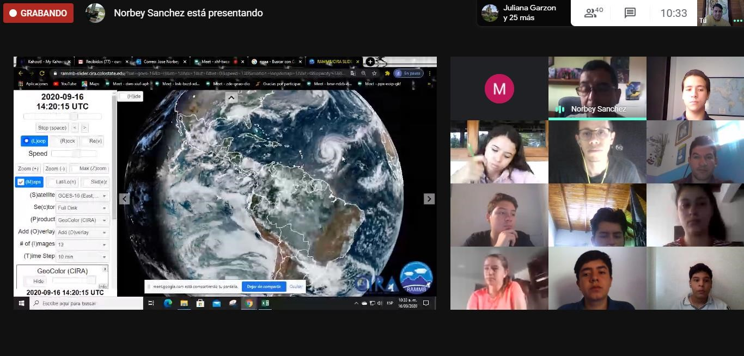
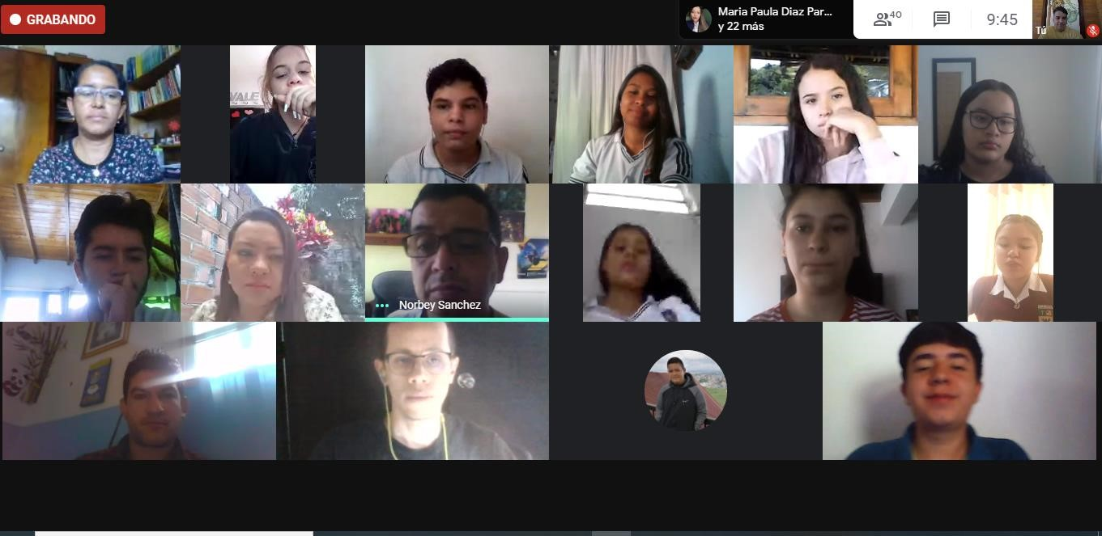

INTERNATIONAL VIRTUAL SCIENCE SYMPOSIUM - IVSS
The International Virtual Science Symposium (IVSS) is a way for elementary and high school students from all GLOBE countries to display their research and work. With GLOBE, students learn the practices of science through hands-on investigations in their own communities, sparking their curiosity and interest in science. This often leads to research that helps solve real-world problems and a greater understanding of our global environment.
In 2020, Colombia participated with three projects, below, we present the recognitions obtained in the last IVSS:
City | School | Project
Barranquilla | Semillero de Investigación en Ciencias Espaciales,  S.I.C. E | Management plan for diseases transmitted by mosquitoes in Las Gardenias Urbanization - Barranquilla, Colombia.
Bogotá | Rochester School | Can clouds help me predict weather?
Cartagena | Montessori School from Cartagena | ONDAS Bio IV Campaign expedition, to two wetlands on the North Coast of Colombia (Las Ciénagas de la Virgen, Juan Polo and El Totumo): biodiversity and physical parameters of water.

- 4 stars: ONDAS Bio IV Campaign Expedition, to two wetlands on the North Coast of Colombia (Las Ciénagas de la Virgen, Juan Polo and El Totumo): biodiversity and physical parameters of water.
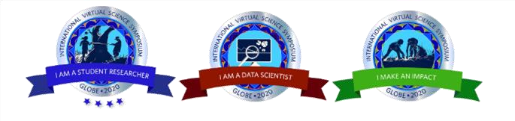
- 3 stars: Management plan for diseases transmitted by mosquitoes in Las Gardenias Urbanization - Barranquilla, Colombia.
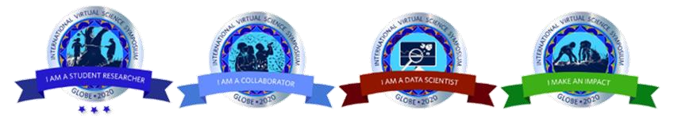
- 2 stars: Can clouds help me predict weather?
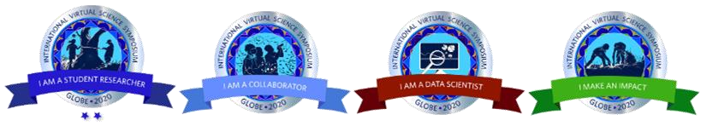

SCIENCE
At the close of this report, the number of GLOBE data loads for Colombia in the GLOBE database for science and research corresponds to 4,050 observations in total.
In the period from 2019 to 2020, a total number of 3,820 observations were reported.
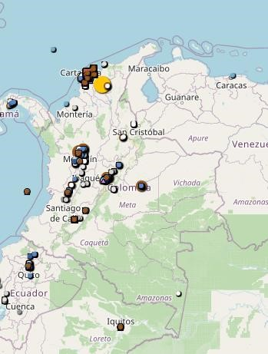
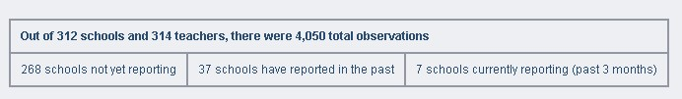

WORKING GROUPS
Professor Juan Felipe Restrepo from Colegio Montessori Cartagena and GLOBE Master Trainer has been selected as a member of the GLOBE Working Group on Diversity, Equity and Inclusion.
With the goal of making GLOBE a more welcoming, diverse, equitable and inclusive community, the task force will create a GLOBE declaration and implementation plan on Diversity, Equity and Inclusion.
The GLOBE Implementation Office (GIO) held a meeting in Boulder, Colorado, February 18-21.
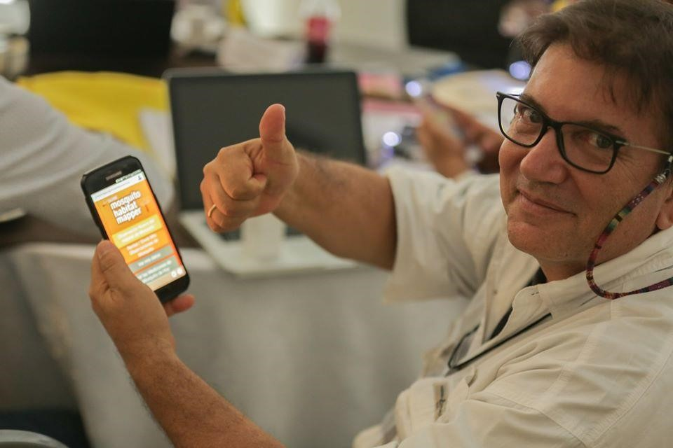

COMMUNITY

APENDIX

