ANNUAL REPORT

GLOBE Peru
2019 - 2020

TABLE OF CONTENTS
INTRODUCTION 3
EDUCATION 4
SCIENCE 8
COMMUNITY 10
APENDIX 11

INTRODUCTION
The year 2020 was very difficult for Peru; the arrival of COVID 19 affected the development of activities in all sectors. The education sector was hit hard and had to adapt to a bleak outlook and a remote education strategy for which it was not prepared.
This scenario affected the development of GLOBE activities in the country. The prolonged quarantine that we experienced for almost the entire year forced teachers and schools to prioritize elementary subjects, so GLOBE activities took a backseat or were not taken into account. The obligation to stay at home, the difficulty of accessing the Internet or not having adequate equipment to follow remote classes, complicated the situation.
Despite the above, we were able to carry out some minimal activities, almost all virtual, which we present below.
By: José Martín Cárdenas Silva - National GLOBE Coordinator

EDUCATION
From February 17 to March 13, in partnership with GLOBE Uruguay, the Biosphere Blended Course - GLOBE Program was held, aimed at schoolteachers in Peru. The course was developed through the EDUCANTEL Platform of the Ministry of Housing, Territorial Planning and the Environment of Uruguay - National Environment Directorate. The facilitators of the course were Claudia Caro Vera – Master Trainer GLOBE Peru, Andrea Ventoso – Master Trainer GLOBE Uruguay and José Martín Cárdenas Silva – Master Trainer GLOBE Peru. More than 50 teachers from Peru participated in the course.
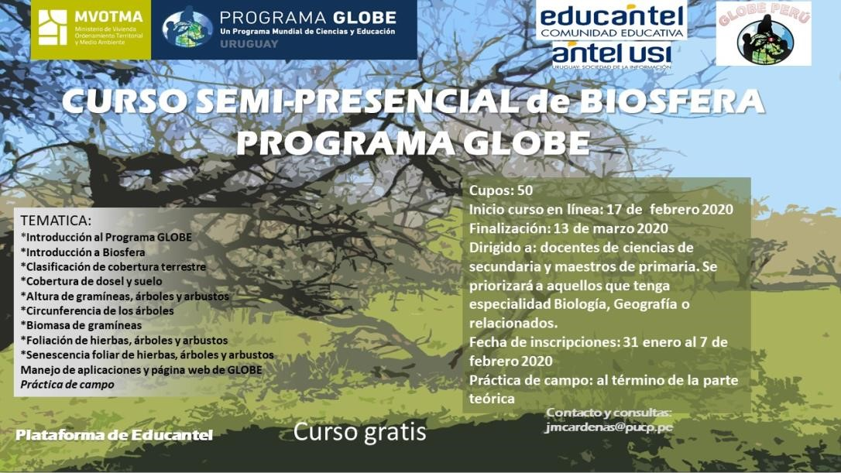
On March 26, we held the Webinar "GLOBE Program: tool to develop ICT inquiry and use skills" where the main elements of the GLOBE Program and its proposal to develop ICT inquiry and use skills in students were presented. The webinar was facilitated by José Martín Cárdenas Silva - National GLOBE Coordinator.
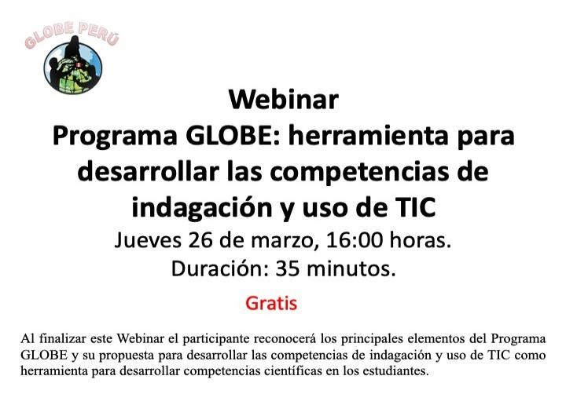
You can see the recording of the webinar at the following link: https://www.youtube.com/watch?v=p-PUgx7BUl8&list=PLJMQjptPfcAguNNcIbYIzEuSH0xLyz1la&index=46
In December, within the framework of National Science Week 2020 and World Soil Day, we held a series of webinars aimed at schoolteachers:
- On December 2, the webinar "Citizen research and the use of the GLOBE Observer application: Investigating clouds" was held.
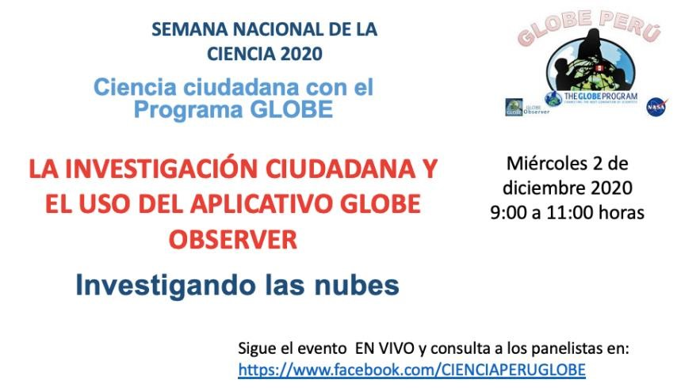
You can see the recording of the event at the following link: https://www.facebook.com/CIENCIAPERUGLOBE/videos/3773065226077809
- On December 3, the web seminar "Citizen Research and the use of the GLOBE Observer application: Investigating mosquitoes" was held.
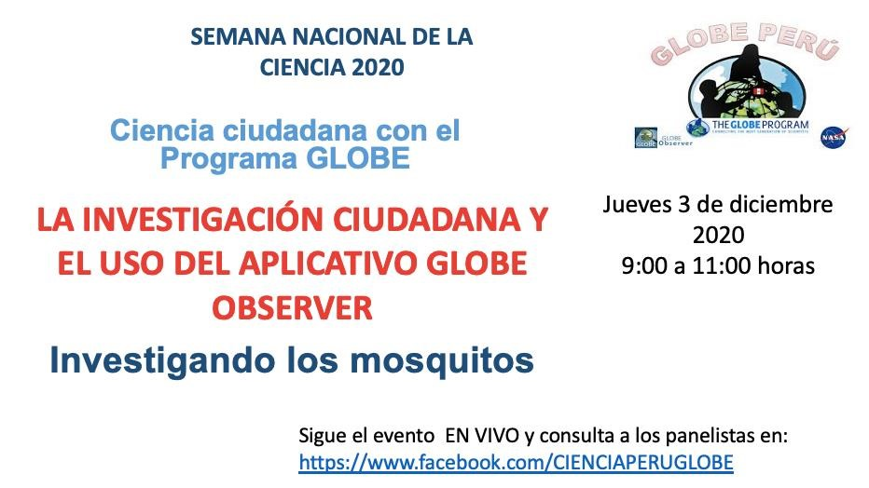
You can see the recording of the event at the following link: https://www.facebook.com/CIENCIAPERUGLOBE/videos/173995311053916
On December 4, the webinar "Promoting soil research from an early age" was held, with Professor Ninozca Lazo, GLOBE Teacher of the l.E. María Parado de Bellido - The Augustinian; Biologist Silvia Aguero, GLOBE soil expert and member of the Soil Biology Institute; the bachelor in Biological Sciences Emilio Lecaros, entomology expert; and to the Blga. Claudia Caro, Master Trainer and expert of the GLOBE Program.
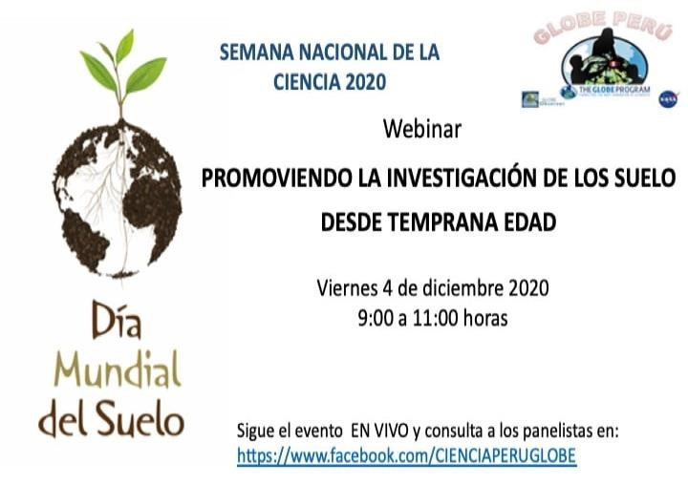
You can see the recording of the event at the following link: https://www.facebook.com/CIENCIAPERUGLOBE/videos/1079724465787297
We also generated some virtual resources to help teachers use the various GLOBE tools:
- Video about using the GLOBE Program BLOG: https://www.youtube.com/watch?v=0bfG0jRnLoA
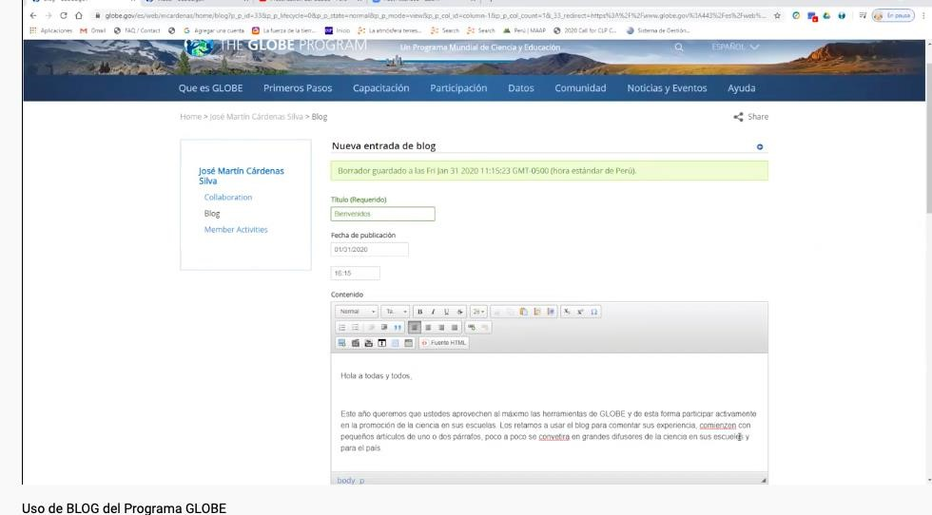
- Guide for the use of the BLOG of the GLOBE program https://globeperu.files.wordpress.com/2020/01/blog-globe.pdf
- Guide using the GLOBE data visualization system https://globeperu.files.wordpress.com/2020/02/usando-el-sitema-de-visualziacic3b3n-de-globe-jmcs_2020.pdf
- Guide for the use of the GLOBE Observer Trees application (Tree Research) https://globeperu.files.wordpress.com/2020/03/3globe-arbol-1.pdf

SCIENCE
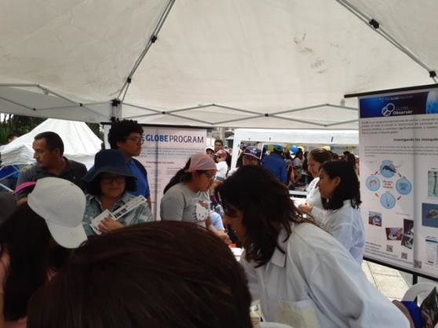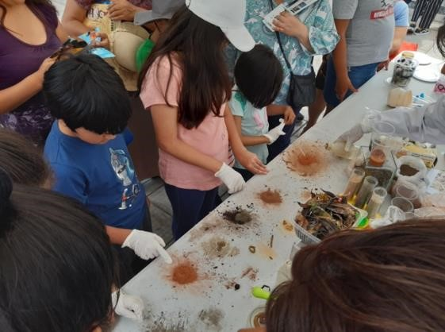
On February 11, GLOBE Peru was presented at the "International Day of Girls and Women in Science 2020" Fair, organized by the National Council for Science, Technology and Technological Innovation (CONCYTEC) in the City of Lima. As part of our participation, we shared some GLOBE activities on the study of soils and mosquito research. For example, the boys and girls experimented with different types of soil and learned about some of its characteristics and its importance. In the mosquito investigation, they were able to learn about disease-transmitting mosquitoes, see and recognize Aedes and Culex mosquito larvae, learn how to eliminate breeding sites and how to report mosquito data in the GLOBE Observer application. Our team was made up of biologists Claudia Caro and Silvia Agüero, as well as GLOBE teacher Ninozca Lazo and two of her students Nícole García and Jhadira Perez.
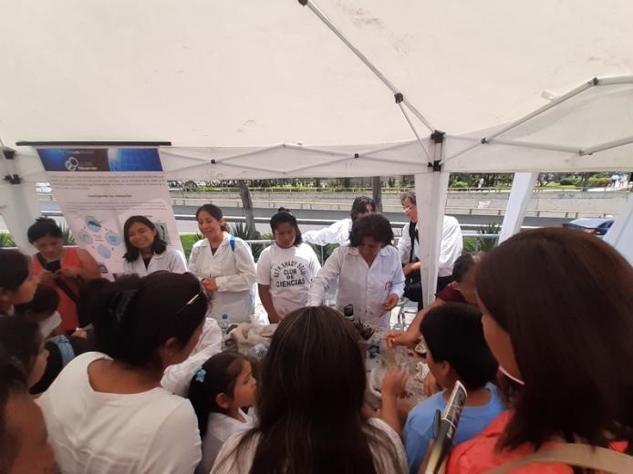
Watch the video with the greeting of the GLOBE Peru National Coordinator in the framework of this event, at the following link: https://www.youtube.com/watch?v=I3XSu7wy8Oc&list=PLJMQjptPfcAguNNcIbYIzEuSH0xLyz1la&index=44

COMMUNITY
Given the limitations that the pandemic placed on us, our main contact with the GLOBE community in Peru was through our Fan Page: https://www.facebook.com/CIENCIAPERUGLOBE/

APENDIX

