ANNUAL REPORT

GLOBE Uruguay
2019 - 2020

TABLE OF CONTENTS
INTRODUCTION 3
EDUCATION 4
SCIENCE 5
COMMUNITY 6
APENDIX 7

INTRODUCTION
The main GLOBE activities carried out by GLOBE Uruguay between October 2019, after the Natal Regional Meeting, and mid-October of this year are presented.
Given the global epidemic of COVID-19 that all countries have faced, with greater or lesser affection, the activities and workshops scheduled for the year had to be completely rethought and formulated according to the new quarantine conditions that we had to respect. In the case of our country, the mandatory quarantine was given from March 13 to May 13 for workers, at that time we returned to our offices but schools and high schools only began to rejoin in person from the end of June , starting with rural schools and rotating the number of students so that on some days they were one, and on other days the other half of the group for reasons of social distancing. This was also accompanied by virtual classes. Then, gradually, the schools of the metropolitan area and Canelones, which are generally schools with a larger number of students, were integrated in the same way, with the same mixed system. So did the high schools or high schools, as we call them. All of this took place within the framework of "non-compulsory attendance", for which some parents chose not to send their children. As of October 13, compulsory attendance is declared and the probable date of completion of courses is set for December 18 for primary and December 4, 10 and 13 for secondary, depending on the grades.
For the reasons stated, it has been a very special year for education in general, and of course teachers have had to adapt their classes and adapt them to virtuality, as well as to the times posed by the rotation of groups in the school. This meant that there was practically no time to implement extra-curricular activities such as science clubs or GLOBE.
Even so, we are looking for a way to reach the teachers, even if it was through virtual training, so as not to lose contact with the teachers.
We continue to prioritize the development of online modules in Spanish in Uruguay and advance in the preparation of the Pedosphere module to implement as soon as possible.
Andrea Ventoso
GLOBE Uruguay Coordinator

EDUCATION
14 Oct -15. Nov 2019
Completion of the 1st online GLOBE Biosphere course on the Educantel platform. Tutors: Andrea Ventoso, Prof. Claudia Caro - La Molina University, Lima, Peru.
Teacher training through the Biosphere online course. Teachers from the Ciudad Vieja School (among others) intervened due to the agreement made with Human Resources of the MVOTMA. Face-to-face workshop scheduled for December 14 at Parque Prado in Montevideo. A total of 25 secondary and primary teachers finished.
October-November: Planning of a workshop on the preparation of scientific research with Claudia Caro via virtual, in preparation for her visit to Montevideo, Uruguay, in December.
Dec 14 2019 - Practical instance of the Biosphere course by Prof. Claudia Caro from Peru. Field practice with the GLOBE Biosphere protocols in Parque Prado de Montevideo. It was carried out with the 25 teachers who completed the online Biosphere course. It was carried out with the collaboration of the GLOBE Regional Office, which provided accommodation and stay for the Master Trainer.
February 17-March 13, 2020 – Organization and technical support for the realization of the Online Biosphere Course for Peru, at the request of its Coordinator, José Martín Cárdenas, and co-tutored with him and Claudia Caro. Project presentation or learning session, as a method of individual evaluation of the participants. Secondary school teachers from multiple regions of Peru participated. No field trip was carried out because quarantines were determined in most of the countries.
March 18-April 27, 2020 – Organization and technical support for the online Atmosphere Course for Argentina, requested by the Coordinator Marta Kingsland, who tutored it with María Marta Daneri. Final project presentation. Secondary teachers from multiple regions participated. No field trip was carried out because quarantines were determined in most of the countries.
June 5-July 15, 2020. Completion of the Hydrosphere online module in Spanish with the technical support of the Educantel platform, a tool provided by the state entity ANTEL (National Telecommunications Administration) and facilitated for the purposes of DINAMA. The translation, adaptation and assembly are carried out by the National Coordinator and the tutoring is shared between the Master Trainer Patricia Píriz and Andrea Ventoso.
The course was structured in the following modules: Introduction to GLOBE, Introduction to the Hydrosphere, Site definition and mapping, Water transparency, Water temperature, Water pH, Conductivity, Dissolved oxygen, Nitrates, Mosquito larvae, Macroinvertebrates.
Each module is made up of the presentation, material in .pdf documents, some learning activity and a final exercise. In this case, the exercise was to choose a body of water closest to their place of residence and develop the definition and mapping of the site there, which was sent, documented (data sheets, photos or video) to the tutors. At the end of each module, the respective evaluation was carried out, which must be approved with a minimum of 80% in order to access the next module.
Once the complete module is finished, the participants are asked to propose a research project for their educational center, of 3-4 pages on the protocol(s) they wish, it is evaluated by the tutors and the feedback is sent to them with suggestions.
The last stage, which consisted of the face-to-face meeting where doubts are clarified, measurement instruments are presented and elaborated, and the field practice is carried out, had to be suspended due to the conditions of social isolation due to the COVID pandemic.
07/13/2020 to 07/16/2019 – Virtual assistance to the 24th. Annual GLOBE Membership Meeting. Part of the work was also two meetings of the Evaluation Working Group (at the beginning of the annual and at the end of all activities) to advance the work tasks and set new goals for the remainder of the year.
July-August 2020 – Planning and writing of an international collaborative project composed of: Coordinator of GLOBE Uruguay, Mtro. Dir. Darío Greni (trainer), Coordinator Marta Kingsland, Biologist Claudia Caro. It will have as its theme the sighting of butterflies in our countries and the atmospheric variables related to the time of the sighting. Primary school students from Uruguay, secondary school students from Argentina and university students from Peru participate. September-October-November: monitoring of the project, accompaniment and supervision.
Aug 13-Sept 10 2020 – Course taken learning to see Butterflies and caterpillars of Uruguay, by the Master in Entomology Gabriela Viglione, Permanent Education course of the Faculty of Sciences.
August 26- October 21: Participation in the webinars to carry out activities on the partial solar eclipse that will take place on December 14, 2020. For Uruguay, it will be partial viewing but we are lucky that the classes that in our country are being face-to-face will be extended until December 18, which will allow them to be on class time for the date of the eclipse. This is unlike the previous year where it fell during the July vacation period and it was late in the evening.
A webinar will be held in Uruguay by the Launch Coordination on November 13 for Uruguayan teachers who register to participate in the activities of measuring atmospheric variables related to the eclipse.
October 19- October 26: "Introduction to Meteorology and Tourism" taught by Meteorologist Mario Bidegain, professor at the Faculty of Sciences

Workshops and teachers trained and certified in numbers:
FOR URUGUAY:
1 Online Biosphere Course: – 25 teachers
1 Hydrosphere Course: - 32 teachers
FOR THE REGION:
1 Online course on Atmosphere for Argentina – 28 teachers
1 Online Biosphere Course for Peru – 27 teachers
TOTAL: 112 teachers trained on Educantel's GLOBE platform.

SCIENCE
Dec. 13, 2019 - Andrea Ventoso and Biosphere Prof. and Master Trainer Claudia Caro from La Molina Agrarian University, Lima, Peru, held a workshop giving guidelines to GLOBE teachers on how to carry out scientific research in general, and in particular for the GLOBE Virtual Science Symposium. Open to all GLOBE teachers. The presentation was recorded for later dissemination among teachers.
March 2020 – Participation as a judge for this year's GLOBE Virtual Science Symposium, evaluating three projects from Argentina, Peru and Saudi Arabia.

TECHNOLOGY
April 2020-October 2020 – Translation and adaptation of the Pedosphere online modules into Spanish, layout and assembly for the Educantel platform. It currently consists of 7 submodules in its Spanish version (the best known and most used in the research area were translated: Introduction to the Pedosphere, Selection, exposure and definition of a soil characterization site, Horizon sampling, SMAP soil moisture, Moisture Soil gravimetric, Soil infiltration, Soil temperature Will be released next year (February) due to the irregular year for the education system.

COMMUNITY
September 15, 2020 – The scientific advisor of the Butterflies a la Carta project, Master in Entomology Gabriela Viglione, gave a virtual presentation via Zoom for the children involved in the project, in which students from Argentina and Peru also participated. The biology of the butterfly was discussed, its habits, how to observe them, their importance as pollinators. The boys intervened asking questions and commenting on images presented by the biologist, and they were very motivated to continue observing, recording and investigating. The talk was voluntary.
October 7, 2020 – When the possibility of visiting schools was opened by the educational authority (ANEP), the Coordination carried out an advisory and supervision visit to the project Butterflies a la Carta with the children of 5th and 6th year of school No. 88 Alfred Nobel de las Violetas, Canelones. A pair of girls from sixth. They presented the project to level 4 children and carried out didactic and motivating activities for that age. (Photos in annex). Then the fifth graders and sixth they were organized in groups and provided with the necessary instruments, we went out to observe butterflies and record the established atmospheric variables.
2019-2020 - Regarding the tasks carried out by the Evaluation Working Group for the GLOBE community, fundamentally work was done on sending surveys to alumni who could be contacted thanks to the collaboration of the Country Coordinators and some coaches. The purpose of this survey is to determine if having had contact with the GLOBE methodology and protocols in primary/secondary school/university determined in some way their subsequent training and/or work.
The data was received and processed, in the month of October the final assembly of the conclusions for their presentation is being finalized.
The group had internal changes in its integration, moving to occupy the position of "member at large" Nádia Sacenco from Brazil, and the position of "GIO liaison" held by Megan Delaney, was held by Mindi de Paola in the month of October. In December my second period of work in the group ends, so new members will be re-elected from the LAC region, from Africa and from North America.

COMMUNICATIONS
STAR “Spanish translation and online training covering GLOBE protocols allows LAC Region to promote collaboration and “break geographic barriers”, published at: https://www.globe.gov/news-events/globe-stars/starsdetail/globe/spanish- translation-and-virtual-training-covering-globe-protocols-allows-latin-america-region-to-promote-collaboration-and-break-geographic-barriers-?
Drafted between the Coordination of Argentina, Peru and Uruguay on collaborative activities between the three countries. Posted Sep 14. 2020.

GOALS FOR NEXT YEAR:
- Offer to other Spanish-speaking countries in the region of the GLOBE online modules in Spanish, so that they join this initiative by facilitating the task of conducting workshops for national coordinators and master trainers and providing tutoring for them.
- Encourage teachers to submit projects again to the GLOBE Virtual Science Symposium.
- Coordination of joint projects between countries and regions with priority issues of common interest.
- Ongoing support for trained teachers to plan projects, loan materials and instruments.
- Resume visits to educational centers for advice that were planned for this year and that for reasons of health measures could not be specified.
- Certify the Teacher Darío Greni as a trainer and check his active status. Nominate him for the position of “member at large” in the GLOBE Education Group for the period 2021-2023.
- Launch of the Pedosphere modules on the Educantel platform, thus completing the four spheres of research, for which the collaboration of a Master Trainer from the area who tutors the course will be required, since we currently do not have one in Uruguay.

APENDIX
Biosphere practical workshop corresponding to the Oct.-Nov. Online Course. 2019. Prado Park in Montevideo.
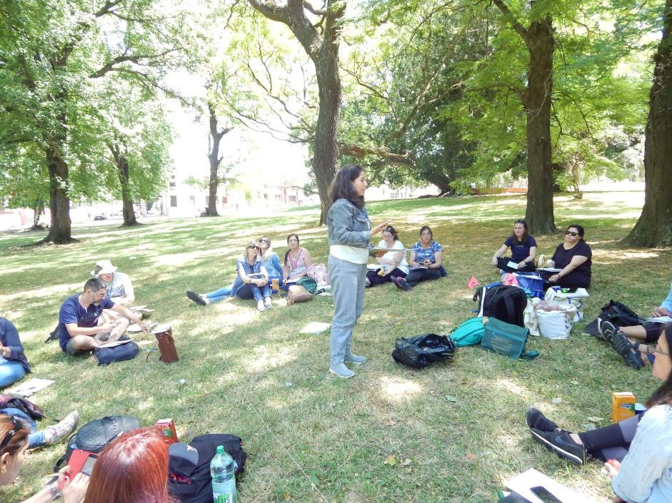
Biosphere practical workshop Herb foliation protocol
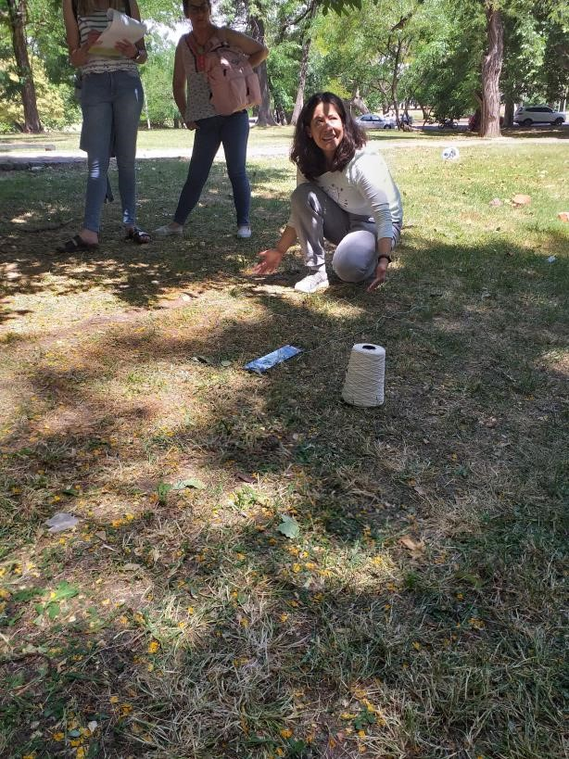
Biosphere practical workshop Foliation protocol for trees and shrubs.
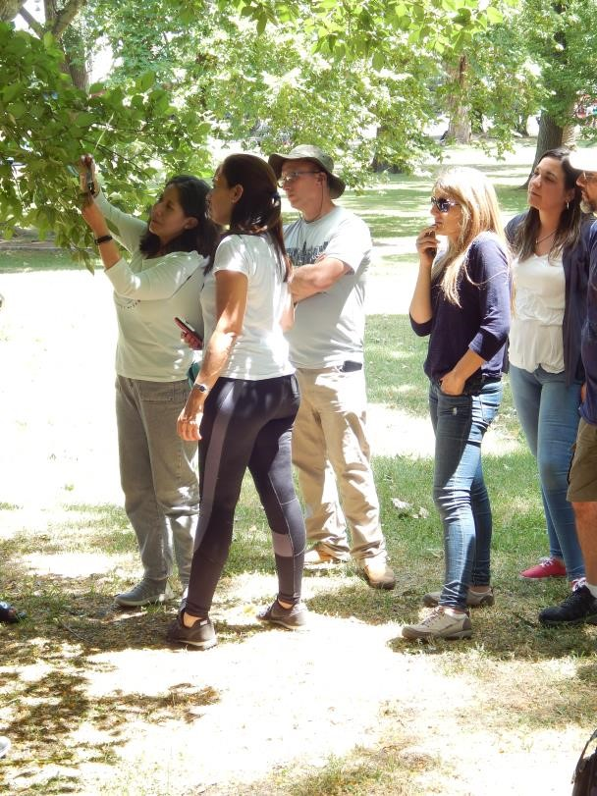
Transect Mapping Protocol for Coverage
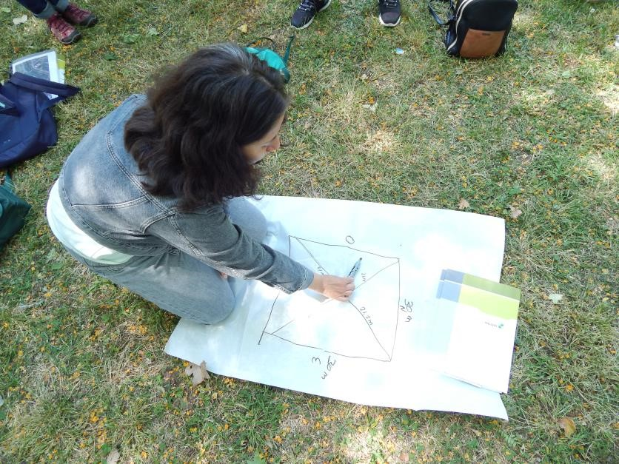
Presentation at DINAMA on How to carry out scientific research by Biól. Claudia Caro
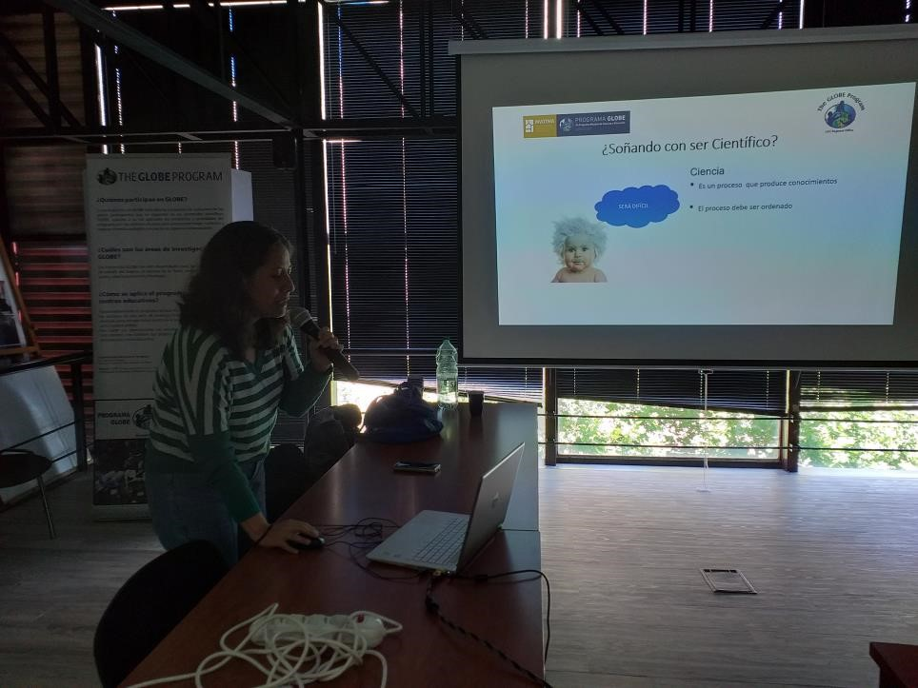
Star publication on the GLOBE website.
14 Sep 2020
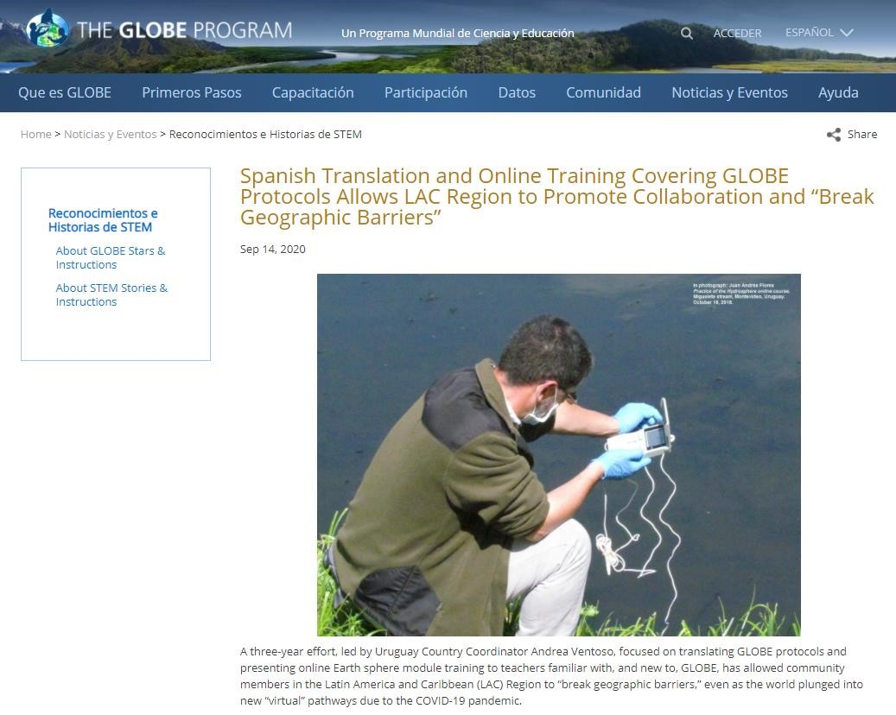

Accompaniment activity to Project Butterflies in the letter at School 88. 15 Sep 2020. Children of 5th and 6th and level 4
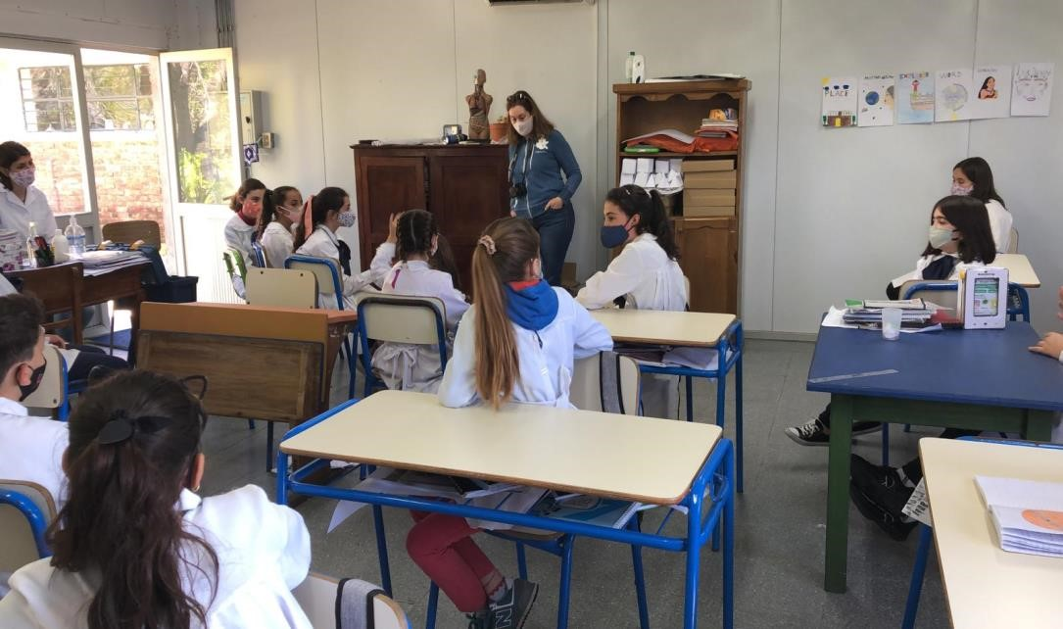
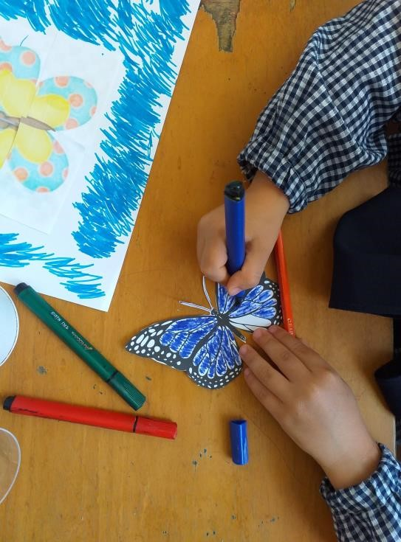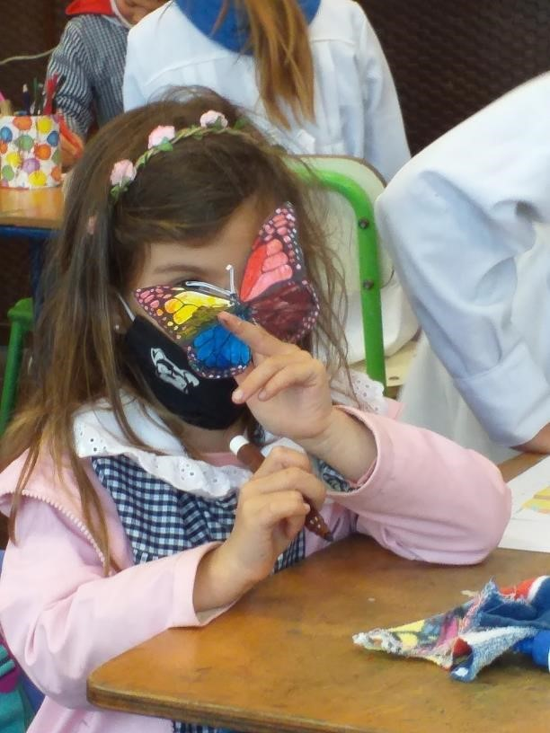
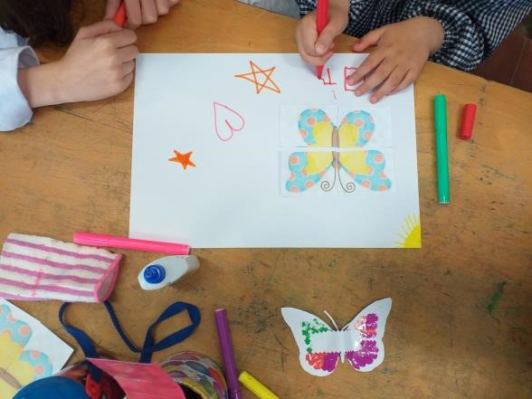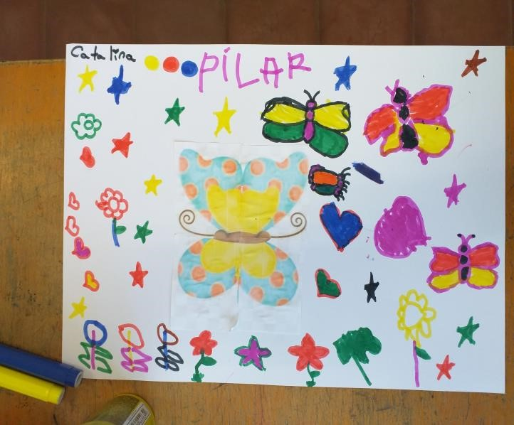

STAFF
GLOBE Uruguay Coordinator:
Lic. Andrea Ventoso
Atmosphere Master Trainer
Hydrosphere Trainer
Secretary GLOBE Task Force on Assessment
Mail: andrea.ventoso@mvotma.gub.uy
Telephone: 2917.07.10 ext. 4654
Honorary Staff:
Alternate GLOBE Coordinator:
Prof. Dir. Patricia Piriz
Hydrosphere Master Trainer - Biosphere Master Trainer
Mail: patywuan@gmail.com
Prof. Chem. Alejandra Gualco
Hydrosphere Assistant Trainer
Mail: prof.alejandragualco@gmail.com
Teacher Dir. Dario Greni
Hydrosphere and Atmosphere Trainer
Mail: dariovgreni@gmail.com
Bachelor of Biol. Elena Rodó
Water Quality Division
National Environment Directorate
Ministry of Environment

