ANNUAL REPORT

GLOBE Argentina
2018 - 2019

TABLE OF CONTENTS
INTRODUCTION 3
EDUCATION 5
SCIENCE 7
TECHNOLOGY 9
COMMUNITY 10
COMMUNICATIONS 12
APENDIX 13
STAFF 17

INTRODUCTION
The GLOBE Program in Argentina, led by its Technical Operational Team, currently counts with the participation of 271 schools, 398 teachers and 811 GLOBE Observers.
This report details the activities that were carried out during the period September 2018 / August 2019. We had active participation of our educational community and citizens, which grows day by day, demonstrated by the number of citizen scientists who participate.
As usual, during the mentioned period we carried out activities and/or participated in events of other Institutions, in order to publicize the Program. It is worth noting the growing interest in the GLOBE Program that was commented to us by various actors in the field of education during these meetings.
The website of The GLOBE Program shows that in Argentina counts with the participation of more than 7,110 students, with an entry of 513,331 data to the Base and 54 Honor Rolls. Although the Operational Technical Team is satisfied with the results, year after year we continues training in the classic face-to-face Training Workshops and incorporating, as of last March, the "online" modality, with the dictation of a workshop on Hydrology. As well as, calling different activities, such as videoconferences, campaigns, visiting schools, etc.
It is very gratifying to know that efforts pay off. There are many groups of students accompanied and guided by their teachers who have been trained over the years in different workshops organized by GLOBE in Argentina, who participate with their GLOBE projects in various science fairs at the local level, reaching the provincial and even national and international instances and manage to obtain the best positions.
In many cases, with these same works they participate in the Virtual Science Fairs convened by The GLOBE Program and obtain outstanding mentions.
On the other hand, the path undertaken last year continues, in the context of the GLOBE project, involving citizens in the forecast and the GLOBE Sika Education and Prevention, giving workshops in different provinces of our country, with a very high level of participation and interest in the subject.
During this period, Marta Kingsland, Master Trainer at the local and regional level and National Coordinator of Argentina, was selected again as a member of the Education Working Group.
Ana Prieto, also a Master Trainer at the local and regional level and Zonal Coordinator of the Province of Neuquén, Argentina, continued her work as a member of the Technology Working Group.
The GLOBE Program, Sika Program and Eclipse 2019 were announced through different media.
Lenses sent from NASA to observe the 2019 Eclipse were received from the United States Embassy and distributed to the GLOBE Schools community.
The United States embassy encouraged students from the GLOBE Program to present themselves in the selection of students to participate in science camps in the United States. Two GLOBE students were selected.
The Technical Team continually advises teachers who are part of this community, thus support, and help to continue with this work proposal.
Marta Kingsland and Ana Prieto attended the Annual Meeting of the GLOBE Program in Michigan USA.

EDUCATION
September 4, 2018 GLOBE ZIKA – Education and Prevention – Alejandro Roca, Córdoba Province.
September 20, 2018 GLOBE ZIKA – Education and Prevention – Yatay Ti Calle, Corrientes Province.
October 02, 2018 GLOBE ZIKA – Education and Prevention – Reconquista, Santa Fe Province.
October 08, 2018 GLOBE ZIKA – Education and Prevention – Zavalla, Santa Fe Province.
October 22, 2018 GLOBE ZIKA – Education and Prevention – Cañuelas, Province of Buenos Aires
November 2018 Marta Kingsland (MT) participated, together with MT Andrea Ventoso from Uruguay, as workshop facilitators in the Training Workshop organized by GLOBE from Colombia.
February 2019 Marta Kingsland Joins the Education Working Group (EWG), Participation in the monthly virtual meetings
February 2019 Marta Kingsland, as Coordinator of Argentina, through GLOBE Videoconference, presented the GLOBE to the participants of the Training Workshop organized by the Regional Office in San Martín de los Andes, Neuquén Province Program in charge of the Master Trainers Ana Prieto and María Eugenia Bertossi
March 25, 2019 Start of the online Hydrology Course. On the virtual platform shared by the coordinator of Uruguay Andrea Ventoso
April 22, 2019 Completion of the Online Hydrology Course.
April 2019 Proposal for collective teacher training. Astronomy at school. Focused on the Total Solar Eclipse event, July 2, 2019 MT Claudia Romagnoli and Viviana Sebben)
LMT carried out at Colegio de Todos los Santos with the participation of high school students.
May 16, 2019
Visit to the ALAS school, in El Palomar, Province of Buenos Aires, where a meeting was held with 1st and 2nd year secondary school students. After the presentation of some of the Atmosphere protocols and the Hydrosphere Mosquito protocol in the context of LMT, the students shared activities with the Master Trainers Marta Kingsland and María Marta G. de Daneri, related to what they had learned. It was an experience that was highly valued by both teachers and students.
May 13 and 14, 2019 Marta Kingsland and María Marta Daneri accompanied Ana Prieto on the second day of the Workshop, organized by the Regional Office at the Universidad Austral.
May 23, 2019 Marta Kingsland, by videoconference, welcomed and explained the scope and characteristics of the GLOBE Program to the participants of the Training Workshop that was held in Neuquén, organized by the Regional Office and the University of Comahue, dictated by MT Ana tight
In the period between May and June, LMTs are developed in the Province of Santa Fe, advised by the Master Trainer Claudia Romagnoli.
On August 20 and 21, 2019 we have scheduled to carry out a Training Workshop, in Río Cuarto, Province of Córdoba, of two face-to-face days plus hours of work. The invitation to teachers is made through the Ministry of Education of the Province, who will certify 30 clock hours to those who complete it, presenting a research project to carry out in their school.
It is successfully managed that the workshops that will be given in Córdoba and Mendoza receive a score for the teacher recognized by the provincial Ministries of Education, as happened in the workshops given in the Province of Neuquén by Master Trainer Ana Prieto.

SCIENCE
Presentation of works carried out by students for the IVSS. Works were sent representing several Argentine provinces
We highlight the important and intense activity of schools from different zonal coordination.
- In Santa Fe Zonal Coordinator Claudia Romagnoli
  - Santa Fe, in the town of Pujato. Some of the research done by GLOBE students is mentioned.
  - E.P.P.I. Nº1345 “Our Lady of Mount Carmel”
    - “More trees we count, more pure air we breathe”
    - “S.O.S. Seeds in Trouble”
    - “Winterclouds”
    - “Winter-Clouds. Clouds in the sky of Pujato during the winter 2018” Paper presented at the International Virtual Science Fair 2019.
  - E.E.S.O. No. 241 “John F. Kennedy”
    - “Impact of cloudiness on photovoltaic performance”, presented at the International Virtual Science Fair 2018) The work obtained 3 stars and the distinctions of “Collaboration”, Impact on the community and “Connection” with STEM professionals. It was also presented at the GLOBE Trainers Workshop - 2018, organized by the Country Coordination, in Munro, Province of Buenos Aires.
    - “Annual Pluviometric Variability” from the Science Club Nº76 “Prof. Dr. Julio Maiztegui”.
    - With several of these research works, they participated in science fairs, approving the local, regional and national instances, reaching the first prize.
  - In Junín de los Andes, Zonal Coordinator Ana Prieto
  - Huechulafquen Science Club, mentions some of the research carried out by its students
    - “Challenge of the Lakes”
    - “Use of macroinvertebrates to monitor disturbances caused by volcanic ash fall in aquatic ecosystems”
    - Biomonitoring of water quality in the Chimehuín River”
    - They participated in the “Virtual International Science Fair 2019, with the research: Aquatic macroinvertebrates and their importance as bioindicators of water quality in the Chimehuín River, Patagonia, Argentina and in the “3rd Meeting of Young people committed to the environment ambient"
    - Students from the Huechulafquen Science Club traveled to the annual congress of the GLOBE Program 2019 based in Detroit for their research on mosquitoes in the context of the ZIKA Program
Organization of proposals for activities to be carried out by students with the follow-up of teachers to present at the Eclipse 2019 event.
Organized by the zonal coordinator of Córdoba, Adriana Mistó, the Eclipse 2019 event was held. The mayor of Alejandro Roca participated in the organization of the event. The event attracted more than 500 people. It was attended by the National Coordinator, Marta Kingsland.
Different events on Eclipse 2019 were held in the provinces of Buenos Aires, Mendoza, Neuquén and Santa Fe. For this reason, the lenses received from NASA were sent to the United States Embassy in Buenos Aires

TECHNOLOGY
March to August 2109 GLOBE Argentina participated in the organization and development of the webinar sequence for the Eclipse 2019 event. The organization was carried out jointly with NASA March 2019 Ana Prieto participated in the GLOBE International STEM Network (GISN ) March / April 209 Participants from Argentina were judges at the IVSS. Ana Prieto and Marta Kingsland participated in said event.
July 02, 2019 Students from the Fasta Villa Eucarística College in the Province of Córdoba made videos during the eclipse to show both this phenomenon and the work carried out
Participation in the webinar on different topics related to Eclipse 2019
Participation of Argentine schools in the Tree Measurement Challenge campaign through the GLOBE Observer App
Attendees in different webinars about GLOBE MISSION Mosquitoes Webinars by Dorian Janney.

COMMUNITY
September 27, 2018 Marta Kingsland participated in the "Eco Semana Huergo" (GLOBE school), where she referred to the Mosquito Protocol, within the GLOBE ZIKA Campaign - Education and Prevention. University of San Andres.
November 06, 2018 A Webinar was held to which GLOBE students were invited to present some of their research. Students from the following schools participated as exhibitors: ETEC from Godoy Cruz, in the Province of Mendoza, Grilli Canning from Canning, in the Province of Buenos Aires, and Primary School Albergue Nº 217 from Ñireco, in the Province of Neuquén. It was a very enriching experience, both for the exhibitors and for the students.
Her work was presented by three schools
- School: ETEC - Theme Impact of hail storms in urban areas Professor Eleonora P. Morelli
- Grilli Canning Topic: The effects of extreme weather events on Ecological Communities Teacher: Florencia Guida
- Elementary School Albergue Nº217 Topic: From my house to NASA Teacher: Natalia Bezier
April 22 to 26, 2019 Participation of both teachers and students as well as citizens in the Tree Measurement Challenge
April 24, 2019 GLOBE ZIKA – LMW – Colegio de Todos los Santos Villa Adelina, Province of Buenos Aires.
May 02, 2019 Participation of teachers and students in Web Seminar #1 "Introduction to Eclipses"
May 08, 2019 GLOBE ZIKA – LMW – Zavalla, Santa Fe Province.
GLOBE ZIKA – LMW – Acebal, Santa Fe Province.
June 06, 2019 Participation of teachers and students in Web Seminar #2 "How cool is the eclipse" "Collect data with GLOBE"
July 02, 2019 Total Solar Eclipse in South American countries. In some areas of Argentina, the total eclipse could be seen and in others, it was partial. Teachers, students and residents of those places participated in the activities organized by the GLOBE Program in Argentina. All those who had the opportunity to experience this astronomical phenomenon felt deeply moved.
July 04, 2019 Participation of teachers and students in the Web Seminar #3 "Share your Eclipse experiences". This is what the students who lived the experience did, belonging to schools in the Provinces of Córdoba, Santa Fe, Mendoza, Buenos Aires and Neuquén.
Publication of information on different social networks (Facebook, Twitter, Instagram) and on the GLOBE Argentina page www.globeargentina.org, announcing the latest news
September 24, 2018 Interview with Marta Kingsland, for the Public TV Program "Everything has a Why", where she had the opportunity to present the GLOBE Program.
August 2019
Students from the Huechulaufquen Science Club were interviewed by the newspaper and television channel about the presentation of their work on Mosquitoes in the city of Detroit in the context of the annual meeting of the GLOBE Program.

COMMUNICATIONS
Information is continuously published on different social networks (Facebook, Twitter, Instagram) and on the GLOBE Argentina page www.globeargentina.org, announcing the latest news
September 24, 2018 Interview with Marta Kingsland, for the Public TV Program "Everything has a Why", where she had the opportunity to present the GLOBE Program.
August 2019
Students from the Huechulaufquen Science Club were interviewed by the newspaper and television channel about the presentation of their work on Mosquitoes in the city of Detroit in the context of the annual meeting of the GLOBE Program.

APENDIX
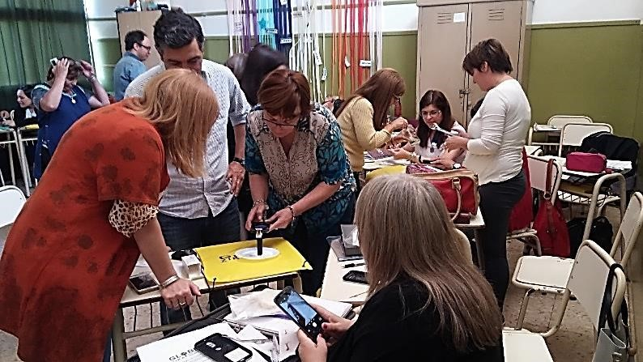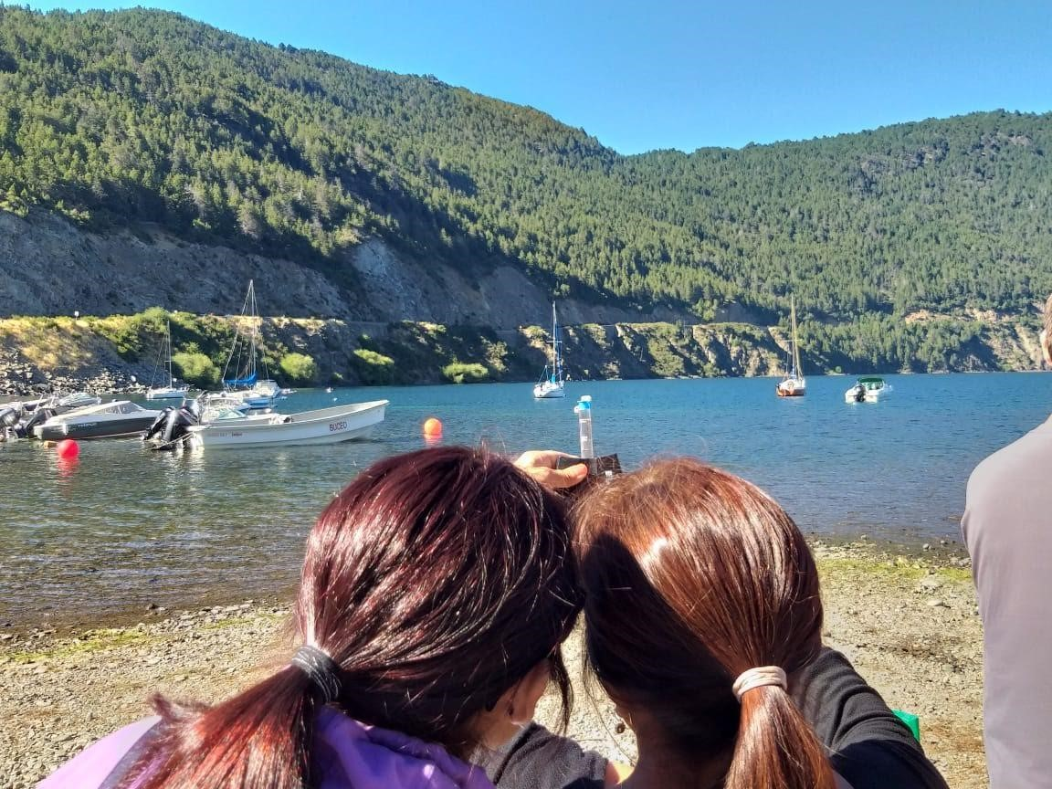

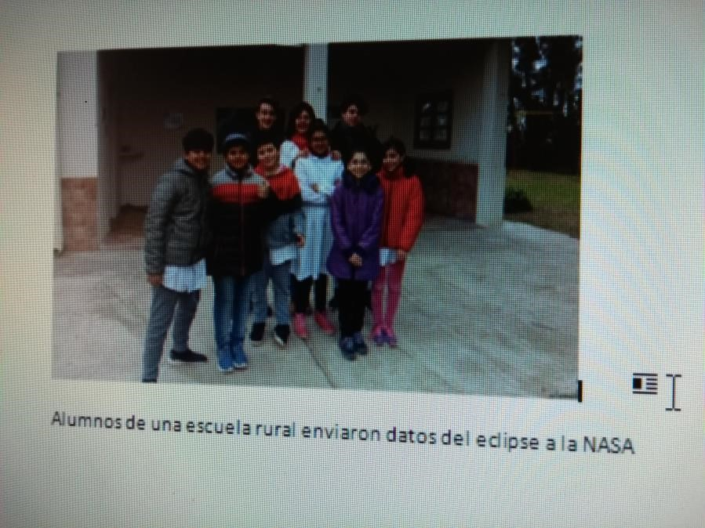
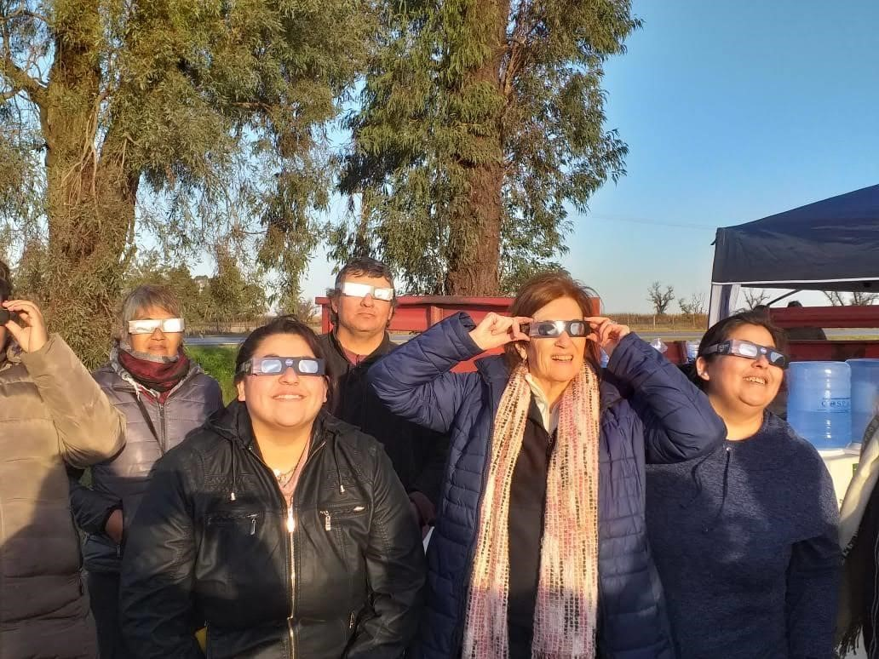
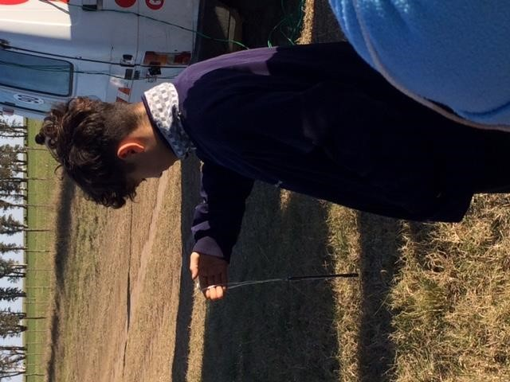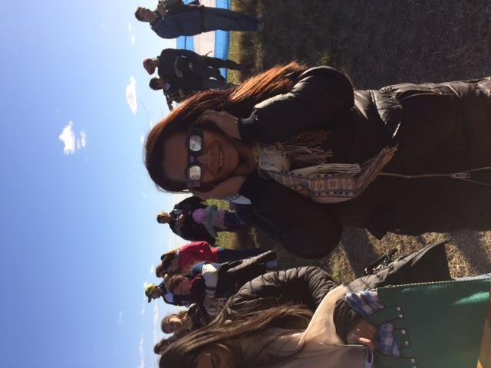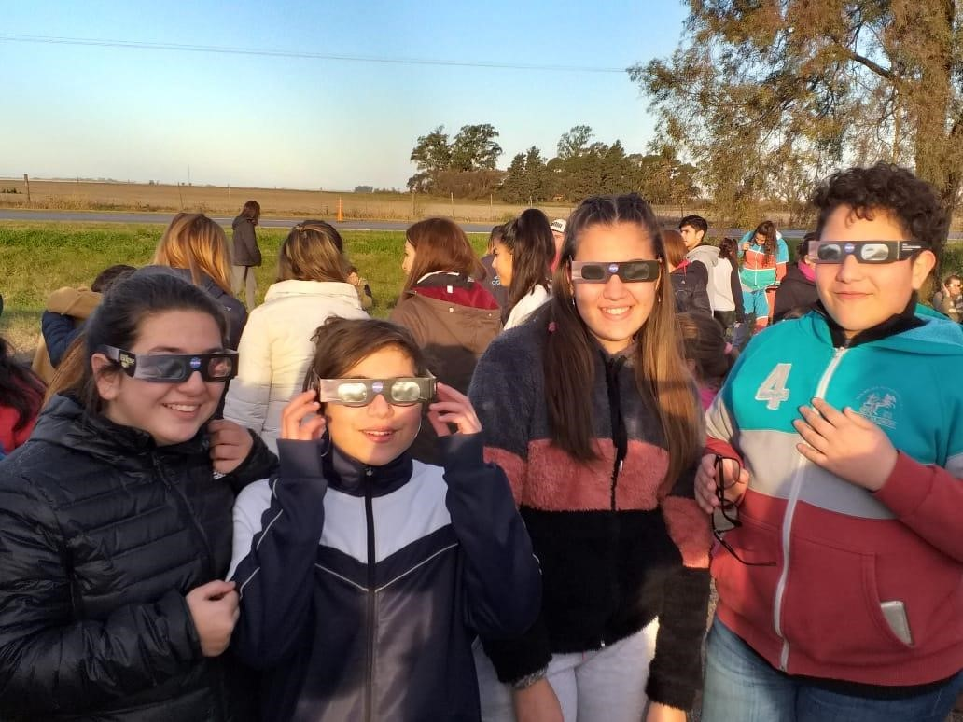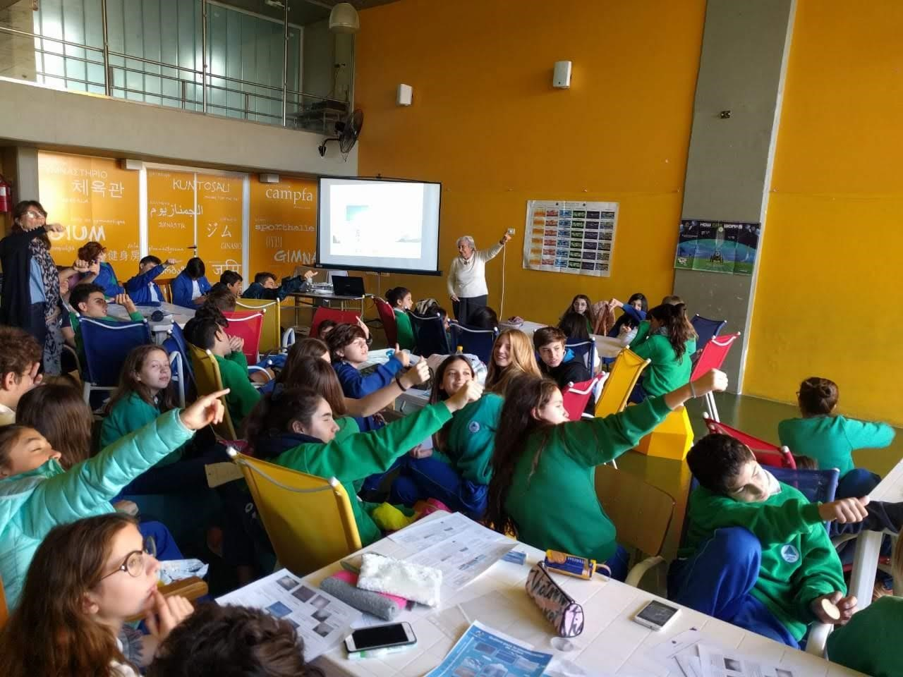
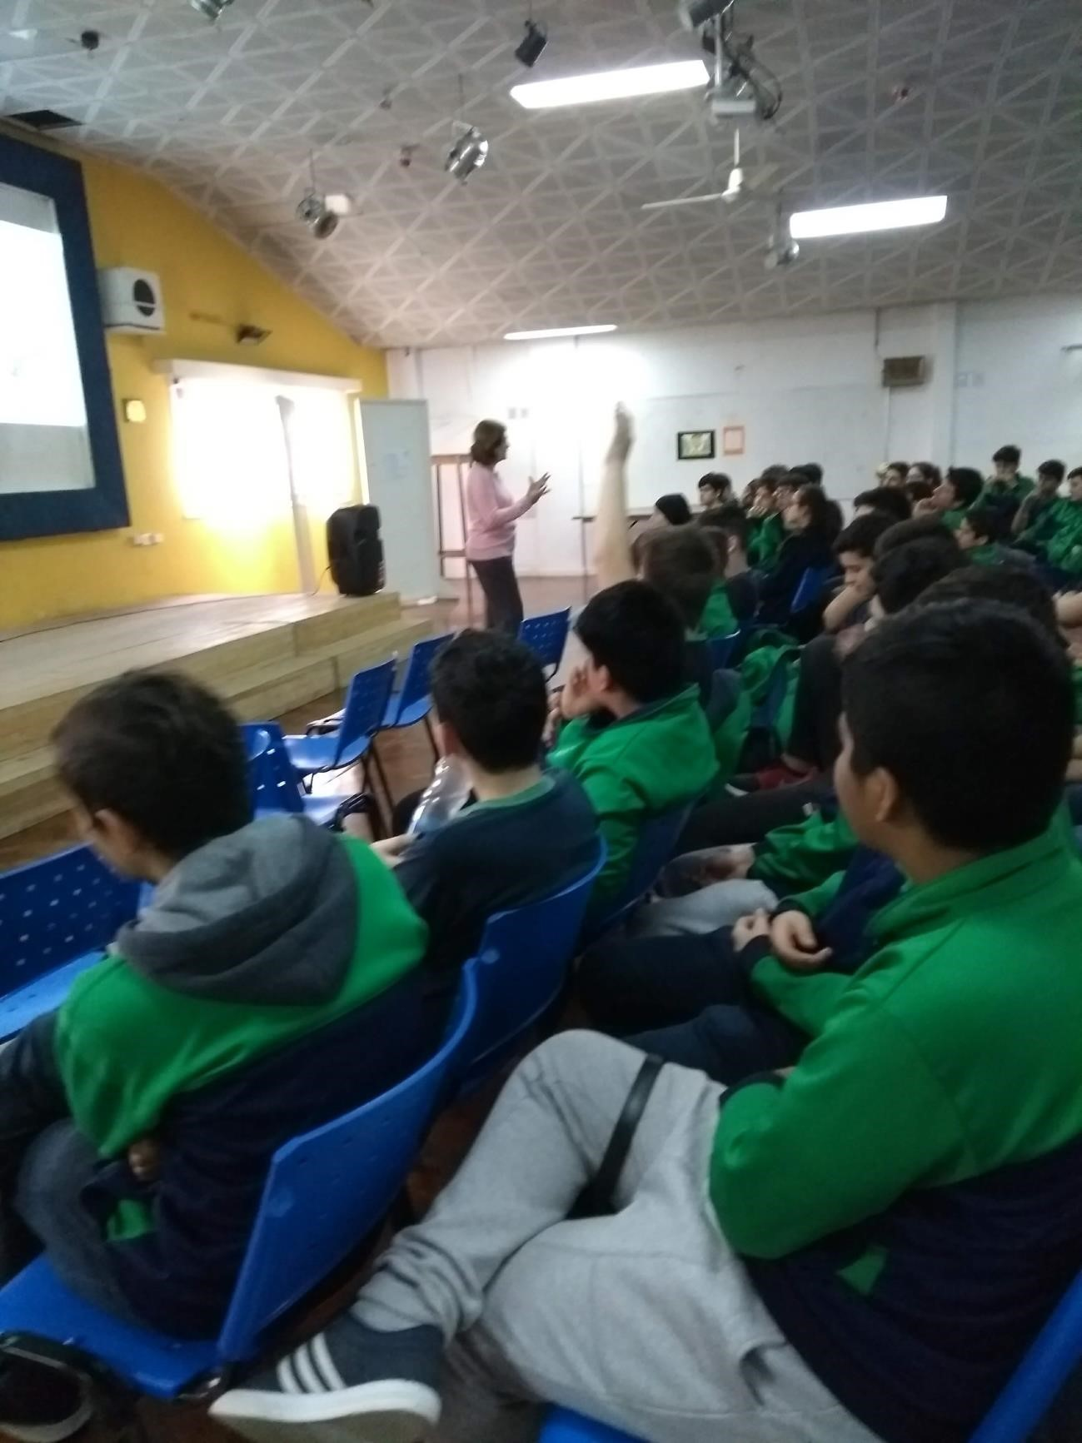

STAFF
Activities carried out in Argentina organized by the National Coordination
September 2018- August 2019
Marta Kingsland Coordinator
María Marta Daneri Alternate Coordinator
Graciela Martínez Operational Secretary
Zonal coordinators:
- Oscar Busch
- Claudia Romagnoli
- Adriana Misto
- Ana Beatriz Prieto
- Maria Eugenia Bertossi (Alternate)
- Gustavo Lescano
- Marisa Dilernia

