ANNUAL REPORT

GLOBE Colombia
2018 - 2019

TABLE OF CONTENTS
INTRODUCTION 3
EDUCATION 4
SCIENCE 8
COMMUNICATIONS 10
STAFF 12

INTRODUCTION
The Administrative Department of Science, Technology and Innovation (COLCIENCIAS) is the coordinating entity for Colombia of the Global Program for Learning and Observations for the Benefit of the Environment. GLOBE is an international science and education program that offers students and the world's public the opportunity to participate in the collection of atmospheric data and the scientific process of analyzing it, thereby contributing to the understanding of the Earth as a system.
In light of its vision, GLOBE becomes a valuable tool for Colciencias, which, through the Ondas program, promotes in children and young people an interest in research and the development of attitudes and skills that allow them to actively insert themselves in a culture of science, technology and innovation.
To date, the GLOBE Colombia community has 301 fully trained teachers.
The activities developed to achieve the objectives are the following:

EDUCATION
With the aim of increasing the availability of teachers and trainers trained in scientific protocols and learning activities within the framework of the GLOBE program in Colombia that allows supporting the processes of scientific and technological vocation in children and adolescents.
Atmosphere workshop
On November 27 and 28, the training workshop for trainers in the areas of atmosphere and hydrosphere research was held in Chía, Cundinamarca with the participation of 15 teachers from the GLOBE program from the departments of Antioquia, Atlántico, Bolívar, Cundinamarca, Huila and Valle del Cauca.
The workshop, which was led by international Master Trainers Marta Kingsland from Argentina and Andrea Ventoso from Uruguay, offered a wide variety of topics that allow attendees to understand the Earth as a system and interpret various phenomena based on data collection.
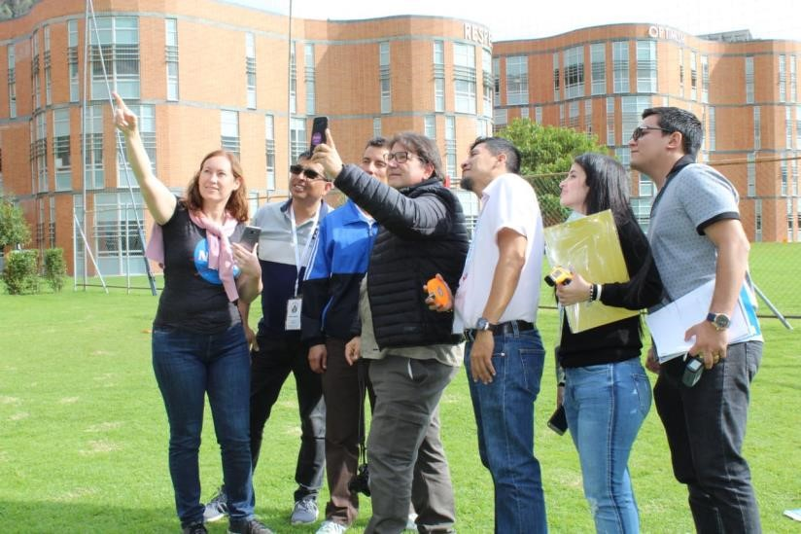
Atmosphere Workshop
On January 25, 38 teachers from Valle del Cauca received training on data collection techniques following the GLOBE Cloud and Surface Temperature protocols under the pedagogical models of the program for reflective research, which will then allow them to answer questions together with their students of scientific research. This training workshop was held within the framework of the pedagogical reflection space of the natural sciences area of the Departmental Secretary of Education.
Trainers Juan Carlos Largacha and Erquinio Taborda, offering a wide variety of topics that allow attendees to understand the Earth as a system and interpret various phenomena based on data collection led the workshop.
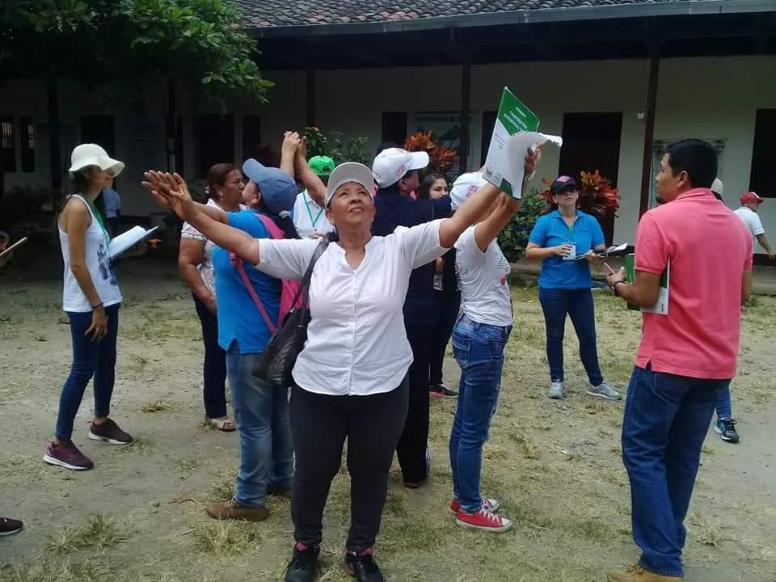
GLOBE Zika Education and Prevention Project
Country Mosquito Training
As part of the second stage of the GLOBE Zika Education and Prevention Project, the Triple Border Workshop was held in Leticia Amazonas on May 3, with the participation of students, teachers, community leaders and public health officials from Brazil, Colombia and Peru. This project seeks to raise the level of participation and impact of citizen science through the commitment of thousands of citizens to make observations and collect data on the existence of mosquitoes that transmit diseases such as dengue, zika and chikungunya in their regions in order to help build a global map of their distribution. The training focuses on how to use the GLOBE Observer Mosquito Habitat Mapper application for the identification of mosquito larvae species and the elimination of mosquito habitat. The organization of this event included the participation of olciencias, the Brazilian Space Agency and the Embassy of the United States of America in Colombia.
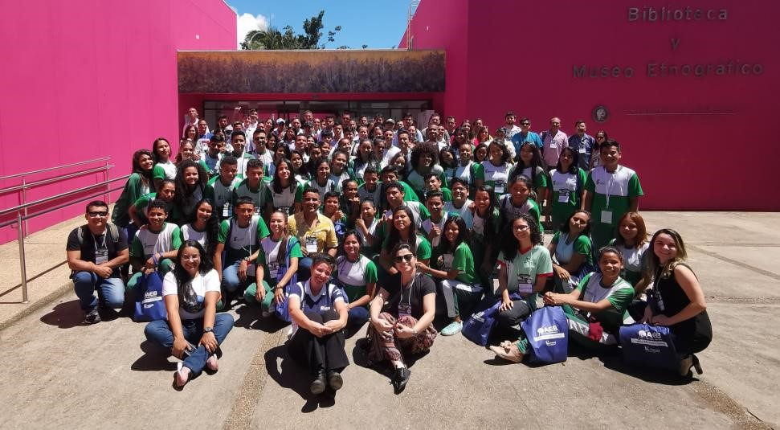
Local Mosquito Workshop
In the department of Atlántico, a workshop was held where 23 teachers from the department and 23 student leaders of the groups were trained in the Mosquito Habitat Mapper protocol.
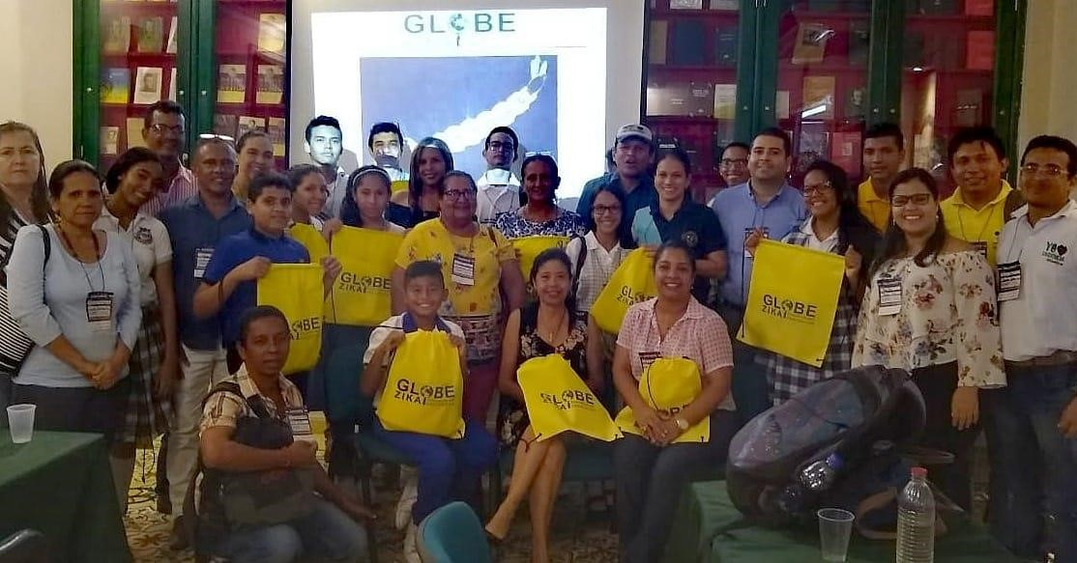
Hydrosphere Workshop
On May 6 and 7, 2019, in Envigado, Antioquia, 33 teachers from the Aburra Valley Metropolitan Area were trained on data collection techniques following the GLOBE hydrosphere protocols, a workshop led by Master Trainer Ana Prieto from Argentina.
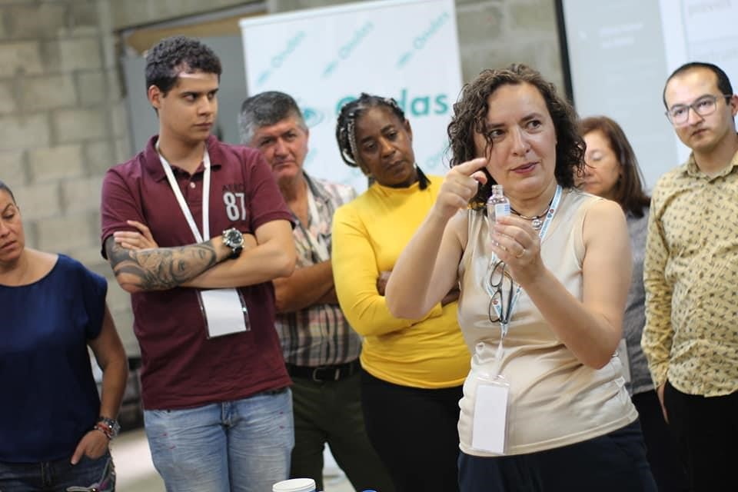
Investigations of Earth systems phenomena
Schools are important in the local context because they are considered educational teaching entities and their roadmap (curricula) must be allied with society and the community to become aware of the importance of preserving the environment and making changes in behavior, lifestyles and encourage them to action, by preventing and mitigating existing and future problems.
Taking into account the above, the implementation of the GLOBE Zika Education and Prevention Project seeks to convert this citizen science strategy towards the benefit of the community and achieve an impact on the problem of the spread of vectors of epidemiological importance.
Currently, the community research guide “¡MOSQUITO!” developed by the Smithsonian Institution in association with GLOBE https://learninglab.si.edu/profile/ScienceForGlobalGoals in 17 educational institutions of 11 municipalities of the department of Atlántico and 6 educational institutions of the department of Huila.
Department | Municipality | Institution
Atlántico | Luruaco | Institución Educativa Técnica Agropecuaria de Luruaco
 | Luruaco | Centro Educativo San Juan de Tocagua
 | Luruaco | Institución Educativa San José de Luruaco
 | Repelón | Institución Educativa José David Montezuma Recuero
 | Repelón | Institución Educativa Técnica Agropecuaria de Villa Rosa
 | Ponedera | Institución Educativa Técnica Comercial de Ponedera
 | Tubará | Institución Educativa Técnica Agropecuaria de Tubará
 | Palmar de Varela | Institución Educativa Técnica comercial de Palmar de Varela
 | Soledad | Institución Educativa Tajamar
 | Soledad | Institución Educativa Gabriel Escorcia Gravini de Soledad
 | Baranoa | Institución Educativa Técnica Juan José Nieto
 | Puerto Colombia | Institución Educativa San Nicolás de Tolentino
 | Sabanalarga | Institución Educativa de Sabanalarga CODESA
 | Candelaria | Institución Educativa de Leña
 | Barranquilla | Colegio Compañía De María La Enseñanza
 | Barranquilla | Institución Educativa Técnica Distrital Meira Delmar
 | Barranquilla | Institución Educativa Distrital Sonia Ahumada
Huila | Neiva | Institución Educativa Agustín Codazzi
 | Neiva | Instituto Técnico y Académico Scout José Martí
 | Campoalegre | Institución Educativa Eugenio Ferro Falla
 | Campoalegre | Institución Educativa Eugenio Ferro Falla
 | Rivera | Colegio Pedagógico la Casita Mágica
 | Santa María | Institución Educativa Santa Juana de Arco

SCIENCE
As a strategy to increase the participation and collaboration of scientists and STEM professionals with the GLOBE Colombia community, a call was opened to allied organizations such as Colombia Science Clubs, Del Laboratorio al Campo, ScienteLab. Young scientists living in several countries around the world, including Colombia.
At the close of this report, the number of GLOBE data loads for Colombia in the GLOBE database for science and research corresponds to 230 observations in total. (Attached)
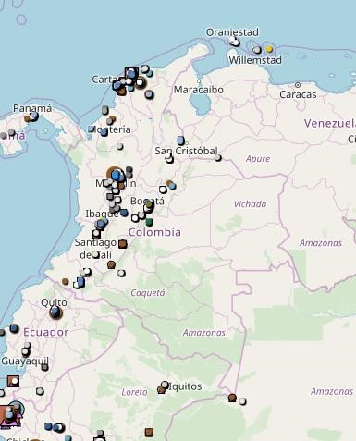
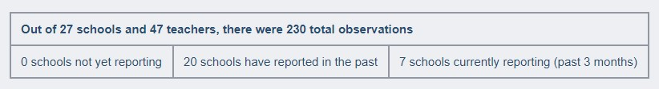
IVSS and Annual Meeting
The GLOBE Program selected the Space Science Research Seedbed, S.I.C.E, to receive a travel grant to attend the GLOBE 23rd Annual Meeting from JULY 14-18, 2019, thanks to their project "Comparative Studies of Mosquito Larvae Present in the Las Gardenia Urbanization, Barranquilla, Colombia", presented at the International Virtual Science Symposium (IVSS).
Teacher Requinteo Taborda leads the Seedbed for Research in Spatial Sciences from the city of Barranquilla. The Travel Grant is sponsored by the Zika Education and Prevention project of the US Department of State.
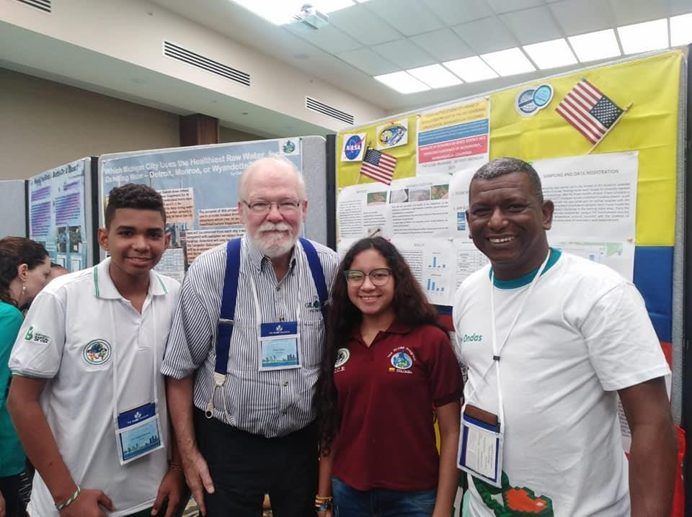

COMMUNICATIONS
As a communication strategy, the GLOBE Colombia program has a Facebook page @GLOBECol. The scope of the page is shown below.
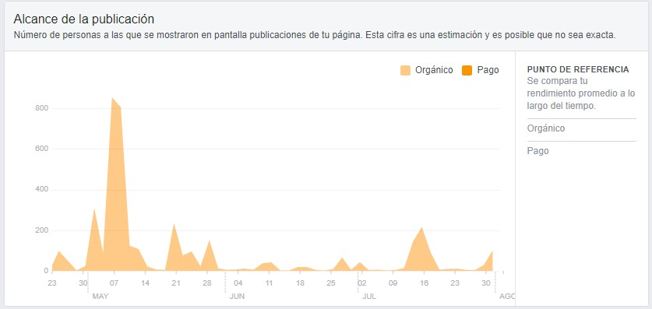
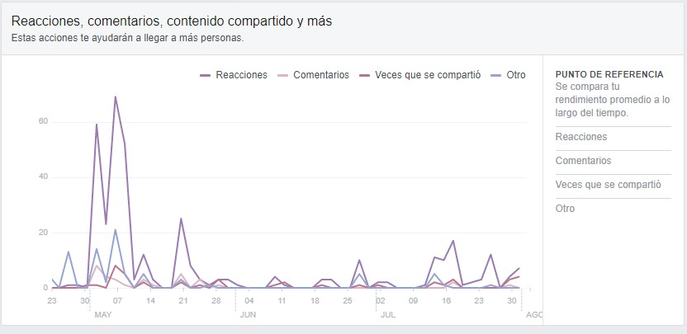
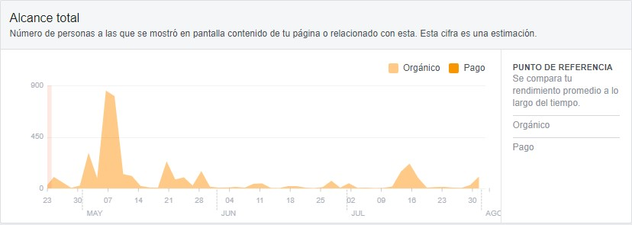

STAFF
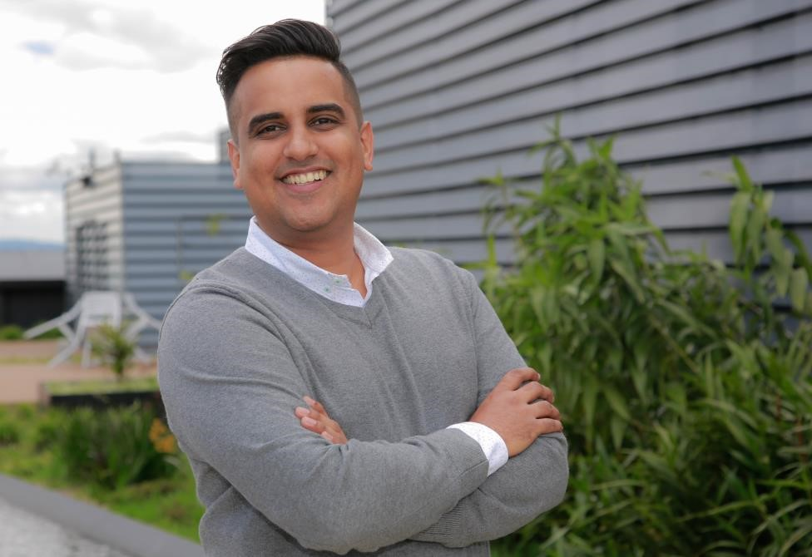
CARLOS DANIEL ACUÑA CALDERA
National Coordinator
Bacteriologist, Master in Local Development Management. Contractor of the Directorate of Mentality and Culture for the CTeI of Colciencias. Leader of special projects of the Ondas de Colciencias program

