ANNUAL REPORT

GLOBE Ecuador
2018 - 2019

TABLE OF CONTENTS
INTRODUCTION 3
EDUCATION 4
TECHNOLOGY 5
APENDIX 6
STAFF 8

INTRODUCTION
GLOBE Ecuador seeks to find a sustainable space for operations in the country, trying to overcome the legal and socio-political obstacles that have prevented or limited for about 14 years that programs of this kind can be carried out within the formal educational community. Overcoming these obstacles means identifying the spaces in which it is possible to act legitimately, and, at the same time, efficiently and effectively.
Legally, it means that it seeks to be under the prevailing legal order until the education law, which is in process, is positively modified, but acting with those institutional and structural elements that do not challenge the established order. Such is the case of the municipal educational establishments, which are administered with an autonomous system in front of the general tax system, where they are seeking to act with legitimacy also overcoming the natural limitations of the respective political-institutional order.
In terms of efficiency and effectiveness, it is sought that the efforts carried out to apply the GLOBE from now on, can be carried out with an evolutionary projection in accordance with the prevailing "GLOBE system" in its various elements. In other words, it implies optimizing what until now has been the practice of measuring-observing-sending data, but advancing to new levels in data analysis and the use of its results by various educational actors and technical and local scientists.

EDUCATION
Regarding the actions carried out and based on the EDUCATION goals of the GLOBE Strategic Plan 2018-2023, the following are detailed.
Student investigations.
We have sought to increase the number of GLOBE schools and students conducting GLOBE-informed research. For the effect:
- Meetings have been held with the highest education authorities in the country to obtain their sponsorship and facilitate action with fiscal educational establishments: the Minister of Education and the Undersecretary of Educational Foundations.
- Two field demonstration sessions were held (with two educational establishments belonging to the Rumiñahui Canton) of the GLOBE observation and measurement processes for the Undersecretary of Educational Foundations.
- Two sessions were held to explain the scope of GLOBE with the Director of Environmental Education of the Ministry of the Environment, in order to include actions as part of the National Strategy for Environmental Education and conduct research with members of rural communities.

TECHNOLOGY
Since 2016, three educational establishments in the Rumiñahui Canton have been working with the coordination of the OIKOS Corporation on Hydrosphere research, in response to the River Recovery Program of the Rumiñahui Municipal Government. The participation of these educational institutions is key in the studies on the state of the rivers throughout the Rumiñahui Canton carried out by the technicians of the Municipality. However, the data obtained is not sent to GLOBE for major political reasons of the Ecuadorian State.
However, after several meetings and conversations held between 2018 and so far in 2019 with the educational authorities of the country and the Rumiñahui Canton, interest and support have been achieved so that teachers and students are trained and can send data to the GLOBE. In order to increase the number of schools that provide data to the GLOBE system, a workshop has been scheduled for five establishments, which will take place in September 2019. For this purpose, the directors of these educational establishments have been interviewed, costs have been verified to estimate the values ​​that schools must assume to acquire equipment and supplies for various protocols (Atmosphere - Hydrosphere).

APENDIX
PERIODIC TRAINING OF TEACHERS
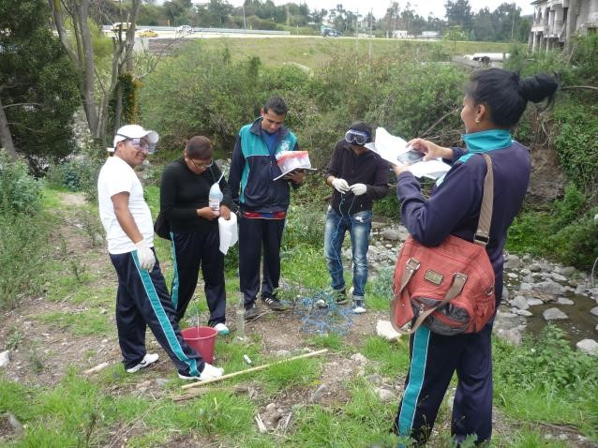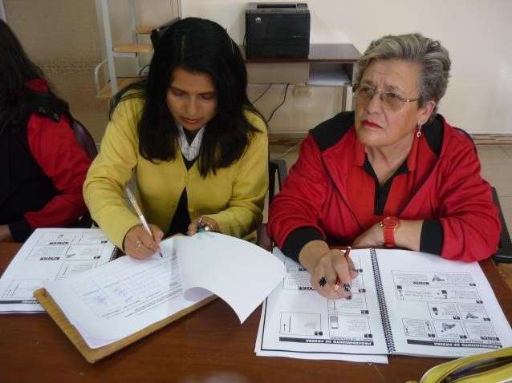

SAMPLING AND MEASUREMENTS BY STUDENTS
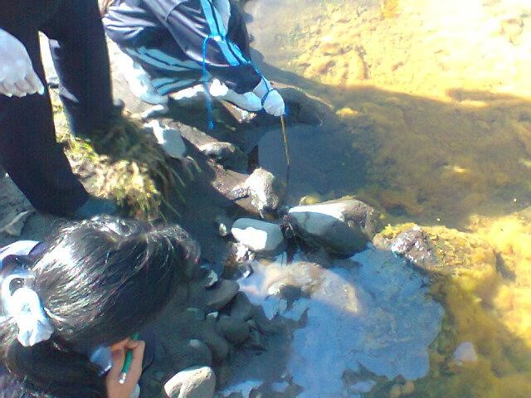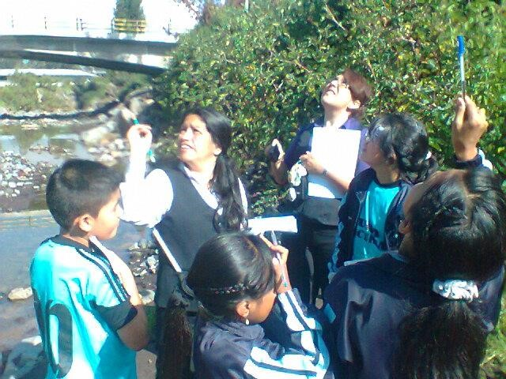

DEMONSTRATIONS TO THE COMMUNITY AND THE MUNICIPALITY OF RUMIÑAHUI
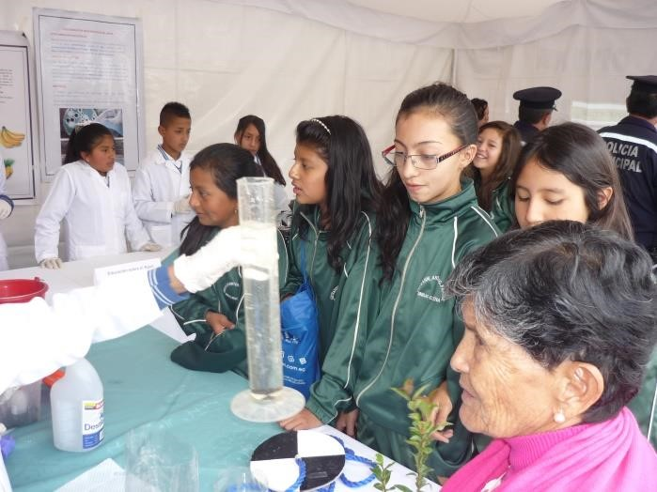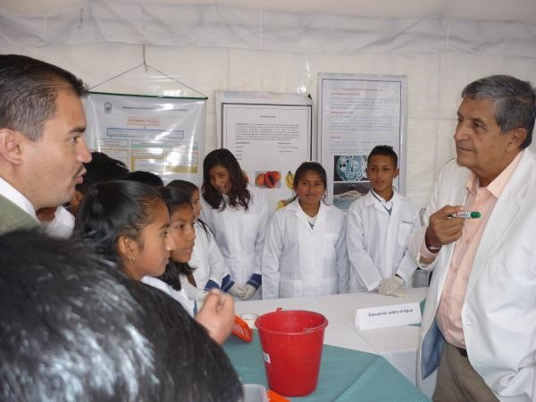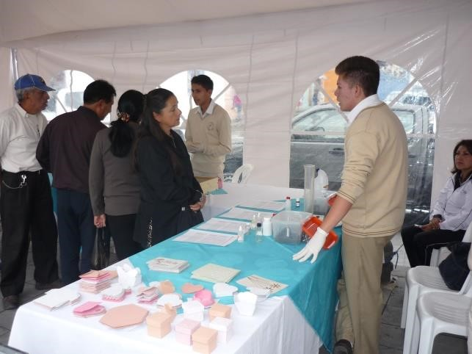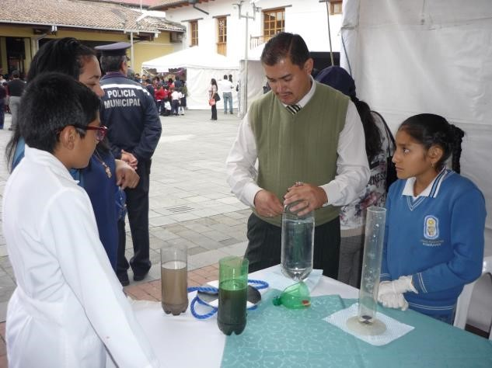

STAFF
Dr. Marco A. Encalada: Globe Ecuador Coordinator
Lic. Darwin Hernández J.: Master Trainer
Lic. Carlos Vacacela: Professor and Assistant

