ANNUAL REPORT
GLOBE Uruguay
2018 - 2019

TABLE OF CONTENTS
INTRODUCTION 3
EDUCATION 4
SCIENCE 6
TECHNOLOGY 7
COMMUNITY 8
GOALS FOR NEXT YEAR 9
APENDIX 10
STAFF 15

INTRODUCTION
The main GLOBE activities carried out by the GLOBE Coordination, teachers, Master Trainers and students between October 2018, after the Panama Regional Meeting, and mid-August of this year are presented.
We continue to prioritize the development of online modules in Spanish in Uruguay and make progress in carrying them out in countries of the region.
We also highlight the participation of the Macrocientis science club, from School No. 88 of Canelones, in the 23rd. Annual GLOBE Partners Meeting this year, as a team representing the LAC region, selected by the 2019 Virtual Science Symposium.

EDUCATION
11/28-29/2018 – At the invitation of the Coordinator of Colombia, Carlos Acuña, we participated in a workshop on Atmosphere and Hydrosphere, the coordinator of Argentina and myself, as Master Trainers, at Colegio Rochester. The participants were teachers of biology, chemistry, geography and mathematics. The practice was also carried out at school and a WhatsApp group is maintained, where doubts, achievements and updates are raised.
March-April 2019 – Online Atmosphere course with modules in Spanish, tutoring by me as Atmosphere MT. The practical exercise consisted of the presentation of photographs and the identification of 2 types of clouds and 2 different condensation trails. 26 participants also presented the project, of which 21 have already carried out the practical application workshop in Montevideo, on the Rambla de la Ramírez beach (May 26) and at the National Directorate of the Environment (July 2). The Cloud GLOBE Observer app was also taught in the practices.
March-April 2019 – Organization and technical support for the online Hydrosphere Course with modules in Spanish for Argentina, tutored by Marta Kingsland and Ma. Marta Daneri. They presented projects in the month of June, as a form of individual evaluation of the participants. Teachers from various regions of Argentina participated, including a participant from Peru. 12 participants completed the course in its entirety.
May-June 2019 – Organization and technical support for the online Atmosphere Course for Peru, at the request of its Coordinator, José Martín Cárdenas, and co-tutored with him. Project presentation or learning session, as a method of individual evaluation of the participants. Secondary school teachers from multiple regions of Peru participated, as well as 2 Uruguayan teachers. 27 participants finished.
The practice for Uruguay grouped the teachers who could not carry out the practice of the March-April course, with those trained in the course of Peru; it was carried out on July 2 in Montevideo, in the National Directorate of the Environment. This activity was combined with the outing for the observation of the eclipse. In the case of Montevideo, the sky was 100% covered with clouds, so the eclipse could not be observed, but current temperature, cloud and surface temperature measurements were made and the GLOBE Observer cloud app was used.
February-July 2019 – I was invited to participate in the Organizing Committee of the 23rd. Annual GLOBE Partners Meeting, with monthly virtual organization and follow-up meetings.
07/14/2019 to 07/19/2019 – Attendance at the GLE and 23rd. Annual GLOBE Partners Meeting in Detroit, Michigan, USA, as secretary of the GLOBE Assessment Working Group.
Fieldwork in clouds, GLOBE Observer app, tree height with GLOBE Trees app, mosquito larvae, land cover and carbon cycle protocol.
Part of the work was also 2 meetings of the Evaluation Working Group (at the beginning of the annual and at the end of all activities) to advance the work tasks and set new goals for the remainder of the year.
August 2018-July 2019 – Translation and adaptation of the Biosphere online modules into Spanish, layout and assembly for the Educantel platform. It currently consists of 17 submodules in its English version, of which the best known and most used in the research area will be adapted.
August 2019 – Launch of the Biosphere GLOBE online learning module for Uruguay, registration for the online course begins on September 2.
A second group will be organized for the same course, which will be the teachers of the Colegio Ciudad Vieja, who recently signed an agreement with the Ministry, and will do so as a form of remuneration in their responsibility policy.

Workshops and teachers trained and certified in figures
FOR URUGUAY:
1 Atmosphere online course + 2 practice days for two groups – 21 teachers
FOR THE REGION:
1 Online Hydrosphere Course for Argentina – 18 teachers
1 Online course on Atmosphere for Peru – 26 teachers

TOTAL: 65 teachers trained on Educantel's GLOBE platform.

SCIENCE
April 2019 - Given the increasing number of projects presented at the GLOBE Virtual Science Symposium this year, and given the limited number of jurors available, the Evaluation Working Group was asked to collaborate with the evaluation and correction of the projects. Therefore, all the members of the group participate, taking charge of at least 3 projects.
March – July 2019 – Participation in webinars to carry out activities on the total solar eclipse that took place on July 2. For Uruguay, it was partial viewing and it coincided with the primary and secondary winter vacations, so the students did not participate. The Coordination organized a conference that was previously discussed to carry out measurements and observations with the teachers.
April 2019 - The Macrocientis science club, from School No. 88 of Canelones, presents its project "Water quality in nearby areas to Canelones city through the use of macroinvertebrates as bioindicators" at the Virtual Science Symposium 2019. Moreover, it is awarded in the draw made by the GIO, among 226 projects worldwide, to represent the LAC region in the 23rd. Annual GLOBE Membership Meeting this year. The three members of the science club attended (Belén Viera, Mariano Aguilar and Nicolás Verde) accompanied by their teacher and director, Mtro. Darío Greni to Detroit to present the project. It was the only project presented by teachers from Uruguay.
Journalistic note (link): Canelones schoolchildren take their water quality research abroad

TECHNOLOGY
Completion of the online Biosphere module in Spanish with the technical support of the Educantel platform, a tool provided by the state entity ANTEL (National Telecommunications Administration) and facilitated for the purposes of DINAMA. The National Coordinator carries out the translation, adaptation and assembly and Biól Claudia Caro carried out the technical review.
The course was structured in the following modules:
- Introduction to GLOBE
- Introduction to Biosphere
- Biometrics: Land Cover Classification
- Biometrics: Canopy and ground cover
- Biometrics: Height of grasses, trees and shrubs
- Biometrics: Circumference of the trees
- Biometrics: Biomass of grasses
- Phenology: Foliation of trees and shrubs
- Phenology: Foliation of herbs
- Phenology: Foliar senescence of trees and shrubs
- Phenology: Leaf senescence of herbs
- Introduction to carbon cycle
Each module is made up of the presentation, material in .pdf documents, some learning activity and a final exercise. At the end of each module, the respective evaluation is carried out, which must be approved with a minimum of 80% in order to access the next module.
Once the complete module is finished, the participants are asked to propose a research project for their educational center, of 3-4 pages on the protocol(s) they wish, the tutors evaluate it and the feedback is sent to them with suggestions.
The last stage consists of the face-to-face meeting where doubts are clarified, measurement instruments are presented and elaborated and the field practice is carried out. The new GLOBE Observer apps are incorporated here: GLOBE Trees and GLOBE Land cover.

COMMUNITY
April 25-May 3: Within the framework of Earth Day, and joining the GLOBE Trees Challenge Campaign, teacher Darío Greni organizes with his students a day to measure the height and circumference of trees in the surroundings of the Alfred Nobel School, carrying out identification of native species. Secondary Prof. Sandra Farina, from the IAVA High School, for her part, joins the celebration with her 5th grade students. Year adults of the night shift, a day where the Santo Domingo School is invited to participate, with its teacher Claudia Maidana and her 4th grade students. Biological. They also carry out measurements of the biosphere, plus some of the hydrosphere, taking advantage of the field trip. 39 students from the 3 institutions participate. They work with the GLOBE Trees app.
May 2019 – Our Ministry signs an Agreement with the Colegio Ciudad Vieja, in Montevideo, with the counterpart that it commits to applying corporate social responsibility policies. Within this framework, it is agreed to carry out GLOBE workshops, training of primary and secondary school teachers, and other environmental education activities. They will begin to be implemented in October 2019 with an online workshop on the biosphere area.
2018-2019 - Regarding the tasks carried out by the Evaluation Working Group for the GLOBE community, there are:
- Preparation of a pre and post test on students' attitudes towards science, at the request of the Coordination of Ireland, to implement with secondary school students at the beginning and at the end of the school term, in order to assess learning with GLOBE. To apply in the second semester of 2019. It is available so that other interested parties can request it. In fact, the Europe-Eurasia regional office stated its intention to apply it in the Czech Republic.
- Application of a 3-question survey for GLOBE teachers, which began to be applied during the annual meeting and was completed in February of this year. The results were presented at the 23rd Annual GLOBE Meeting in Detroit, USA.
- A form was prepared to disseminate to the Regional Offices, national coordinators and teachers, about publications and studies they have carried out on longitudinal and impact studies, on the evaluation of the GLOBE program. The products obtained will be disseminated through the GLOBE page.
- At the end of Siham Salman's period in the group, in December 2018, a member of the NENA region, he joins Hanan Albuflasa, from Bahrain, in May.

GOALS FOR NEXT YEAR
- Offer to other Spanish-speaking countries in the region to join this initiative of the GLOBE online modules in Spanish, facilitating the task of conducting workshops for national coordinators and master trainers and providing tutoring for them.
- Engage more projects in the GLOBE Virtual Science Symposium.
- Coordination of joint projects between countries and regions with priority issues for our country.
- Continuous support for trained teachers to plan projects, loans of materials and instruments, visits to the educational center for advice, etc.
- Certify the Mtro. Darío Greni and one more teacher as Leader Trainer in the GLOBE protocols.

APENDIX
Earth Day Conference "GLOBE Trees Challenge" in Montevideo and Canelones in Montevideo and Canelones: Liceo IAVA, Colegio Santo Domingo, Esc. Alfred Nobel. April 2019
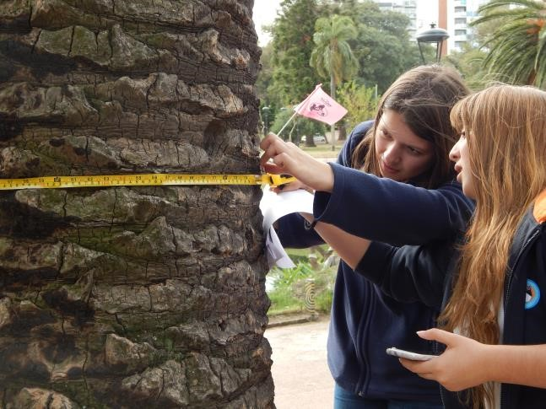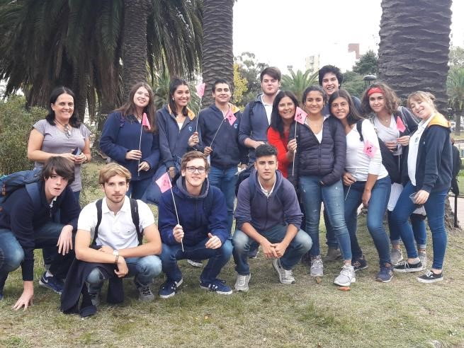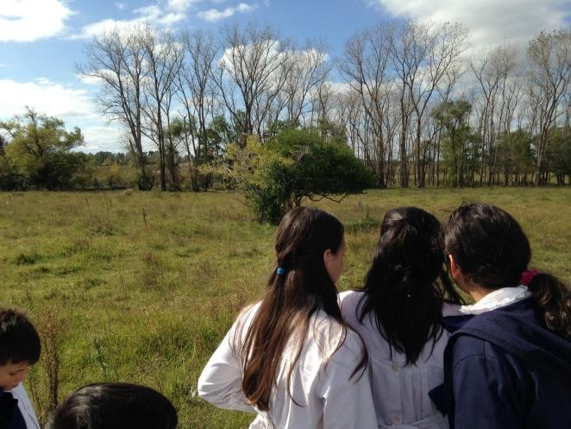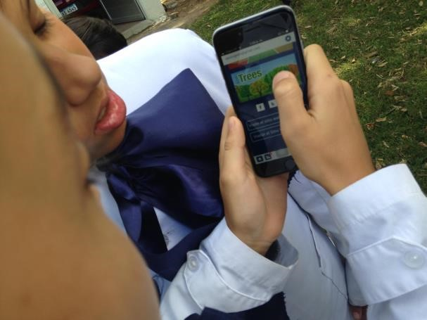

Practical Workshop on Atmosphere corresponding to the March 2019 Online Course. Playa Ramírez and DINAMA.
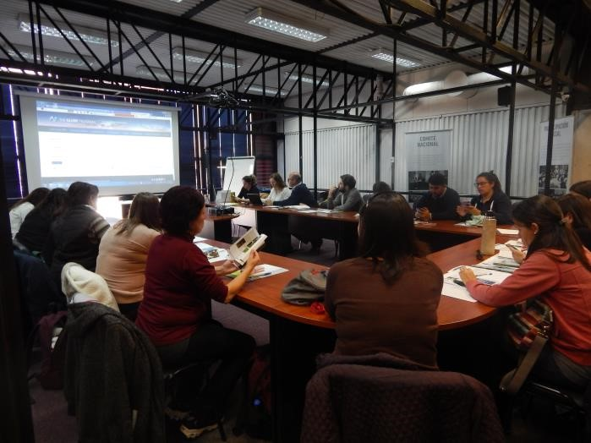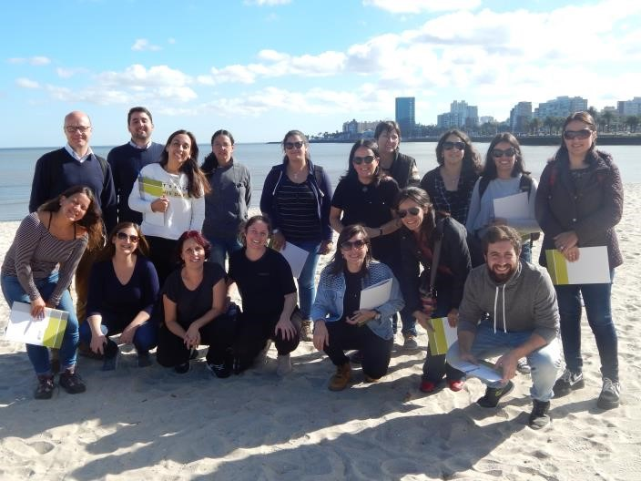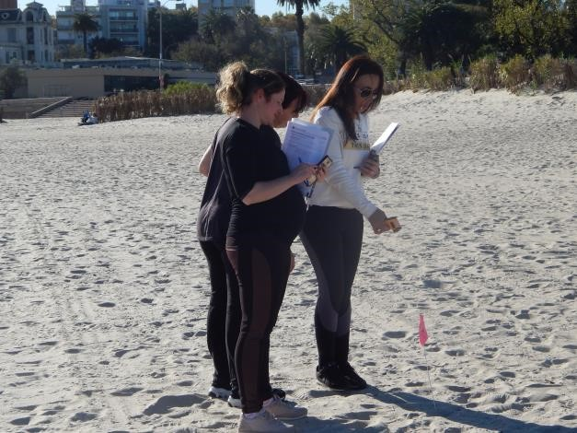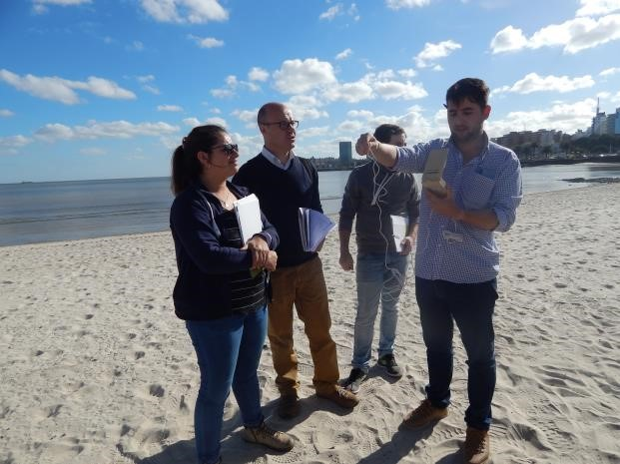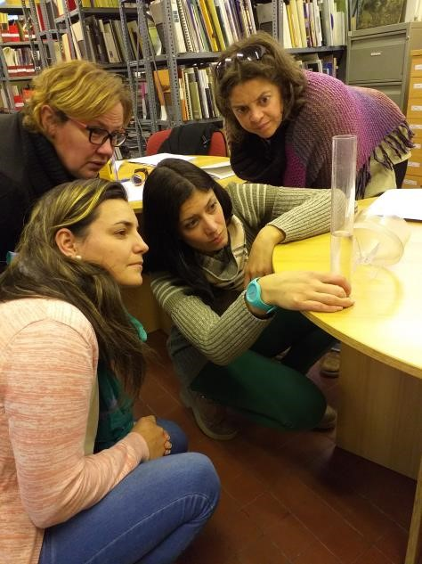

Mail from Julie Malmberg informing us of the IVSS winning project for the LAC region. May 2019
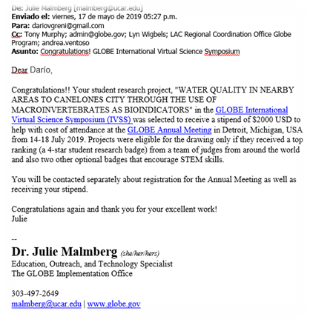

Presentation of the Macrocientis science club of Uruguay at the 23rd. GLOBE Annual Meeting Teacher: Darío Greni Students: Nicolás Verde, Mariano Aguiar, Belén Viera Detroit, July 2019
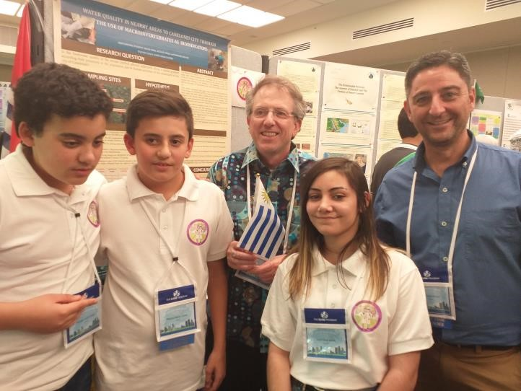
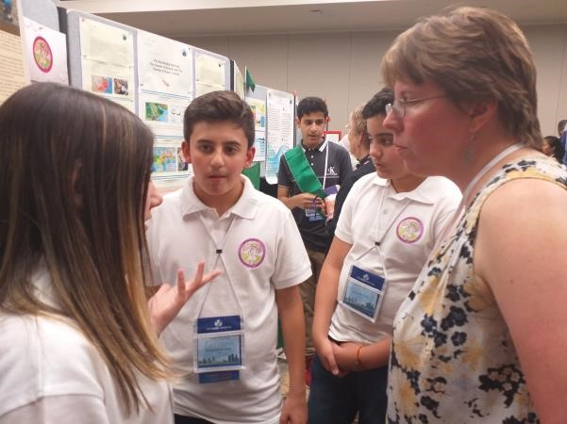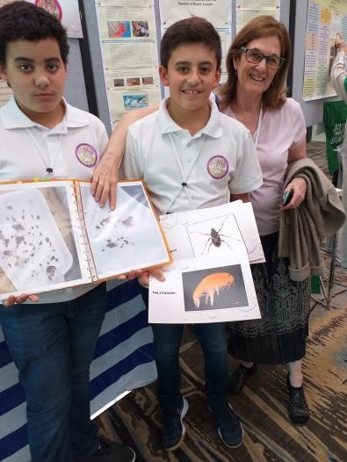
Presentation of the group of students from Latin America after working in the science camp during the 23rd. GLOBE Annual Meeting
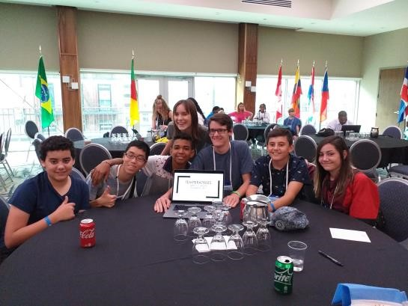

Presentation of the GLOBE Task Force on Assessment of the questions to teachers applied in the GLE 2018. Andrea Ventoso-Nektaria Adaktilou
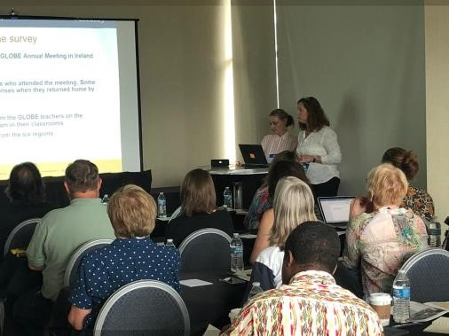
Field work during the 23rd. GLOBE Annual Meeting. Detroit, July 2019.
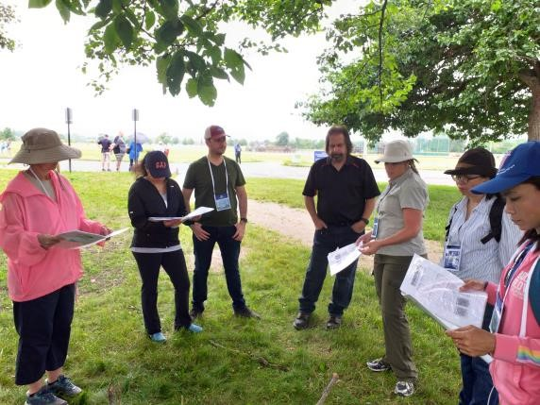
Observation of the covered sky during the solar eclipse, July 2019.
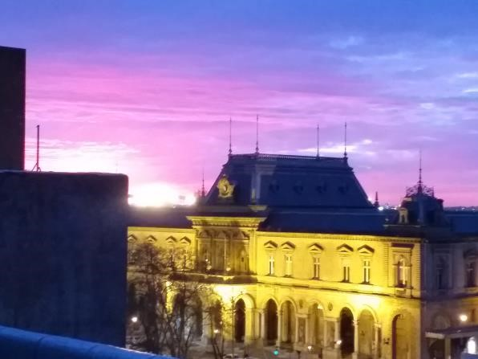

STAFF
GLOBE Uruguay Coordinator:
Lic. Andrea Ventoso
Atmosphere Master Trainer
Hydrosphere Trainer
Secretary GLOBE Task Force on Assessment
Mail: andrea.ventoso@mvotma.gub.uy
Telephone: 2917.07.10 ext. 4654
Honorary Staff:
Alternate GLOBE Coordinator:
Prof. Dir. Patricia Piriz
Hydrosphere Master Trainer - Biosphere Master Trainer
Mail: patywuan@gmail.com
Prof. Chem. Alejandra Gualco
Hydrosphere Assistant Trainer
Mail: prof.alejandragualco@gmail.com
Master Dir. Dario Greni
Hydrosphere Trainer
Atmosphere Trainer
Mail: dariovgreni@gmail.com
Bachelor of Biol. Elena Rodó
Water Quality Division
National Environment Directorate

