ANNUAL REPORT
GLOBE Argentina
2017 - 2018

TABLE OF CONTENTS
INTRODUCTION 3
EDUCATION 4
SCIENCE 5
TECHNOLOGY 8
COMMUNITY 9
COMMUNICATION 10
APENDIX 11
STAFF 13

INTRODUCTION
The activities that the Technical Operational Team, in charge of the GLOBE Program in Argentina, carried out in the period September 2017 / August 2018, together with more than 937 members, including teachers and students, representing more than 262 schools, are detailed below.
The various activities carried out reflect the constant diffusion of the Program in Argentina as well as the interest of the educational community in the GLOBE Program. In this period, we have carried out activities in order to publicize the Program, working together with teachers and students, accompanying them as far as possible in the different projects and activities that they carry out related to the GLOBE Program in Argentina.
Groups of students accompanied and guided by their teachers who have been trained over the years in different GLOBE Workshops, have participated in various science fairs, participated in collaborative work, sending works to the Virtual Science Fair and sending more than data to the database.
On the other hand, and in the context of the GLOBE project, involving citizens in the forecast and observation of Mosquito threats, we have participated in the Regional Workshop together with Paraguay and Brazil in the workshop held at the Itaipu binational dam. Continuing to develop the actions to complete the workshops to which we have committed ourselves.

EDUCATION
SEPTEMBER 2017 Talk by Peter Falcon (GLOBE Program and NASA) at Todos los Santos school.
SEPTEMBER 2017 Presentation at the Science Week at the Huergo Institute by Prof. Marta Kingsland who spoke to teachers and students about the characteristics and application of the different Apps developed by the GLOBE Program.
APRIL 2018 GLOBE Workshop April 24 and 25, 2018 at the Province of Buenos Aires. The Workshop focused on the Atmosphere research area. New teachers and others attended with the aim of updating different topics on Atmosphere. During the GLOBE Workshop, Dr. Paola Salio PhD in Environmental Sciences - Member of the Research Center of the Sea and the Atmosphere - CIMA/CONICET-UBA. She spoke about the Storm Project
MAY 2018 Collaborative work on "Water in the environment we live in", activity convened and programmed from NASA by Dorian Janney and Brian Campbell. The activity was developed jointly with the Todos los Santos school in Argentina, two schools in the USA and one in Suriname. It was a three-week project in which teachers and students participated in theory and practice applying protocols from the Atmosphere and Hydrosphere research areas, linking content from different disciplines. Finally and closing the activity and participation in a webinar where they shared the work done.
JANUARY 2018 Marta Kingsland ends the period in the EDUCATION working group

SCIENCE
AUGUST 2017: From the National Program for the Popularization of Science and Innovation Ministry of Science, Technology and Productive Innovation, the FIRST NATIONAL ENCOUNTER was organized from August 16 to 19, at the Cultural Center of Science of the city of Buenos Aires. THEME OF THE SCIENCE CLUBS NETWORK. In said meeting, the clubs of the country that at that time were working on Technology or Environment projects were presented. The province of Santa Fe selected the project "Global Climate Change, Local Impact III, does it rain or does it not rain?" of the CC76 for the Environment area. The participation was very successful; Professor Stella Marino, who joins the group of teachers of Club 76, accompanied the delegation, which was taken into account for future presentations.
SEPTEMBER 2017: On September 18 and 19, 2017, Peter Falcon, NASA and GLOBE Program trainer, visited Argentina and developed various activities at Colegio de Todos los Santos, GLOBE school. In said workshop, he spoke about different activities related to science and space rockets, as a topic to interest students in the importance of scientific careers in the world today and in the future.
OCTOBER 2017: The members of the CC76 participated with the project "Annual and multi-annual pluviometric variability" of the EXPOCYTAR 2017 Fair - V EXPOCIENCIAS, organized by the Science and Technology Club No. 459 "AMÜN KAMAPU" with the aim of generating a space for exhibition of research projects and exchange of work, interpersonal and cultural models. The event was held from October 5 to seven in Santa Rosa de la Pampa, with the assistance of clubs from other countries.
On this occasion, the student Jazmín Almará and the teachers Alejandra Romagnolli and Stella Maris Marino attended. With great joy, the participants received the highest prize, the accreditation to participate in the OESEF Expociencias in Turkey 2018.
OCTOBER 2017: Eng. Eugenia De Marco, Argentine Engineer from NASA visited the Colegio Nicolás Copernico School and in a meeting with students from that house of study, she explained the work that NASA was doing in Antarctica-
NOVEMBER 2017: GLOBE students from EESO 241 in Pujato, Santa Fe in Tecnópolis presented the work "Impact of cloud cover on photovoltaic performance" during the week of November 17 to 20. Buenos Aires was selected first in Oriented Secondary Education for the Natural Sciences area (Physics).
This highlight was obtained by the project within 44 secondary NC works from all over the country and with the consensus of all the evaluators of the Secondary Natural Sciences Commission, made up of teachers and professionals from the 24 Argentine jurisdictions.
Two students made the presentation of the study from third B: Martina Caturano and Naiara Barrios, who were accompanied in CABA throughout the event by the Director of the School, Prof. María Ana Sormanni.
APRIL AND MARCH 2018: Participation of the members of GLOBE Argentina in a webinar on several occasions: What is the Child? March 2018, Surface and Soil Temperature, April 2018
APRIL 2018: Participation of Marta Kingsland Ana Prieto as a jury at the International Virtual Science Symposium Fair. Online modality
JUNE 2018: GLE 2018 in Ireland the following works were presented
GLOBE Learning Expeditions 2018 - Killarney, Ireland. July 1 to 6, 2018: The Huechulafquen Science Club presented the following reports:
- Aquatic macroinvertebrates and their importance as bio indicators of water quality in the Chimehuín River, Patagonia, Argentina. Video Research Report
- Substrate evaluation for horticultural use in arid zones of the Patagonia region, Argentina.
Moisture retention and growth of radishes in the orchard and greenhouse were evaluated in different substrates (volcanic ash, vermicompost, vermicompost mixture, yerba mate and volcanic ash, control soil). Investigation report
GLOBE Learning Expeditions 2018 - Killarney, Ireland. July 1 to 6, 2018:
Claudia Romagnoli and Viviana Sebben, teachers from Santa Fe, Argentina, presented the work "Meteorology at school". A training project was presented for primary teachers (1st-7th grades) on topics related to the Atmosphere, included in the curricular contents of Natural Sciences. The objective is to train teachers to introduce their students (6-13 years old) to the observation and recording of meteorological variables following the GLOBE protocols. Finally, students do different school investigations.
JUNE 2018: Presentation in Turkey
From June 4 to 9, 2018, the OKSEF International Science Fair (OGUZHAN OZKAYA EDUCATION KARADEMIR ENERGY ENGINEERING SCIENCE) was held in Cesme, Turkey. Members of the Science Club N 076 “Prof. Dr. Julio Maiztegui” with the work “Multiannual and Annual Rainfall variability”, in the BIOLOGY: Enviromental Science: Meteorology Category, applying various protocols of the GLOBE Program. A student presented it and the advisors for the aforementioned work were Prof. Adriana del Carmen Iturre, and Lic. Prof. Stella Maris Marino. Alejandra Mónica Romagnolli, Principal Director of School No. 1345.
MAY 2018: Marta Kingsland, Adriana Fernández and Claudia Romagnoli participated in the Workshop on ZIKA Mosquito prevention and detection, in Lima, Peru
MAY 2018: Remote participation in the event "Vector-borne and Water-related Disease Workshop" May 2018
AUGUST 2018 Workshops on Mosquitoes in some cases sharing the workshop with neighboring countries such as Paraguay and Brazil
SEPTEMBER 2018: Free workshop "Involving Citizens in the Prevention and Observation of Diseases transmitted by Mosquitoes" by #GLOBEArgentina on #Zika and #Dengue on September 4 in the city of Alejandro Roca, Córdoba. Argentina
The development of the workshops in Argentina continues. They are scheduled for the month of September in Tucumán, Corrientes, Santa Fe and Buenos Aires.

TECHNOLOGY
Video explaining in Spanish how to participate in the GLOBE 2018 Virtual International Science Symposium and tips for developing a project. Marta Kingsland, Andrea Ventoso and Claudia Caro participated.
Making a video of the Annual GLOBE Argentina Workshop 2018 Ana Prieto, teacher GLOBE Argentina is part of the Working Group, integrating the Technology group whose purpose is to advise and test modifications to the GLOBE Program website and cell phone applications.
Presentation of an Institutional video, made by the GLOBE teacher, Adriana Mistó.

COMMUNITY
Teaching support: GLOBE teachers who request it are continuously advised and assisted
Adriana Mistó, a teacher who works in Córdoba. She learned about a NASA program to observe clouds and thus came to the GLOBE Program. Today she is a GLOBE teacher. Learn about her story https://eldoce.tv/sociedad/adriana-misto-maestra-rural-ensena-emociona-alejandro-rojaraul- romero-educacion-dia-maestro-cordoba-telenoche-videos_49923
María Marta Daneri participated in the delivery of recognition diplomas to the GLOBE students and teachers who worked on the "Impact of cloud cover on photovoltaic performance" in Pujato Pcia de Santa Fe
María Marta Daneri and Claudia Romagnoli participated in Rosario Santa Fe in a meeting with representatives of the Ministry of Education of that Province, explaining the scope of the program and the possibility of signing agreements with it.
Participation in meetings at the US Embassy with Vice Consul Nicholas D. Austin, with Michael García, Counselor for the Environment, Science, Technology and Health, and Ángeles Coscolla from the same area.
Communications with representatives of the Rotary Club of Iguazú in order to organize the Regional Workshop held at the Itaipú binational hydroelectric plant, Paraguay.
Meeting with representatives of the Ministry of Health of the City of Buenos Aires.

COMMUNICATION
We continuously keep updated information on both Facebook and Twitter of the GLOBE Argentina page, making the latest news known www.globeargentina.org
On September 11 Teacher's Day, GLOBE teacher Adriana Mistó received an important recognition. Her government declared her "Outstanding Teacher 2017" for her noble work at the Raúl Romero rural school in Alejandro Roca, a town south of Córdoba in Argentina.

APENDIX
Visit of Peter Falcon to the College of All Saints - September 2018
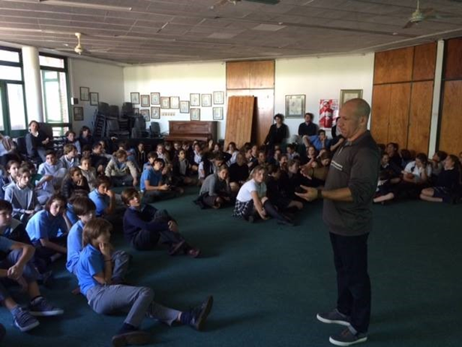
Visit of the Ing. Argentina: Eugenia De Marco from NASA to the Colegio Nicolás Copernico
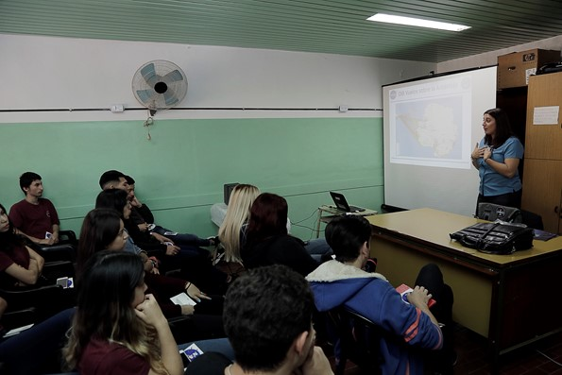
GLOBE students of the EESO 241 of Pujato. Santa Fe November 2017
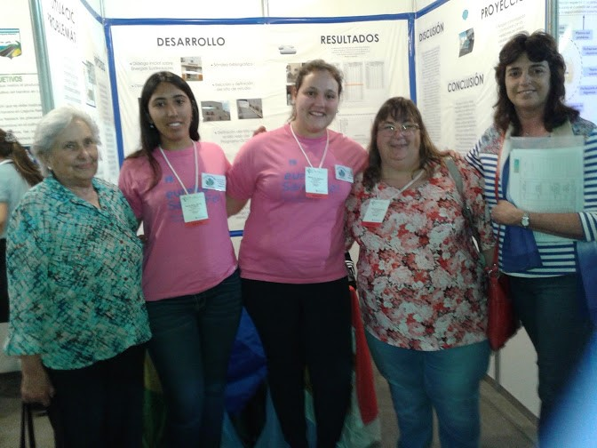
Annual Workshop 2018, Buenos Aires
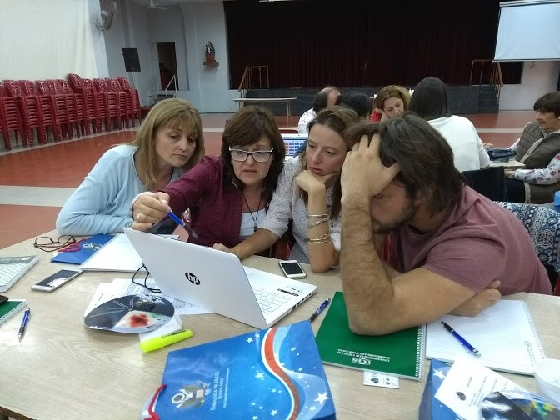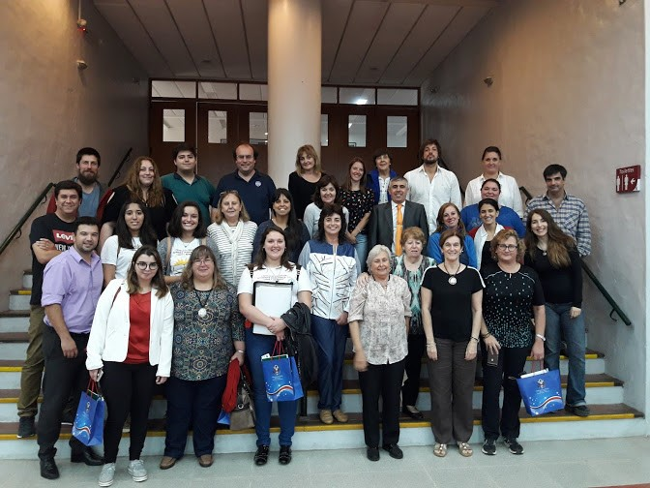
Argentine teachers and students at the GLE 2018 in Ireland
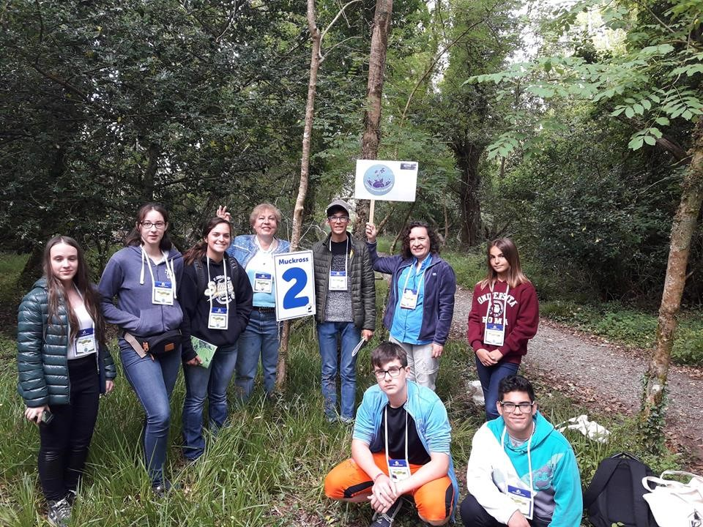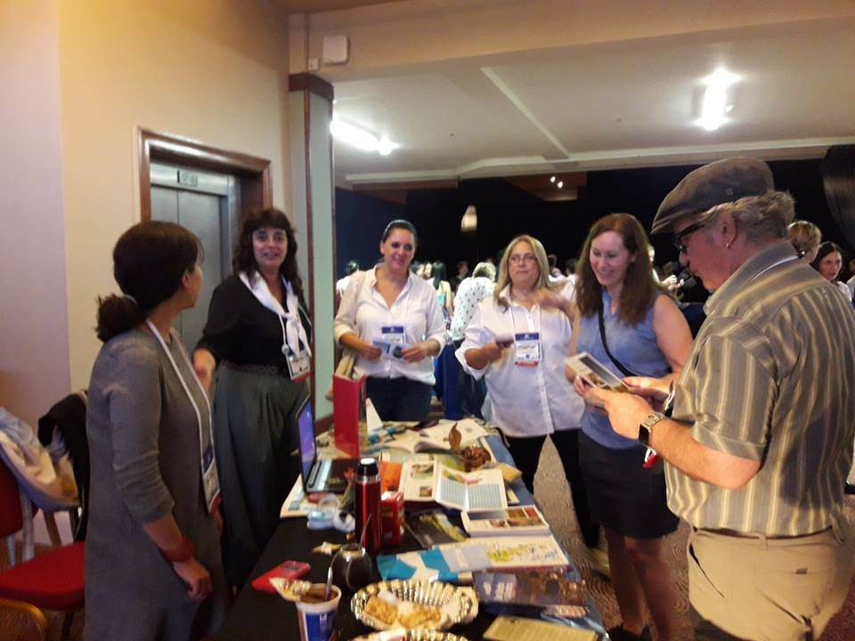

STAFF
National Coordinator: Marta Irene Kingsland
Alternate National Coordinator: María Marta G. de Daneri
Operational Secretary: Graciela María Martínez
Zonal Coordinations:
Autonomous City of Buenos Aires: Marisa Dilernia
Province of Buenos Aires: Oscar Busch Norra Garra
Province of Neuquén: Ana Beatriz Prieto, Maria Eugenia Bertossi (Alternate)
Province of Santa Fe: Claudia Romagnoli
Province of Tierra del Fuego, Argentine Antarctica and South Atlantic Islands: Gustavo Lezcano

