ANNUAL REPORT
GLOBE Mexico
2009 - 2010

TABLE OF CONTENTS
INTRODUCTION 3
LINES OF INVESTIGATION 6
SCHOOLS 14

INTRODUCTION
WHAT IS THE GLOBE PROGRAM?
It is an international science and technology program, which takes place in schools and brings together students, teachers and scientists from around the world in the study of the environment.
GLOBE stands for Global Observations and Learning for the Benefit of the Environment.

GOALS OF THE GLOBE PROGRAM
Promote environmental awareness by stimulating
interest in the environment in the world population.
• Contribute to increasing scientific knowledge about the Earth.
•Increase the achievement, performance and academic improvement of students and teachers in relation to science and mathematics.

Who participates?
Worldwide, 112 countries participate with 23,000 schools in which students, guided by trained teachers, carry out environmental measurements to significantly strengthen the analysis and knowledge of the environment and environmental problems in their places of origin. Mexico has participated since 1996 and currently 112 schools have been incorporated nationwide.
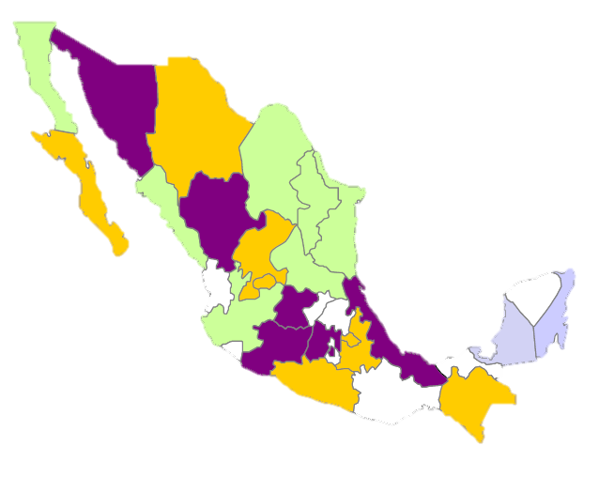
Violet: Entities in operation, already sending data
Green: Entities trained and with significant progress in the integration of instructor templates
Yellow: Entities trained, pending integration of instructor templates.
Gray: Entities in diffusion
Schools of the basic, normal, upper secondary and superior levels registered in the Globe Program 1997-2009
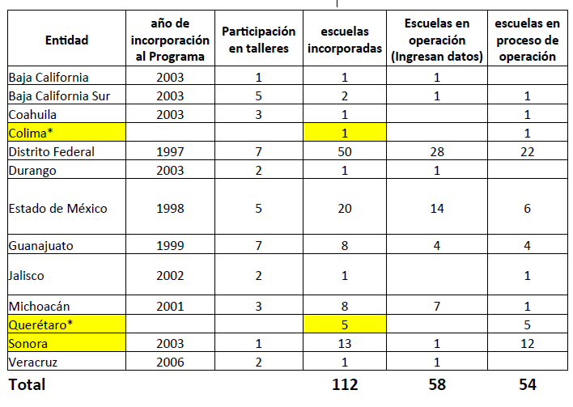
NOTE: In August 2009, the access code was managed and granted to 8 Technical High Schools in the D.F. and a campus of the Technological Institute of Higher Studies located in Valle de Bravo, State of Mexico.
*The Globe Mexico Coordination did not make the request for incorporation, nor was it aware of it.

Of the 58 active schools nationwide in the system, only 34 send data frequently.
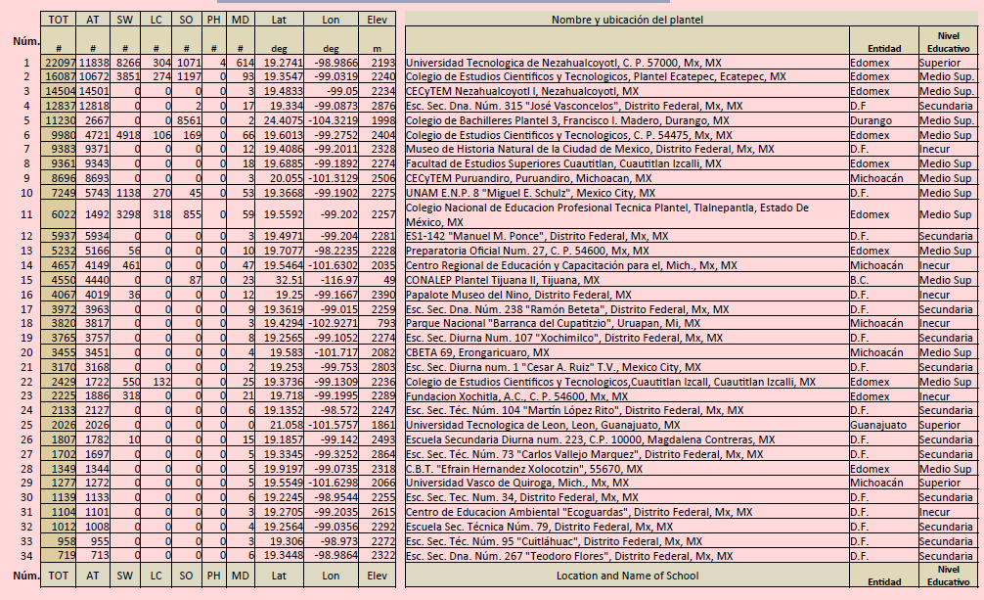

In the federal district have been incorporated
- 21 secondary schools belonging to the Coord. Secondary Education Sector,
- 21 Technical High Schools,
- 6 Day High Schools in Iztapalapa,
- 2 education, culture and recreation institutions.

LINES OF INVESTIGATION
- Atmosphere
- Soils
- Hydrology
- GPS
- Plant Cover
Atmosphere
Atmosphere protocols and equipment necessary to carry out the measurements
Protocols of:
- Maximum and minimum temperature, temp. air or current,
- Quantity and pH of precipitation,
- Cloud type and cover.
Necessary measuring instruments:
- Maximum and minimum thermometer
- Calibration thermometer
- pH indicator paper
- Rain gauge
- Weather shelter
- Cloud type chart
- Computer equipment with internet access available for data entry.
Frequency of realization: daily
Hydrology
Hydrology protocols and equipment necessary to carry out the measurements
Protocols
  - Transparency,
  - Temperature,
  - Dissolved oxygen,
  - pH,
  - Electric conductivity,
  - Alkalinity,
  - Nitrates
Necessary measuring instruments:
- GPS to locate a sampling site near the campus.
- calibration thermometer
- Dissolved Oxygen Meter Kit
- Alkalinity test kit
- Nitrate measuring case
- pH indicator paper
- tds tester
- Standard solution (e.g. Potassium chloride solution)
- Distilled water
- 50 or 100 ml beakers.
- A jewelry screwdriver for calibration
- Containers for collecting samples (cuvettes with resistant cords)
- Turbidity tube or Secchi disk.
- Computer equipment with internet access available for data entry.

Performance frequency: weekly
Land Cover
Land Cover and Biology Protocols and Equipment necessary to perform the measurements
Protocols of:
- Identification of species,
- Classification of modified vegetation,
- Calculation of biomass.
Necessary measuring instruments:
- GPS to locate the site for sampling near the campus
- MUC classification scheme
- Tape measure
- Clinometer (crafting)
- Densiometer (elaboration)
- 20 stakes to mark and delimit the quadrant in the study site.
- Drying oven
- Computer equipment with internet access available for data entry.
Performance frequency: Once or twice a year at each change of season.
Soil
Soil protocols and equipment necessary to carry out the measurements
Protocols
- Identification of horizons,
- Structure,
- Consistency,
- -Texture,
- Carbonate content
Measurement tools required:
- GPS for the location of a site near the campus to carry out the sampling
- Shovel and pick
- Spray bottle
- Tape measure
- 10 golf ball holders to mark the limits of horizons
- Floor color chart
- Soil thermometer
- Three beakers
- Ph indicator paper or pen
- Soil dispersant (sodium hexametaphosphate) or low foaming detergent.
- Kit to measure soil fertility (nitrogen, phosphorus and potassium)
- Oven for drying
- Garnet balance
Performance frequency: Once or monthly for a year.
GPS uses and applications
The Global Geopositioning System:
It is the geographical location of the study sites previously selected for sampling through a satellite system.
The GPS is a device used to obtain the location of a study site to carry out sampling near the campus.
Necessary instruments:
- Global Positioning System (GPS) Receiver
- Data sheet
Performance frequency: Once for each study site

SCHOOLS
Role of schools incorporated into GLOBE
- Curriculum support,
- Formation of an interdisciplinary group,
- Approach of students to scientific subjects,
- Important contribution with the data generated by each school, for research on environmental issues,
- Preparation of environmental improvement projects based on the data generated both locally and globally.
Implementation of the GLOBE Program in Schools
- The incorporation of the GLOBE Program to the School Project is proposed.
- Each school determines the protocols it wishes to develop.
- Close link to the curriculum.
- multidisciplinary work.

