ANNUAL REPORT
GLOBE Mexico
2015 - 2016

TABLE OF CONTENTS
INTRODUCTION 3
EDUCATION 4
SCIENCE 5
COMMUNITY 6
APENDIX 7

INTRODUCTION
SEMARNAT, through the Center for Education and Training for Sustainable Development, initiated a training strategy throughout the country. Since 2001, institutional links have been established with the Secretariat of Public Education (Ministry of Education) in most of the Federative entities of the country, with secondary and higher education institutions, as well as with civil society organizations, in order to spread the educational benefits of the program and train to be able to implement it in schools.
Starting in 2001, the GLOBE Program Coordination in Mexico designed an outreach training strategy regional, with the aim of training instructors in the states that showed interest, in this way they were partially or fully integrated templates instructors in 28 entities of the country.
The Technical Secondary Education System (DGEST) periodically holds GLOBE Schools meetings where teachers and students prepare essays and propose projects derived from the Program's activities. They also document their teaching practice, to address scientific-educational issues. The measurements they make of the GLOBE protocols support specific projects such as: "Let's do a miracle through the air." They also participate in specific programs promoted by the GLOBE Program such as GLOBE at Night.
5th Meeting of GLOBE youth from Technical High Schools in the Federal District.
The General Directorate of Technical Secondary Education, through the Technological Subdirectorate, held the 5th GLOBE Youth Meeting, which was held on June 3, 2016 at the Sustenta Bioparque Urbano San Antonio - SEMARNAT in Mexico City.
Teachers and students from Technical High Schools participated in addition to 8 guests from national organizations
Participation focused on the formative contribution of the GLOBE Program to students.
EST 73 GLOBE Alumni Experience
EST 79 Clouds
EST 34 Climate change mitigation actions
EST 18 The GLOBE Program
EST 5 Environmental Actions in the GLOBE Program
EST 56 Experiences and environmental awareness from the GLOBE Program
EST 71 GLOBE at our school
EST 52 GLOBE and climate change
GLOBE Experiences at EST 76
The GLOBE Program at EST 117
EST 120 GLOBE and water care
EST 112 GLOBE and air pollution
EST 95 The GLOBE Program

Collaboration in the GLOBE Program of the Faculty of Higher Studies Cuautitlán
Delegation of Mexico and the Representatives of the GLOBE Program in Mexico and in the United States. (Santo Domingo, DR, May 2012)

ACHIEVEMENTS
To date, 27 meetings have been held; 65 workshops.
There are 2033 trained teachers, a staff of 29 Masters Trainers and 105 regional Instructors from 23 entities in the country.
GLOBE campuses in Mexico have reported 380,523 data points on the GLOBE page.
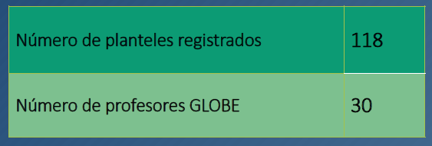

MAIN PROBLEMS
GLOBE teachers due to workloads in their respective subjects spend little time on the program.
Data entry is done infrequently, because they do not have computer equipment available or it is slow and they cannot do it in a timely manner.
Sometimes there is rotation of functions and therefore GLOBE teachers cannot attend the GLOBE Program, losing continuity.

STAFF
M. en E.A. Teresita del Niño Jesús Maldonado Salazar
tmaldonado@semarnat.gob.mx

