Tree height and carbon stored (40 minutes)
Steps for facilitators
- Aim: we will create a tree trail with some tree characteristics. ID, measurements, age and carbon stored (details in the worksheet).
- Create the groups. Assign them a tree to study.
- Parts 1, 2 and 3 in 30 minutes: prediction, height with clinometer (repeated), circumference with tape and calculate (ask tutor for carbon calc.).
- Part 4 (record on map): 5 minutes.
- Demonstrate use of a clinometer with another tutor. Explain how we can use the trigonometry rule for a simpler calc.
- Ask one person per group to collect the hand-out and equipment.
- Groups start. Facilitators go around the groups and observe, let them try and error, step in when asked or necessary. Facilitators provide the result of the carbon stored based on circumference and the equation in the Excel sheet.
- Call them to record their data on the map (tree trail).
- Unpacking the STE(A)M concepts covered by this activity, such as. Another tutor takes some notes on a page that will later be displayed (5 minutes).
  - Making a prediction, hypothesis (estimating the size before applying a method), thinking of ways of measuring without tape
  - Following a protocol, repeating a measurement, using instruments
  - Calculus, trigonometry, averaging…
  - Recording/comparing data
  - Tree trail for seeing and highlighting to others what is around
- Let them know about ground truthing of satellite images by NASA (Trees around the GLOBE)
- Demo measuring tree height with the GLOBE Observer app.

Tree measurements (3 parts)
1) As a group estimate:
- Your chosen tree height: meters
- And circumference of the tree trunk at chest height: centimetres
2) Estimate tree height using a clinometer:
What you need
Measuring tape Clinometer
In the field
A. Practicing: take the clinometer and look through the clear window. You will see an arrow, a line and a scale. The scale moves as you tilt the clinometer up or down. Notice how you can point at an object using the horizontal line and get a reading. Your partner can see that same reading when looking at the side of the clinometer.
B. Put yourself at a distance from your tree. You should be able to see the top of the tree from there. Now, looking through the clinometer and aligning the top of the tree with the horizontal line, note the reading from the clinometer.
C. At this location, have a partner stretch the measuring tape from the base of the tree to your toes (distance to the tree). Your partner then steps on the tape at the ground and runs it up to your eye level (height to eyes).
D. Give the clinometer to your partner and repeat the steps above for the same tree starting from a different starting point.
Recording your data
Measurement date: Time:
Instructions: measure the same tree 3 times, using the formula:
Tree Height = [TAN of Clinometer Reading] x [Distance from Tree (m)] + [Eye Height (m)]
>> To obtain TAN of Clinometer Reading refer to the table on the last page.
1) Clinometer reading (°): Tan of Clinometer reading:
Distance from tree (m): Eye height (m): Tree height (m):
2) Clinometer reading (°): Tan of Clinometer reading:
Distance from tree (m): Eye height (m): Tree height (m):
3) Clinometer reading (°): Tan of Clinometer reading:
Distance from tree (m): Eye height (m): Tree height (m):
Your comments: how do the three tree heights compare? Which one(s) will you select for the tree trail?

3) Estimate the age and carbon stored by the tree
What you need
Measuring tape Pen or pencil Tree swatch or ID guide
In the field
Measure 1.35m from the highest point of ground at the base of the tree upwards. Ask a partner to mark this height by putting their finger on the tree trunk. Then, measure the circumference of the tree trunk at that height.
Recording your data
Tree name (common or latin):
Tree circumference (cm): Age (years): (divide circumference by 2.5)
Carbon stored: kg (provide tree circumference and ID to facilitator who will then give you this figure)
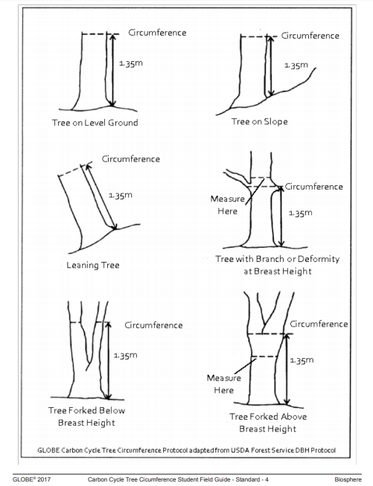
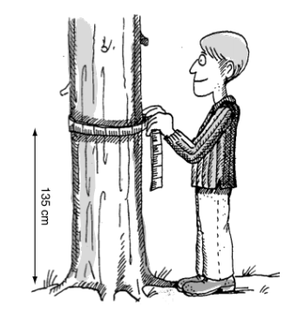

4) Tree trail
What you need: map post-it notes pen
- Add your tree data on the map:
- Put a number on a map where your tree stands.
- Put the same number on your post-it note. Add the tree’s ID, height, circumference, age, carbon stored. Put your post-it at the bottom of the map.

5) Height of a tree using GLOBE app (demo by tutor)
What you need
Phone or tablet with GLOBE Observer app and account created
Measuring tape (optional)
In the field
- Choose a tree on level ground
- Open the GLOBE observer app. If prompted to sign in, enter your log in details.
- Choose “Trees” protocol. If you are new to this protocol, complete the short tutorial. The most important tip is to keep your device at eye level when measuring the angles. Tilt it to point to the base of the tree and the top of the tree. Avoid moving it up-and-down when doing so.
- Click on “New Trees Observation” and follow the steps.

Comments:

