This tutorial was made to help with downloading and processing of cloud data for student research projects focused on contrails, obscured vs. overcast or smoke observations.
Retrieve Data
- Go to https://datasearch.globe.gov/.

- Click on ‘Select Protocols’ and choose up to five protocols. You can use the GLOBE Data Visualizer (https://vis.globe.gov/GLOBE/) to explore and determine what you’re looking for. Click ‘Add to Filter’ once you’ve checked up to five boxes.

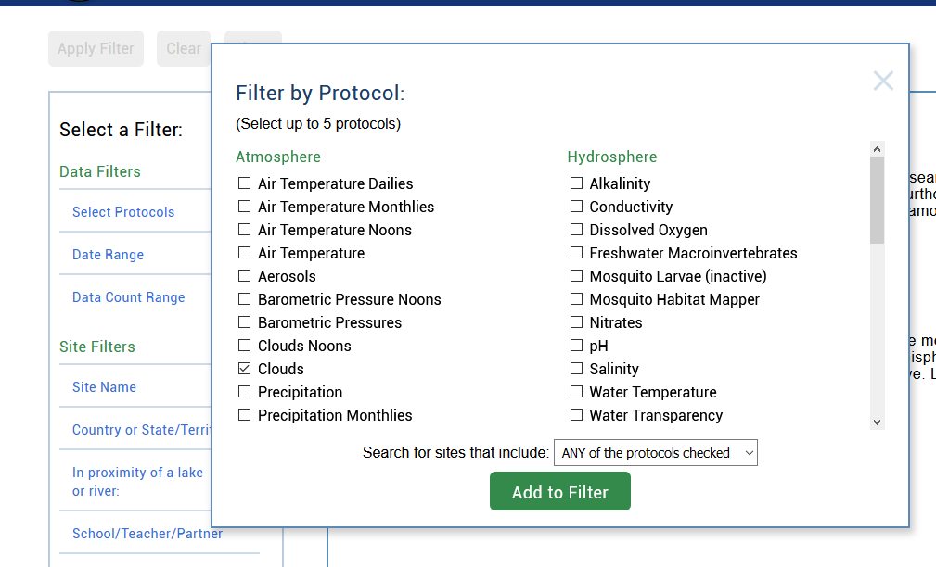
Check up to five

- Click ‘Date Range’ and then drag the blue boxes or click on the text boxes below ‘Start’ and ‘End’ to select the range of data you want to download.

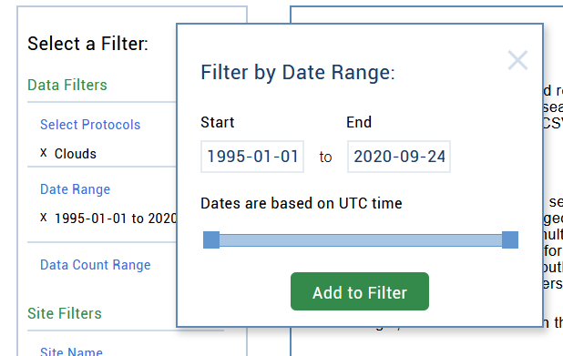

- Once you have decided on your range, click ‘Add to Filter’. There are often large amounts of data even among small periods of time. We recommend downloading no more than one month at a time. In the below image, we clicked on the ‘Start’ and ‘End’ boxes to bring up a calendar that let’s us select a week’s worth of data.

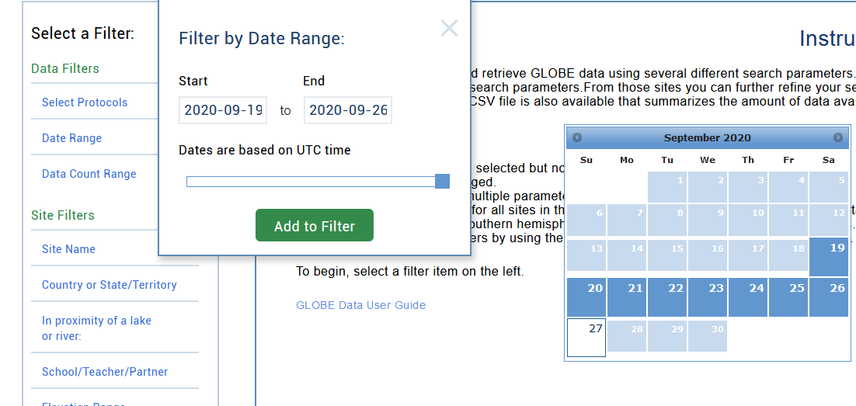
Clicking on the ‘Start’ or End’ box brings up this calendar. Click on a square to choose that day.

- Click ‘Apply Filter’ at the top of the page.

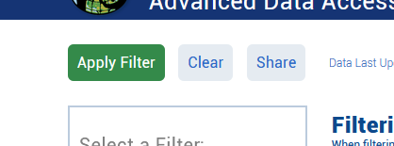

- The number at the top of the page represents the number of sites found. A site in GLOBE is a location (a unique latitude and longitude) where an observation was taken at. If you are good with the number of sites found, click ‘Obtain Measurement Data’, then ‘Download Measurement Data’ (it’s the same button as the one you just clicked) to download a ZIP file. Inside the ZIP file is a comma-separated values (.csv) file with the data you requested. This file can be opened in common spreadsheet editing software like Microsoft Excel or Google sheets.
‘Obtain Measurement Data’
becomes ‘Download Measurement
Data’ after clicking
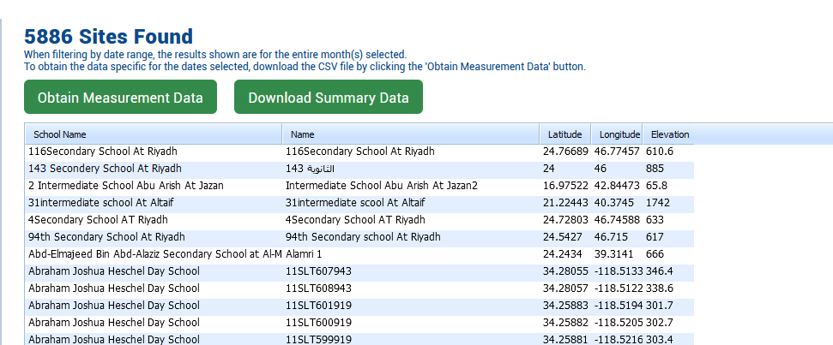
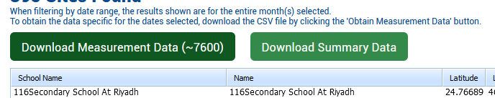
Number of lines of data
- If you want more data, use the ‘Clear’ button at the top of the page and then repeat the previous steps, this time choosing more protocols and/or a larger timeframe. If you want a smaller data set, choose fewer protocols and/or a smaller timeframe.

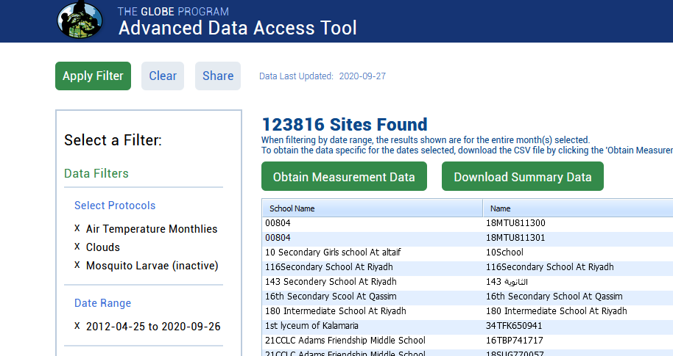

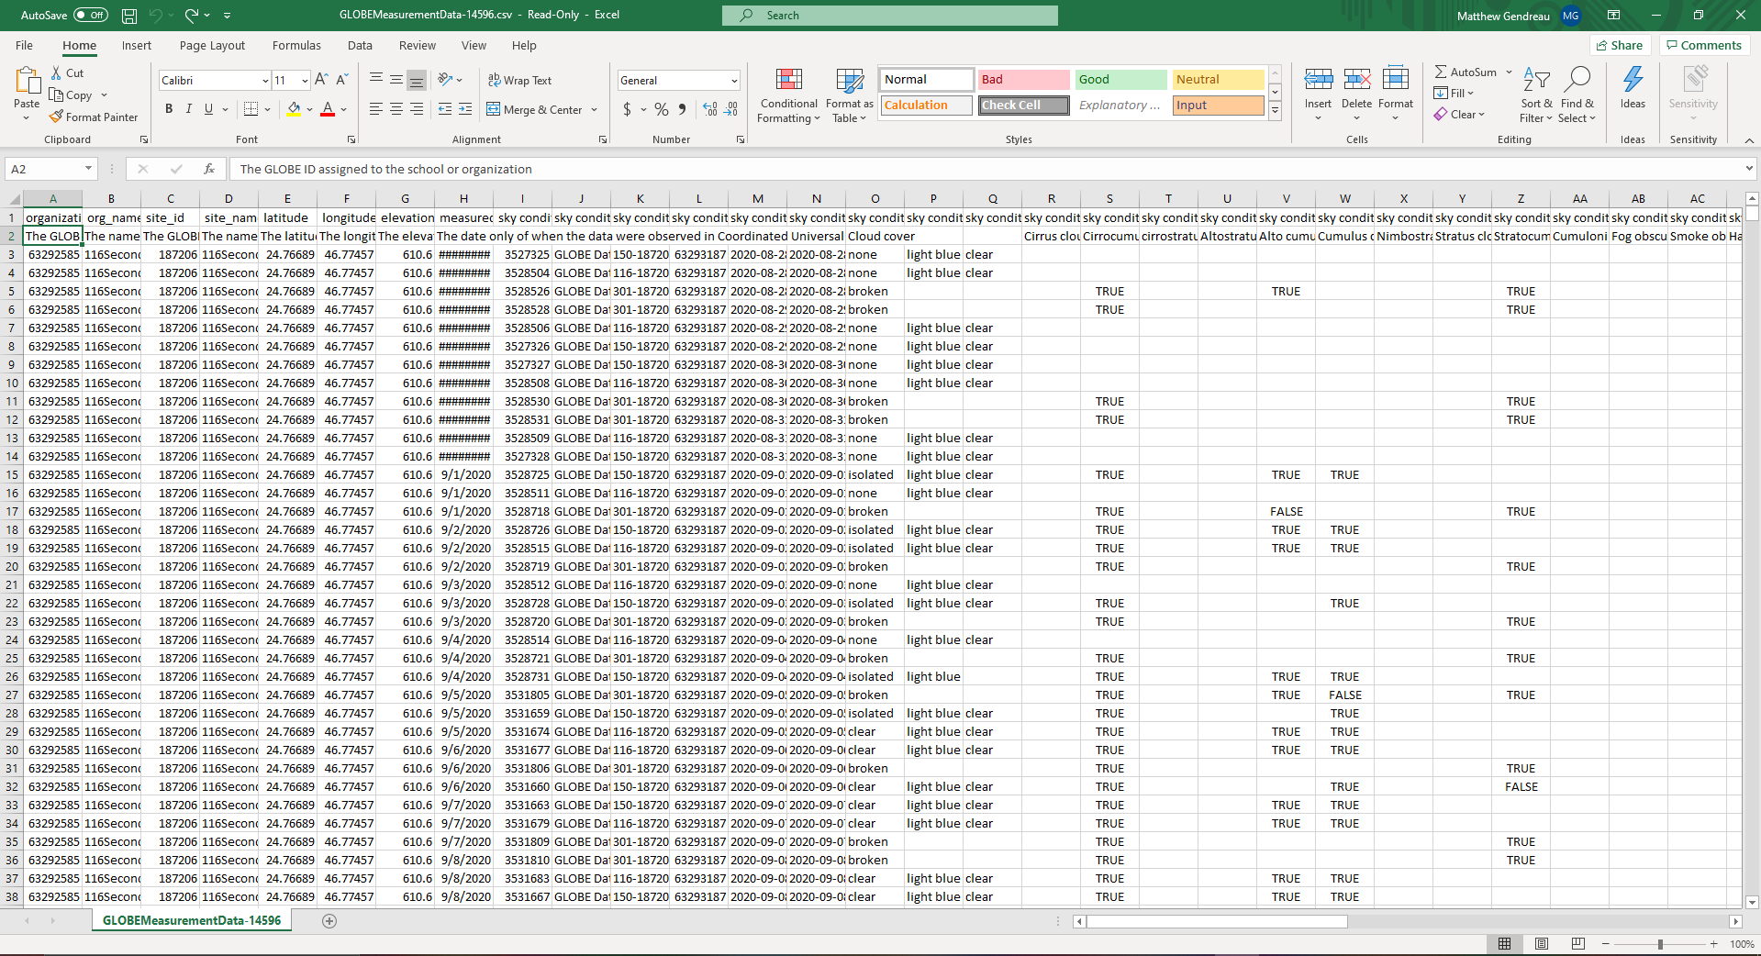
- Open the .csv file in the software of your choice. It is recommended that you use Microsoft Excel and save the document as an Excel Workbook (.xlsx) for easier editing and analysis. You should make a copy of the data in case you make any permanent changes that you don’t like. Row 1 of the spreadsheet contains short abbreviations for the categories of each column, while Row 2 has a more detailed description of the significance of the data below. Not every cell will be filled. Feel free to add, hide, or remove columns or rows to make working with the data easier.

Process Data
- Contrails
  - Sort the data. You will sort by Number of short-lived contrails observed, then number of spreading contrails observed then number of non-spreading contrails observed (Columns AM, AN, and AO).
  - Select all rows from row 3 to the last row. You will not select row 1 and 2 because it is the header data. If you sort the header data, it will not stay at the top. You also can not indicate that you have a header row because there are two rows.
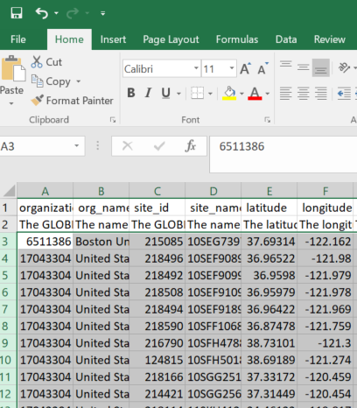

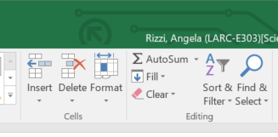
  - Select the Sort and Filter option from the toolbar.

  - Select the Custom Sort option from the dropdown.
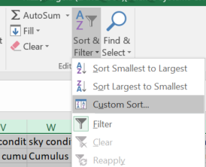

  - Click on Add Level in the box that pops up.
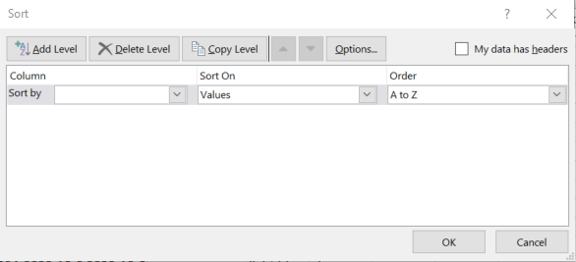

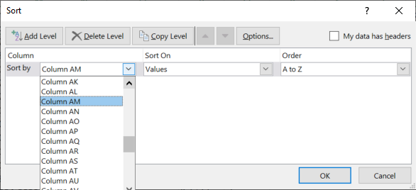
  - Select column AM from the drop down in the Sort By category.

  - Click Add Level.
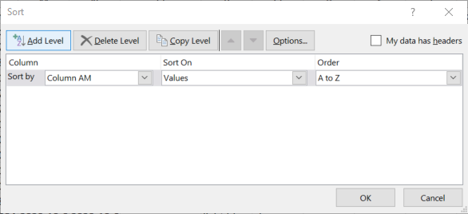

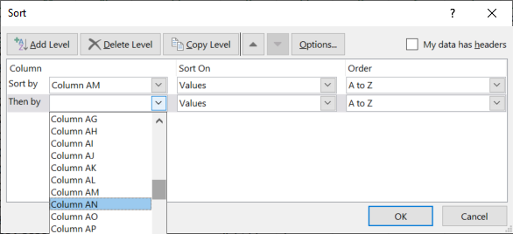
  - Select Column AN from the dropdown in sort by.

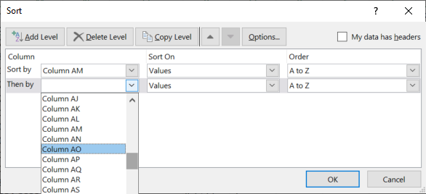
  - Repeat the process for column AO.

  - This should bring all observations with contrails to the top of your file. You can then work with those rows.

- Obscured vs. Overcast
  - You can filter the data by clicking on Row 1 (circled) to highlight it, then clicking ‘Filter’ from the ‘Sort & Filter’ tab.
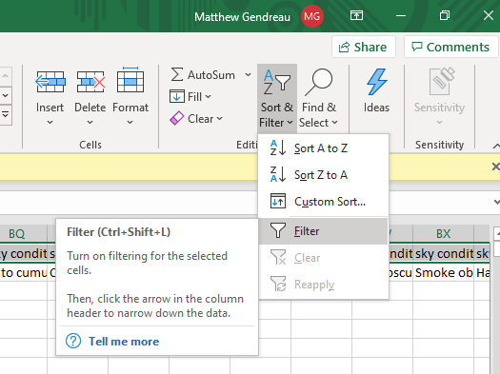
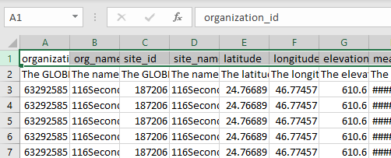

  - Filtering the first row adds an arrow at the end of every cell in the row. To filter based on certain criteria, click on the arrow of the cell you want and then make sure only the values that you want to see are checked. In the below example, to filter the data so that I only see submissions where the cloud cover is either obscured or overcast, I find the column that describes the cloud cover (called ‘sky conditions: cloud cover’ or column O), click the arrow, then uncheck every value in the dropdown except for ‘overcast’ and ‘obscured’. If you’d like to filter out empty values for a certain variable, just uncheck ‘(Blanks)’ in the dropdown.
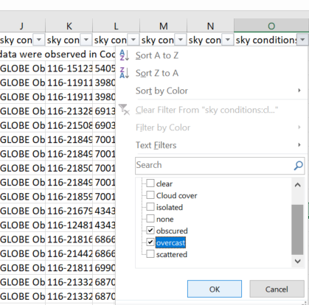

- Smoke
  - Follow the filter directions for obscured vs. overcast using the criteria below.
  - Filter on column O, sky conditions, for obscured and on column AC, sky conditions:smoke for TRUE. This can be done in one or two steps
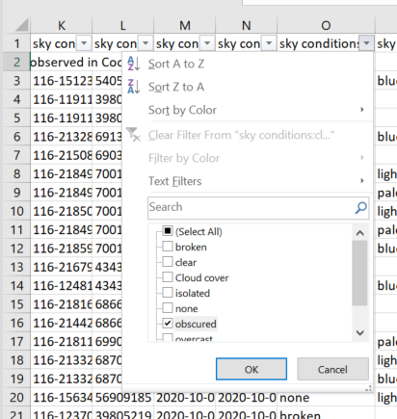

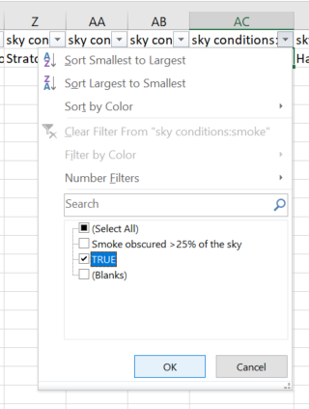

Data Tip
To hide a column, right click on the alphabetical label and click “hide”. It is recommended to hide instead of delete columns you don’t want, as you can bring them back later by clicking unhide.
