NASA GLOBE CLOUD GAZE Data Description
NASA GLOBE CLOUD GAZE is a collaboration between two giants of citizen science: The GLOBE Program and The Zooniverse online citizen science platform. The project uses sky photographs taken by participants in the GLOBE Program. These photographs run through two separate interactives on the project to collect information on the amount of cloud cover and cloud types present in each photograph. Results from these two interactives are based on an agreement value selected between the citizen scientists analyzing the photographs.
Participants select the best option from the list. The photograph is seen by participants until it is retired. The photograph can reach consensus or meet a predetermined classification count.
Consensus: when all participants that analyzed the photograph agree.
Classification count: when 8 participants or 80% of those that classified the photograph agreed on the result.
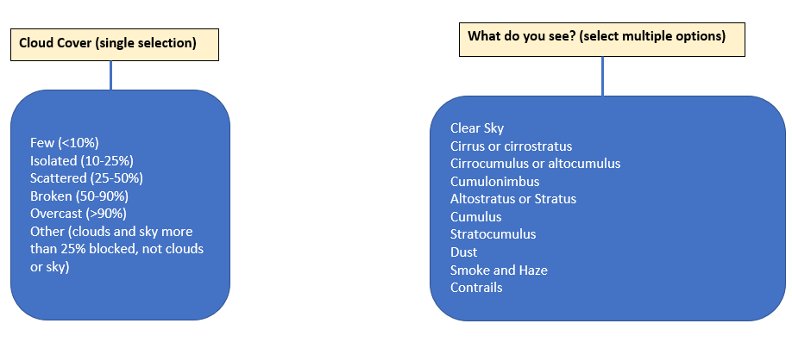
Figure 1: Simple description of two available interactives on NASA GLOBE CLOUD GAZE.

*Note about What Do You See? interactive: Each category will have information about the agreement between citizen scientists for each photograph, taken in each cardinal direction as well as upward.

Appendix A: Summary of Cloud Cover Data Variables
*Note: The image URL, Most Likely, Agreement, Classification Count, and Retirement values are available for each photograph. The direction of the photograph will be found added to the titles of these variables.

Variable | Units | Definition
Observation Number | string | Observation ID is a unique observation identifier within GLOBE
Measurement Date (UTC) | YYYY-MM-DD | Date image was taken in Coordinated Universal Time (UTC)
Measurement Time (UTC) | HH:MM:SS | Time image was taken in Coordinated Universal Time (UTC)
Observation Latitude | decimals degree north | Latitude where the image was taken. Range [-90, 90] (i.e.,)
Observation Longitude | decimals degrees east | Longitude where the image was taken. Range [-180, 180]
(N,S,E,W,Up) Image URL | link | URL link to image taken in each cardinal direction and up.
(N,S,E,W,Up) Most Likely | integer | Cloud cover consensus from Zooniverse CLOUD GAZE system for that direction.  0 = Few or > 10%  1= Isolated or 10%-25%  2 = Scattered or 25-50%  3 = Broken or 50-90%  4 = Overcast or > 90%  5 = Other category
(N,S,E,W,Up) Agreement | integer | Level of confidence for that direction’s Most Likely value. (range 0-1)  Agreement = $\frac{Total number of votes for one option }{\sum{All observation for that photograph}}$
(N,S,E,W,Up) Classification Count | integer | Number of citizen scientists who classified the image.
(N,S,E,W,Up) Retirement | consensus or classification count | The reason for retirement either due to consensus or classification count.

Appendix B: Summary of What Do You See Data Variables
*Note: Each photograph (each cardinal direction and upward) will have true/false values for each possible category. For each direction (cardinal directions and upward) the retirement information (most Likely, agreement, classification count, and retirement values) are printed. The direction of the photograph will be found added to the titles of these variables. Values of “other” refer to images where cloud cover could not be categorized. These are images blocked by trees or buildings (25% or more), is of the inside of a room or building, or was taken at night.

Categories: clear sky, cirrus or cirrostratus, cirrocumulus or altocumulus, altostratus or stratus, stratocumulus, cumulus, cumulonimbus, contrails, smoke or haze, dust.
Variable | Units | Definition
Observation Number | string | Observation ID is a unique observation identifier within GLOBE
Measurement Date (UTC) | YYYY-MM-DD | Date image was taken in Coordinated Universal Time (UTC)
Measurement Time (UTC) | HH:MM:SS | Time image was taken in Coordinated Universal Time (UTC)
Observation Latitude | decimals degree north | Latitude where the image was taken. Range [-90, 90] (i.e.,)
Observation Longitude | decimals degrees east | Longitude where the image was taken. Range [-180, 180]
(N,S,E,W,Up) Image URL | link | URL link to image taken in each cardinal direction and up.
Clearsky (N,S,E,W,Up) | integer | 0, 1 or 5 (cloud type not classified - other)
Cirrus or Cirrostratus (N,S,E,W,Up) | integer | 0, 1 or 5 (cloud type not classified - other).
Cirrocumulus or altocumulus (N,S,E,W,Up) | integer | 0, 1 or 5 (cloud type not classified - other).
Altostratus or stratus (N,S,E,W,Up) | integer | 0, 1 or 5 (cloud type not classified - other).
Stratocumulus (N,S,E,W,Up) | integer | 0, 1. or 5 (cloud type not classified - other)
Cumulus (N,S,E,W,Up) | integer | 0, 1 or 5 (cloud type not classified - other).
Cumulonimbus (N,S,E,W,Up) | integer | 0, 1 or 5 (cloud type not classified - other).
Contrails (N,S,E,W,Up) | integer | 0, 1 or 5 (cloud type not classified - other).
Smoke or Haze (N,S,E,W,Up) | integer | 0, 1. or 5 (cloud type not classified - other)
Dust (N,S,E,W,Up) | integer | 0, 1 or 5 (cloud type not classified - other).
Agreement  (N,S,E,W,Up) | integer | Level of confidence for that direction’s Most Likely value.  (range 0-1)  Agreement = $\frac{Total number of votes for one option }{\sum{All observation for that photograph}}$
Classification Count  (N,S,E,W,Up) | integer | Number of citizen scientists who classified the image.
Retirement  (N,S,E,W,Up) | consensus or classification count | The reason for retirement either due to consensus or classification count.

