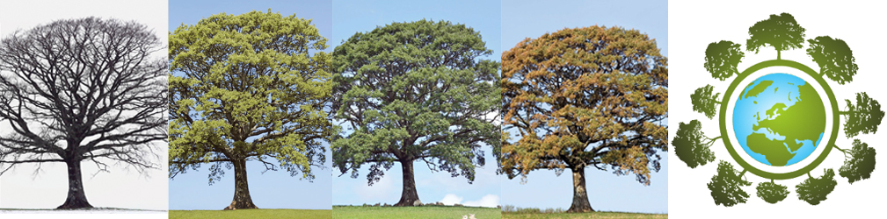

European Phenology Campaign
Track nature’s Green Wave

Observe how trees change during the year 2018!
The Earth from space in spring: You see a green wave of vegetation moving from the southwest of Europe (Spain) to northeast (Russia) indicating that the trees grow new leaves, flowers blossom and fields turn green. But this green wave does not start every year at the same time.
Why do trees in the city already have leaves while in the rural areas they are still dormant?

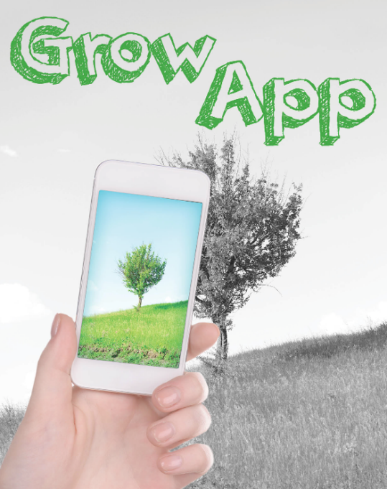
With the GrowApp smartphone app you can observe plants changing over seasons, make time lapse videos and learn how plants react to climate. This is a perfect and easy to use app for biology and geography classes alike.
- Observe buds, leaves and canopy of your tree
- Compare your observations with these taken by others
- See how the green wave moves through Europe
- Check out how elevation affects the greening up of the vegetation and compare your observations with satellite data and with meteorological measurements.
You can do all this and more by participating in the GLOBE Phenology Campaign 2018. Make learning fun and exciting with the new GrowApp and GLOBE learning activities.
How to join?
GLOBE teachers can become a member of the Phenology Campaign. You can pick any tree close to your school. Students then monitor how the buds grow and burst into green leaves during spring months. Download the GrowApp and GLOBE learning materials.
PS: Scientists call the green up and down cycle of plants “phenology”.

www.globe.gov/web/european-phenology-campaign

