The Effect of Household Items on Soil pH

Mary Lathrop and Jasmine Hajjar

Grade 10

Ottawa Hills Junior/Senior High

United States of America

Dr. Kreischer - Gajewicz

Table of Contents

Page 1 . . . . . . . . . . . . . . . . . . . . . . . . . . . . . . . . . . . . . . . . . . . . . . . . . . . . . . . . . . . . . . . . Title Page

Page 2 . . . . . . . . . . . . . . . . . . . . . . . . . . . . . . . . . . . . . . . . . . . . . . . . . . . . . . . . . Table of Contents

Page 3 . . . . . . . . . . . . . . . . . . . . . . . . . . . . . . . . . . . . . . . . . . . . . . . . . . . . . . . . . . . . . . . . . Abstract

Page 4 . . . . . . . . . . . . . . . . . . . . . . . . . . . . . . . . . . . . . . . . . . . . . . . . . . . . . . . . . . . . . . Introduction

Page 8 . . . . . . . . . . . . . . . . . . . . . . . . . . . . . . . . . . . . . . . . . . . . . . . . . . . . . .Methods and Materials

Page 10 . . . . . . . . . . . . . . . . . . . . . . . . . . . . . . . . . . . . . . . . . . . . . . . . . . . . . . . . . . . Data Summary

Page 11 . . . . . . . . . . . . . . . . . . . . . . . . . . . . . . . . . . . . . . . . . . . . . . . . . . . . . Analysis and Results

Page 13 . . . . . . . . . . . . . . . . . . . . . . . . . . . . . . . . . . . . . . . . . . . . . . . . . . . . . . . . . . . . . .Conclusion

Page 14 . . . . . . . . . . . . . . . . . . . . . . . . . . . . . . . . . . . . . . . . . . . . . . . . . . . . . . . . . . . . . .Discussion

Page 16 . . . . . . . . . . . . . . . . . . . . . . . . . . . . . . . . . . . . . . . . . . . . . . . . . . . . . . . .Acknowledgments

Page 17 . . . . . . . . . . . . . . . . . . . . . . . . . . . . . . . . . . . . . . . . . . . . . . . . . . . . . . . . . . . . . .References

Abstract

In this project, we hoped to discover how certain household items change soil pH. In doing this experiment, we aimed to give a better understanding of pH to people like groundskeepers and gardeners, to whom it would benefit to be able to understand how to change soil pH without needing to purchase additional equipment or materials. We hypothesized that the addition of eggshells and baking soda would increase soil pH, while Epsom salts and pine needles would decrease it. In our experiment, we put five cups filled with the same amount of soil but different additives onto a windowsill. We watered each cup until the end of the week, when we measured the final soil pH and compared it to the constant pH to see how each additive affected the soil pH. We found that while the pine needles and eggshells did not affect the pH, Epsom salts decreased the pH, and the baking soda increased the pH, which is what we hypothesized. Through our data, our hypothesis was supported, and our research backed what our experiment found.

Introduction

When testing soil pH in our area, the question of how soil pH changes due to the environment arose. Then, the question was proposed: How can soil pH be manipulated using household substances? After conducting research, it was hypothesized that if baking soda or eggshells are added to soil, then the pH will increase because of the added hydrogen ions. However, if Epsom salts or pine needles are added to the soil, then the pH will decrease because those materials contain elements of aluminum sulfate, which are commonly used to decrease soil pH.
Before understanding how the pH of the soil can be changed, it is important to understand what both variables represent. Soil, first and foremost, is a combination of minerals and organic materials used to mediate plant growth (What is Soil? n.d.). The mineral element of soil consists of small portions of rock that have been disintegrated by weathering, and the organic materials in soil are made up of the remains of plants and animals at various stages of decomposition (Gibson, M. J. 2023, June 28). Soil also stores vital nutrients and contains quantities of air and water, which dictate the texture and structure of the substance. Soil’s primary purpose is to anchor plant roots and provide nutrients for plants and other living organisms to survive. Many factors affect the soil’s capability in doing so, one of which is soil pH.
pH represents “the power of hydrogen” in a material. This value helps determine how acidic or alkaline a substance is. This pH value is measured by the concentration of H+ and OH- ions present in a substance (Acids, Bases, and the pH Scale). If a material has a greater amount of hydrogen ions, that material is, therefore, more acidic and has a lower pH. The material with less H+ and a high concentration of OH-, or hydroxyl ions, is more alkaline, or basic, and has a higher pH value. A scale of 0-14 is used to measure pH. 7.0 represents a neutral pH, values below 7.0 represent an acidic solution, and values above 7.0 represent basic solutions. Each increase or decrease of 1.0 on the pH scale makes the pH ten times more or less acidic (Pettinelli, D. 2021). For example, a pH of 3.0 would be ten times more acidic than a pH of 4.0.
Soil pH can change due to things like rainwater, fertilizer, and other changes to your yard's conditions. However, soil pH can easily be manipulated to achieve the target pH for the crop being grown. Commonly, limestone is used to raise soil’s pH. Limestone is efficient at neutralizing soil acidity, as a higher pH is more basic, while also adding elements like calcium and magnesium that are necessary for the soil. Lime does this by replacing hydrogen ions in the soil. Limestone is not the fastest working solution, as it may take anywhere from 6 to 12 months to react in the soil and change the pH, however, it is commonly used for its inexpensive and non-caustic traits. (Pettinelli, D. 2021). Other household items, such as baking soda and wood ashes, can be used to increase soil pH, however, they do not have long-term effects.
As previously stated, soil pH can be changed using natural environmental processes, or it can be changed manually by using different products. To lower the pH of the soil, elemental sulfur, and aluminum sulfate are commonly used by homeowners (Combs, S. 2007, October 27). Although elemental sulfur is slower-acting, it is more economical than aluminum sulfate. However, most favor aluminum sulfate due to its faster working qualities. Both elemental sulfur and aluminum sulfate are safe to use, unlike sulfuric acid, which can also be used to lower soil pH. Sulfuric acid is also known as battery acid and is highly dangerous, although it is fast-acting (Combs, S. 2007, October 27). While these materials can be efficiently and effectively applied to reduce the pH of large areas, organic materials are an alternative that can be useful in reducing smaller quantities of soil. Materials such as pine needles and peat moss can be utilized in small areas and can slowly reduce the pH, although this method is not as effective. Ultimately, each of these methods can be used in varying situations to lower soil pH when necessary.
The right soil pH is crucial for plants because it affects the solubility of nutrients or minerals, directly impacting the plants' growth. Plants rely on soil to provide nearly all of their 17 essential nutrients (Bickelhaupt, n.d..). For the plant to use these nutrients, they must first be converted into forms that can be absorbed through the roots. Soil pH affects nutrient solubility, which directly impacts their availability to plants. Solubility is directly related to how well the nutrient can dissolve into the soil water. The soil water is taken up through the roots, so the plants depend on the nutrients to be dissolved into the soil water for them to grow and develop. Most minerals are soluble in lower pH soils compared to higher pH soils, though when the soil pH drops too low (below 5), nutrients may also become less available to plants. The ideal soil pH for most plants is between 6.2 and 6.8, where the most nutrients are readily available. In addition to nutrient solubility, soil pH also affects the activity of beneficial microorganisms. These bacteria work to decompose soil organic matter, but when the pH is too high, they reproduce less, and their work is hindered. Without the breakdown of organic matter, nutrients like nitrogen cannot dissolve into the soil water, leading to nutrient deficiencies. Therefore, the pH of soil is highly important to plant growth and its ability to thrive in a given environment.

Methods and Materials
Materials for this project included: soil, Epsom salts, baking soda, pine needles, eggshells, warm spring water, clear plastic cups, and Hydrion pH strips. The Epsom salts are an unscented, neutral brand, the baking soda is from Arm and Hammer. The following steps were conducted: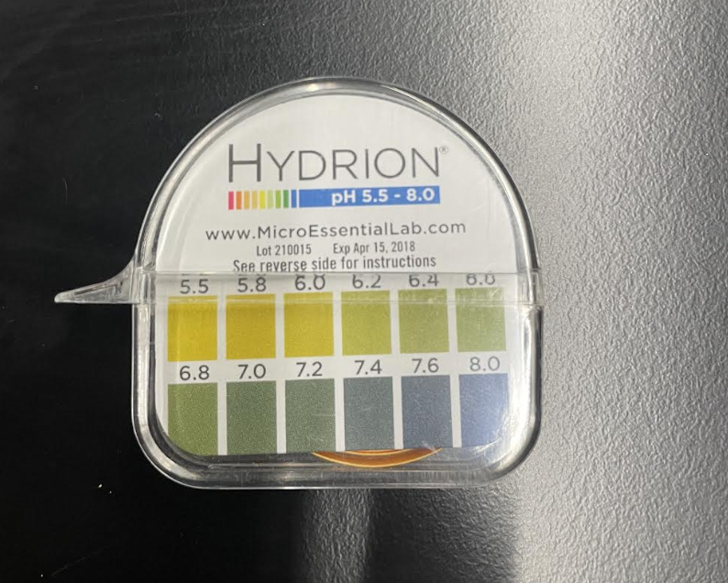
To begin the experiment, collect all previously stated materials. Next, label each of the 5 plastic cups with the additive, including the control group. Measure 20 grams of soil into each cup and measure 7.5 mL of each additive out on the side. Finely crush the pine needles and eggshells using a mortar and pestle. Then, mix each additive with 7.5 mL warm spring water before adding the water and substance mixture to the correctly labeled cup with soil. Mix soil and added substance together for 30 seconds, and repeat until all additives have been correctly applied. Place cups in an area with direct sunlight exposure. For the next 10 days, add 15 mL of warm spring water to each cup every day. Take the pH of each soil at days 5 and 10 using soil pH protocol, record and analyze data using the described process, noting the final result.
To find the soil pH, begin by gathering 20 grams of soil and 20 grams of water. The specific amounts of water and soil can be changed as long as the ratio remains constant, 1:1. Combine with soil and water, stirring for one minute. Set a timer to three minutes, and at the three-minute mark, stir the soil and water mixture for thirty seconds. Repeat this process until you have stirred for a total of 2.5 minutes or five repetitions. Let the mixture sit for about 5 minutes or until a supernatant forms. (When the clear liquid separates from the soil.) Dip the tip of a strip of pH paper into the top liquidy substance, and let the paper rest for 20 seconds before taking the results. Record.
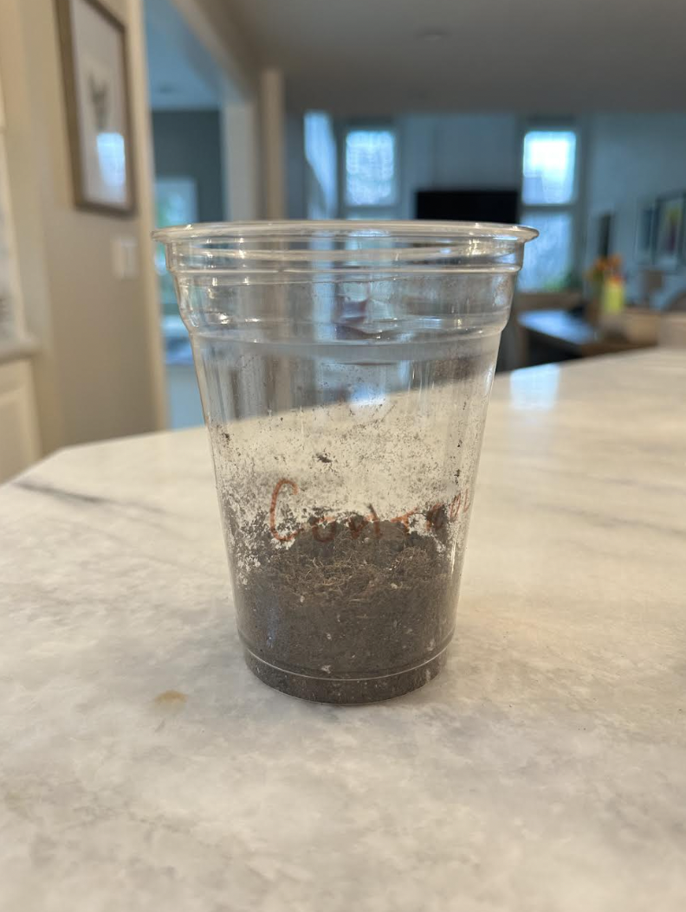
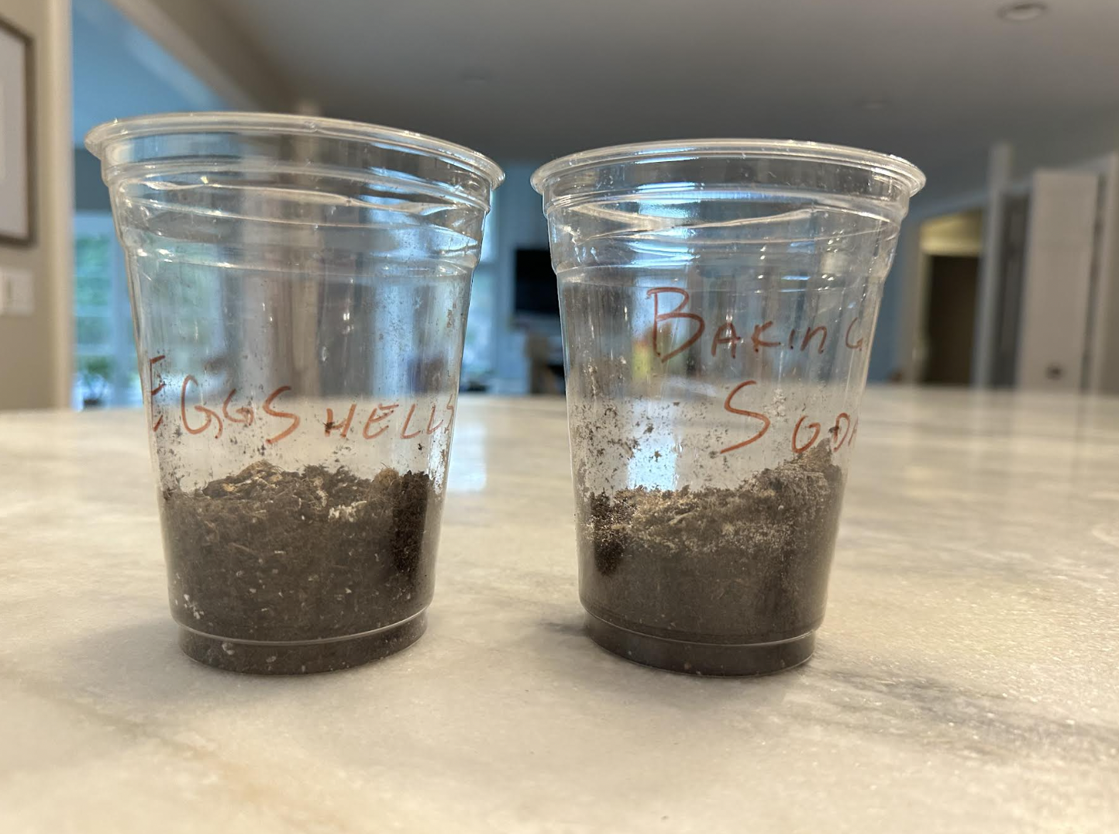
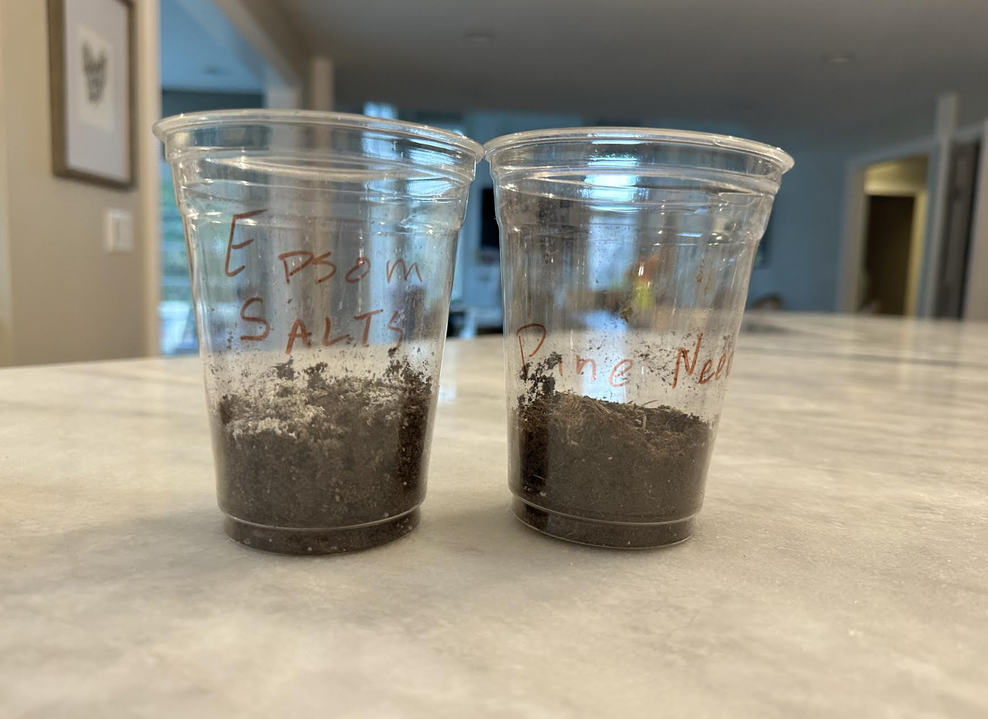

Data Summary
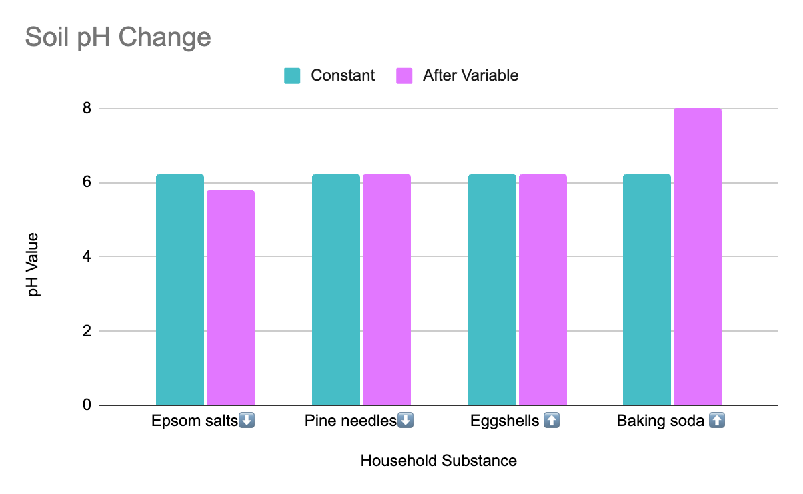
The constant variable consists of soil with no additives that underwent the same process as the other variables, simply without the addition of a household substance. The pH of the constant was a 6.2 value. The data shows that when Epsom salts were added to the soil, the pH slightly decreased, dropping to 5.8 from the constant 6.2. Both pine needles and eggshells showed no change in pH from the constant variable. Baking soda had the most drastic change, increasing by 1.8 pH value, from 6.2 to 8.0, and becoming slightly basic.

Analysis and Results
Through our data, it can be observed that the more natural altering substances, like pine needles and eggshells, are less likely to cause a pH change or need significantly more time to cause any true effect on the soil. Our study also shows that more concentrated and processed additives, like Epsom salts and baking soda, proved more likely to cause a change in pH, likely due to their higher potency. These substances are also more finely granulated, which likely contributed to their solubility when interacting with soil water.
It was hypothesized that the addition of baking soda or eggshells would cause an increase in the soil pH because of the added hydrogen ions. However, if Epsom salts or pine needles were added to the soil, then the pH would decrease. Our results were backed by our research. Our research stated that added hydrogen ions, like those in baking soda or eggshells, would increase the pH. We found that baking soda increased the pH, while eggshells kept it constant. Our research also described that the addition of Epsom salts or pine needles would decrease the soil pH, which is exemplified by the data collected. Therefore, this experiment supported the hypothesis. A small change in pH was expected based on what was added to the soil. We believe that baking soda increased the soil pH because of an increase in hydrogen ions. In addition, we believe that Epsom salts lowered the pH because of the presence of aluminium sulfate.
Further research and thought lead to the belief that the eggshells and pine needles may not have had enough time to fully break down and dissolve into the soil water. This could have been why we saw no change in the soil pH when either of these two substances was added to the soil. Our hypothesis was accurately tested through our experiment. We made sure to use household substances and easy-to-attain tools while carrying out this experiment.

Conclusion
Through experimentation, the question of how the pH of soil can be changed using household substances is succinctly answered. Our hypothesis stated that if baking soda or eggshells are added to soil, then the pH will increase because of the added hydrogen ions; however, if Epsom salts or pine needles are added to the soil, then the pH will decrease because those materials contain elements of aluminum sulfate. Through data collection, it was found that baking soda increased the pH, pine needles and eggshells did not change the pH, and Epsom salts caused the pH to decrease.
Therefore, our hypothesis was mostly proven correct, as expected due to research. To collect data that would affirm our hypothesis, our methods consisted of testing small, isolated soil samples containing the additive we were evaluating. We tested these samples over a course of 10 days to allow a pH change to occur before assessing our results. Research and published data show similar effects, although much of the previous testing uses more agricultural substances, such as dolomitic limestone, rather than household items of similar characteristics, such as baking soda (Pettinelli, D. 2021). Therefore, the lower concentration and application of our testing likely contributed to the smaller pH change and could be why pine needles and eggshells did not have an effect. However, the data collected can be clearly backed by our research.

Discussion
As previously stated, our hypothesis was mainly supported, with a few errors that were expected and can be explained. We believe the lack of change exemplified in adding pine needles and eggshells are for a couple of reasons; both substances are natural and come directly from a plant or animal process. This means that its qualities are less potent, and therefore either needed more time to show a significant pH change, or were unable to cause a change in the amount of soil it was placed in. For example, while eggshells contain sulfur, which is the main substance we predicted would change the pH, less than 10% of the material contains such sulfur (Eggshells and their valuable minerals. 2021, March 16). This would support the belief that the eggshells either needed to be applied to a smaller portion of soil, or simply needed more time to fully break down and release the mineral.
Another possible explanation for the lack of change could be in part due to the granularity of the substance, as the other 2 additives were much more finely ground and therefore could be absorbed by the soil more efficiently. Therefore if the pine needles and eggshells had been more powdery, they would have been better taken in by the soil and in turn caused a greater effect on the pH, as “the smaller the shells are, the faster they decompose and develop their effect.” (Eggshells and their valuable minerals. 2021, March 16). In future experimentation, it would be pertinent to ensure that every substance is equally ground, which could be done by blending and sifting each substance.
This kind of experimentation is essential for farmers, to find the most efficient and cost effective way to maintain the pH of their land. As described, a soil’s pH is integral in how its inhabiting plants survive and grow to their full potential. This research can also inform farmers of why their pH may be changing without their direct hand in it through the testing of naturally occurring substances. For example if pine trees or chickens are present on the land, it could explain why the soil pH is changing over an extended period of time. The data also shows that baking soda makes the most drastic change over a short period of time, which can be essential to know in times of desperate need or for a quick fix. Student research such as this is important because it informs us of the value and meaning of our environment and the impact we have on it, and more importantly, the impact it has on us.

Acknowledgments

First and foremost, our extended gratitudes to our mentor and teacher Dr. Gloria Kreischer - Gajewicz for her guidance, time, and encouragement. Thank you as well to Grant and Sara from the University of Toledo for their critiques and suggestions that both greatly improved and helped to form the basis of our experiment. And to our peers who supported us and listened to all our questions, this project would not have been possible without your support.

References

Acids, Bases, and the pH Scale. (n.d.). https://www2.nau.edu/lrm22/lessons/acids_and_bases/acids_and_bases.html
Bickelhaupt, D. (n.d.). Soil pH; What it means. https://www.esf.edu/eis/eis-soil-ph.php#:~:text=Soils%20tend%20to%20become%20acidic,inorganic%20acids%2C%20such%20as%20nitric
Combs, S. (2007, October 27). Reducing Soil pH. University of Wisconsin - Madison. https://hort.extension.wisc.edu/articles/reducing-soil-ph/
Eggshells and their valuable minerals. (2021, March 16). Leroma. https://leroma.de/blog/id/EggShells.html
Gibson, M. J. (2023, June 28). Understanding Soil pH. PennState Extension. https://extension.psu.edu/understanding-soil-ph
Pettinelli, D. (2021). Soil pH and Management Suggestions. University of Connecticut. https://soiltesting.cahnr.uconn.edu/soil-ph-and-management-suggestions/#:~:text=Manure%2Dbased%20composts%20may%20also,to%20raise%20a%20soil's%20pH.
What is Soil? (n.d.). Natural Resources Conservation Service. https://www.nrcs.usda.gov/resources/education-and-teaching-materials/what-is-soil

