Lowering Leaves: An Observation

By: Taiyibah Grewal

Do you ever wonder why leaves change during the fall? Well, got curious, so we decided to take matter into our own hands, and see how this is possible. I made my observations of the leaves around Melvindale High School through October 4th,and then again on October 27th. These observations were made atAllen Park at my school at a latitude degrees 42.2734° N, and the longitude degrees of 83.2040° W. I made these observations facing all directions, particularly the north campus. The leaves I looked at came from sugar maple, acer maple, plum, cardiocrinum giganteum, and acre campestre, which all generally changed their colors.

However, some leaves had decayed, while some leaves also stayed green. For the leaves to change color, the chlorophyll chemical is important, as it breaks down, making the molecules like anthocyanins and carotenoids show, which make leaves look yellow, red, and even purple at times. Weather impacts the color change because when there's less sunlight during the day, leaves stop producing chlorophyll (unlike the summer months where there is enough sunlight for photosynthesis). So, days that are sunny during the day, but cool overnight help molecules produce chemicals other than the chlorophyll. This makes sense for what I saw in my observation as fall starts off sunny and a little warm during the days and cool during the night.

During thehe first week of my observations, The weather was warmer in comparison to the rest of the month with cool nights, which makes the bright colors I saw make sense. However, as noted from the weather channels, weather in the middle of the month got quite frigid, rainy, and windy which can make the leaves fall off before they can change color or even decay faster. I noticed that overall the weather got colder throughout the month, and more rainy and windy, very similar to what the weather reported, but this does not mean there was rarely any sun. It was likely to see more sunlight during the day but less than the usual amount of sunlight.

The leaves were a big part of this observation, but I'd like to talk about the clouds as well. I noticed in the first week of taking my observations that the sky was a clear blue with very few clouds. This makes sense because of how much warmer it was in the beginning of the month. In my last week of taking observations, the sky had drastically changed. The cloud type was nimbostratus and the sky was a grey-blue color. Making the connection between the leaves and the weather, as this happened because of the rainy cold conditions at the end of the month.

Ultimately, I learned some interesting things about the way chemistry and chemical changes work in changing leaves and how those chemical changes are impacted by weather.I also learnedwhy the clouds change because of the weather. With this information, I hope to continue to find new findings for the changing leaves. As well as for how it affects our sky and weather.

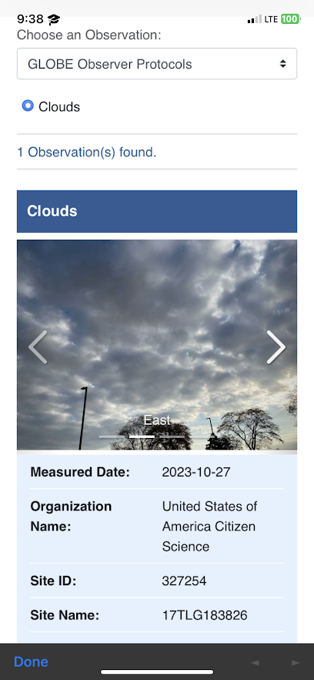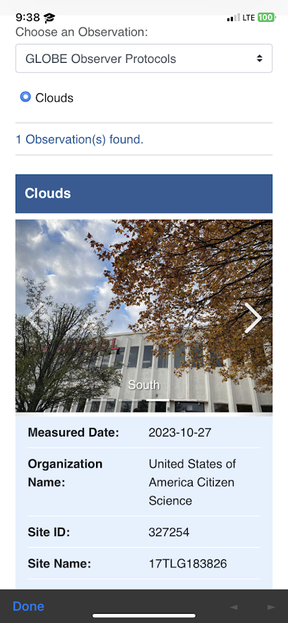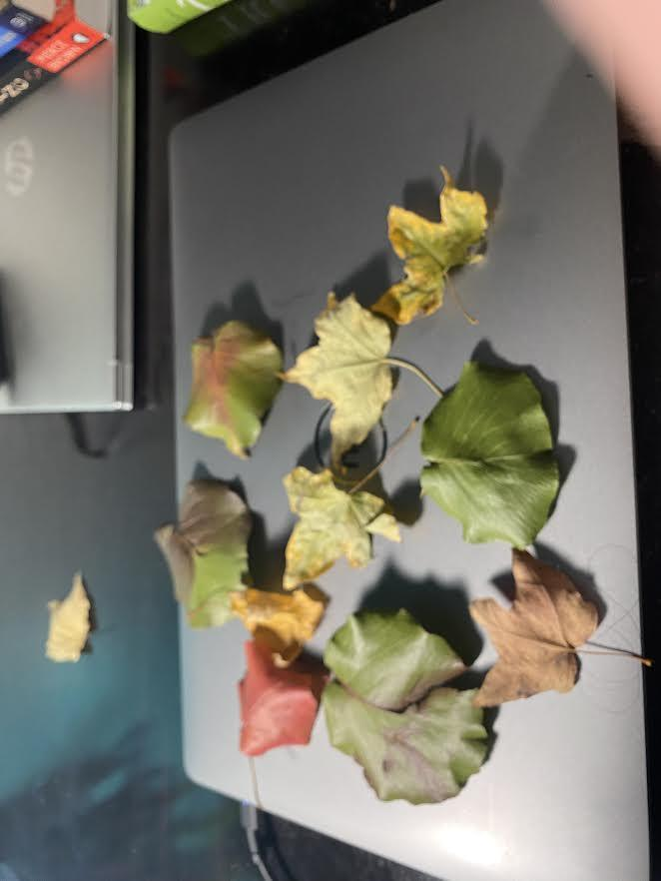

Sources:

<https://www.nationalgeographic.com/travel/article/why-leaves-change-color>

<https://weather.com/news/news/2018-08-25-the-weather-channel-app-update>

<https://mynasadata.larc.nasa.gov/globe-connections/globe-connections-plant-growth-patterns#:~:text=Green%2Ddown%20Protocol%3A%20Students%20use,of%20the%20plant%20growing%20season>.

<https://observer.globe.gov/do-globe-observer/trees>