Wren Krajniak

Vibrant Leaves Beneath a Brilliant Blue Sky

The sky was a brilliant blue, cluttered with cumulus and stratus clouds. It felt chilly, but not so cold that I needed a coat. It was mostly cloudy for a majority of the month, and on the third day, it was raining before we went out. The average wind speed was about 9 mph, but it became more windy near the end of the month. It wasn’t very humid. We were facing north at a latitude of 42.2748 and a longitude of -83.2029. On the first day, the leaves were green, but as the month progressed, the leaves changed to vibrant yellow, orange, and red. We went outside on October 4th, 12th, and 27th, around 9:15 - 9:45, at Melvindale High School in Allen Park, Michigan to make observations for the Green Down Protocol. The main goal of this protocol was to observe how the weather and changing seasons affects the trees. This paper will discuss my observations.

Because of where we live, we have seasons. We are about halfway between the Equator and the North Pole, so when we are tilted away from the sun (in the colder months), the days get shorter and the temperature drops. According to weather.com, the temperature on the first day was 83 degrees Fahrenheit, which dropped to 63 degrees by the second day. Strangely, the temperature rose to 78 degrees by the third day. This is not what is typically expected during the start of autumn, because the temperature is supposed to steadily drop as we transition to the frosty seasons. However, this October, the temperature is fluctuating rather than just getting colder. This could be a sign of climate change affecting the seasons.

As the weather got colder, it impacted the trees as well. While outside, we collected three leaves from two different trees. I collected leaves from a callery pear tree and an unhealthy red maple tree. Leaves in areas with seasons, like where I am, change color and fall off the trees at the start of autumn. This is because the chlorophyll, which causes the green color, starts breaking down into carotenoids, flavonoids, and anthocyanins when it gets more difficult to photosynthesize. These chemicals make the leaves appear as the usual “fall colors”, such as red, orange, and yellow. In the case of the red maple tree, the leaves changed relatively predictably. They started out solid green, and then the edges turned yellow as small spots of dark red appeared. By the third day, they were almost completely yellow, with brown edges. This represents that the chlorophyll changed into carotenoids and flavonoids.

However, the callery pear tree did not change as predicted. Similar to the red maple leaves, they started off as green, but rather than changing, they stayed mostly green for a while. On the second day, the tree had some yellowish-brown leaves, but was mostly still green. By the third day, all the yellowish-brown leaves had fallen off the tree, making the lower part of the tree look entirely green. Meanwhile, the leaves at the very top had turned reddish-purple. These colors show that the chlorophyll in this tree broke down into anthocyanins and carotenoids.

In conclusion, my Green Down Protocol observations showed that the weather and leaves did not behave exactly as expected. The temperature was not following the normal pattern, and some of the leaves took a while to change. But overall, there was not anything incredibly surprising. The weather did get colder, just not at the expected rate. Additionally, the leaves did change, just not at the same speed as other trees. The callery pear tree apparently breaks down chlorophyll later than the other trees do, and the temperature is being affected by climate change.

Map:



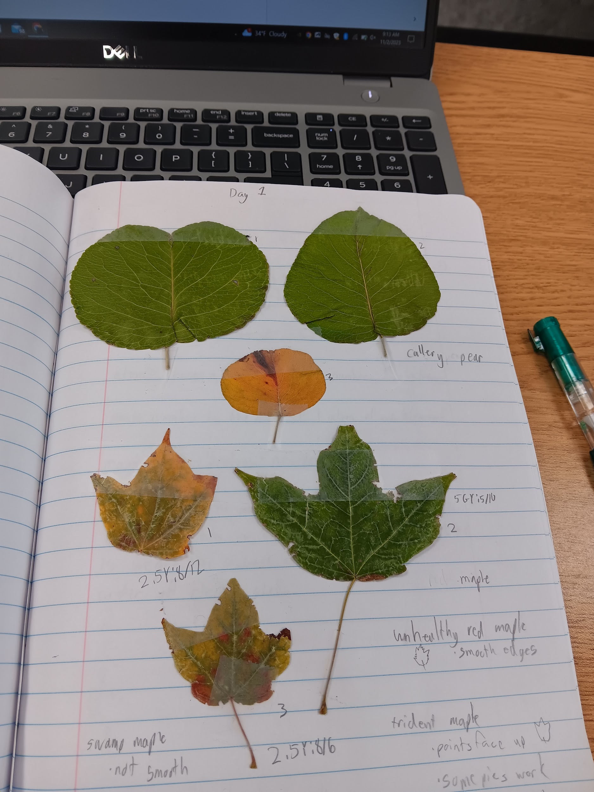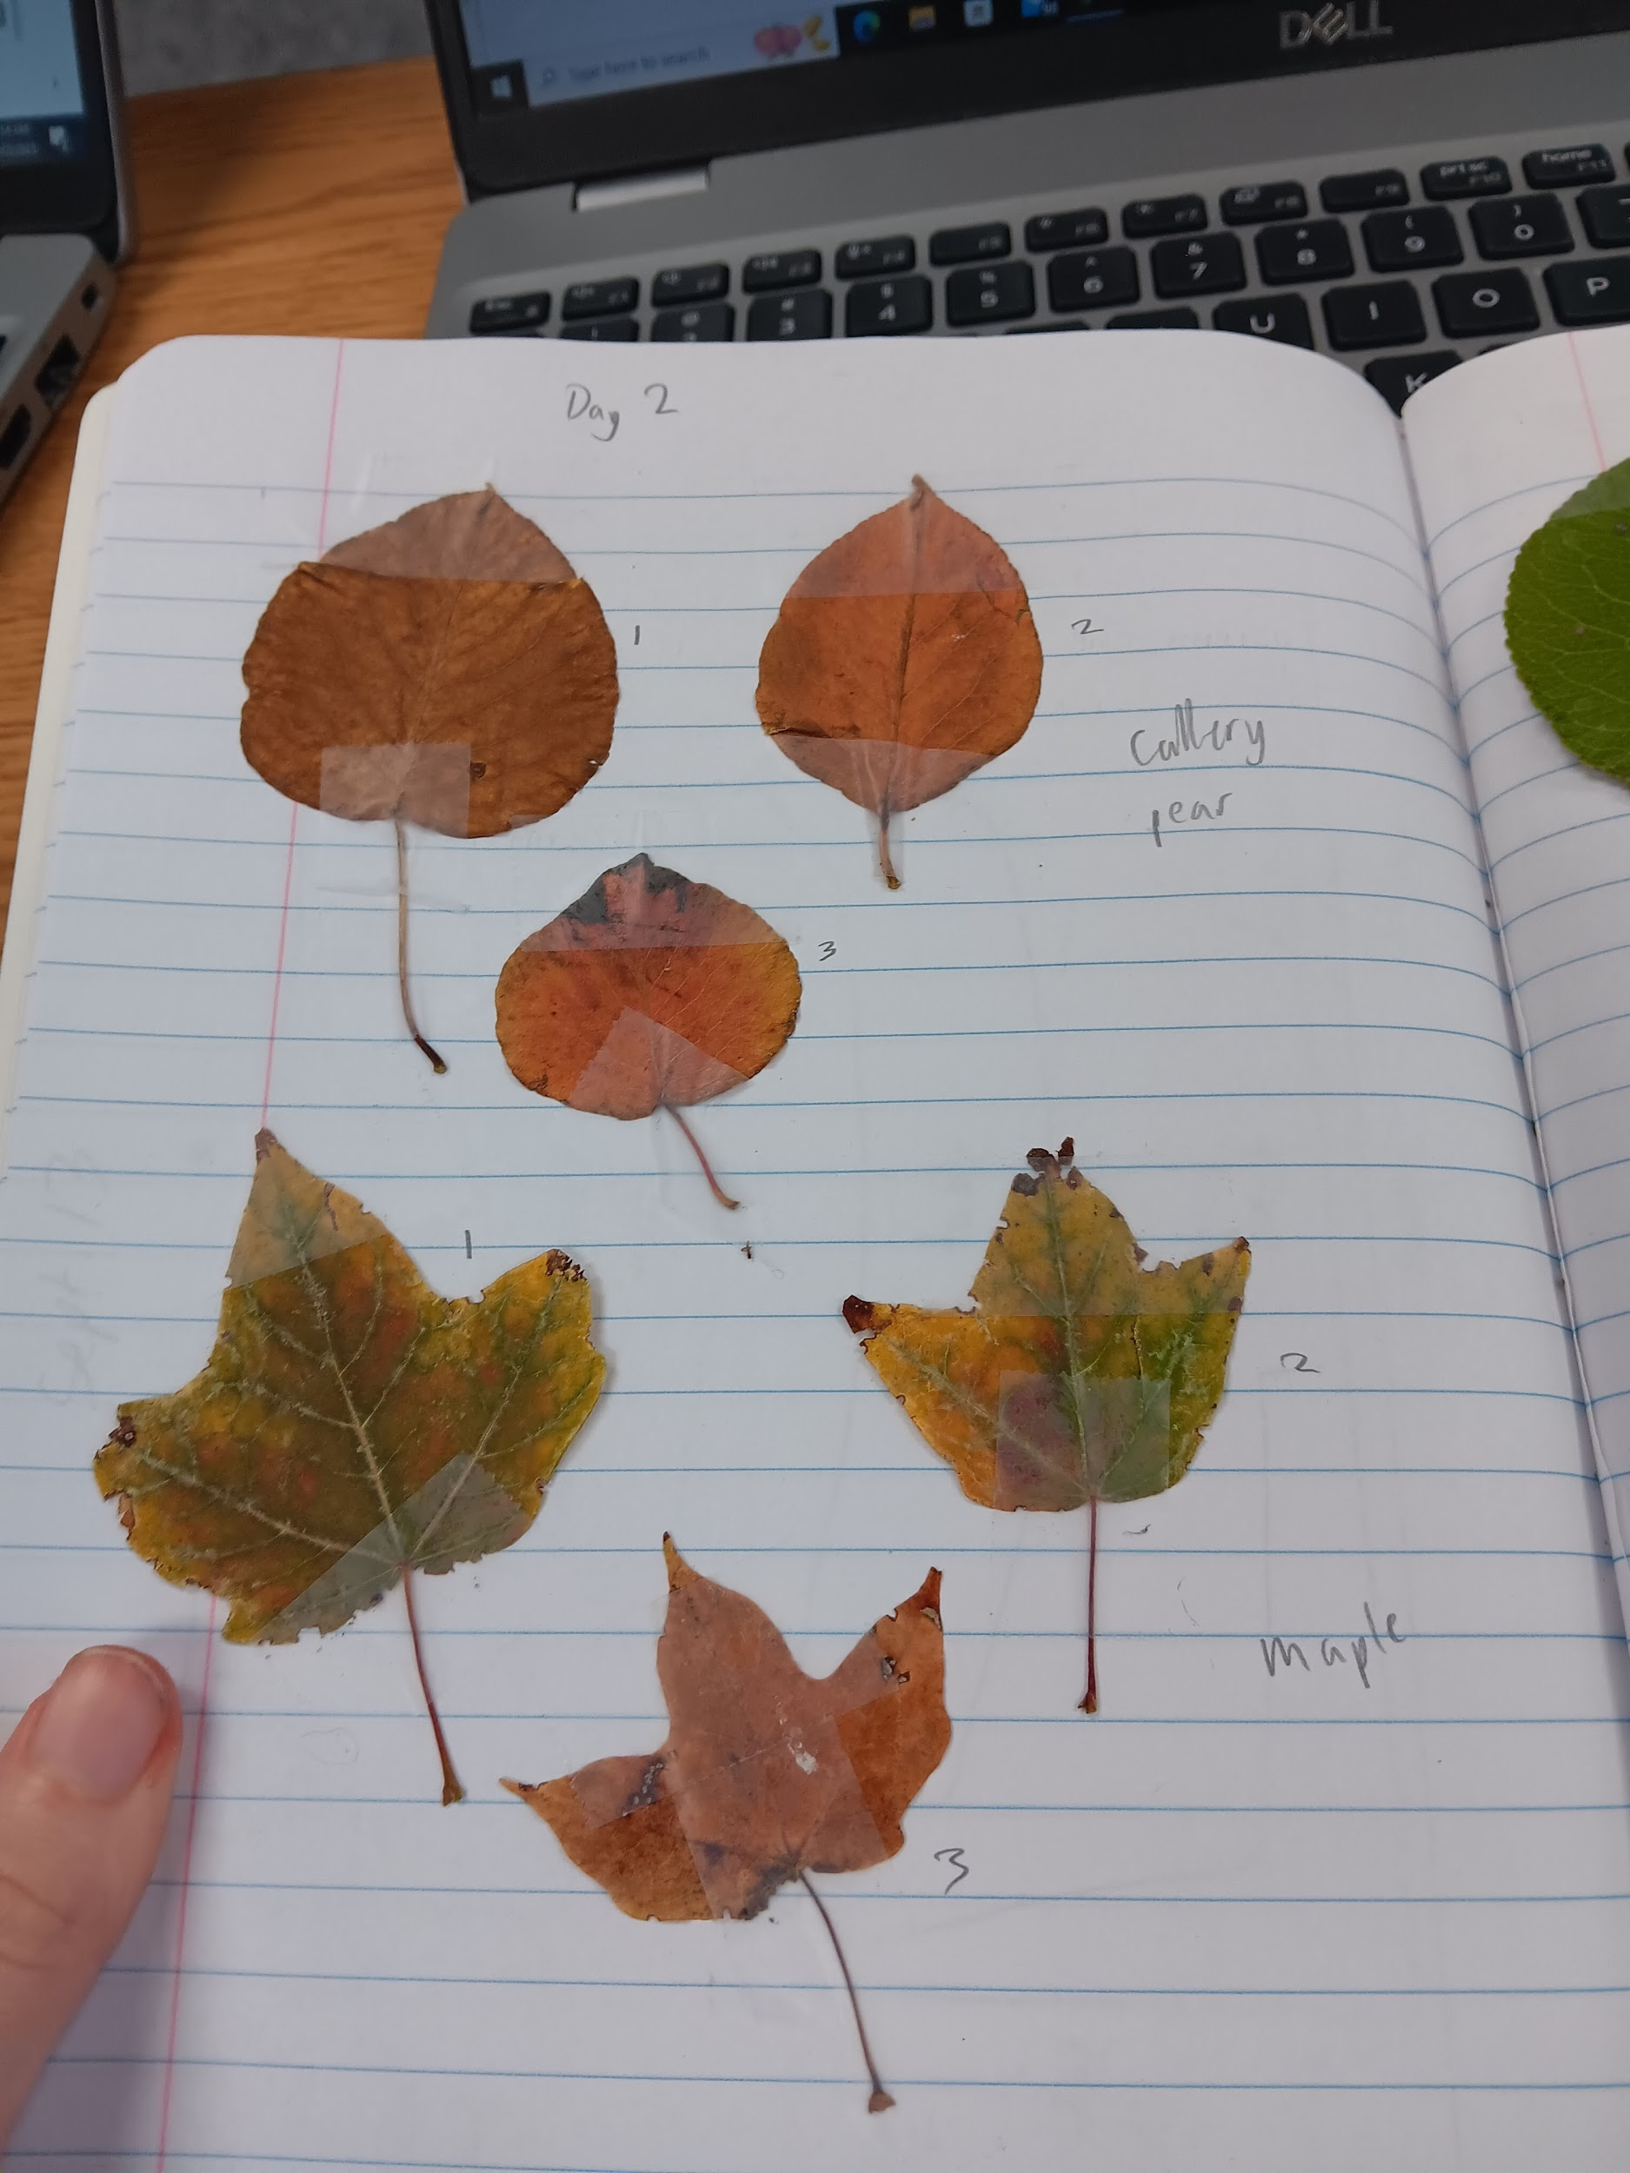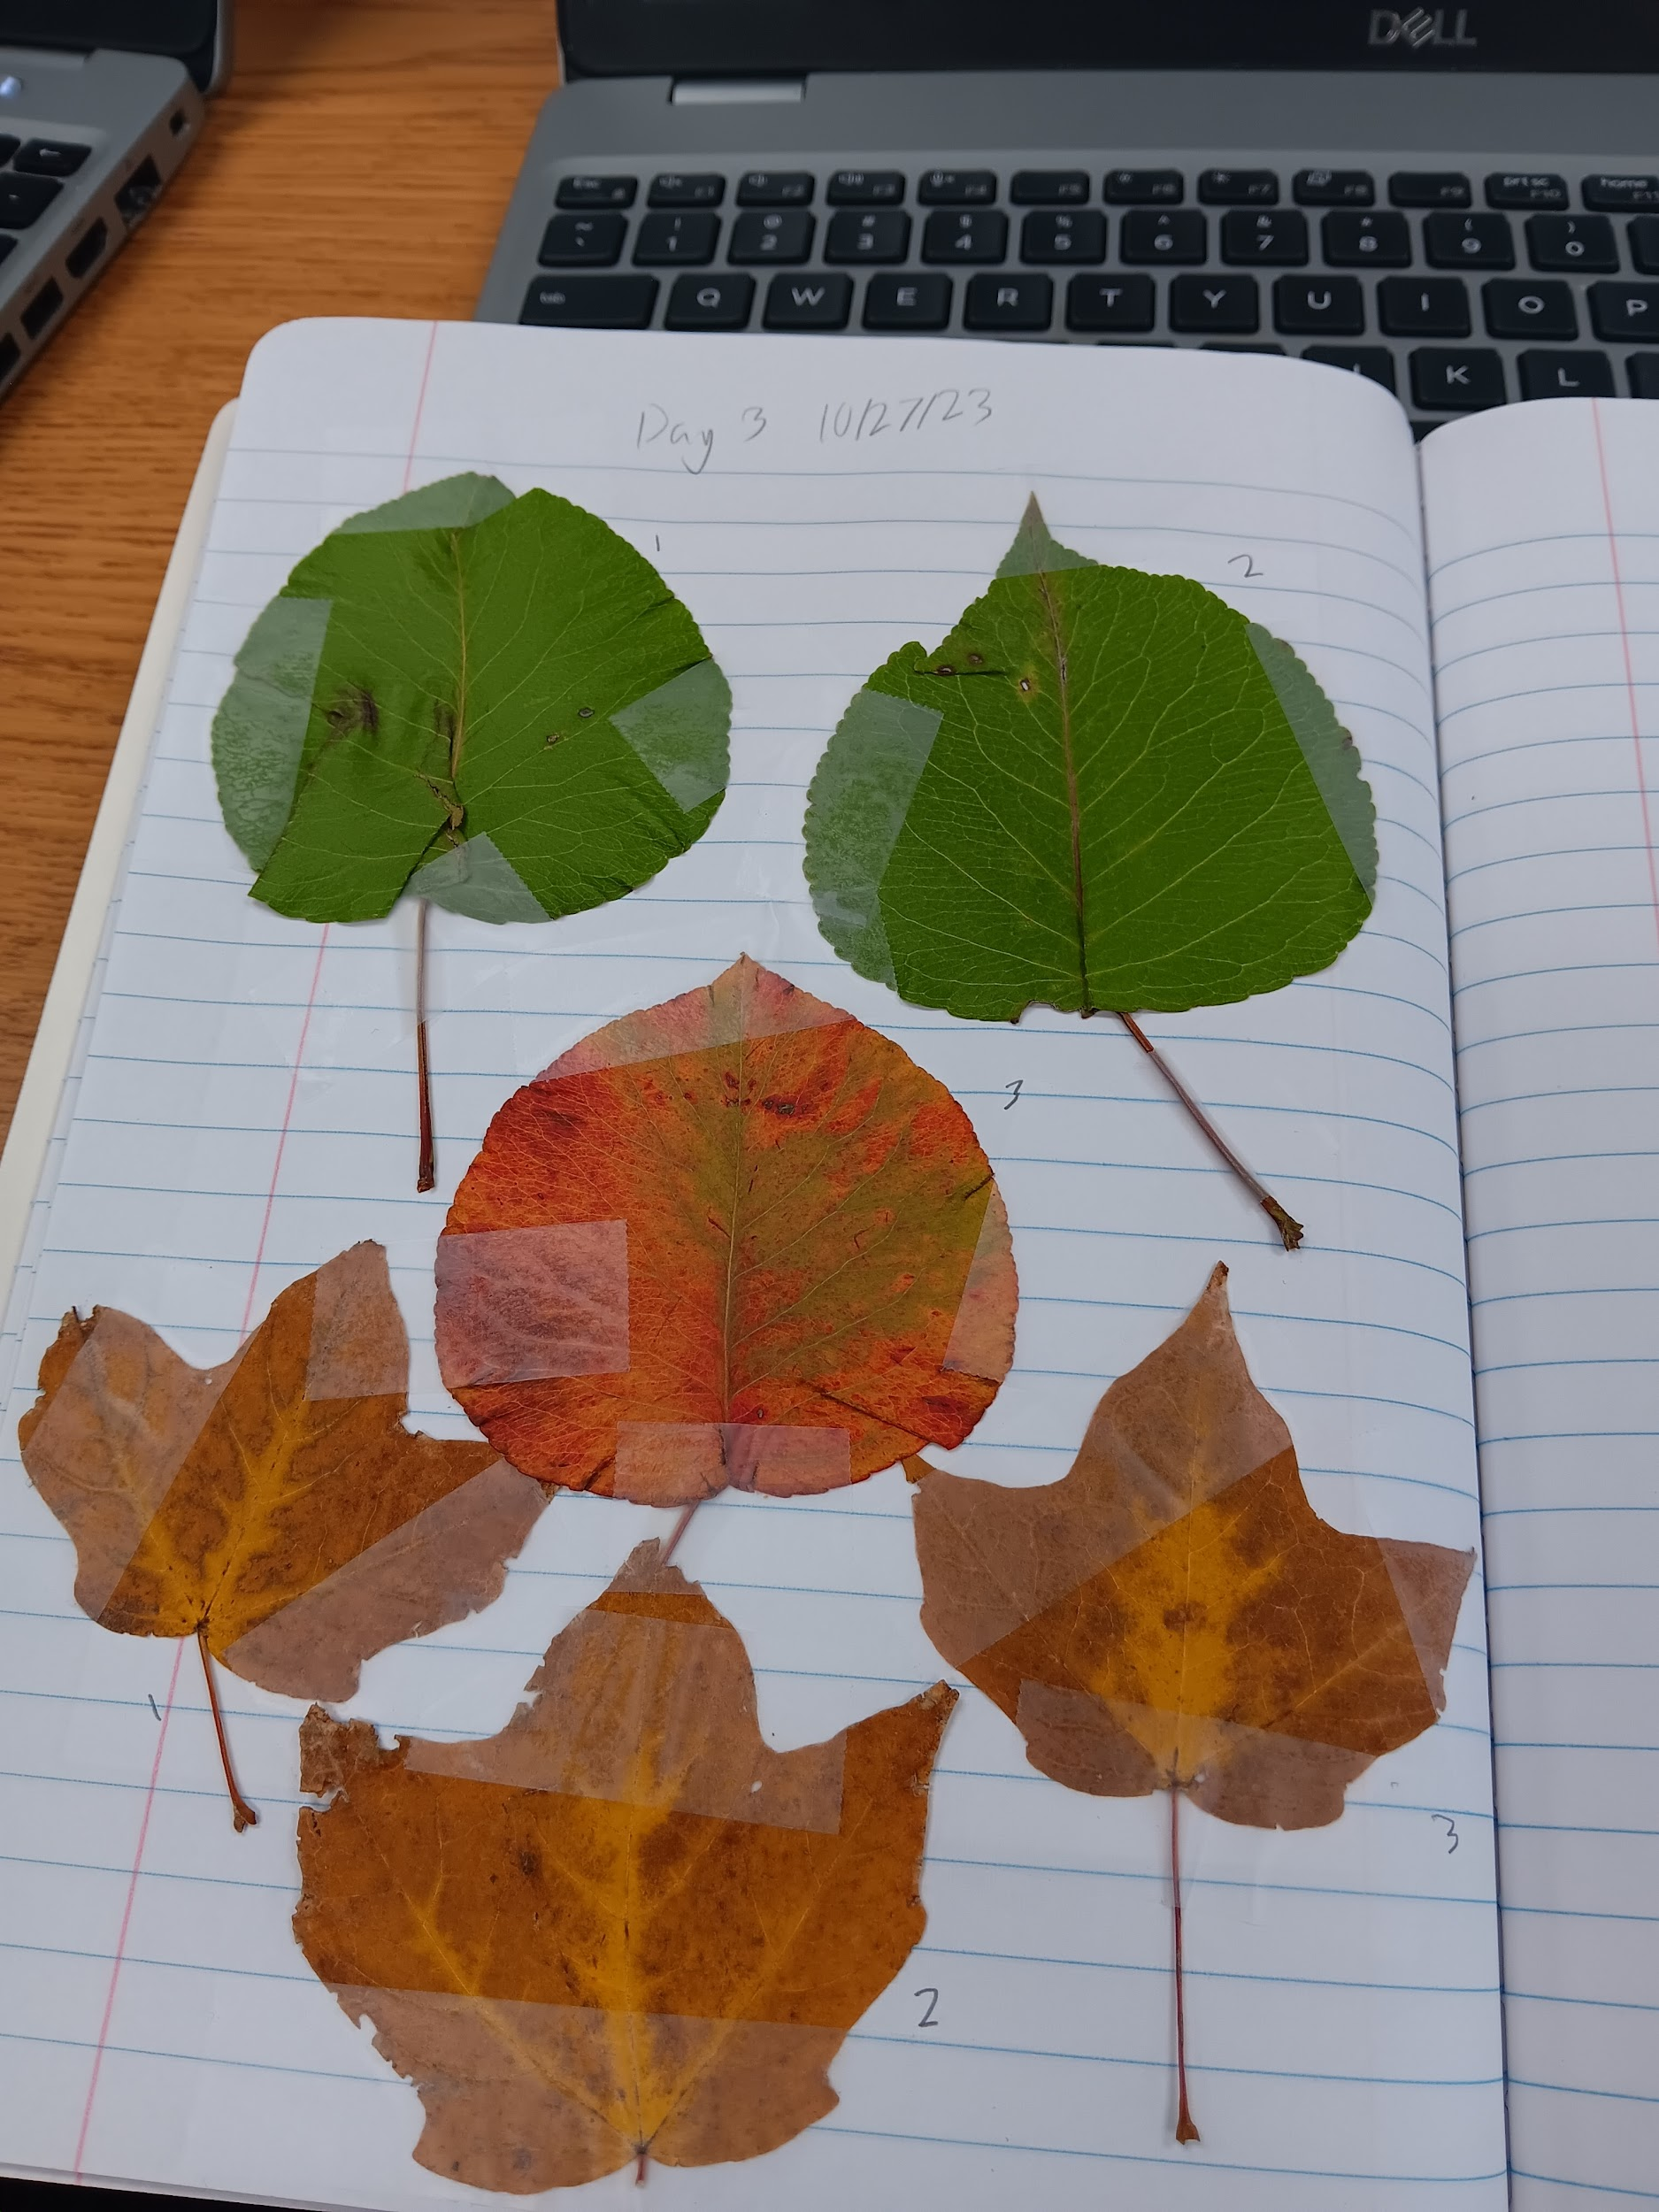

10/4 10/12 10/27

Clouds on 10/4:

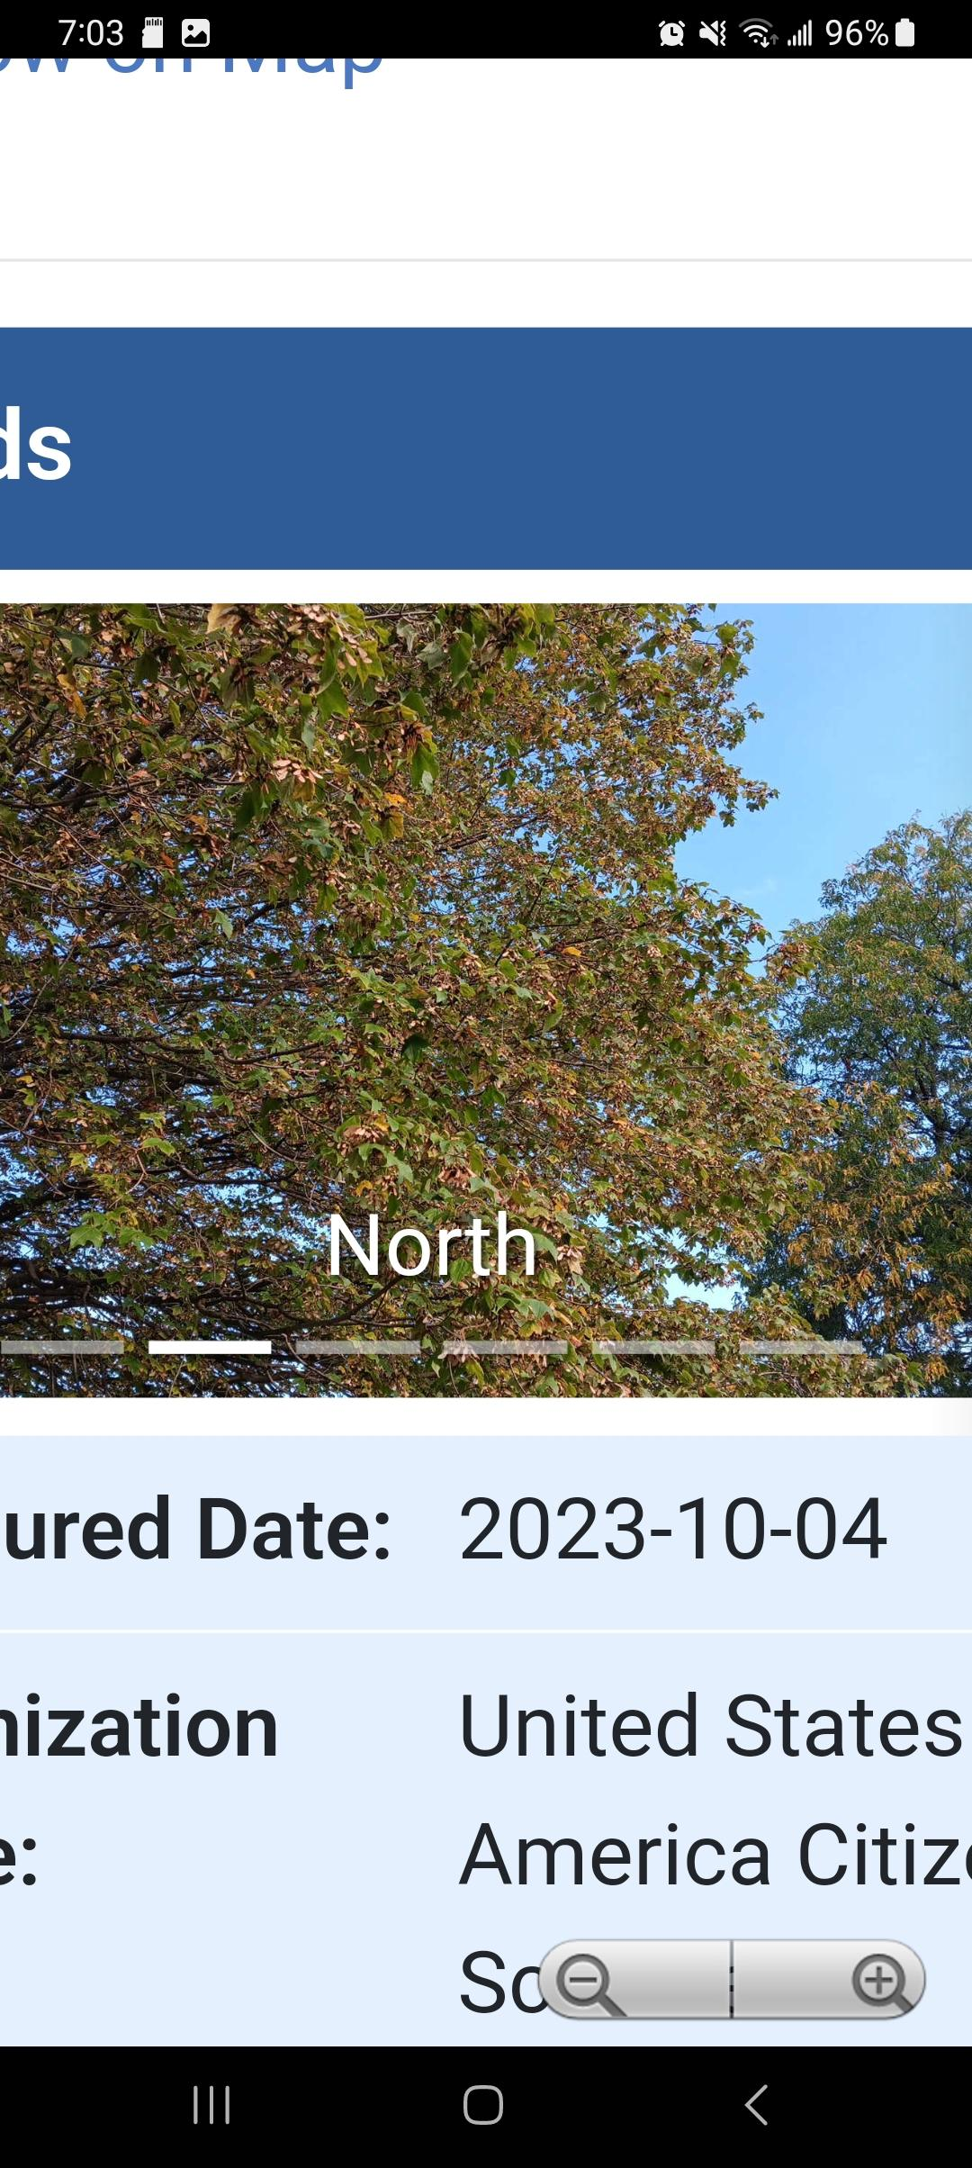



Works Cited:

<https://weather.com/weather/today/l/1c69b3283bda3676e430888578408cdac662e1038ca453b2ba43496cc91fb6ce>

<https://www.esf.edu/eis/eis-leaves-color-change.php#:~:text=But%20in%20the%20fall%2C%20because,part%20of%20their%20fall%20splendor>.

<https://www.globe.gov/web/s-cool>