Teacher Preparation:

Materials and Tools
- At least 6 Glass Jars with a hole punched in the lid (use a nail) (or Plastic Bottles) Label each jar according to treatment (where it will be and if/how it will be watered)  - DRY, SUNNY  - MOIST, SUNNY  - WET, SUNNY  - DRY, SHADY  - MOIST, SHADY  - WET, SHADY  - Permanent Marker (or Labels)  - Something for students to mark/label their jars with (stickers, tape…) |  | - 6 Cups Dry Soil (12 Cups if using plastic bottles)  - Measuring Cup (or graduated cylinder)  - 1 stirring stick per student  - Organic material: (can ask students to bring)  - chopped fruit, chopped vegetables, fruit or vegetable peels, used coffee grounds, used tea/tea bags, leaves, grass clippings, flowers  NOTE: DO NOT USE MEAT, DAIRY, OR ANY PROCESSED FOODS  - Optional: Red wiggler worms
- Locate areas in the classroom that will provide variable conditions required for the experiment
- Sunny site | - Shaded site
- Set the jars out so each group has a compost jar to make (you may have more than one jar per treatment)
- Have students take turns completing steps
- When students have finished and the jars are set in their designated locations, take some pictures of the finished compost jars
Maintenance and Observations:
- Every Monday, Wed, Friday:
  - Re-saturate jars marked WET by adding ¼ to ½ cup water
  - Re-moisten jars marked MOIST by adding 2-4 Tablespoons of water OR spritzing with a spray bottle
- Every Day for at least 2 weeks:
  - Have students observe their jars and record their observations of:
    - Mix (Compost) height
    - Mix (Compost) temperature (both feeling with hands and measuring with soil thermometer.
    - Appearance of the mixture
- At the end of the investigation:
  - Graph and discuss the results: How will this affect your composting?

Intentionally Blank Page
DRY,
SUNNY
MOIST,
SUNNY
DRY,
SHADY
WET,
SUNNY
WET,
SHADY

MOIST,
SHADY

LET’S MAKE OUR COMPOST JARS!
Your Supplies:
At your table  - 1 Mason Jar with a label  - 1 Bag of SOIL  - 1 ORGANIC SCRAPS  - Measuring Cups  - Measuring Spoons  - 1 Soil Thermometer  - 1 Permanent Marker | In front of you  - 1 Stirring Stick  - 1 Ruler  - 1 Observation Sheet
Steps: When you finish a step put a check in the box
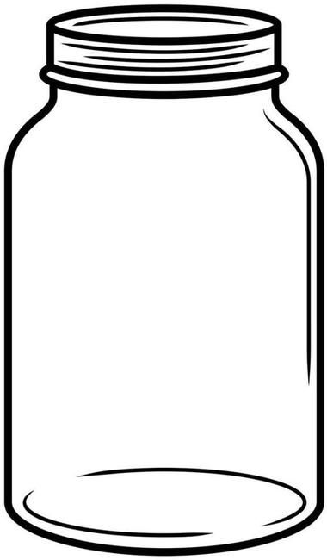
- 1. Add 1 cup of SOIL to your jar

- Add 5 Tablespoons of ORGANIC SCRAPS

- Take turns and MIX your ORGANIC SCRAPS with the SOIL using your STIRRING STICK
- Look at the FIRST WORD ON YOUR JAR LABEL to learn the next step:
  - The FIRST WORD ON MY JAR LABEL IS (check the box then follow the step next to the word you checked):
    - WET : Add 1 cup of WATER to your jar
    - MOIST : Add 8 Tablespoons of WATER to your jar
    - DRY : Don’t add anything else to your jar
- Fill in your OBSERVATION SHEET
Time to take MEASUREMENTS
This line shows where the TOP of my mix is on my jar
- ON YOUR JAR, use the MARKER to draw a line where the top of your mix is
________________________________

________________________________
- COPY what your JAR LABEL says:
- Use your RULER to measure the HEIGHT of your mix
  - The HEIGHT of my mix is __________________
- FEEL the TEMPERATURE of the outside of your jar
  - My jar FEELS (circle one):
COLD (like ice) | NORMAL (Just like the rest of the room) | WARM (like when I put my hands on my neck)
COOL (like tap water) | NORMAL (Just like the rest of the room) | HOT (like really hot soup or cocoa)

- Use your SOIL THERMOMETER to MEASURE the TEMPERATURE of your mix (your teacher will demonstrate what to do)
  - The MEASURED TEMPERATURE of my mix is __________________
- What does your mix LOOK like? (what color or colors do you see in your mix?)
____________________________________________________________________________________
____________________________________________________________________________________
- Put the lid on your jar
- USE the back of this page to DRAW A PICTURE OF YOUR JAR
- When you are done, your teacher will help your group put your jar where it goes (SUNNY or SHADY)

DATE | What is the HEIGHT of your mix? | What does your jar TEMPERATURE FEEL like?  (COLD, COOL, NORMAL, WARM, HOT) | What is the MEASURED TEMPERATURE of your mix? | What does your mix LOOK like (what COLOR is it, what has CHANGED in how it LOOKS)?

