WHAT YOU KNOW:
Share about it: After students have written down what they “know,” they can pair and share, share with their tables and/or have a science circle discussion to share their answers.
WHAT YOU THINK:
Write about it: As a table or as a class, write the story about what made the canyon.
Optional: Provide students with vocabulary list with words to be included in their story.
BUILD HILLS AND CARVE CANYONS – Let’s Investigate Our Hypotheses
There are two options for this. Inside will be set up in a foil pan. Outside can be done on an existing hill.
Materials
- “What Color is the Soil Investigation Tool”  - “How Clean is the Water Investigation Tool”  - Clear plastic cups  - Magnifying glasses  - Paper cup with holes in it (inside) | - 1 container with CLEAN water  - Foil pan (inside)  - SOIL  - ROCKS  - GRASS or MOSS
Vocabulary
Breakdown – to break something into smaller pieces  Canyon – a deep valley with steep sides (like a V shape)  Deposition – soil, sand, and small rocks set down in a new location. | Erosion – to slowly breakdown or wear away a surface.  Glacier – A huge river of ice that is SLOWLY moving. Glaciers flow like a river but REALLY slow.  Weathering – how surfaces change color, shape, and texture over time. Weathering is the breakdown of surfaces caused by weather (wind, rain, snow, sun, and temperature)
Inside:
- Build a hill on ½ of the pan with firmly packed soil. The empty side of the pan will be the “lake.” You can run this 3 times – once with bare soil, once with grass or moss, once with small rocks on the soil.

Outside:
- Find a slope large enough for multiple small groups.
- Optional: Select areas with different surface cover
  - One with bare soil
  - One with rocks and pebbles
  - One with grass
Both inside and outside
- DRAW WHAT YOU SEE: Students draw what the hill looks like before it “rains” on the hillfor the 1st time.
- Students look at the soil and determine the SOIL COLOR using the “Soil Color Investigation Tool.”
  - Students record the “beginning soil color” in their “Carved Canyons Casebook.”
- Water Clarity: Students look at the water and determine WATER CLARITY
(Optional) Using the “How Clear is the Water Investigation Tool.”
  - For each table/group: Fill a 9oz clear plastic cup ½ full with water.
  - Place the cup on top of one of the circles on the Water Investigation Tool.
  - Students take turns looking straight into the cup.
  - Students record their answer to “What does the fish look like?” in their “Carved Canyons Casebook.”
- Students PREDICT what will happen to the hill’s surface (soil, pebbles, rocks, grass…) when it “rains” on the hill.
- Grade 4+: Students write their predictions in their “Carved Canyons Casebook.”
- Grade 2+: Students share their predictions. Teacher records predictions on paper/whiteboard.
- Hold the paper cup with holes in the bottom 10-15cm (4-6in) above the hill.
  - Inside: make sure you are above the top of the hill you made.
  - Water Clarity Outside: have one person hold a cup 30-45cm (1-1.5ft) downhill to catch water that flows down the hill (“downhill cup”).
- Quickly pour clean water into the paper cup to fill the cup to the top.
- Students observe what happens to the hill as it rains out of the cup onto the hill.
- AFTER the rain stops, students write what they observed in their “Carved Canyons Casebook.”
- Water Clarity
  - Inside:
    - Use a 9oz clear plastic cup to collect water from the “lake.”
    - Students look at the water in the “lake” cup and discuss what they see (does it look the same or different?)
    - Pour the water directly back into the lake.
  - Outside:
    - Students look at the water in the “downhill cup” and discuss what they see (does it look the same or different?)
    - If possible, do not pour the water out of the cup.
- Students PREDICT what will happen to the hill’s surface when it rains again on the hill.
- Repeat steps 6-10 in the same spot 2-4 more times with students PREDICTING what will happen prior to each repetition.
- Soil Color Wrap Up
  - Students look at the soil and determine the SOIL COLOR using the “Soil Color Investigation Tool.”
  - Students record the “beginning soil color” in their “Carved Canyons Casebook.”
- Water Clarity Wrap Up:
  - Inside:
    - Use a 9oz clear plastic cup to collect water from the “lake.”
    - Place the cup on top of one of the circles on the Water Investigation Tool.
    - Place a cup ½ full of clear water on top of the other circle on the Water Investigation Tool.
    - Students take turns looking straight into each cup.
    - Students record their answer to “What does the fish look like?” in their “Carved Canyons Casebook.”
    - Students share what they think is in the “lake” water.
  - Outside:
    - Place the “downhill cup” on top of one of the circles on the Water Investigation Tool.
    - Place a cup ½ full of clear water on top of the other circle on the Water Investigation Tool.
    - Students take turns looking straight into each cup.
    - Students record their answer to “What does the fish look like?” in their “Carved Canyons Casebook.”
    - Students share what they think is in the “downhill cup” water.
- Science Circle: Introduce vocabulary
  - Discuss what the class saw – what happened to the soil, what formed, what moved?
  - Discuss where students think the soil that was moved from the hill went
    - Support claims with evidence (before and after water clarity)
SOLVE THE CASE:
Revise the story written during Part 1: WHAT YOU THINK: As a table or as a class, re-write the story about what made the canyon.

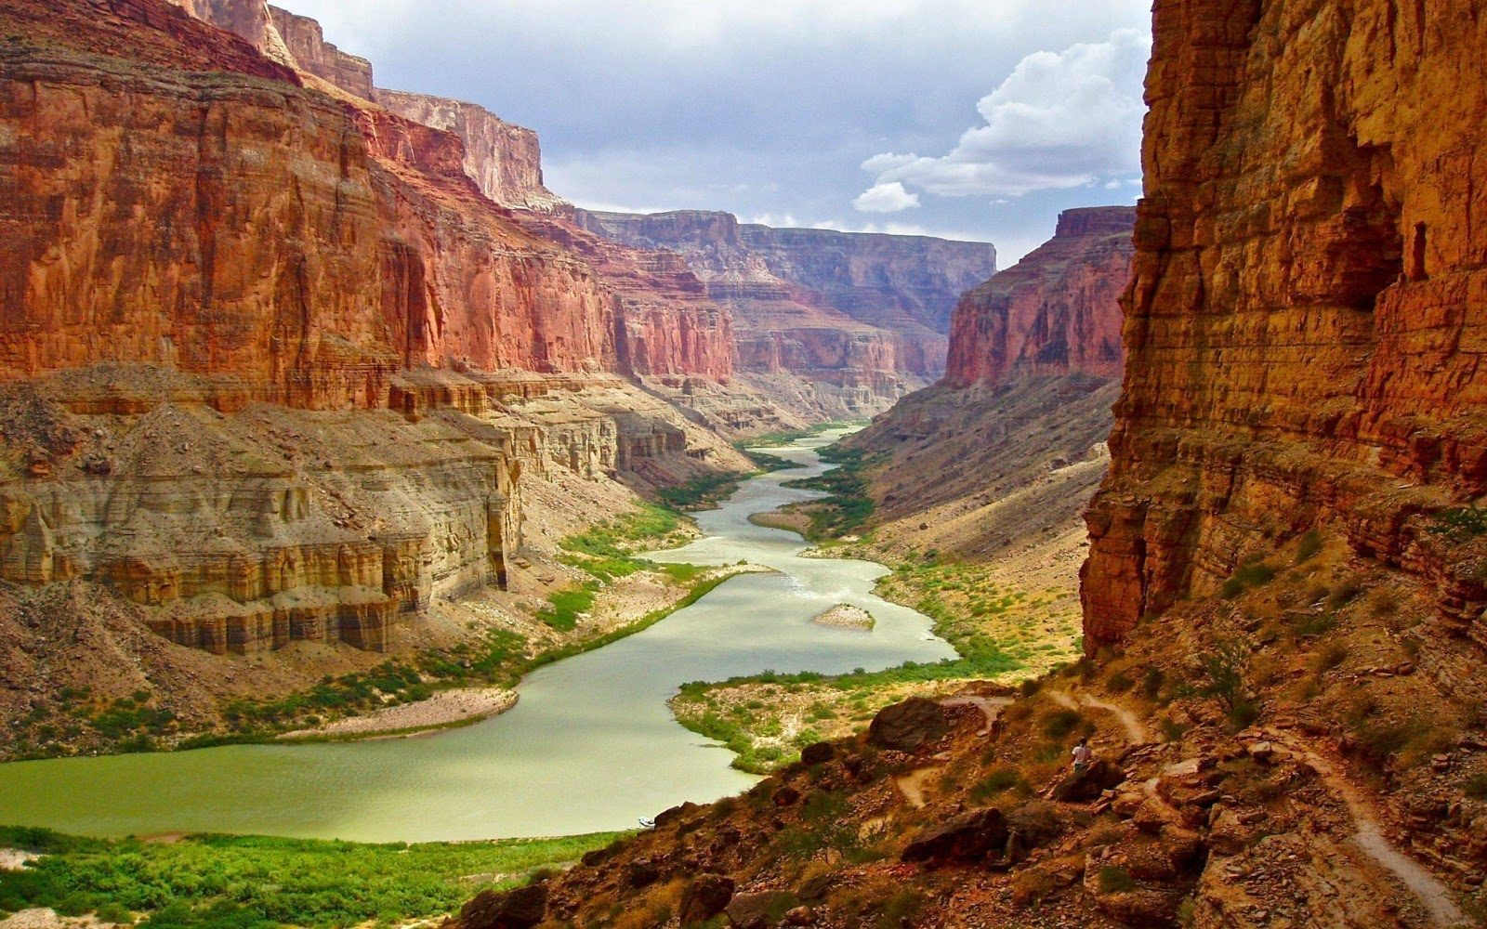
Carved Canyon Casebook

Image From: https://enjoyourholiday.com/2014/06/27/three-spectacular-canyons-americas/

Science Detective Name:____________________________

Room Number: ____________________________________
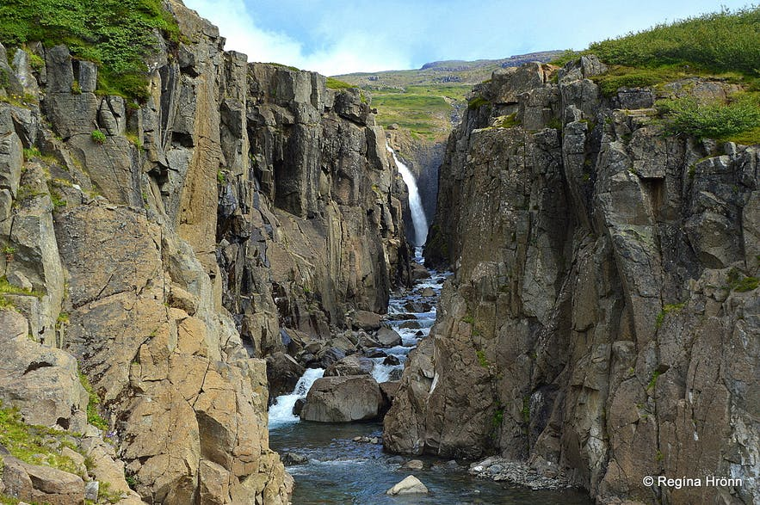
A river canyon in Iceland
MISSION: Look at the picture of the river canyon above. This was a giant field a long time ago. The canyon was not always there. Something carved the canyon by breaking down the rocks. Your mission is to find out how canyons are made.
WHAT YOU KNOW:
- Name two things you KNOW can break down rocks.
- I know _______________________________________________ can break down rocks.
- I know _______________________________________________ can break down rocks.
- Name two things you KNOW can move rocks.
- I know __________________________________________________ can move rocks.
- I know __________________________________________________ can move rocks.

WHAT YOU THINK: This is how WE think the Canyon was made!
_____________________________________________________________________________
-----------------------------------------------------------------------------------------------------------------------------
_____________________________________________________________________________
-----------------------------------------------------------------------------------------------------------------------------
_____________________________________________________________________________
-----------------------------------------------------------------------------------------------------------------------------
_____________________________________________________________________________
-----------------------------------------------------------------------------------------------------------------------------
_____________________________________________________________________________
-----------------------------------------------------------------------------------------------------------------------------
_____________________________________________________________________________
-----------------------------------------------------------------------------------------------------------------------------
_____________________________________________________________________________
-----------------------------------------------------------------------------------------------------------------------------
_____________________________________________________________________________
-----------------------------------------------------------------------------------------------------------------------------
_____________________________________________________________________________
-----------------------------------------------------------------------------------------------------------------------------
_____________________________________________________________________________
-----------------------------------------------------------------------------------------------------------------------------
_____________________________________________________________________________
-----------------------------------------------------------------------------------------------------------------------------
_____________________________________________________________________________
-----------------------------------------------------------------------------------------------------------------------------
_____________________________________________________________________________
-----------------------------------------------------------------------------------------------------------------------------
_____________________________________________________________________________
-----------------------------------------------------------------------------------------------------------------------------
_____________________________________________________________________________
-----------------------------------------------------------------------------------------------------------------------------
_____________________________________________________________________________

DRAW WHAT YOU SEE: Sketch what the hill in the pan looks like.

WRITE WHAT YOU SEE:
- What color is the SOIL on the hill? Use the Soil Color Investigation Tool to help you decide.
The SOIL on the hill is the color______________________________________________.
- What color is the WATER in the RAINWATER container? Use the Water Color Investigation Tool to help you decide.
The WATER in the container is the color_______________________________________.
- What does the fish look like through the water from the RAINWATER container? Check the box next to your answer:
- The fish is very easy to see.  - The fish is a little bit blurry.  - The fish is very blurry. | - I can barely see the fish.  - I can’t see the fish at all.
PREDICT:
- WHERE do you think the water will flow when it rains on the hill?
I think the water will flow___________________________________________________
________________________________________________________________________
I think this because________________________________________________________
________________________________________________________________________
________________________________________________________________________
________________________________________________________________________
- HOW do you think the water will flow when it rains on the hill? Check the box next to your answer.
- I think the water will flow everywhere.
- I think the water will flow in many little straight lines.
- I think the water will flow in one big straight line.
DRAW WHAT YOU SEE: Color in the box to show what the SURFACE of the hill looks like.
UPHILL

DOWNHILL
WRITE WHAT YOU SEE:
- What color is the SOIL on the hill? Use the Soil Color Investigation Tool to help you decide.
The SOIL on the hill is the color______________________________________________.
- What color is the WATER in the RAINWATER container? Use the Water Color Investigation Tool to help you decide.
The WATER in the container is the color_______________________________________.
- What does the fish look like through the water from the RAINWATER container? Check the box next to your answer:
- The fish is very easy to see.  - The fish is a little bit blurry.  - The fish is very blurry. | - I can barely see the fish.  - I can’t see the fish at all.

PREDICT:
- WHERE do you think the water will flow when it rains on the hill?
I think the water will flow___________________________________________________
________________________________________________________________________
I think this because________________________________________________________
________________________________________________________________________
________________________________________________________________________
________________________________________________________________________
- HOW do you think the water will flow when it rains on the hill? Check the box next to your answer.
- I think the water will flow everywhere.
- I think the water will flow in many little straight lines.
- I think the water will flow in one big straight line.
WHAT YOU KNOW:
- Name two things you KNOW can breakdown rocks.
- I know _______________________________________________ can break down rocks.
- I know _______________________________________________ can break down rocks.
- Name two things you KNOW can move rocks.
- I know __________________________________________________ can move rocks.
- I know __________________________________________________ can move rocks.
We will look at 3 different spots on our hill.
One spot will only have bare soil.
One spot will be covered in grass.
One spot will be on top of a big rock.
What Color is the SOIL on the hill?  Use the Soil Color Investigation Tool | What Color is the WATER in the container?  Use the Water Color Investigation Tool | Water Clarity — What does the fish look like through the water from the RAIN WATER container?
From the CLEAN water container
- The fish is very easy to see.
- The fish is a little bit blurry.
- The fish is very blurry.
From the bottom of the hill with SOIL
- The fish is very easy to see.
- The fish is a little bit blurry.
- The fish is very blurry.
From the bottom of the hill with GRASS
- The fish is very easy to see.
- The fish is a little bit blurry.
- The fish is very blurry.
From the bottom of the hill with ROCKS
- The fish is very easy to see.
- The fish is a little bit blurry.
- The fish is very blurry.

BUILD HILLS AND CARVE CANYONS – Let’s Investigate Our Hypotheses
Vocabulary Word | Definition (What this word means)
Break down | 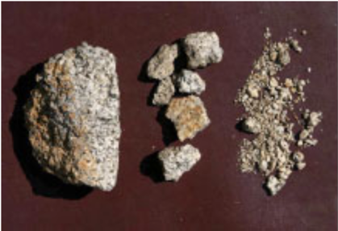  Breaking something apart into smaller pieces.
Canyon | 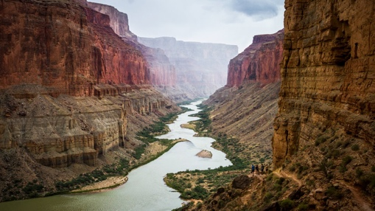  A deep valley with steep sides called cliffs.
Deposition | 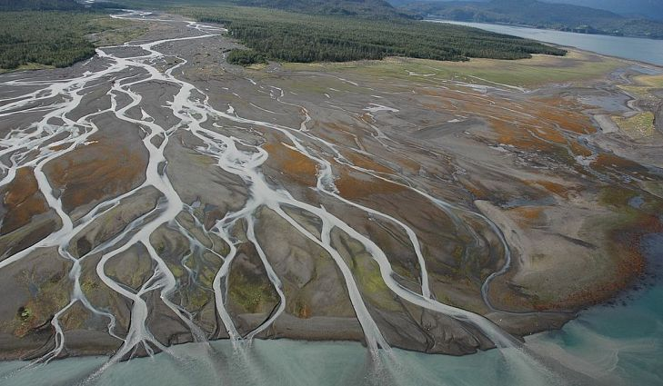  The settling of soil, sand, and small rocks in a new location.
Erosion | 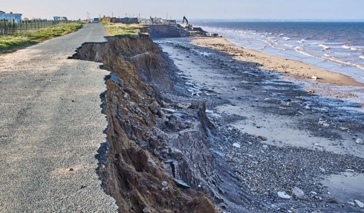  To slowly breakdown or wear away a surface.
Glacier | 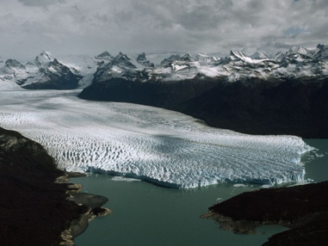  A huge block of ice that is SLOWLY moving. Glaciers flow like a river but REALLY slow.
River | 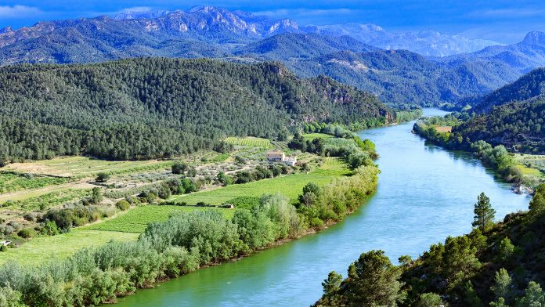  A large stream of water that runs through the land.

Materials
- “What Color is the Soil Investigation Tool”  - “How Clear is the Water Investigation Tool”  - Magnifying glass | - Pencil  - “Carved Canyons Casebook”
What to do
- PREDICT
- OBSERVE
- MEASURE
  - Water Clarity (something we CAN see)
- SHARE

Water Sample | Water Clarity — How easy is it to through the water in your cup? | What Color is the WATER in the container?  Use the Water Color Investigation Tool
From the CLEAN water container | The fish is_____________________________  _____________________________________  _____________________________________ | The water is the color___________________  _____________________________________
From the bottom of the hill with SOIL | The fish is_____________________________  _____________________________________  _____________________________________ | The water is the color___________________  _____________________________________
From the bottom of the hill with GRASS | The fish is_____________________________  _____________________________________  _____________________________________ | The water is the color___________________  _____________________________________
From the bottom of the hill with ROCKS | The fish is_____________________________  _____________________________________  _____________________________________ | The water is the color___________________  _____________________________________

Black | Brown | Sepia
Tumbleweed | Apricot | Gray

