Preparation:

Materials and Tools
- 12 Glass Jars (or Plastic Bottles)  - Permanent Marker (or Labels)  - 6 Cups Dry Soil (12 Cups if using plastic bottles) | - Organic material: (can ask students to bring)  - chopped fruit, chopped vegetables, fruit or vegetable peels, used coffee grounds, used tea/tea bags, leaves, grass clippings, flowers  NOTE: DO NOT USE MEAT, DAIRY, OR ANY PROCESSED FOODS
- Measuring Cup (or graduated cylinder) | - Optional: Red wiggler worms

Locate areas in the classroom that will provide variable conditions required for the experiment
Conditions required for the experiment
- warm, sunny site  - cool, sunny site | - warm, shaded site  - cool, shaded site

LET’S MAKE COMPOST JARS!

Steps (AFTER your complete a step, check it off so you remember it is done)

1. Set out 12 jars or beakers on table. Label each as follows:
1. Dry, warm, sunny 2. Moist, warm, sunny 3. Wet, warm, sunny 4. Dry, warm, shady 5. Moist, warm, shady 6. Wet, warm, shady 7. Dry, cool, sunny
8. Moist, cool, sunny 9. Wet, cool, sunny 10. Dry, cool, shady 11. Moist, cool, shady 12. Wet, cool, shady
2. Add equal amounts of soil (about 10 cm) to each jar.
3. Add equal amounts (about 2-3 cm) of vegetable material to each jar and evenly mix the soil and vegetable material. Use the same type of vegetable material in all jars.
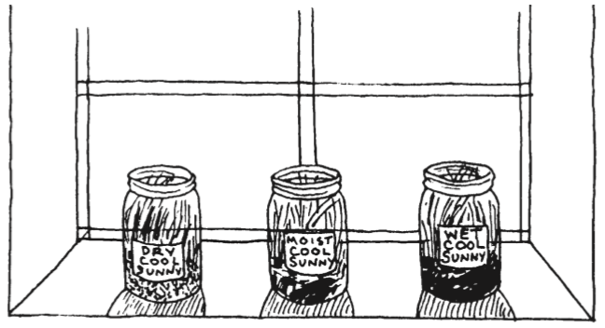
4. In each of the 4 jars marked “wet,” saturate the mixture with water (allow water to cover the surface of the soil).
5. In each of the 4 jars marked “moist,” moisten the mixture with water.
6. Leave the mixture to dry in the 4 jars
marked “dry.”
7. Place one wet, one moist and one dry
jar in a warm place that is shaded (as
marked).
8. Place one wet, one moist and one dry
jar in a warm place that also gets sun
for part of the day (as marked).
9. Place one wet, one moist and one dry
jar in a shaded, cool place.
10. Place one wet, one moist and one dry
jar in a cool place that also gets sun
for part of the day (as marked).
11. Cover the jars but poke small holes in
the top for air to circulate.
12. Every other day, saturate soils in jars
that are marked “wet,” and moisten soils in jars marked “moist.” At this time, stir the soil/vegetation mixture in each jar.
13. For a period of two weeks, observe the jars daily (or every other day) and record observations. Note changes in water content and the condition of organic matter.
Discuss with the class how light, temperature, and water content affected the amount of organic material left in the soil after 2 weeks. Which jars (conditions) show the most decomposition? Which jars show the least decomposition? Can you rank the jars from the least to most decomposition after 2 weeks? What other changes have been observed in the soil (such as color, ponding, others)?
Once students have discussed their observations, have them design their own optimal decomposer using any combination of the variables in the investigation. Have them justify their choice of conditions and predict how each factor will contribute to decomposition.

Adaptations for Younger and Older Students
For Younger Students
Reduce the number of jars to either:
1. moist, wet, and dry (same temperature and light conditions), or
2. moist, warm and moist, cool (same light conditions).
Discuss the climates across the globe that would have these conditions, and compare them to the climate in your local area.
For Older Students
Discuss and relate how decomposition of organic material varies across the globe. What are the sources of organic material in different areas? How does climate affect how fast the organic material will become humus? Have them speculate on what climate conditions will promote the decomposition of organic material and what will inhibit the decomposition of organic material? How would decomposition in a tropical soil differ from that in a northern forest?
Further Investigations
Using soils with “optimal conditions,” place earthworms in one jar and leave a second jar earthworm-free. Observe and record earthworm activity, rate of decomposition, and differences in soil properties after 2 weeks for each jar. You may also want to create a “worm farm” in a glass jar to observe worm behavior, decomposition, and changes in soil over a longer period of time.
Do a similar experiment as above but vary the soil texture. Include jars with predominantly sandy soil or clayey soil and observe differences as above.
Ask students to research composting.

