Data Entry

A. Setting up a GLOBE Data Collection Site

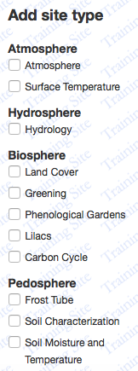
- Use your GLOBE log-in, then Click on GLOBE Data/Data Entry/Training Data Entry

- You should see IN RED at the top of the page the words Training Site

- Set up a fictitious site by clicking on “Add site” IN BLUE on the right of your school site – You can use the Fictitious Site Definition Sheet that we have provided. You only need a site name and coordinates to set a new site up.

- On the LEFT side margin click on:
- Atmosphere
- Surface Temperature
- Hydrology

- When you do this, you will see you need to provide additional information about your site from the “Fictitious Site Definition Sheet”. Follow along and complete the site set up. When you are done press the blue button on the bottom of the page – CREATE SITE. You should get a GREEN banner up top with a happy face if you have entered all of the required information.

- Correct the information if you get a PINK banner up at the top with a frown face. If you have had to make corrections, then update the site using the bottom blue button UPDATE SITE. Keep modifying your site set up until the green banner appears on top.

B. Entering Data
- Find your fictitious site in training data entry. Use the datasheets provided to enter atmosphere and hydrosphere data for the training site. To do this, you will need to click on the training site, look at the datasheet and click on the protocol where the data are provided. Enter all of the atmosphere and hydrosphere data into your training site.

Please note: you may have 3 data points for a particular protocol, on the right hand side you will see the green “ADD” button so you can add more than 1 entry for a particular protocol.

C. School Profile and Teacher Profile
1. Ok – Now you are not only ready to enter data from your school site…you are ready to for others to SEE your data…but Oh – no Wait – your school site is blank and your teacher profile looks ghostly…Time To Fix This

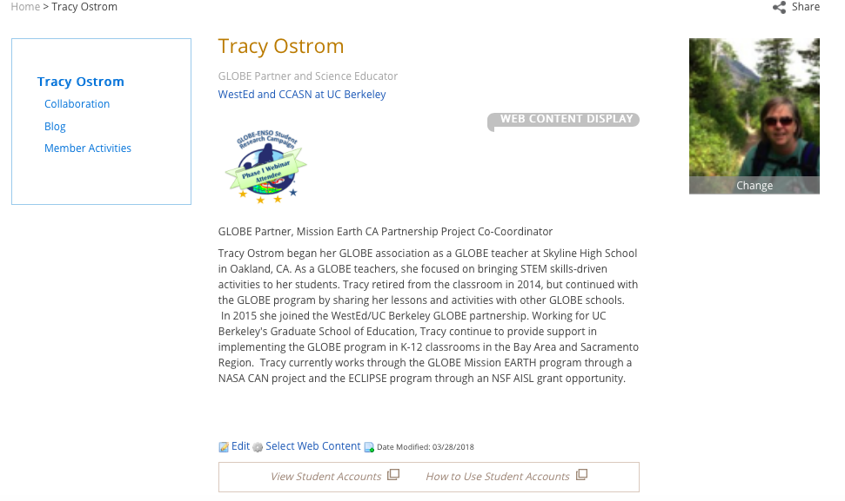
- Teacher Profile: Sign into the GLOBE website and in the upper right corner you will see your name. right click and scroll down to “my page” and click it. You will be able to “edit” your page (see bottom of this page for the edit button.) Add a picture of yourself. Write down what you teach, a little bit about your background and philosophy towards teaching. Here is what mine looks like:

- Student Accounts: At the bottom of your profile page, you should see:
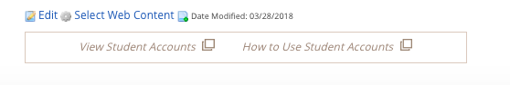

Click on “View Student Accounts” You should see a list of student accounts under your name. You can click on any student account you have listed and modify it and/or change the password. Please note that if you have NO student accounts, you can add a new account by clicking on “new account”. You can have multiple student accounts, or just 1 account that all of your students can use. Multiple students can be using the student account at the same time….I think. Make sure you create/have at least 1 student account!

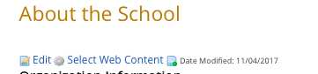
- School Profile: Sign into the GLOBE website and click the “Go To” button to the right of your name which is in the upper right corner. You should see your school listed. Click on it. You should see a map of your school and on the right side bar something that says “About & Contacts” Click on this. Underneath the “About the School” on the page, you will see an “edit” button. Click on the edit button and write something about your school and/or school site. If you don’t know what to write, go to your schools website and pull information off of the website.

Data Visualization

- The Basics

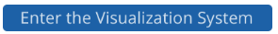
- Using your GLOBE log-in Click on GLOBE Data/Visualize Data and then enter the Data Visualization Tool

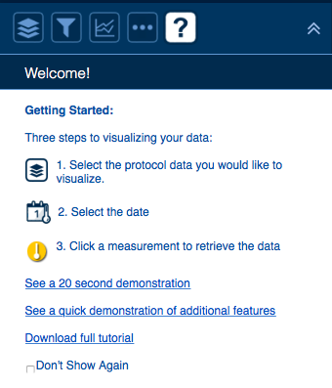
- On the LEFT side, you should see the following:
Click the “stack of papers” first and select atmosphere/temperature noon/solar noon temperature and click the green and white “submit” button

You should see some colored thermometers show up on the screen. These are the reported noon temperatures for the date identified in the center above window:
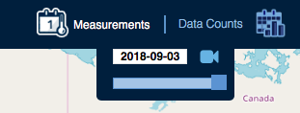

- A legend is always provided for you on the bottom right side of your screen. If you click on ANY of the thermometers, information about the data collection site is provided.

- You can click on more than one protocol and submit the submit button. This time, go back to the stack of papers and unclick solar noon temperature and click on cloud cover at noon and relative humidity at noon and click on the green and white submit button. You should see 2 sets of data on your map with 2 legends that look like:
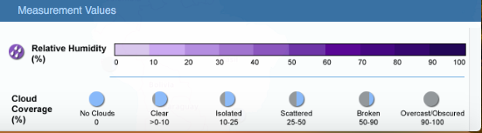

- Go back to the stack of papers and unclick the humidity and cloud cover protocols and find at least 1 protocol you know your school has entered and click on it.

- Now Click the “funnel icon” next to the “stack of papers icon” and look up YOUR school and select your GLOBE data collection site. Now click on the green and white submit button. Select a date above center.

- You should see a graph of the data collected at your site for the protocol selected. If you don’t see it, look to the left on the graph and make sure the correct protocol is selected. You can adjust the date range at the bottom of the graph.

- To the right of the graph, you can click on the data table icon and see your data in a table format. This table can be downloaded.

- You can manipulate how your data look by clicking on the graph icon
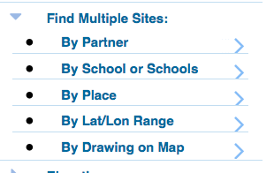
- You can compare data from two sites by going back to the funnel icon and entering the information for multiple sites. Choose two sites and compare at least 1 protocol for both sites.
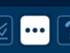
- The next icon allows you to change your base map.

- Advanced Look at Data
- On the GLOBE website: Click GLOBE Data/Retrieve Data/Enter the Data Access Tool. This tool allows you to find and retrieve GLOBE data using several different search filters. The narrower your search, the better your results. Based on your filters, you can download data as a CSV file for detailed analysis. The filters are listed on the left.

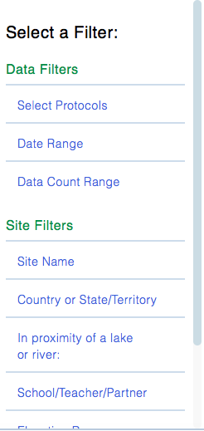
- Use the following filters to generate your data CVS:
- Protocols: Aerosols, Air Temperature – click on each and then click ADD Protocols
- Date Range: 2013-09-04 to 2018-09-04 – click ADD to Filter
- Data Count Range: leave at default
- Site Filter: no filters
- Click “Apply Filter (on top of page in GREEN) You should get 26,913 sites found. That’s TOO MANY. We need to add more filters!
- Now click on some site filters:
  - United States
  - Antioch High School
- You should get a message that 1 site was found and ~180 Measurements

- You can download the CVS file and there will be 183 entries on it.

- What is wrong with this data with respect your goal of comparing air temperature to aerosols? In other words, do you see that the temperature data and aerosol data were not taken on the same dates? If they were, then you could create a graph of the temperature vs. aerosol data.
