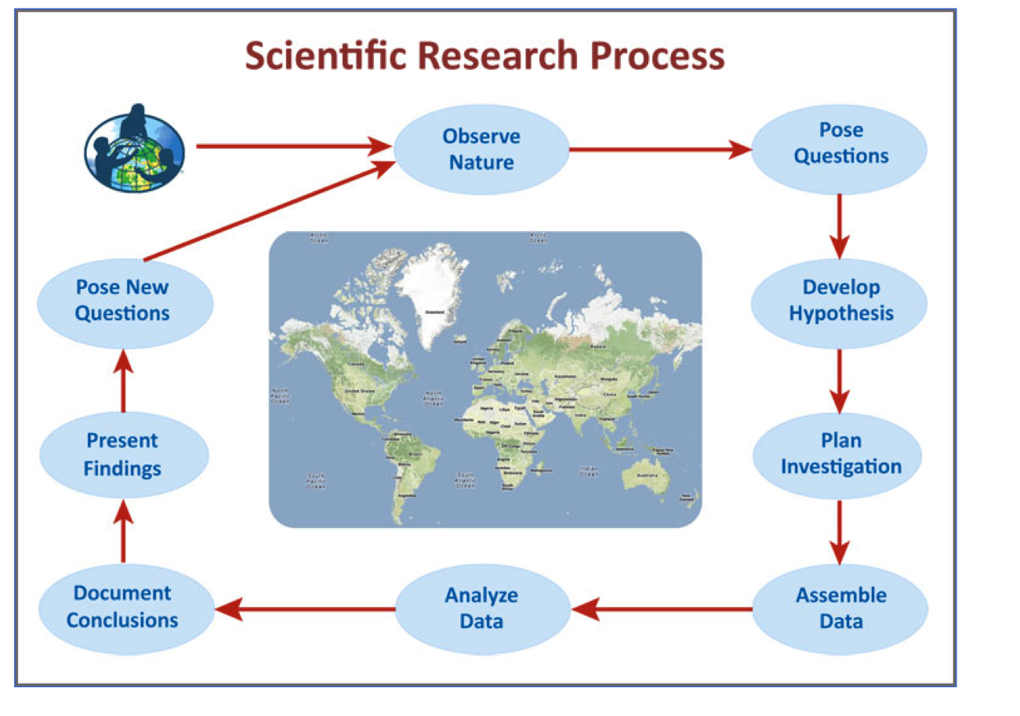
      - Pose a Research Question
- Develop a Hypothesis
- Plan an Investigation
- Assemble Data
- Analyze Data
- Draw Conclusion

Pose Research Question: ___________________________________________________________________________________________________________________

Develop Hypothesis: ___________________________________________________________________________________________________________________

Plan Investigation:
Equipment: 1. 2. What Data will be collected? 1. 2.
Where will Data be collected?
How much Data will be collected?

Record/Assemble Data in a Table:

How Will Data Be Visually Displayed? ___________________________________________________________________

Analyze Data:
- The data results support (do not support) our hypothesis because…
- This data is important to science and our community because…
- Limitations to our data are…
- Possible sources of error data collection and recording include…

Draw Conclusion:
- Our conclusion is (or is not) supported by the results because…
- Improvements to our research can be….

